Eldorado – Pisgah – Lugo Project

Attachment H.8
Nesting Bird Management Plan
Prepared for
Southern California Edison
February 2026

Prepared by
Arcadis U.S., Inc.
Applicable agencies
Bureau of Land Management
National Park Service
California Public Utilities Commission

Contents
Acronyms and Abbreviations
1. Introduction 1
1.1. Project Description 1
1.1.1. Transmission 2
1.1.2. Distribution 2
1.1.3. Substations 2
1.1.4. Project Activities 2
1.2. Agency Roles and Responsibilities 5
1.2.1. CPUC 5
1.2.2. BLM 6
1.2.3. NPS 6
1.2.4. CDFW 6
1.2.5. NDOW 6
1.2.6. USFWS 6
1.3. Regulatory Setting 7
1.3.1. Federal Regulations 7
1.3.2. State Regulations 7
1.4. Measures and Conditions from Environmental Documents 9
2. Management for Nesting Birds 10
2.1. Management Summary 10
2.1.1. Management Roles and Responsibilities 10
2.2. Nest Definitions 13
2.2.1. Active Nest 13
2.2.2. Inactive Nest 14
2.3. Active Nest Avoidance and Documentation 14
2.3.1. Determination of Species-specific or Avian Group/Family Specific Buffers 14
2.3.2. Implementation of Species-specific Buffers 21
2.3.3. Buffer Reductions 23
2.3.4. Accidental Disturbance of Active Nests 26
2.4. Exceptions to Notification Requirements 26
2.4.1. Critical Construction Activities 26
2.4.2. Buffer Distances for Access Roads 26

2.4.3. Active Substations and Yards 27
2.4.4. Minimal Disturbance Activities 28
2.5. Nesting Bird Deterrent Methods 30
2.6. Inactive Nest Management 33
2.6.1. Raptors 33
2.6.2. Burrowing Owl 34
2.6.3. Colonial Birds 34
2.6.4. Non-listed Special-Status, Non-Special-Status, Non-Game Bird Species Nest Removal 35
3. Field Approach 36
3.1. Survey Requirements 36
3.1.1. Survey Experience and Training 36
3.1.2. Qualifications 36
3.2. Field Maps 37
3.3. Nesting Season Survey Methodology 37
3.3.1. Active Nest Determination 39
3.4. Monitoring 39
3.5. Reporting 41
3.5.1. Data Sheets 41
4. Plan Approval and Amendment 44
5. References 45
6. Revisions 46

Tables
Table 1. Typical Project Activities and Their Disturbance Levels 3
Table 2. Nesting Bird Buffers for Horizontal and Vertical Ground and Helicopter Construction 20
Table 3. Active Nest Monitoring Schedule 40
Table 4. Field Definitions for Online Entry into FRED 42

Figures
Figure 1. Avian Monitoring Communication Flow 12

Appendices
Appendix A Species Information
Appendix B Species Sensitivities
Appendix C Wildlife Rehabilitation Facilities
Appendix D Critical Construction Activities
Appendix E Netting
Appendix F Bird Spikes
Appendix G Reflective Tape
Appendix H Nest Platform

Acronyms and Abbreviations
ACCC Aluminum Conductor Composite Core
ADSS All-Dielectric Self-Supporting
BGEPA Bald and Golden Eagle Protection Act
BLM Bureau of Land Management
BMP Best Management Practices
BSA Biological Survey Area
CAISO California Independent System Operator
CDFW California Department of Fish and Wildlife
CESA California Endangered Species Act
CEQA California Environmental Quality Act
CFGC California Fish and Game Code
CNDDB California Natural Diversity Database
CPUC California Public Utilities Commission
CSS California Species of Special Concern
EPM Environmental Project Manager
EPL Project Eldorado – Pisgah – Lugo Project
ESA Environmentally Sensitive Area
FESA Federal Endangered Species Act
FRED Field Environmental Reporting Database
GPS Geographical Positioning System
kV Kilovolt
LWS lightweight steel
MBTA Migratory Bird Treaty Act
MEER mechanical electrical equipment room
MM Mitigation Measure
MW Megawatt
mph miles per hour
NBMP Nesting Bird Management Plan
NDOW Nevada Department of Wildlife
NEPA National Environmental Policy Act
NPS National Park Service
NRS Nevada Revised Statutes
NTP Notice to proceed
OHGW overhead ground wire
OPGW optical ground wire
Plan Nesting Bird Management Plan
SCE Southern California Edison
SPUT USFWS Special Purpose Utility (permit)
TSP tubular steel pole
USFWS U.S. Fish and Wildlife Service
WEAP Workers Environmental Awareness Plan

Introduction
The proposed Eldorado – Pisgah – Lugo Project (EPL Project) is located in unincorporated San Bernardino County and in the City of Hesperia in the State of California and in unincorporated Clark County and the City of Boulder City in the State of Nevada. The existing transmission facilities that would be rebuilt or replaced under the EPL Project are located on or span private and public lands, including lands owned, administered, or managed by the Bureau of Land Management (BLM), National Park Service (NPS), California State Lands, and the City of Boulder City. Southern California Edison (SCE) proposes to (1) reconductor portions of the transmission lines, (2) install inter-set structures and replace the hardware on adjacent structures, and (3) replace the existing insulator assemblies with shorter assemblies on some other structures.
The purpose of this Nesting Bird Management Plan (Plan or NBMP) is to specify the SCE strategy and procedures to comply with applicable federal and state regulations and permits as well as to identify specific mitigation measures pertaining to nesting birds encountered during construction of the EPL Project, and to obtain agency feedback on the strategy and procedures.
This is an adaptive management plan that may be revised or modified in consultation with the California Public Utilities Commission (CPUC), BLM, NPS, the California Department of Fish and Wildlife (CDFW), Nevada Department of Wildlife (NDOW), and the United States Fish and Wildlife Service (USFWS) to address field conditions, to improve the mitigation measures outlined in this plan, or to address changes in local, state, and federal regulations. The amendment process is described in Section 4.
This Plan includes the following:
The definition of active and inactive nests
Establishing species-specific default buffers for construction activities
Establishing procedures for implementing species-specific default buffers
Establishing communication protocol for proposed reduction in established species-specific default buffers
Survey methodology and monitoring procedures,
Reporting contents, format, and schedule

Project Description
Under the EPL Project, SCE proposes to remediate physical clearance discrepancies on four existing transmission circuits. The EPL Project includes the following components to remediate the identified discrepancies:

Transmission
The EPL Project would install new, and replace existing infrastructure along portions of existing 220 kilovolt transmission lines by:
Installing new inter-set transmission structures and replacing or modifying the existing hardware on adjacent structures.
Replacing the insulator assemblies on some existing structures that are not adjacent to new inter-set transmission structures.
Removing existing conductor and installing new 609.5 Irving Aluminum Conductor Composite Core Ultra-Low Sag transmission conductor (ACCC conductor) on existing structures.
Removing existing overhead groundwire (OHGW) and installing 7#7 Alumoweld OHGW on existing structures for system protection.

Distribution
No distribution-related work is included under the EPL Project.

Substations
The EPL Project would include the following substation-related work:
Disconnect existing conductor from existing positions at the existing Pisgah Switchyard and Cima Substation and connect newly installed conductors to existing substation positions.
Remove existing OHGW and install new OHGW at the existing Pisgah Switchyard and Cima Substation. Make minor modifications to the existing terminal racks to accommodate the new OHGW.
Update, as necessary, relay settings at the existing Lugo, Cima, and Eldorado substations and at the existing Pisgah Switchyard.

Project Activities
Table 1, below, provides a list of typical project activities and their corresponding disturbance level for nesting birds. The disturbance levels in Table 1 were categorized based upon the activities’ disturbance to nesting birds observed on previous similar projects and analysis of the following factors. The disturbance level category for any construction activity may be revised by SCE and the agencies on a case-by-case basis to account for site-specific conditions or unforeseen circumstances (e.g., contractors may use equipment or techniques not anticipated here).
Duration of activity
Type of equipment used
Noise Level associated
Number of personnel needed
Position of equipment used to complete activity
Types of helicopters used
The disturbance-level category for any construction activity may be revised by SCE and the agencies on a case-by-case basis to account for site-specific conditions or unforeseen circumstances (e.g., contractors may use equipment or techniques not anticipated here).
Low disturbance level activities generally produce little to no noise, utilize no machinery, create minimal fugitive dust, are short in duration, and cause minimal to no ground or vegetation disturbance. Examples of low disturbance activities are Vegetation Clearing (Hand Tools) and Bird Deterrent Installation. Some low disturbance level activities such as surveys, staking and flagging, and BMP (best management practice) installation and repairs generate very minimal levels of disturbance compared to other construction activities. These activities are classified in Table 1 as minimal disturbance level activities and do not require the typical buffers that other construction activities necessitate. Minimal disturbance level activities and their applicable buffers are described in greater detail in Section 2.4.2 and Section 2.4.4.
Medium disturbance level activities generally produce some noise, create minimal fugitive dust, utilize light machinery that may cause noise and vibrations, and cause medium ground and vegetation disturbance; however, the activities are relatively stationary and shorter in duration than high disturbance level activities. Light construction machinery is considered to be equipment such as or similar to power tools, small Bobcats, Ditch Witch, small skid steers, small backhoes, small excavators, boom trucks, and small bulldozers. Vegetation clearing (light machinery), foundation drilling, and grading (hand tools/light machinery) are examples of medium disturbance level activities.
High disturbance level activities generally produce high levels of noise, create fugitive dust, utilize heavy machinery that create noise and vibrations, and cause ground and vegetation disturbance. Heavy machinery is considered to be equipment such as or similar to: cranes, large Bobcats, large bulldozers, large excavators, large skid steers, and motor graders. Vegetation clearing (heavy machinery) and structure erection are examples of high disturbance activities. These high disturbance level activities usually take place over larger areas and for longer durations.
Construction activities and typical equipment used are classified in Table 1 and are categorized as a Minimal, Low, Medium and High.
Table 1. Typical Project Activities and Their Disturbance Levels
Construction Activity Category | Construction Activity | Disturbance Level
Preconstruction | Environmental Resource Surveys* | Minimal
 | Civil Survey* | Minimal
 | Construction Staking and Re-staking* | Minimal
 | ESA Staking and Re-staking* | Minimal
 | Site Visits* | Minimal
 | Utility Potholing | Medium
 | Bird Deterrent Installation* | Low
Site Preparation | Vegetation Clearing (Hand Tools)) | Low
 | Vegetation Clearing (Light Machinery) | Medium
 | Vegetation Clearing (Heavy Machinery) | High
 | Grading (Hand Tools/Light Machinery) | Medium
 | Grading (Heavy Machinery) | High
 | BMP Installation (Hand Tools)* | Minimal
 | BMP Maintenance (Hand Tools)* | Minimal
 | BMP Installation (Light Machinery) | Medium
 | Fence Installation | Medium
Foundation Construction | Casing/Steel Preparation | Low
 | Drilling | High
 | Casing/Steel Installation | Medium
 | Concrete Pouring | High
 | Concrete Finishing/Cleanup (Excluding Grinding) | Low
 | Concrete Finishing (Grinding) | Medium
H-Frame Assembly | Delivery (Truck) | Medium
 | Delivery (Helicopter) | Helicopter Buffer
 | Assembly (Crane) | Medium
 | Assembly (Helicopter) | Helicopter Buffer
H-Frame Installation | Pole Erection (Crane/Ground) | High
 | Pole Erection (Helicopter) | Helicopter Buffer
 | Pole Erection (Bolting Only) | Low
 | QA/QC Inspection* | Minimal
Wire Stringing | Traveler Installation | Helicopter Buffer
 | Remove/Install Insulators | Helicopter Buffer
 | Wire Stringing (Ground Equipment) | Medium
 | Wire Stringing (Helicopter) | Helicopter Buffer
 | Spacer Installation | Helicopter Buffer
 | Helicopter Transport | Helicopter Buffer
 | Clipping | Medium
 | Guard Structure Placement (Truck) | Low
 | Guard Structure Installation | Medium
 | Guard Structure Removal | Medium
Construction Yards | Personnel Meeting | Minimal
 | Material Storage | Minimal
 | Deliveries | Minimal
Restoration | Site Re-contouring (Grading) | High
 | Topsoil Replacement | Medium
 | Hydraulic BMP/seed application | Low
 | Seeding (Hand) | Low
 | Seeding (Machinery) | Medium
 | Watering | Low
 | Herbicide Application | Low
 | Weed Removal (Hand) | Low
 | Weed Removal (Machinery) | Medium
Substations | (Assume activities will take place within existing disturbance limits, but see Tower Assembly, Tower Erection, Wire Stringing for activities that may occur at locations just within the substation fence. | Low-High
General | Existing Access Road Grading | Medium
*See Section 2.4.2 and Section 2.4.4

Agency Roles and Responsibilities
The CPUC is the state lead agency responsible for California Environmental Quality Act (CEQA) review and compliance. The BLM is the federal lead agency responsible for National Environmental Policy Act (NEPA) review and compliance. Under CEQA and NEPA, both lead agencies must address the project as a whole. CDFW is responsible for the California Endangered Species Act and the California Fish and Game Code (CFGC) and is the trustee agency for activities affecting wildlife in California. Nevada Department of Wildlife (NDOW) s the state agency responsible for wildlife management in Nevada (Nevada Revised Statutes [NRS] Title 45 – Wildlife). USFWS is responsible for consistency with Federal Endangered Species Act, Migratory Bird Treaty Act (MBTA), and Bald and Golden Eagle Protection Act (BGEPA).

CPUC
CPUC staff have participated in development of the Plan and, upon finalization, will recommend its adoption as a condition of the CPUC’s decision on the Project. In addition, CPUC will review any proposed amendments of the Plan. CPUC staff reviews and approves biologists that will work on the Project. CPUC designated avian consultant reviews nest buffer reduction notifications and requests and may confer directly with the SCE Environmental Project Manager (EPM), SCE Avian Protection Specialist, Avian Biologists, and Biological Monitors for information on bird behavior at specific nests. In addition, the CPUC monitor may confer with the designated SCE construction representative, in coordination with the SCE EPM, for information about project activities.

BLM
BLM staff provides feedback on drafts and amendments of the Plan. BLM staff provides concurrence on the final version of the Plan. In addition, BLM will review any proposed amendments of the Plan. BLM staff may confer directly with the SCE EPM, SCE Avian Protection Specialist, Avian Biologists, and Biological Monitors for information on bird behavior at specific nests.

NPS
NPS staff provides feedback on drafts and amendments of the Plan. NPS staff provides concurrence on the final version of the Plan. In addition, NPS will review any proposed amendments of the Plan. NPS staff may confer directly with the SCE EPM, SCE Avian Protection Specialist, Avian Biologists, and Biological Monitors for information on bird behavior at specific nests.

CDFW
CDFW is a Trustee Agency for fish and wildlife resources (CFGC Sections 711.7 and 1802; and CEQA Guidelines Section 15386), and a Responsible Agency regarding any discretionary actions taken by CDFW (CEQA Guidelines Section 15381). CDFW provides feedback on drafts and amendments and reviews and comments on the final version of the Plan. Buffer reduction requests for special-status species are submitted to CDFW staff for review in accordance with state regulations. EPL Project defines a special-status species to be any state or federally listed (threatened, endangered, or candidate) species under CESA (or FESA), California species of special concern (CSS), California “fully protected” species under (CFGC), California “special animals”, and “watch list” species (non-listed special-status species).

NDOW
NDOW is the state agency responsible for wildlife management in Nevada (NRS Title 45 – Wildlife). NDOW provides feedback on drafts and amendments and reviews and comments on the final version of the Plan, as it applies to Project activities in Nevada. Buffer reduction requests for special-status species (see Section1.4) in Nevada are submitted to NDOW staff for final review in accordance with state and federal regulations.

USFWS
USFWS is responsible for consistency with the federal Endangered Species Act (FESA), MBTA, and BGEPA. USFWS provides feedback on drafts and amendments of the Plan. USFWS staff provides feedback on the final version of this Plan. Buffer reduction requests for special-status species are submitted to UFWS staff for review in accordance with federal regulations.

Regulatory Setting
There are a number of federal and state laws that protect birds and their nesting activities. The applicable regulations and statutes are summarized below to provide the regulatory framework within which the EPL Project must comply. In the event regulations impacting nesting birds are revised prior to or during implementation of EPL Project, the Plan may be modified to reflect these revisions. Proposed revisions to this Plan will be provided to the reviewing agencies as described in Section 4.

Federal Regulations

Federal Endangered Species Act
The FESA and its subsequent amendments provide guidance for the conservation of endangered and threatened species and the ecosystems upon which they depend. Section 9 of FESA lists activities that are prohibited by the act. For example, unauthorized “take” of any listed species is prohibited. FESA defines take as to harass, harm, pursue, hunt, shoot, wound, kill, trap, capture, or collect, or to attempt to engage in any such conduct. No take of federally listed endangered or threatened species is proposed in this plan. See applicable permits and consultation documents for direction on these species.

Migratory Bird Treaty Act
The federal MBTA makes it unlawful, except as formally permitted, to “take” (pursue, hunt, take, capture, or kill) migratory birds, except under permits for special situations such as imminent threat to human safety or scientific research. The law currently applies to more than 1,000 species, including most native birds, and covers the destruction or removal of active nests of those species.

Bald and Golden Eagle Protection Act
Bald and golden eagles, their eggs, and their nests receive additional protection under the BGEPA (16 U.S.C. 668-668d, 54 Stat. 250 and Amendments). The BGEPA states “no person shall take, possess, sell, purchase, barter, offer for sale, transport, export, or import any bald or golden eagle alive or dead, or any part, nests or eggs, thereof without a valid permit to do so.”

State Regulations

California Fish and Game Code
Section 2050 et seq. – California Endangered Species Act. The California Endangered Species Act (CESA) establishes the policy of the state to conserve, protect, restore, and enhance threatened or endangered species and their habitats. The CESA is administered by the CDFW and prohibits the take of any species that the California Fish and Game Commission determines to be a threatened or endangered species. The CESA also mandates that, “state agencies should not approve projects as proposed which would jeopardize the continued existence of any endangered species or threatened species,” if reasonable and prudent alternatives are available that would avoid jeopardy. The CDFW administers the act and authorizes take through CFGC Section 2081 Incidental Take Permits or through Section 2080.1 (for species also listed under FESA, consistency determination with Biological Opinion). No take of state listed endangered or threatened species is proposed in this Plan. See the applicable permits and consultation documents for management direction on these species.
Section 3511 – Fully Protected Species. The legislature of the State of California designated certain species as “fully protected” prior to the creation of CESA. Section 3511 states that fully protected birds or parts thereof may not be taken or possessed at any time. Lists of fully protected species were initially developed to provide protection to those animals that were rare or faced possible extinction and included fish, mammals, amphibians and reptiles, and birds. Most fully protected species have since been listed as threatened or endangered under CESA and/or FESA. The “fully protected” designation applies to several non-listed species in the EPL Project vicinity, including golden eagle and white-tailed kite.
Sections 3503, 3503.5, 3505, 3513 – Birds. These CFGC sections protect all birds, birds of prey, and all nongame birds, as well as their eggs and nests, for species that are not already listed as fully protected and that occur naturally within the state. Sections 3503 and 3503.5 of the CFGC stipulate the following regarding eggs and nests: Section 3503 states that it is unlawful to take, possess, or needlessly destroy the nest or eggs of any bird, except as otherwise provided by CFGC or any regulation made pursuant thereto; and Section 3503.5 states that is it unlawful to take, possess, or destroy any birds in the orders Falconiformes or Strigiformes (birds-of-prey) or to take, possess, or destroy the nest or eggs of any such bird, except as otherwise provided by CFGC or any regulation adopted pursuant thereto. Section 3513 states that it is unlawful to take or possess any migratory nongame bird as designated in the MBTA, or any part of such migratory nongame bird, except as provided by rules and regulations adopted by the Secretary of the Interior under provisions of the MBTA.
CDFW Special Animals List. “Special Animals” is a broad term used to refer to all the animal taxa tracked by the CDFW’s California Natural Diversity Database (CNDDB), regardless of their legal or protection status. This list is also referred to as the list of “species at risk” or “special-status species.” CDFW considers the taxa on this list to be those of greatest conservation need. The “special-status species” designation applies to several non-listed bird species in the EPL Project vicinity, such as loggerhead shrikes and yellow warblers.
In most cases, issues that will arise during construction will be associated with species protection under the MBTA and the CFGC sections pertaining to native birds. Therefore, the management strategies presented in this Plan focus on those species protected under these regulations.

Nevada Revised Statutes
Nevada Revised Statutes Chapter 503 Section 584-589: Chapter 503.584 of the NRS provides for state conservation and protection of certain fish and wildlife species. Chapter 503.584-589 provides a ‘program for the conservation, protection, restoration and propagation of selected species if native fish and other vertebrate wildlife, including migratory birds, and perpetuation of the populations and habitats of such species. This program includes under NRS 503.585 the “Placement of animals threatened with extinction on a list of fully protected species; special permit for capture, removal or destruction” and for “[a]ny animal so declared to be threatened with extinction must be placed on the list of fully protected species, and no member of its kind may be captured, removed or destroyed at any time by any means except under special permit issued by the Department.”
Section 610: NRS Chapter 503.610 provides for the protection of bald eagle and golden eagle and states that without a state issued permit, “it is unlawful for any person, firm, company, corporation or association to kill, destroy, wound, trap, injure, possess dead or alive, or in any other manner to catch, capture, take or remove from the wild, or to pursue with such intent, the birds known as the bald eagle and the golden eagle, or to take or remove from the wild, injure, possess or destroy the nests, eggs or newly hatched offspring of such birds.”
Section 620: NRS Chapter 503.620 furthers the intent of the MBTA by providing the ‘Protection of birds’ making it “unlawful for any person to hunt or take any dead or alive birds, nests of birds or eggs of birds protected by” the MBTA, as amended.

Measures and Conditions from Environmental Documents
Section 3.13 of the EPL Project PEA, to which this Plan is an Appendix, contains a host of standard construction measures that SCE will apply during the construction of the EPL Project. This Plan has been developed per Section 3.13.2.1.1, Nesting Bird Management Plan:
3.13.2.1.1 Nesting Bird Management Plan
SCE has prepared and will implement a Nesting Bird Management Plan (NBMP). The NBMP shall describe methods to minimize potential project effects to nesting birds and avoid any potential for unauthorized take. The NBMP is contained in Appendix S.

Management for Nesting Birds

Management Summary
When practicable, EPL Project activities will be conducted outside of the nesting season in the project area. However, this Plan focuses on managing nesting birds and nests both outside of and during the nesting season. Management of nesting birds means avoiding or minimizing project activities that have the potential to cause active nest failures as well as to minimize or avoid construction delays. Protecting active nests involves establishing construction disturbance-free buffers within which construction activities are restricted. Establishing and maintaining buffers is designed to prevent take of active nests, eggs, nestlings, or nesting birds as a result of construction activities. Tolerance to disturbance can vary from one bird species to another. Therefore, it is feasible to establish species-specific, or family/group-specific, variances to default buffers that would allow successful nesting of these groups, while reducing constraints on construction activities. This Plan details buffers per species or family/group (see Table 2).
Nest buffers for avian species listed under CESA and FESA are not addressed in this Plan. Three avian species listed under CESA and/or FESA have potential to occur within or near the EPL Project alignment, burrowing owl (Athene cunicularia), Swainson’s hawk (Buteo swainsoni), and the gilded flicker (Colaptes chrysoides):
- Burrowing owl has moderate potential to occur and nest within suitable habitat in Segments 1, 2, 3, and 4, where it has been observed in the Apple Valley and near the Bristol Mountains; and low potential to occur and nest elsewhere within the EPL Project alignment.
- Swainson’s hawk is likely to forage within the EPL alignment on an occasional basis during spring and summer months and may nest in isolated locations; based on documented nesting records, the one location where the Swainson’s hawk may nest occurs near the Cima Substation and the area to the east within the Mojave National Preserve. It is unlikely to nest elsewhere within the EPL alignment, based on the lack of nesting records within 5 miles (8 kilometers) of the alignment.
- Gilded flicker has a low to moderate potential to occur within the EPL Project alignment in suitable habitat in Segments 3, 4, 5, and 6, where it is unlikely to nest.
Nest management for listed species will conform to any applicable conditions or requirements adopted by the lead agencies or permitting agencies, including conditions of the CPUC’s Decision, federal agency records of decisions, Biological Opinion, among other authorizations or permits as required.
This section describes the definition of an active nest, determination, and implementation of reduced species-specific or family/group-specific default buffers, implementation of nest buffers, nesting bird deterrent methodologies, and the removal of inactive nests.

Management Roles and Responsibilities
The following describes the roles and responsibilities of the persons discussed in this Plan in determining active nests and implementing the appropriate default buffers or buffer reductions. Figure 1 presents the flow of information between roles on this Project. SCE’s average qualifications for Avian Biologist and Biological Monitor described in this Plan are included in Section 3.1.2, below.
Environmental Project Manager (EPM): Manages the overall environmental compliance monitoring aspects of the Project, coordinating all environmental compliance activities, operations, and reporting, and managing the mitigation compliance for the Project, among other responsibilities. The EPM reports to the Project Manager, directs the work of the Project Environmental Compliance Field Team, and communicates with all members of the Project Environmental Compliance Monitoring Team.
Lead Avian Biologist: Evaluates and approves Bird Nest Events (i.e., nest records) in the Field Reporting Environmental Database (FRED), default buffers and contractor-initiated buffer reduction requests for special status species to be implemented per this Plan; will be primary point of contact with CDFW, NDOW, USFWS, CPUC, BLM, and NPS regarding active nests, default buffers, and reduced buffers; regularly reviews and critiques FRED nesting bird database (i.e., Bird Nest Events) and submits reports to CDFW, NDOW, USFWS, CPUC, BLM, and NPS. Reviews and approves the Avian Biologist’s conservation recommendations and directs the contractor to implement them; confers directly with agency staff regarding Project activities, bird behavior, and nest locations.
Avian Biologist: Searches for and identifies active bird nests; documents behavior to evaluate appropriate default buffer (for species such as red-tailed hawk with more than one default buffer); recommends buffer reduction distances as appropriate and communicates these to the Lead Avian Biologist; the avian biologist may also recommend indirect impact reductions, such as establishing no parking/stopping/loitering zones or chick fencing for ground-nesting precocial species; approves buffers larger than standard buffers; determines when a nest is active or no longer active based on personal observations or those of the Biological Monitor (including all nests located at any time during project survey efforts); tracks and updates the Bird Nest Events in FRED. May also erect any required Environmentally Sensitive Area (ESA) staking and fencing around an active nest. Confers directly with agency staff regarding bird behavior at specific nest locations.
Biological Monitor: Responsible for monitoring compliance during construction activities, documenting non-compliances and wildlife species observations. Establishes any required ESA staking and fencing around an active nest following guidance provided by the Avian Biologist; assists with monitoring nests and adjacent construction activities under supervision of the Avian Biologist; conducts regular sweeps to search for and identify additional nests; communicates regularly with the Avian Biologist about any nesting bird behaviors observed; reports observations and recommendations of nest activity and inactivity; and creates new and updates existing Bird Nest Events in FRED. Confers directly with agency staff regarding bird behavior at specific nest locations.
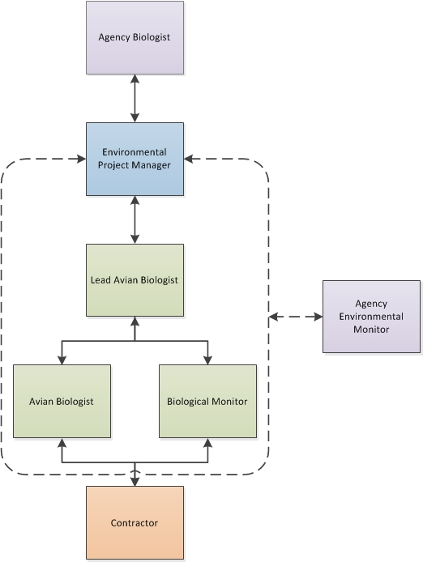
Figure 1. Avian Monitoring Communication Flow

Nest Definitions

Active Nest
Birds and their nests are protected in the state of California by both state and federal law. At the federal level, the MBTA states:
it shall be unlawful at any time, by any means or in any manner, to pursue, hunt, take, capture, kill, attempt to take, capture, or kill, possess, offer for sale, sell, offer to barter, barter, offer to purchase, purchase, deliver for shipment, ship, export, import, cause to be shipped, exported, or imported, deliver for transportation, transport or cause to be transported, carry or cause to be carried, or receive for shipment, transportation, carriage, or export, any migratory bird, any part, nest, or eggs of any such bird, or any product, whether or not manufactured, which consists, or is composed in whole or part, of any such bird or any part, nest, or egg thereof.
At the state level, CFGC Section 3503 states:
It is unlawful to take, possess, or needlessly destroy the nest or eggs of any bird, except as otherwise provided by this code or any regulation made pursuant thereto.
CFGC Section 3503.5 states:
It is unlawful to take, possess, or destroy any birds in the orders Falconiformes or Strigiformes (birds-of-prey) or to take, possess or destroy the nest or eggs of any such bird except as otherwise provided by this code or any regulation adopted pursuant thereto.
NRS 503 Section 610 states:
“it is unlawful for any person, firm, company, corporation or association to kill, destroy, wound, trap, injure, possess dead or alive, or in any other manner to catch, capture, take or remove from the wild, or to pursue with such intent, the birds known as the bald eagle and the golden eagle, or to take or remove from the wild, injure, possess or destroy the nests, eggs or newly hatched offspring of such birds.”
NRS 503.620 states:
“[it is] unlawful for any person to hunt or take any dead or alive birds, nests of birds or eggs of birds protected by” the MBTA, as amended.
While MBTA does not clearly define what an active (or inactive) nest is, the USFWS (USFWS, 2003) has clarified that the federal regulations do not pertain to the destruction of nests alone (without birds or eggs), provided that possession of the nests does not occur and the activities do not otherwise result in take of migratory birds covered by the MBTA. CDFW has not provided clarification on the regulations pertaining to nesting birds. CFGC 3503 provides protection of nests and eggs from “needless” destruction. Therefore, for purposes of this Plan, non-raptor, non-special-status species nests without eggs or chicks are considered inactive. For raptors and special-status species, a nest is considered active upon initiation of construction or when raptors exhibit “nest decorating” behavior. The initiation of nest construction will be determined by an Avian Biologist based upon field observations of the activity at each nest.
Because a moderate number of avian species never “build” nests, special attention will be provided to potential nests, known old nests, and the behavior of adults of any member of the orders Strigiformes (owls), Caprimulgiformes (nightjars), Cathartidae (new world vultures) or families in the order Falconiformes (diurnal birds of prey) including Falconidae (falcons), and Accipitridae (eagles, hawks, and kites), and some ground-nesting species (e.g., killdeer). The determination of an active nest will be made by the Avian Biologist with a minimum observation time as described below.

Inactive Nest
For the purpose of implementing this Plan, non-raptor and non-special-status species nests that are under construction will be considered inactive until eggs are present within the nest. Raptor and special-status species nests will be considered active during the nest building phase.
A previously active nest becomes inactive when it no longer contains viable eggs and/or living young and is not being used by a bird as part of the reproductive cycle (eggs, young, fledging young still dependent upon nest). Egg inviability will be inferred if eggs are present or believed present, but the adult birds have stopped brooding the eggs or abandoned the nest, based upon repeated observations of inactivity at the nest location when required. In some cases, a nest can be abandoned by the bird constructing it and become inactive prior to egg laying. In such cases, determination that the nest is inactive is made on a case-by-case basis based on consistent observations and the determination of an Avian Biologist.

Active Nest Avoidance and Documentation
During construction of the EPL Project, the Avian Biologists, Biological Monitors and the SCE construction team will work together to avoid or minimize impacts to active nests. The principal means of avoiding or minimizing impacts will be to establish designated areas (“buffers”) surrounding each nest, where most project activities will not be authorized. When work activities are required adjacent to an active nest, the SCE construction team will work with the SCE biology team and the agencies to determine whether the following default buffer distances may be modified to minimize impacts to the nest while allowing work to proceed.

Determination of Species-specific or Avian Group/Family Specific Buffers
The recommended default buffers around active nests for the various groups of birds depicted in Table 2 are the recommended distances at which construction activities can occur without disturbing the nest, adults and/or young to the point of potential nest failure. The default buffers established in Table 2 will be applied, unless a specific change is approved by the Avian Biologist to increase or decrease the buffer on a case-by-case determination based on the behavior of the bird and planned project activities. The procedures for buffer reductions (i.e., decreased distances) are described in this section below and in Section 2.3.3.
It is important to emphasize that species-specific buffers are measured from the nest to the site of the construction activity outwards (horizontally for ground or helicopter activities) or upwards (vertically for helicopter activities), as appropriate, and accounts for the nest’s location, including the height of the nest (see Figures 2, 3, 4, and 5). Upon discovery of an active nest the Biological Monitor shall mark the cylinder-shaped buffer area by ESA signage or markings on the work site, based on horizontal distance from the nest location. The buffer distances in the figures are for illustration purposes only; please see Table 2 for species specific default buffers.

Ground Based Construction Activities
A cylinder-shaped default buffer (Figures 2 and 3) will be established around active nests prior to the initiation of ground-based construction activities or upon discovery of a new active nest by the Biological Monitor or Avian Biologist. The default buffer distance established around a particular nest will be species-specific, according to the established buffer distances in Table 2.

Helicopter Based Construction Activities
Helicopter activities typically include moving crews, moving equipment, moving materials, construction activities, and wire stringing/removal. The duration of helicopter use varies based on activity, type of construction, and terrain.
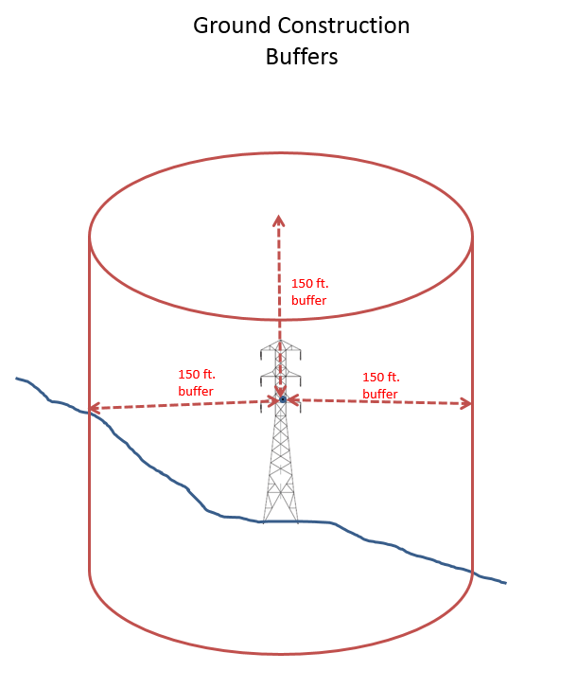
Figure 2. Example of Cylindrical Ground Construction Buffers for Nest in a Structure

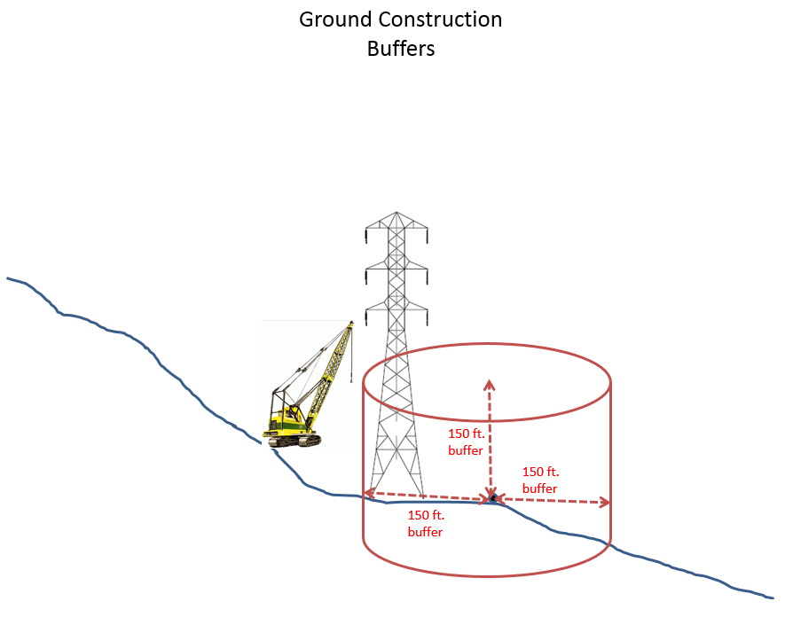
Figure 3 Example of Cylindrical Ground Construction Buffers for a Nest Nearby Construction Activities
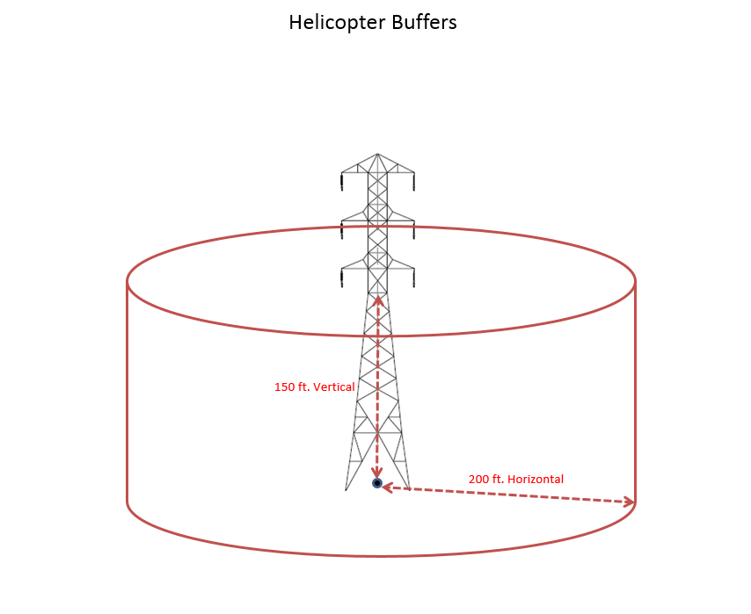
Figure 4. Example of Helicopter Buffer When Nest Is on the Ground

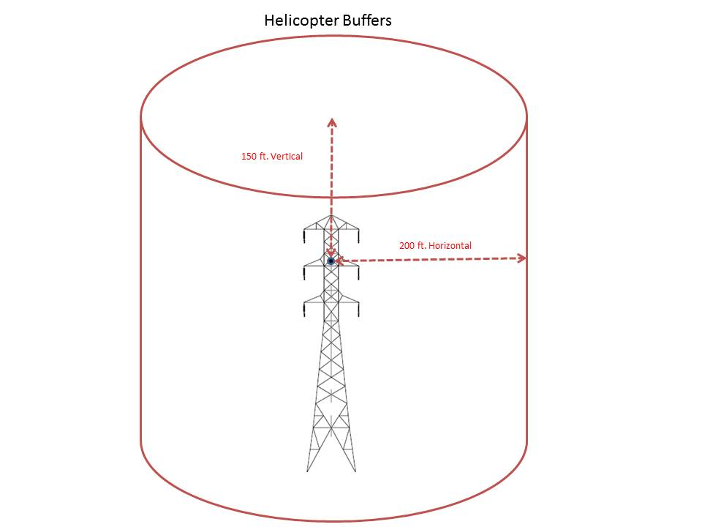
Figure 5. Example of Helicopter Buffers When a Nest Is Located Within the Tower
Cylinder-shaped horizontal and vertical default buffer distances will be established for helicopter construction activities according to the distances established in Table 2 due to the limitations of the Global Positioning System (GPS) units on the helicopter. Project Team members shall monitor the helicopter tracks (flight patterns and durations) daily to ensure compliance with established helicopter buffers and document any non-compliances. SCE shall retain helicopter track data and provide the agencies with these tracks when requested.
In many respects, helicopter construction work is similar to heavy ground-based construction activity. Therefore, the horizontal species-specific default buffers established for helicopter construction activity are greater than those for light ground-based construction activity (see Table 2, Column 4). The only exception is for raptors in Category 3, for which a 300-foot species-specific default buffer is adequate under most circumstances for both ground-based and helicopter construction activities.
Vertical species-specific default buffers established for helicopter work are also greater than for ground-based construction work in most cases (Table 2), although generally not as great as the horizontal helicopter species-specific default buffers. The species-specific default buffers provided in this Plan may need to be adjusted based on site-specific and nest-specific observations in the field. The vertical species-specific default buffers take into account the effects of rotor wash from the smaller helicopters proposed for use on the EPL Project, which typically cause a down draft of 15 to 18 miles per hour (mph) at up to 150 feet. Larger-sized helicopters with greater rotor wash could require larger buffers. For exposed nests, vertical default buffers will be modified accordingly, based on site-specific conditions recorded in FRED.
The duration and frequency of activity in the vicinity of a nest should also be taken into consideration when evaluating whether or not the buffer requirement is met. The default buffers were established based on construction activities that are temporary or infrequent in nature. If a construction crew will be working in the vicinity of an active nest for an extended period depending on the nature of the work (an extended period can be defined as a few minutes for heavy construction or helicopter work to an hour or more for light construction), then the Avian biologist may determine that species-specific default buffer is insufficient for the nest and adjust the distance appropriately. The helicopter species-specific buffers assume that the helicopter will only be present in the area for a brief period adjacent to the nest, typically less than a minute, and that it will only visit the site once in a day, or once in the early morning and again in the late afternoon. This time frame is consistent with most types of anticipated helicopter use on the project. Helicopter flight track data will be reviewed by project team members as described above, to confirm helicopter activity periods near nests.
The vertical helicopter buffers are projected on the GPS displays in all helicopters based upon the elevation from sea level. The elevation of each nest is taken during the initial determination of “active nest.” The location of the nest in relation to the biologist taking the GPS coordinates is also added to the buffer prior to the nesting data being pushed to the helicopters daily. For example, to maintain a vertical species-specific default buffer of 100 ft. for a nest that is 100 ft. off the ground in a tower arm will appear in the GPS as a 200 ft. buffer from the ground elevation.
In Table 2, some species fall into more than one category and may therefore have more than one species-specific buffer associated with it. A blue-gray gnatcatcher (Polioptila caerulea), for example, nesting in a thicket or understory is less likely to be disturbed than one nesting in a more exposed location in a shrub or small tree even though both nests are the same distance from the construction activity. Likewise, a red-tailed hawk (Buteo jamaicensis) that has acclimated to human activities is less likely to be disturbed at its nest (and thus placed in Birds of Prey Category 2) than one that is not accustomed to human activity (placed in Birds of Prey Category 3).
The category for each nest will be determined by the Avian Biologist based upon location of the nest relative to surrounding commercial, residential areas, or other activities, as well as, the bird’s documented tolerance to human activity observed during field observations. For specific construction activities, sound monitoring information may be used during analysis of potential impacts from construction-related activity. For similar reasons, birds assigned to a category based on their nesting habits are not all likely to have similar thresholds of disturbance. In these instances, a range of species-specific buffers is indicated in Table 2.
Default buffers consider species tolerances for disturbance, if known. Larger default buffers are used for large avian species and for species that are not tolerant of disturbance. Smaller default buffers are generally used for smaller avian species and also species that have a high tolerance for disturbance, such as those that are commonly found nesting close to development. Several species have been identified as common species that use some electric power transmission structures (lattice steel towers) or build nests in or on equipment that is stored at a site. These include some red-tailed hawks, common ravens, western kingbirds, Cassin’s kingbirds, and house finches.
Appendix A provides relevant natural history information for species, including breeding information and the potential to nest in the Project area. Appendix B provides additional information on species and their sensitivity to construction. Biological Monitors will have this Plan in their possession to refer to individual species to assist in determining appropriate buffers in the field for specific construction activities. There may be instances where a bird may be showing signs of agitation and the buffer may need to be increased. The Avian Biologist will approve increases to buffer sizes as needed.
Table 2 provides nesting bird buffers for horizontal and vertical ground and helicopter construction for only those birds with a potential to nest within the EPL Project alignment.
Table 2. Nesting Bird Buffers for Horizontal and Vertical Ground and Helicopter Construction
Avian Group  (nest type /location) | Species Potentially Nesting within  EPL Project Limits and Survey Area¹ | Default Buffers for Ground Construction Per Disturbance Level (feet) | Horizontal Buffer for Helicopter Construction (feet) | Vertical Buffer for Helicopter Construction (feet)²
Quail | California quail, Gambel’s quail | 150 | 200 | 150
Birds of prey  (Category 1) | American kestrel, barn owl, merlin | 300 | 200 | 150
Birds of prey  (Category 2) | Red-tailed hawk (2); some urban/suburban), red-shouldered hawk, great horned owl, peregrine falcon, prairie falcon | 300 | 300 | 200
Birds of prey  (Category 3) | Turkey vulture, red-tailed hawk (2; some rural/remote), white-tailed kite, northern harrier, long-eared owl | 500 | 500 | 300
Birds of prey  (Category 4) | Prairie falcon, peregrine falcon | 0.5 mile | 0.5 mile | 0.5 mile
Eagles | Golden eagle | 1 mile | 1 mile | 1 mile
Shorebirds | killdeer | 200 | 200 | 200
Doves | Mourning dove, white-winged dove, common ground-dove | 150 | 200 | 150
Roadrunners | Greater roadrunner | 300 | 200 | 150
Nightjars | Lesser nighthawk, common poorwill | 150 | 200 | 150
Swifts | White-throated swift | 200 | 200 | 150
Hummingbirds | Black-chinned hummingbird, Anna’s hummingbird, Costa’s hummingbird | 100 | 200 | 150
Woodpeckers | Ladder-backed woodpecker | 150 | 200 | 150
Passerines (cavity and crevice nesters) | Say’s phoebe (2), ash-throated flycatcher, violet-green swallow, rock wren (2), canyon wren, house wren, juniper titmouse | 100 | 150 | 100
Passerines (bridge, culvert, and building nesters) | Say’s phoebe (2), house finch (3) | 100 | 150 | 100
Passerines (ground nesters, open habitats) | Horned lark, rock wren (2), western meadowlark | 150 | 200 | 150
Passerines (understory and thicket nesters) | Bushtit (2), blue-gray gnatcatcher (2), blue grosbeak, white-crowned sparrow | 150 | 200 | 150
Passerines (shrub and tree nesters) | Olive-sided flycatcher, vermillion flycatcher, Cassin's kingbird, western kingbird (2), loggerhead shrike (2),* Cassin’s vireo, California scrub-jay, Woodhouse’s scrub-jay, pinyon jay, common raven (2), verdin (2), bushtit (2), black-tailed gnatcatcher (2), blue-gray gnatcatcher (2), cactus wren (2),* northern mockingbird (2), Le Conte’s thrasher (2), Bendire’s thrasher (2), Crissal thrasher, phainopepla (2), Bell’s sparrow, black-throated sparrow, California towhee, summer tanager, great-tailed grackle (2), hooded oriole, Bullock’s oriole, Scott’s oriole, house finch (3), lesser goldfinch (2), western wood-pewee, brown-headed cowbird, sage thrasher, California thrasher | 150 (300 for species marked with an *) | 200 | 150
Passerines (open scrub nesters) | Loggerhead shrike (2),* verdin (2), cactus wren (2),* black-tailed gnatcatcher (2), northern mockingbird (2), Le Conte’s thrasher (2), Bendire’s thrasher (2), phainopepla (2), southern rufous-crowned sparrow, black-throated sparrow, Brewer’s blackbird, lesser goldfinch (2) | 150 (300 for species marked with an *) | 200 | 150
Passerines (tower nesters) | Western kingbird (2), common raven (2), house finch (3) | 150 | 200 | 150
Passerines (marsh nesters) | Great-tailed grackle (2) | 150 (300 for species marked with an *) | 200 | 150
Species not covered under MBTA. | Domestic waterfowl, including domesticated mallards, feral (rock) pigeon, ring-necked pheasant, chukar, Eurasian collared-dove, spotted dove, parrots, parakeets, European starling, house sparrow | NA | NA | NA
Notes:
1. For species listed under two or more categories, the number of categories is indicated in parentheses, e.g., “red-tailed hawk (2).”
2. Standard distances applicable only to small helicopters, which typically cause a down draft of 15 to 18 mph at up to 150 feet, operating in nest vicinity for up to 3 minutes once or twice per day, with a minimum of 4 hours between helicopter activities. Larger helicopters or longer work periods may require larger buffers.

Source: Nesting ranges from Birds of the World (Cornell Laboratory of Ornithology 2022) and Baicich, P. J. and C. J. O. Harrison (1997)

Implementation of Species-specific Buffers
This section describes the process of implementing species-specific default buffers for active nests. Species-specific nesting buffer implementation during construction will be designed to avoid take of an active nest. Buffers implemented for each particular nest may be greater than the buffers detailed in this Plan (Table 2) if deemed necessary by the Avian Biologist. Implemented buffers for non-special-status species may be reduced to smaller buffers than detailed in the Plan (Table 2), on a case-by-case basis as determined by an Avian Biologist as described in section 2.3.3.1, below.
When an active nest is discovered during a preconstruction nest survey, a Biological Monitor will delineate the buffer area and restrict construction as necessary per the species-specific default buffer (Table 2). A Biological Monitor will document the individual behavior of the bird; the stage of the reproductive cycle; and the site conditions. Section 3 provides survey methods for identifying nests within the Project area.
In the event an active nest is detected by a Biological Monitor during construction activities at a specific work site during a work day, construction activities will be suspended and the species-specific default disturbance-free buffer will be established around the active nest. Demobilization activities, for work that was occurring inside the disturbance free buffer prior to the identification of the active nest, will be allowed within the buffer in order for field personnel and equipment to vacate the affected work site utilizing approved access roads and maintain vehicle speeds under 15 miles per hour, in a timely manner once the site has been secured and can be left safely. Monitoring of the nest will continue to track the status and stage of the nest site. The Avian Monitor or Biological Monitor will observe and record the work suspension and demobilization activities.
For ground-based construction activities, vertical separation of the nest from the construction area may be considered when selecting the appropriate horizontal buffer. Some species build their nests very high in trees and structures. For example, a common raven nest 150 feet off the ground in an existing structure is less likely to be affected by ground work occurring directly below than a nest 50 feet off the ground. The horizontal and vertical buffers will be implemented using the guidelines as described in Section 2.3 of this Plan.
For species such as red-tailed hawk with two or more default buffer distances, as shown in Table 2, the default distance will be determined by site-specific conditions. For these species, the habitat and infrastructure surrounding a nest location will be evaluated for its ability to provide a visual and/or acoustic barrier to construction. This information will be used to help determine the appropriate avian group from Table 2 for implementation of the default buffer.
The observed behavior of an individual bird during the nest search process and consequent nest monitoring will help determine the appropriate buffer distance. For example, an incubating adult that appears more skittish and is readily disturbed could receive a larger buffer than an incubating adult that sits tight and appears more acclimated to disturbance.
Generally, nesting birds are most susceptible to failure early in the nesting cycle when fewer resources have been invested towards the nest. Therefore, it is more important to reduce disturbances during egg laying rather than later in the nesting cycle, which could result in the determination of a larger buffer being necessary early on, then reducing its size later in the nesting season.
Extreme weather events may produce conditions that would increase the likelihood of nest failure. Combined with the stress of nearby construction activity, a nest might fail that would otherwise succeed. On unseasonably hot, cold, or windy days, species-specific buffers may need to be temporarily increased.
Information will be maintained in FRED for all nests identified within active EPL Project construction areas. At a minimum, for each nest, the following information will be documented:
Status (active or inactive)
Species
Nest location including nest height
Behavioral observations
Site conditions
Nest exposure
Estimated date of nest establishment
Estimated fledge date
Buffer size implemented
To avoid take of active nests whose buffer areas overlap active construction areas or access roads, an Avian Biologist or Biological Monitor will implement and maintain the established default ESA buffer, monitor adjacent construction activities, and document the nesting birds’ behavior observations and active nest status. SCE will ensure that the construction contractor is made aware of the ESA buffers through the use of construction maps outlining environmental and biological constraint areas, flagging, staking and signage, and direct communication in the field. Nest monitoring will be discussed in more detail in Section 3.4 below.

Buffer Reductions
For project activities of any disturbance level that are inconsistent with established buffer distances, the SCE EPM and Avian Biologists will evaluate the proposed activity on a case by case basis. Where appropriate, they may work with the construction team to revise a buffer reduction request to minimize potential impacts to nesting birds. A reduced buffer distance, as outlined below, may be implemented if recommended by the Avian Biologist and approved by the SCE EPM. For common species, SCE will notify the agencies of each buffer reduction. For special-status species, SCE will submit a request for agency review of any proposed buffer reduction. This Plan does not include a buffer reduction procedure for listed threatened or endangered species. Buffer reduction for listed species will be issued by CDFW or NDOW and/or USFWS only.
For each proposed buffer reduction, an Avian Biologist will be consulted and will determine whether the default species-specific buffers (Table 2) may be reduced for the specific activity and duration associated with the active nest. An Avian Biologist will make this determination based on the information provided by a Biological Monitor, the species’ natural history, and its known tolerances including those observed during SCE nesting bird management on the EPL Project. If a reduced species-specific buffer can be implemented, the SCE EPM will be consulted prior to the reduction of the default buffer. Buffer reductions will take place only after consideration of site-specific conditions such as distance to construction, type of disturbance activity, anticipated duration of the disturbance, microhabitat at the location of the nest that may provide visual and acoustic barriers, behavior of the pair, and its reproductive stage

Common Species Buffer Reductions
For common species, buffers listed in Table 2 may be reduced to smaller buffers through the following notification process:
- The Construction Contractor will file a buffer reduction request to the Lead Avian Biologist, describing the proposed work activity within the default buffer area, reason the activity must be completed while the nest remains active, and total period of proposed buffer reduction.
- Once a request for a buffer reduction is received from the Construction Contractor, the Lead Avian Biologist will review the nest status and the need for the reductions with the contractor or construction manager. Potential avoidance of the buffer reduction will be evaluated by the Lead Avian Biologist (e.g., staging equipment in a different location). Wherever feasible, proposed work activities and locations will be adjusted by the Avian Biologist or Biological Monitor to avoid or minimize incursion into the buffer area.
- The SCE EPM, SCE construction team, and Lead Avian Biologist will evaluate the request and determine whether a reduced buffer can be applied. The decision will be based on the documented nest information and site‐specific conditions such as distance to construction, type of disturbance activity, anticipated duration of disturbance, microhabitat at the nest location that may provide visual and acoustic barriers, behavior of the pair, its reproductive stage, the species’ natural history, species’ known tolerances to human presence and activities, proposed buffer reduction distance and start and end dates, and anticipated work activities and durations. If determined to be acceptable by the SCE team, the SCE EPM will submit a buffer reduction notification to the CPUC, BLM, NPS, USFWS, and CDFW or NDOW. The following will be included in the notification:
  - Complete description of activities proposed within the reduced buffer, including types of equipment, duration, and start date
  - Description of project activity in the vicinity of the nest within the last 30 days
  - Identification of the current and reduced buffers
  - Map showing current and reduced buffers
  - Avian species, nest activity, location, topography or other features that may shield the nest from the work area, the pair’s response to the biologist, and photos
  - Assessment made by the Avian Biologist
  - Description of monitoring if different from the monitoring protocol described within the Plan
  - Statement regarding returning to the established default buffer after work has been completed in the reduced buffer area.
- The SCE EPM or Lead Avian Biologist will notify the Avian Biologist and the Biological Monitor. The Biological Monitor will modify the ESA markers to the new buffer distance. The SCE EPM will modify the buffer distance, upload the notification information, document the notification and feedback (if applicable) dates in FRED.
- As the work activity is initiated, the Avian Biologist will monitor the nest long enough to determine how the nesting pair is responding to the disturbance activity. If necessary, the avian biologist will adjust the buffer accordingly to minimize disturbance at the nest.
- If the activities described in the notification do not begin within seven calendar days or if project activities change to a higher level of disturbance the nest will be re‐evaluated and an updated buffer reduction notification will be submitted for the proposed activities.
Once the project activity is complete, the buffer will revert back to the original established buffer. The Biological Monitor will adjust the ESA markers and the SCE EPM will update the nest record in FRED.

Special-Status Species Buffer Reductions
Buffers listed in Table 2 for special-status species may be reduced to smaller buffers through consultation with the appropriate resource and land management agencies (refer to Appendix A). This NBMP does not fully address buffers or buffer reductions for listed threatened or endangered species. Project activities that may affect those species will be regulated according to conditions of the project’s Biological Opinion and Incidental Take Permit. If a buffer for a special-status species nest impedes Project activities, a reduced buffer may be implemented according to the following process:
- The Construction Contractor will file a buffer reduction request to the SCE EPM, describing the proposed work activity within the default buffer area, reason the activity must be completed while the nest remains active, and total period of proposed buffer reduction.
- Once a request for a buffer reduction is received from the Construction Contractor, the SCE EPM will review the nest status and the need for the reduction with the contractor or construction manager. Potential avoidance of the buffer reduction will be evaluated (e.g., by staging equipment in a different location). Wherever feasible, proposed work activities and locations will be adjusted to avoid or minimize incursion into the buffer area.
- The SCE EPM, SCE Construction team, and Avian Biologist will evaluate the request and determine whether a reduced buffer can be applied. The decision will be based on the documented nest information and site‐specific conditions such as distance to construction, type and anticipated duration of construction, microhabitat at the nest location that may provide visual and acoustic barriers, behavior of the pair, its reproductive stage, the species’ natural history, species’ known tolerances to human presence and activities, proposed buffer reduction distance and start and end dates, and anticipated work activities and durations. If determined to be acceptable, the SCE EPM will submit a buffer reduction request to CPUC, BLM, NPS, USFWS, and CDFW or NDOW.
- If no objections are received within 24 hours (or within a period identified in coordination with the CPUC, BLM, or NPS and incorporated in a later version of this Plan, or in a mitigation measure established by the CPUC, BLM, or NPS [if such period is greater than 24 hours]), the buffer reduction may be implemented at the discretion of the SCE Biologist and Avian Biologist. The Biological Monitor will then modify the ESA markers to the new buffer distance. The SCE EPM will modify the buffer distance, upload the approval information, document the request and approval dates in FRED.
- As the work activity is initiated, the Avian Biologist will monitor the nest long enough to determine how the nesting pair is responding to the disturbance activity. If necessary, the avian biologist will adjust the buffer accordingly to minimize disturbance at the nest.
- If the activities described in the request do not begin within seven calendar days or if project activities change to a higher level of disturbance the nest will be re‐evaluated and an updated buffer reduction request shall be submitted for the proposed activities.
Once the project activity is complete, the buffer will revert back to the original established buffer. The Biological Monitor will adjust the ESA markers and the SCE EPM will update the nest record in FRED.

Accidental Disturbance of Active Nests
In the event project activities cause abandonment of a nest with eggs or chicks or damage to eggs, chicks, or the nest resulting in a low chance of survival, the eggs or chicks will be transported by a Biological Monitor to the closest wildlife rehabilitation facility able to accept the eggs or chicks and the CPUC, BLM, NPS, USFWS, and CDFW or NDOW will be immediately notified (within 24 hours). See Appendix C for a list of permitted wildlife rehabilitation facilities. The final disposition of the eggs or chicks will be reported in FRED as well as by the SCE EPM directly to the CPUC, USFWS, and CDFW or NDOW via email. SCE will cover the cost of the care by the wildlife rehabilitation facility. When incidents like this occur they will be documented as non-compliances and provided to the agencies and included within daily incident email summaries and weekly reports.

Exceptions to Notification Requirements
The following sections describe construction activities that do not follow the buffer implementation and reduction procedures in Sections 2.3.2 and 2.3.3. In each of the scenarios below, every effort will be taken to avoid take of active nests. These activities are not exempt from nest protection but are either necessary to ensure public health and safety or are considered such low impact as to be unlikely to cause nest failures. Crews or personnel performing these activities will be made aware of nest locations to avoid impacting these nests.

Critical Construction Activities
Some critical construction activities must be completed to ensure public health and safety, and structural integrity. When an active nest that had not been documented prior to beginning the activity is identified during performance of a critical construction activity, the construction team may complete the necessary task to ensure public health and safety or structural integrity is not compromised. SCE will provide a valid USFWS Special Purpose Utility (SPUT) permit allowing management of nests in emergency circumstances or, if the permit has expired, will provide the expired SPUT and USFWS confirmation that the expired permit remains valid until issuance of a new or renewed permit. The SCE EPM will follow the notification of USFWS and CDFW or NDOW required by the permit as well as CPUC, BLM, and NPS. The Avian Biologist or Biological Monitor will monitor the nest throughout the continuing activity and will work with the construction crew during the activity and demobilization to take action as feasible to minimize impacts to the nest. These actions may include repositioning equipment to take advantage of visual or sound barriers, shutting down unneeded equipment, or minimizing work activities in some portions of the site. Following completion of the activity the work area will be promptly demobilized and the default buffer distance will be put into place. The list of critical construction activities is included in Appendix D. When incidents like this result in a nest failure, it will be documented as a non-compliance, provided to the agencies, and included within a daily incident email summary, weekly report, and annual report.

Buffer Distances for Access Roads
Substations, material storage yards, helicopter landing zones, assembly and support yards, contractor yards, and construction areas associated with EPL Project may be accessed by a single ingress/egress point. These access roads into construction areas are frequently located adjacent to vegetation (e.g., shrubs and trees) or other habitat, including vegetation planted to screen substation facilities, which provide suitable nesting habitat for birds. Implementing buffers for active nests that become established along access roads may restrict access to and construction activities within substations and yards.
In the event of an active nest located less than the default buffer distance from the ingress/egress point, ingress/egress to the project work areas will be managed by the Biological Monitor working with the Avian Biologist to avoid take of an active nest, while allowing use of these roads for construction activities. Take of an active nest from vehicular travel along Project access roads can be avoided through the implementation of the following management practices:
The areas along access roads will be surveyed up to 100 feet on either side by the Avian Biologist to document locations of active nests and to assess buffers,
The speed limit on all project access roads will be restricted to 15 mph or less,
Use alternative access roads, where feasible, to avoid nests along main access roads.
Vehicles will not stop or idle along Project access roads within an active nest buffer if an access road gate lies within an active nest buffer then a brief stop will be allowed for gate opening/closing.
Avian Biologists or Biological Monitors will place no parking/idling/stopping signs and ESA staking along the road at the limits of nest buffers to avoid impacts.
Construction personnel will not loiter through or within an active nest buffer.
Watering of access roads for dust control will be limited to prevent direct watering of an active nest within active nest buffers.

Active Substations and Yards
Once construction or clearance of vegetation for a yard or substation is complete and the yard or substation is established and is in active operation, buffers for non-special-status species’ nests found inside or adjacent to the yard or substation will be determined by an Avian Biologist. The distance will generally be smaller than the default buffer for a given species, in consideration of the project-related disturbance present as the nest was being built. Reduced buffers for nests inside of yards and substations are acceptable for non-special-status species due to acclimation to the regular construction activities. Indirect impacts to the individual nests are not anticipated as work will occur within the yard or substation only. If the activity occurring in the yard may cause accidental nest damage due to the nest location or the nest was built on equipment/materials in the yard, then ESA signage will be erected to restrict workers from accidentally disturbing the nest or causing nest failure. However, if a major change in the activity level or activity type within the yard or substation will occur, there may be situations where appropriate nest buffers will be implemented within the yard or substation specific to that activity. Examples may include helicopter use or mobilization of a large piece of equipment, where the Avian Biologist determines it is not reasonable to assume the individual birds are acclimated to the activity. In these situations, these types of activities may occur within the yard or substation but outside the nest buffer. The CPUC, BLM, NPS, USFWS, and CDFW or NDOW will be notified of planned buffer changes and related activity.

Minimal Disturbance Activities
Certain minimal disturbance construction activities that may occur inside of nest buffers without going through the buffer reduction request process are listed below and in Table 1. During these minimal impact activities, crews and supplies would be transported to the construction site via pickup truck; where feasible, the truck will be parked outside the species-specific default buffers in Table 2. However, if necessary, crews would access the site on foot. All staking, creation or repair of divots, and removal/replacement of wattles or BMP fencing would be performed by hand using non-power hand tools if necessary; areas will be accessed on foot.
In some cases, these activities include some level of habitat disturbance (e.g., hand vegetation clearing). For those activities, an Avian Biologist will be present and record observations in the monitoring log. These activities include installation or Repair of Water Quality BMPs, Tower QA/QC Site Finalization Activities, Fiber Optic Splicing at Tower Splice Boxes, and Resistance Testing. Other activities have no ground disturbance or vegetation disturbance. For those activities, a Biological Monitor will be present and record observations in the monitoring log. These activities include Environmental Resource Studies, Civil Engineering Surveys, Site Visits, Site Staking/Flagging and Re-staking/Re-flagging. For all minimal disturbance activities, ongoing nest surveys would occur to update nests and identify new nests within and adjacent to these construction areas (see Section 3.3).

Environmental Resource Surveys
Environmental resource surveys include biologists walking transects in the field to collect biological resource information such as special-status plant and wildlife species, vegetation mapping, jurisdictional water mapping and surveys for other environmental resources within the project area.
A pick-up truck will deliver supplies and the crew to the site, or access will be by foot.
Where feasible, the truck will be parked outside of the species-specific default (Table 2) nest buffer.

Civil Engineering Surveys
Civil Engineering Surveys include marking engineering features in the field by a civil surveying crew. Crews may use GPS devices to mark out these features will wooden stakes.
A pick-up truck will deliver supplies and the crew to the site, or access will be by foot.
Where feasible, the truck will be parked outside of the species-specific default (Table 2) nest buffer.
The work will be performed using non-power hand tools.

Site Visits
Site visits from SCE and agency personnel may occur for various reasons.
A pick-up truck will deliver supplies and the crew to the site, or access will be by foot.
Where feasible, the truck will be parked outside of the species-specific default (Table 2) nest buffer.

Site Staking/Flagging and Re-staking/Re-flagging
Site staking and re-staking consist of marking with wooden stakes the limits of an area and maintaining this staking over time. This includes staking of approved work sites, ESAs, and other areas where staking is required. In addition to stakes, this activity may consist of placing or replacing flags, signs, and rope as needed to indicate the boundary of an area that is not to be entered.
A pick-up truck will deliver supplies and the crew to the site, or access will be by foot.
Where feasible, the truck will be parked outside of the species-specific default (Table 2) buffer.
The work will be performed using non-power hand tools.

Installation and Repair of Damaged Straw Wattles and BMP Fencing
Following installation, straw wattles (or similar product) and BMP fencing (e.g., slit fencing) around construction sites may require repair or replacement from time to time. This activity consists of installing, realigning, replacing, or re-staking wattles or BMP fencing as necessary.
A pick-up truck will deliver supplies and the crew to the site, or access will be by foot.
Where feasible, the truck will be parked outside of any established buffers.
Installation, staking, creating or repairing divots, and removal/replacement of wattles or BMP fencing will be performed using non-power hand tools.

Resistance Testing
Following the assembly and erection of TSPs and metallic wood pole-equivalents, but prior to conductor installation, each TSP or metallic wood pole-equivalent requires resistance testing. Resistance testing involves the use of a low-voltage hand held resistance tester to measure a tower’s resistance given the underlying soil conditions. Two small wires are spread out by a 2-man team on foot to a distance of 150 feet and 105 feet from the base of the pole, staying inside the approved work limits. Each wire is then attached to grounding probes that are inserted into the ground by hand using a hammer. Following the test, crews will remove the probe and wire and leave the site. This activity will take one hour or less per pole site. The test will determine the need for counterpoise installation, which requires the use of a skid steer with a trenching device or a mini excavator. A separate buffer reduction notification will be submitted for counterpoise installation where needed. Typical personnel/equipment include:
A 2-person crew
Pick-up truck for transport
A low-voltage hand held resistance tester to measure soil resistance. Thin probes are driven into the ground using a hammer and removed after the test is complete.
Activity Duration: Typically 30 minutes at the base of a structure.
The activities described above are intended to capture typical, representative activities to be performed in areas near active nests. In the event a BMP repair/installation activity requiring significantly different methods (e.g., power tools) or greater work duration within an active buffer, a normal nest buffer reduction notification would be submitted.

Nesting Bird Deterrent Methods
This section details nesting bird deterrent methods and examples that can be used for the EPL Project. These methods are considered already noticed to the agencies and only new deterrents not used before or netting on vegetation would need to be notified. SCE’s nesting bird management plan includes methods that may deter nesting within and adjacent to (i.e., within 300 feet) active construction areas, including substations and yards. Implementation of deterrent methods within and adjacent to active construction areas may reduce the potential for an active nest to restrict EPL Project construction activities. Effective nesting bird deterrent methods within active construction areas will reduce the likelihood that construction will result in take of an active nest. Installation and maintenance of exclusionary devices by the construction team will be conducted following approval by SCE in accordance with this Plan.
SCE will implement the following types of nesting bird deterrents, as needed:
Removal of vegetation from areas that would be directly disturbed by construction prior to the nesting season;
Create disturbance by removing or moving equipment, vehicles, and materials on a daily basis within an active construction area;
Installation of appropriate-sized mesh netting on construction equipment and materials in staging areas, helicopter assembly and support areas, and construction yards, or other project facilities or work areas;
Use of bird spikes placed on towers, substations, or other facilities to discourage birds from perching and nesting on these structures;
Installation of visual deterrents such as tangle guard bird repellent ribbon in active construction areas, yards, substations, and on materials and equipment;
Covering straw wattle and other potential nesting materials in active construction areas, yards, and substations;
Wrapping, stuffing, or covering ends of pipes or other materials within which birds could nest;
Use of colored gravel, such as red or white, in active construction areas, yards, and substations; and/or
Managing construction yard trash in a manner to reduce potential point food sources in active construction areas, yards, and substations.
Specific locations for the use of exclusionary or deterrent devices will be determined in coordination with the Avian Biologist, SCE EPM and the construction team. The construction manager is responsible to furnish labor and materials for bird exclusion or deterrent devices, unless otherwise directed by the SCE EPM. Bird exclusion or deterrent devices will be installed, maintained, and removed by the construction contractor according to product specifications, and as directed by the Avian Biologist, following SCE approval in accordance with this NBMP. These activities will be included in the weekly reports prepared by the Avian Biologist in FRED.
Nesting Habitat Reduction. Removing potential nesting habitat within approved work areas is the first component to effectively exclude nesting birds within a construction area. To the extent feasible, prior to the onset of the nesting bird season, construction areas may be cleared of vegetation and grubbed, as appropriate to reduce potential conflicts between construction activities and nesting birds during the nesting season. Where possible, vegetation will be trimmed rather than removed or cut at ground level in lieu of grubbing. Vegetation removal will typically include removal of trees, shrubs, and herbaceous species. Prior to vegetation clearance, an Avian Biologist will conduct a preconstruction nest survey (see Section 3.3) to confirm the absence of nesting birds, including raptors, and year-round residents, such as burrowing owl, in the area planned for vegetation removal.
Mesh Netting. Use of mesh netting to cover equipment, stored materials and equipment, and partially constructed facilities can be a very effective means to exclude birds from suitable nesting sites within construction areas. Netting may be left in place year-around on facilities or equipment where it poses no undue hazard to wildlife. Netting will not be used outside of the nesting season in areas supporting special-status species. When not in use, netting will be stored where it is inaccessible to birds or other wildlife. By preventing birds from accessing potential nesting sites within the construction areas, conflicts between nesting activities and construction and yard operations can be reduced. Netting of vegetation would only be used under consultation with CPUC, USFWS, and CDFW or NDOW.
Netting can be specially ordered for this purpose from a number of companies including USA Bird Control (http://www.usabirdcontrol.com/), Nylon Net Co. (http://www.nylonnet.com/), and Nixalite http://www.nixalite.com/birdnetting.aspx). An example of a specification sheet for such netting (PollyNet™) is included as Appendix E.
The size of the mesh grid can vary depending on the size of birds that are being excluded. Given the diversity of birds that could nest within construction areas throughout the EPL Project, a 0.75‐inch sized mesh may be suitable for excluding most birds, including small birds such as house finches and swallows. Selection of mesh size will be coordinated with the CDFW or NDOW and USFWS.
Mesh netting, if employed, must be installed and maintained according to manufacturer specifications to be provided by SCE for agency review prior to its use of any mesh netting. To increase the effectiveness of the mesh netting as a bird exclusion device, equipment or other objects should be completely covered leaving no gaps in the netting through which birds could enter and build a nest under the netting. Mesh netting shall also be inspected daily by the Biological Monitors to detect, document, and remove any trapped wildlife, and to identify and notify the construction contractor of any rips or gaps in the netting that could permit birds to pass through and to look for wildlife that have become trapped in the netting. Lizards and snakes are especially prone to becoming entangled in excessive netting draped along the ground. Therefore, installed mesh netting should not drape on the ground. Netting shall be monitored twice daily where netting is installed on vegetation. If the Construction Contractor observes wildlife inside or trapped in the mesh netting, the Biological Monitor will be contacted immediately. Any wildlife found trapped or entangled will be documented through FRED and reported to the CPUC, BLM, NPS, USFWS, and CDFW or NDOW through FRED daily and weekly monitoring reports. SCE will document and correct any non-compliance related to mesh netting. Additional measures such as personnel training or changes to netting use will be taken if re-occurrence is a problem. If properly installed netting results in recurring entrapment, alternative methods will be implemented.
Bird Spikes. Use of plastic or stainless-steel spikes can be effective in discouraging birds from landing on structures and to deter nest establishment. Bird spikes typically consist of groupings of stainless steel or UV‐resistant polycarbonate spikes that are spaced in such a way as to prevent birds from landing and gaining a foothold on the surface to which the spikes are adhered. As birds cannot comfortably land on surfaces covered with the spikes, the likelihood that birds will attempt to build nests in these areas is low.
Bird spikes can be specially ordered for this purpose from a number of companies including Bird Barrier (https://birdbarrier.com/) and Bird‐B‐Gone (http://birdbgone.com/). An example of a specification sheet for such bird spikes (Bird‐B‐Gone™) is included as Appendix F. Bird spikes, if employed, must be installed and maintained by the Construction Contractor according to manufacturer specifications.
Bird spikes are designed to be affixed to structures to provide longer‐term deterrents to birds. Therefore, use of bird spikes may be more practical to deter nesting on structures like towers and substations. Such devices are not likely practical for use on equipment, material storage areas, or contractor yards. Installation of bird spikes on tower structures concurrent with structure construction may discourage birds from nesting on tower structures during construction. Because they are affixed to structures, maintenance of bird spikes is low; however, these devices must be replaced periodically per the product specifications to maintain effectiveness.
Visual Deterrents. There are a wide range of visual deterrents that can be used to discourage birds from nesting. These range from predator decoys (e.g., plastic owls) to reflective ribbon that provides visual and auditory discomfort to birds. Reflective ribbon such as Tangle Guard Bird Repeller Ribbon (http://www.nixalite.com/tangleguard.aspx; Appendix G) is a Mylar reflective ribbon that can be affixed to construction equipment, around the perimeter of storage yards, or on towers or other facilities, as appropriate, to scare birds from the area, thereby reducing the likelihood of nesting. Movement from wind action produces a metallic rattling sound and its holographic surface may be construed as menacing to birds. Use of reflective ribbons can be particularly effective in material storage yards and contractor yards that may be used for a long period of time. Holographic reflective ribbons can be specially ordered from a number of companies including US Bird Control.
Material and Pipe Covers. Sheltered spaces such as pipes or stacks of stored materials provide potential nesting sites for some birds. To reduce the likelihood that birds will build nests in these areas and therefore constrain the use of construction areas, substations and yards, such materials can be covered with mesh netting (discussed above) or other materials. Routinely covering equipment and stored materials will be used as a standard management practice to deter birds from nesting in these areas.
Yards often contain suitable nesting materials or opportunities for birds, especially for cavity nesting. For example, straw wattles can be attractive to birds as they provide excellent nesting material for a wide range of species. Birds attracted to this nest material may be more likely to build a nest in close proximity to these stored materials (e.g., within a yard), which can constrain work activities. To reduce the likelihood for nesting with yards where wattles are stored, such materials should be covered so birds cannot access the wattle material to use as nesting.
Colored Gravel. Use of colored gravel in graveled construction and facility areas can be effective in discouraging ground nesting birds. The eggs of ground nesting birds are colored in a manner to be camouflaged against naturally colored substrates such as soil or pebbles. By covering the ground surface with colored gravel that contrasts sharply with the color of the birds’ eggs, ground nesting birds can be effectively discouraged from nesting in such locations. Colored gravel installation will be consistent with visual resource measures (if any are applied to the EPL Project) and will be removed, where required, following the completion of the EPL Project.
Trash Management. Although not a specific deterrent, management of trash on and around construction areas is important to reduce the potential for construction activities to attract birds. Trash from food waste can provide an attractive food source for birds thereby increasing the likelihood of them nesting within construction areas. Effective management of food waste and other trash will be important to avoid attracting birds to construction areas. Such management measures will include daily removal of trash from the site as well as covering trash bins with wildlife-proof lids.
These methods, either on their own or in combination with other measures discussed above, can be effectively employed to potentially discourage birds from nesting within and immediately adjacent to construction areas. However, there is no single practical method to permanently exclude birds from construction yards, staging areas, or transmission structures. Knowledge of bird behavior and interactions and adaptive management in collaboration with the Construction Contractor is essential in understanding the implementation and effectiveness of deterrents.

Inactive Nest Management
This section of the Plan discusses the protocol to remove inactive nests in and within 300 feet of active construction areas, including yards, substations, and materials and equipment to minimize opportunities for nesting birds. Based on the Migratory Bird Permit Memorandum (USFWS 2018), unoccupied nests (without birds or eggs) may be destroyed. This protocol does not cover listed species or bald or golden eagles. The purpose of inactive nest removal is to prevent or reduce the potential reuse of a currently inactive nest (e.g., return of a pair to the specific site) in a high-risk location. Nest removal as described in this Plan will only be applicable to removal for Project construction and post-construction site restoration or remediation. Nest removal for non-project activities, including routine operation and maintenance, would be conducted pursuant to existing permits or agreements with the resource agencies. At the end of each yearly nesting season SCE will inventory all nests proposed for mooring ball installation prior to the beginning of the following nesting season and prepare an installation schedule. To the extent feasible, inactive nest removal will take place prior to the onset of nesting bird season. However, there may be scenarios where SCE will need to remove inactive nests during nesting seasons.
The following sections describe inactive nest removal for raptors, colonial bird species, and other non-listed, non-game native birds. All inactive nest removals for the EPL Project will be documented in FRED.

Raptors
Raptors have additional protection under the CFGC. Since raptors exhibit nest site fidelity, inactive raptor nests may be protected even though no eggs or young are present. Inactive or partially built raptor nests will be mapped and documented by the Biological Monitor/Avian Biologist. Inactive raptor nests that will be impacted by EPL Project construction activities will be removed according to the following protocol. Removal of raptor nests is not proposed under any other circumstances.
An email notification will be sent out to CDFW and CPUC providing details of the nest location, reason for nest removal, nest ID number, and nest removal schedule 24 hours prior to nest removal.
An Avian Biologist or Biological Monitor under the direction of an Avian Biologist will observe the nest for four hours (breeding season) or one-hour (non-breeding season), during favorable field conditions (good visibility, low wind) to determine whether there is any activity at the nest site.
If an Avian Biologist determines that the nest is unlikely to be active based on these observations (e.g., absence from the nest site and no “nest decorating” observed), the construction team will provide personnel to inspect the nest if it is not accessible by a Biological Monitor or Avian Biologist due to safety concerns.
For inaccessible nests (e.g., on transmission towers and poles), the construction team will take a photo of the nest contents and provide the photograph to a Biological Monitor/Avian Biologist.
Once a Biological Monitor or Avian Biologist has confirmed from the photo that the nest is inactive, the construction contractor will remove the nest immediately following confirmation that it is inactive.
The agencies will receive notification of the nest removal through FRED and the weekly report. Nests will not be collected or taken off site.
If necessary and feasible, nest platforms may be constructed according to SCE-provided guidelines (see Appendix H).
Removal of all inactive raptor nests will be documented on a daily basis through a FRED daily monitoring report and summarized in weekly FRED monitoring reports that are sent via email to CPUC, BLM, NPS, USFWS, and CDFW or NDOW.

Burrowing Owl
Burrowing owls nest in burrows in the ground and are mostly non‐migratory, meaning that burrows may be utilized (i.e., occupied) year‐round as escape burrows. Additionally, because they nest in burrows in the ground, further surveys may be required (per the Staff Report on Burrowing Owl Mitigation; CDFW 2012) to determine whether or not their nest burrows are active, or their escape burrows are being used.
Preconstruction nest surveys will determine the presence/absence of suitable habitat (i.e., burrows) for burrowing owl occupation and/or nesting. Management of active burrowing owl nests are addressed in the species-specific Burrowing Owl Management and Passive Relocation Plan.

Colonial Birds
Based on the Migratory Bird Permit Memorandum (USFWS, 2018), colonial nesting birds (which include swifts and swallows) are highly vulnerable to disturbance. These birds may re-use nests in successive years. Destruction of unoccupied nests during or near the nesting season could result in take. Outside the species-specific nesting season, CDFW or NDOW staff and USFWS staff will be consulted regarding removal of colonial bird species’ inactive and partially built nests. Inactive nests of colonial bird species will be removed or collapsed only after review by CDFW or NDOW and USFWS staff. Currently, there are no known colonial nests within or near the ROW.
If a colonial nest is found, colonial bird nests that would be impacted directly by EPL Project construction activities will be removed according to the following protocol:
- A Biological Monitor/Avian Biologist will determine whether the nests are active through observation of bird sign and behavior, as described in Section 3.3. The Construction Contractor will provide personnel to inspect the nests and take a photograph of the contents if they are not accessible by the Biological Monitor/Avian Biologist.
- If the Biological Monitor/Avian Biologist determines the nests are not active, CDFW or NDOW and USFWS will be consulted regarding removal of colonial bird species nests. Nests will be removed or collapsed immediately after they are confirmed to be inactive and following review with CDFW or NDOW and USFWS. CPUC, BLM, and NPS will be copied on any correspondence when CDFW or NDOW and USFWS are consulted.
Nest removals will be documented in FRED and summarized in the weekly reports. Nests will not be collected or taken off site by biologists.

Non-listed Special-Status, Non-Special-Status, Non-Game Bird Species Nest Removal
Removal/deterrence of non-special-status, non-game bird inactive nests, for species other than raptors, burrowing owl and colonial bird species will be completed as discussed below. For these species, nests being constructed, but not containing eggs or chicks, are considered inactive (see Section 2.2). For non-listed special-status species, nests are considered active during nest building; therefore, removal of non-listed special-status nests will only occur once the nest is confirmed inactive by this definition.
Inactive nests found within construction areas, including substations, yards, materials, and equipment, may either be removed and dropped to the ground, or have an in-nest deterrent (see Section 2.5) Mesh netting will not be installed in nests. The Construction Contractor will provide personnel to inspect the nest and take a photograph of the contents if it is not accessible by a Biological Monitor/Avian Biologist. Nests will not be collected or taken off site.
When construction takes place during the nesting season, inactive nests will be identified during preconstruction nest surveys and during construction monitoring, if not previously identified during earlier EPL Project or non-project SCE surveys or monitoring.
Non-listed special-status, non-special-status, non-game bird nests that would be impacted directly by EPL Project construction activities will be removed according to the following protocol:
- To determine whether a nest is inactive, the Biological Monitor/Avian Biologist will conduct a minimum of one uninterrupted, consecutive hour of monitoring in suitable conditions for detecting nesting activity prior to removal, as described in Section 3.3.
- The construction contractor will provide personnel to inspect the nest and take photographs of the contents if it is not accessible by a Biological Monitor/Avian Biologist. In rare circumstances, such as nests in substation equipment, it may not be possible to photograph a nest prior to removal.
- After the Biological Monitor/Avian Biologist confirms the nest is inactive and that it does not belong to a listed species, it will be removed and left on site.
- Implement some form of nesting deterrent, where feasible, so that the same bird will be less likely to try and rebuild the nest after its removal.
No nests will be taken off site or collected. The nest location will be subsequently monitored to detect any re-nesting attempts. Initial re-nesting attempts on EPL Project elements or equipment will be deterred until the bird selects an alternative nest site.

Field Approach
Nesting bird surveys will be carried out in several stages during the nesting season (typically February 1 through August 31, but will be based on seasonal variation). An Avian Biologist will conduct a preconstruction nest survey within ten days prior to the start of work at any given site. Preconstruction nest survey results are submitted to CPUC, BLM, and/or NPS, as appropriate, to obtain approval prior to beginning work at the site. The designated avian consultant will review the preconstruction nest surveys reports within two business days of submittal or may request additional information, as necessary. On the first day of construction at any given site, a qualified Avian Biologist will perform a pre-construction “sweep” to identify any bird nests or other resources that may have appeared since the preconstruction nest survey. On each subsequent day of construction during the nesting season, the Biological Monitor will first perform daily sweeps at each work site to look for resources, including nesting birds. The daily sweeps will be conducted to identify new nests (partially built, active, or inactive) not detected during the preconstruction survey or clearance sweep and to also document the status (active or inactive) of known nests in a construction area. The preconstruction nest survey, and daily sweeps will be conducted within suitable habitat for nesting birds within the construction areas and include a 300-foot survey area for non-raptors and 500-foot survey area for raptors, collectively referred to as the Biological Survey Area (BSA). Prior to scheduling a survey or determining a change in status of a nest, adverse weather conditions and time of day (surveys typically should be conducted in the early morning) will be considered because these conditions reduce the likelihood of detecting nesting birds and associated nesting behavior. Care will be taken to avoid potential take of a nest due to surveying and monitoring efforts. The status of all active nests within the BSA will be documented and summarized in weekly reports and the weekly nesting bird table. This information will be provided weekly to the CPUC, USFWS, BLM, NPS, and CDFW or NDOW via email summary reports (see Section 3.5, Reporting).

Survey Requirements

Survey Experience and Training
Avian Biologists and Biological Monitors, hereafter collectively referred to as surveyors, will meet the qualifications described below. As different species have different nesting niches and different breeding strategies, surveyors must be able to readily distinguish species that may breed locally from those that do not; they must have knowledge of habitat contexts and types of behaviors to look for when evaluating nesting potential.
Appendix A contains a list of the potential nesting bird species and relevant information on their nesting behaviors. This list draws on information presented in Baicich and Harrison (1997), Kiff and Irwin (1987), and the online Cornell Laboratory of Ornithology Birds of the World (https://birdsoftheworld.org), as well as SCE’s Biological Consultants’ extensive experience surveying for and studying nesting birds in southern California. All surveyors will receive training on the information and procedures detailed within this Plan.

Qualifications

Lead Avian Biologist
To be approved as a Lead Avian Biologist, an individual is expected to have the following average qualifications:
Two or more years of focused experience with a range of bird species in Southern California performing nesting bird surveys or monitoring nests
Worked on 10 or more substantial multi-season bird projects, or the equivalent, performing surveys, habitat assessments, etc. in the field. Of these, at least 8 must be in the Southwest, preferably in California

Avian Biologist
To be approved as an Avian Biologist, an individual is expected to have the following qualifications:
Worked on 3 or more substantial multi-season bird projects or the equivalent, performing surveys, habitat assessments, etc. in the field. Of these, at least 2 must be in the Southwest, preferably in California

Biological Monitor
To be approved as a biological monitor, the recommended qualifications are listed below:
Worked on construction monitoring of biological resources on 2 or more projects (6 months or more total)
Avian experience on previous projects

Field Maps
All surveyors will be provided with maps that depict the project disturbance limits, ROW, access roads and other project features and current nest and buffer data. Surveyors will have access to the FRED database to view all previously collected data. The database and associated mapping interface will be regularly updated so real-time nest and other biological resource data will be available to the surveyors.

Nesting Season Survey Methodology
A survey will consist of a pedestrian search by an Avian Biologist for both direct and indirect evidence of bird nesting. Direct evidence will include the visual search of an actual nest location. Indirect evidence will include observing birds for nesting behavior, such as copulation, carrying food or nesting materials, nest building, adult agitation or feigning injury, feeding chicks, removal of fecal sacks, and other characteristic behaviors that indicate the presence of an active nest. Surveys will be conducted in accordance with the guidance in Martin and Guepel (1993).
The size of the survey area physically surveyed will vary according to site specific conditions and according to the prescriptions contained in applicable resource management plans, land use, plans, and mitigation measures. The amount of acreage covered by surveyors will be determined based upon the nesting bird activity encountered and the opinion of the qualified personnel conducting the surveys. The density and complexity of habitat type will be taken into account during survey planning to determine the field methods, number of qualified personnel, and the time needed to locate nests. Surveys located in riparian woodland habitats or riparian or wetland vegetation types as defined in the DRECP LUPA, found on the Project, may require observations from multiple vantage points due to the density and height of vegetation, as well as additional search effort in trees and bushes in order to locate all potential nests prior to construction. Surveys located in shrubland habitats, found on the EPL Project, will require observations from less vantage points than woodlands but due to the considerably denser vegetation may require extensive searching and longer behavior observations in order to detect all potential nests prior to construction. Surveys located in alluvial scrub and desert scrub habitats, found on the EPL Project, may be completed in less time, relative to woodland, shrubland, or due to lower vegetation density that would allow surveyors to spot nests and nesting activity. Surveys located in grassland and agriculture lands on the EPL Project would be expected to take less time and more area would be covered over a given period, relative to denser vegetation types due to the increased visibility and uniformity found in these vegetation communities.
Additional time or surveys will be conducted if the surveyor does not feel that the area has been adequately covered. A variety of survey approaches may be needed to locate nests depending on the species likely to be encountered at each BSA. Under some circumstances, the surveyor may be able to survey a substantial portion of the BSA from one (or more) inconspicuous location(s) to detect birds entering and leaving the BSA. Sitting quietly in inconspicuous locations when other types of disturbance are absent allows observers to intensively listen and observe bird behaviors for discernible direct and indirect evidence of nesting. When moving through vegetation, surveyors will watch for distraction displays, aggressive responses and interactions, and birds flushing suddenly from atypically close range (often an indicator of a nest site). If defensive or distraction displays from birds are observed, an active nest is likely to be nearby. Surveyors will utilize visual observations of nests and bird behavior as a method for detecting potential nests.
Nests that pose constraints to the EPL Project activities will be directly observed or inferred by behaviors such as feeding chicks or removing fecal sacs. If the presence of a potentially active nest is suspected but cannot be confirmed, additional surveys will be conducted. If construction is planned to occur in the area and additional surveys have not determined the precise location of a nest, a disturbance free buffer may be implemented that would protect the relative location until the biologist has located the precise location of a nest. The Avian Biologist will notify the SCE EPM of all active and potentially active nests detected during the preconstruction surveys and sweeps as well as report them in FRED and include in weekly reports to the agencies. Preconstruction and daily clearance sweeps during nesting bird season will follow the same methodology discussed in this section to ensure that all active nests are located prior to construction occurring in the vicinity. Prior to vegetation removal activities within the nesting bird season, a sweep will be conducted by an Avian Biologist preceding the scheduled construction activity to help document and protect nests have been built since the preconstruction survey.
Once a nest is found, it will be observed for activity, if no activity is observed within a minimum one-hour monitoring period (four hours for raptor nests), the nest would be approached to check the status. The Avian Biologists will use best professional judgement regarding the monitoring period and whether approaching the nest is appropriate. If no adult or juvenile bird activity is observed within one hour (four hours for raptor nests), the nest can be considered inactive. If an inactive nest will be directly impacted by the EPL Project activities due to the location of the nest in a tower, or vegetation in an approved project work area, then the removal procedures outlined in Section 2.6 of this plan will be implemented. If an Avian Biologist/Biological Monitor determines that an hour (or four hours for raptors) is not sufficient to make a determination on the nest status, then one-hour increments will be employed until a final determination regarding nesting status can be made. Every effort will be made as to not expose the nest to potential predation as a result of survey and/or monitoring activities. All nest visits will be conducted by a single surveyor and will last only as long as necessary to check the nesting stage or until circumstances necessitate departure (e.g., potential nest predator detected or sustained indications of stress by any protected bird).
When approaching a nest, surveyors will first determine whether there are any potential nest predators nearby (e.g., California scrub-jays [Aphelocoma californica], common raven [Corvus corax], cactus wren [Campylorhynchus brunneicapillus], and house wren [Troglodytes aedon]). If no predators are observed, the surveyor will approach the nest. Surveyors will be carefully aware of the possibility of additional, undetected nests nearby. They will avoid creating a scent or visual path that directs animals to the nest (e.g., leaving no trampled spot by the nest and continuing past the nest upon leaving it rather exiting on the entrance path). Surveyors will also briefly look in at least two empty potential host plants for bird nests before and after looking in the nest in an attempt to deter predators.

Active Nest Determination
When an active nest (defined in section 2.2) is confirmed, the default species-specific buffer will be implemented per this Plan (Table 2) and work within the new nest buffer will cease immediately. If a bird is seen carrying food or feeding nestlings, but the vegetation is too dense for the surveyor to visually locate the nest, the approximate nest location will be inferred by the surveyor based on observed bird behaviors. Surveyors are not to risk the failure of a nest in an effort to discern an exact location or exact status (e.g., number of eggs, size of nestlings, etc.). If a buffer reduction is requested by the contractor, the surveyor will then continue to observe the nest and parental behavior to determine whether a reduced buffer can be appropriately implemented. Active nests will be monitored before implementing a reduced buffer. Prior to implementation, all buffer reductions will follow the process outlined in Section 2.3.3.
A nest completion date can be estimated by combining the stage of nesting at discovery and the known typical nesting duration for the species. However, because the date will be estimated, it is important to note that a nest may be active for a shorter or longer period of time than that estimated. For altricial species, a time buffer from three days up to three weeks will be added to every nest to allow for post-fledging nest dependence.

Monitoring
As a part of construction monitoring, Avian Biologists and Biological Monitors will check the status of any active nests within the BSA and update the nest monitoring database (Nest Event). This will ensure that nests around active construction areas are being given proper attention. The Biological Monitors will be responsible for monitoring the contractor’s adherence to the established nest buffers, the contractor’s adherence to the conditions of buffer reduction approvals and monitoring the nesting birds’ behavioral reaction to construction throughout the day during active construction.
Both nests with default buffers and nests with reduced buffers will initially require frequent monitoring to establish if the buffer is sufficient to prevent impacts to the nests. Thereafter, for most species, active nests will be monitored on intervals no longer than every four days (weekly for birds with longer nesting periods, over two months, such as ravens, great horned owls and red-tailed hawks). Under the default buffers, active nests do not require further monitoring once work is completed in the area. For nests with reduced buffers, the same monitoring protocol will be followed until the nest is determined to be fledged or inactive. New nests discovered after work completion in an area would not require monitoring. Table 3 illustrates the monitoring frequency that SCE will utilize when an active nest is located.
Avian Biologists will be responsible for documenting new nests, providing status updates of previously identified active nests, and monitoring implemented buffers within and adjacent to construction areas. They will utilize construction maps, flagging, staking, and signage, and in-field communication to monitor for compliance with plan requirements. Avian Biologists and Biological Monitors will utilize monitoring methods as described in Sections 2 and 3 to minimize disturbance to active nests while conducting updates and documenting behavioral reaction to construction. Nests updates may be modified to accommodate adverse weather conditions where flushing an adult off of the nest could threaten the nest outcome or to accommodate nests noted as being sensitive to human presence.
Table 3. Active Nest Monitoring Schedule
Work Location | Nest Location |  | Frequency
Between original buffer and reduced buffer | Inside work area | 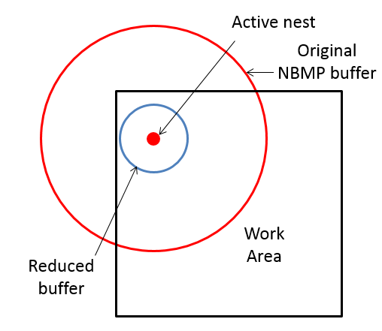 | Max interval every 4 days (weekly for some large-bodied species) until nest fledges or declared inactive
Between original buffer and reduced buffer | Not inside work area | 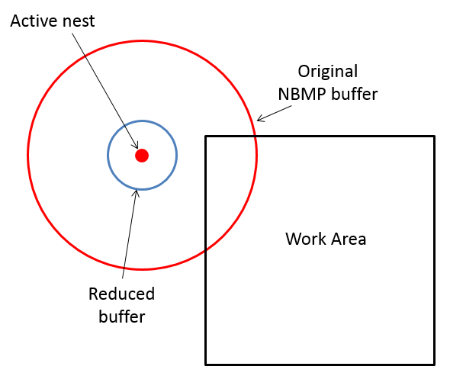 | Max interval every 4 days (weekly for some large-bodied species) until nest fledges or declared inactive
Not in nest buffer | N/A | 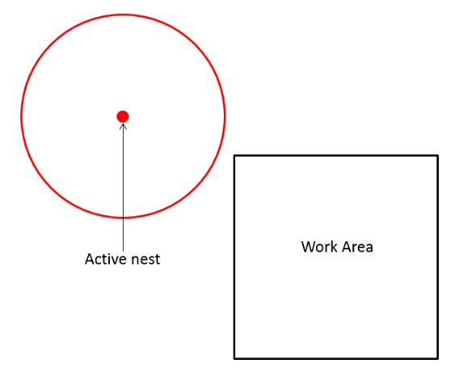 | Max interval every 4 days (weekly for some species) until completion of work
For some hazardous construction activities (i.e. wire stringing) it is unsafe for the biological monitor to be too close to construction. In these scenarios, the biological monitors will observe the activity from outside of the right-of-way at a safe distance. Where feasible and safe around these activities, the monitor will still perform a clearance sweep at the beginning and end of the day to confirm the status of the active nests present in the BSA around the site. All nest visits will be documented in FRED (for biological resources), and reported to agencies, as requested.
In the case of precocial species such as killdeer, Biological Monitors will track broods after hatching to ensure chicks are not harmed by construction activities until chicks are capable of flying or are no longer found within active construction areas. Avian biologists may recommend chick fencing or other measures to prevent chicks from entering roads or work areas, as needed (see Section 2.3).

Reporting
Pre-construction nest survey reports will be submitted to the CPUC, BLM, and NPS electronically via FRED and will include the time, date, and duration of the survey; identity of the surveyor(s), a list of species observed, and electronic data and maps identifying nest locations and the boundaries of established buffer zones. The electronic data set will be updated following each pre-construction survey and will be accessible to CPUC, BLM, and NPS in the FRED Database. Regular calls will take place between SCE and the agencies to discuss the weekly reports.
The SCE EPM will receive the project plan of the day listing scheduled project activities for that day. Daily and weekly biological monitoring reports will be generated for the EPL Project and submitted in FRED. All data collected for the daily reporting will be input from the field via hardcopy forms or mobile smartphones using an offline form, and then entered/uploaded online into FRED. New nest events will be entered into FRED and agency biologists will be notified by automated email within 24 hours. A nesting bird table, updated weekly for submittal to the CPUC, BLM, NPS, CDFW or NDOW, and/or USFWS will show the current status of all active nests within the BSAs, distances of disturbance-free buffers that have been implemented to avoid nest failures, proximity to active construction activities, construction activities occurring, and estimated fledge date. Further detail on data collection and processing is provided in Section 3.5.1.
An annual report shall be submitted to the CPUC, USFWS, BLM, NPS, and CDFW or NDOW by November 30 for each year the EPL Project is under active construction or post-construction remediation or restoration providing a summary of the results of nest monitoring activities throughout the year, including reported nest success and failures. SCE will provide USFWS a summary spreadsheet of all nests tracked as a part of EPL Project for the previous nesting season. An annual meeting to review the annual report and “lessons learned” will occur prior to the start of the subsequent nesting season. The annual report will include sufficient substance and detail to provide the basis for the adaptive management and evaluation of lessons learned. Specific contents and format of the annual report will be reviewed and approved by the lead agencies in consultation with the resources agencies.

Data Sheets
All nesting bird data will be entered into the FRED Bird Nest Events (online forms). This will provide the SCE EPM, Avian Biologist, and Biological Monitor current information pertaining to a specific nest, as well as the ability to print maps with the nest data (nest location and buffers). The data fields that have been established in FRED are defined in Table 4. FRED fields represent the most current fields and may be subject to updates as improvements to the FRED Database are made.

Table 4. Field Definitions for Online Entry into FRED
Field | Explanation
Date | Use calendar icon to choose date.
Time | Time (defaults to time of data entry).
Nest number | A unique identifier entered by the surveyor. The name will consist of the surveyor’s initials and a number. For example – KF1.
Lead Monitor / SME | Segment Lead’s name
Surveyor | Your name.
Segment | Pull-down menu for the segment numbers.
GPS coordinates  UTM (meters) | Collected in latitude and longitude. Make sure that measuring device (Garmin, etc.) is set to proper units. Zone:___ ; N or S ; ________mE and _________mN  Ground Buffer Radius in feet. “O” for no buffer drawn  Helicopter Buffer Radius: in feet.
Buffer Implemented | Yes or No
Device type | Pull-down menu choices are: “Garmin/Other-Recreational Grade (+/-40’)”, Smart Phone w/GPS-Advanced Recreation Grade (=/-10-15’)”, Trimble (Yuma)/Other-Professional Resource Grade (+/-1-3meter)”, Trimble (GOXH)/Engineering Survey Grade (Sub Meter accuracy)”, “Launched From Map”, and “Device Unavailable”
Species | Pull-down menu based on the four-letter codes defined in Appendix A.
Offset | Check box for noting if the nest is offset from the GPS coordinates.
Direction | Pull-down menu of eight directions.
Distance in meters | How far the nest is from the GPS coordinates (in feet). In meters or feet?
Nest location description | Where is the nest (specific description)? Be specific…anything that can help another person finds the nest; i.e., nest within top half of the oak tree or nest is located within a rocky outcrop. Use descriptive words. TAKE A PICTURE of the nest, at least one overview, and one close-up.
Nest status | Active, Inactive, Inactive Vacant Raptor, Removed, Deterrent Installed.  Active is a nest with eggs, nestlings, or recent fledglings.  Inactive is a nest that no bird is currently using.
Number of eggs | If able to observe eggs, number of eggs observed.
Number of chicks | If applicable, number of chicks observed in nest.
Estimated fledge date | General estimate of how long before young fledge.  Use Appendix A for reference.
Nest activity | Information on activity/behaviors observed. “Feeding Chicks”, “Fledglings close to nest” (i.e. branching), “Incubation”, “Nest Building”, “No Activity Observed”, Failed/Non-Project related, Failed/Project-related, Fledged, or Unknown Outcome.
Height from ground in feet | How high the nest is from the ground measured in feet.
Distance from work area in feet | Approximate distance from nest to the active work area in feet.
Distance from access road in feet. | Approximate distance from the nest to the access road in feet.
Substrate/species | What is the nest in (e.g., plant species, structure, bridge, and ground)? TAKE PICTURES from at least three directions.
Nest name | A unique identifier entered by the surveyor. The name will consist of the surveyor’s initials and a number. For example – KF1.
Location description/habitat | General area of the nest in relation to the surrounding vegetation/unique features. Be specific…anything that can help another person find the nest. i.e.: nest is located x-feet north/northwest of access road. Or, nearest street address, cross streets etc. TAKE A PICTURE.
Is there an offset? | Are the measurements skewed from the actual location of the nest?
Offset directions | Pull-down menu options are: “N,” “NE,” “NW,” “S,” “SE,” “SW”, “E,” OR “W.”
Offset distance in feet | 0.000
Descriptions of existing work activities. | Describe work activities currently occurring at nest site and adjacent to the nest site. Be sure to cover all directions (i.e. N/S/E/W). Note which activity is highest disturbance.
Environmentally Sensitive Area established? | Yes or No
ESA type | Two options: ground or helicopter
Work area affected? | Yes or No.
Name of road affected? | Access Road or Named Road.
SCE Notes | Record of agency engagement for the nest event.
Agency-reduced buffer in feet | Current Ground/Helicopter Buffer Radius
Tower or Work Area ID | Tower X or Construct X

Plan Approval and Amendment
This Plan will be implemented following approval or review by the CPUC, BLM, NPS, CDFW or NDOW and/or USFWS. Any proposed revision or amendment must be reviewed by BLM, NPS, and CPUC to confirm consistency with any mitigation measures identified for the EPL Project by the BLM, NPS, or CPUC, and by CDFW or NDOW and/or USFWS for consistency with the respective state and federal wildlife statutes.
Minor amendments or clarifications to the Plan will be implemented following coordination with the USFWS and CDFW or NDOW, and concurrence from CPUC, BLM, and/or NPS staff. Minor amendments or clarifications may include, but are not necessarily limited to, additional blanket or programmatic buffer reductions/exemptions, additional construction activities and disturbance levels not already included in Table 1. Major amendments to this plan that may result from changes in applicable regulations, which alter the procedures outlined in this plan, will be developed in coordination with the USFWS and CDFW or NDOW and submitted to the CPUC, BLM, and/or NPS for concurrence prior to implementation. Following concurrence of minor or major amendments, a revised version of the plan with date of revision will be provided to USFWS, CPUC, BLM, NPS, and/or CDFW or NDOW.

References
Baicich, P. J. and C. J. O. Harrison. 1997. A Guide to the Nests, Eggs, and Nestlings of North American Birds, 2nd edition, published by Academic Press.
Birds of the World (Billerman, S. M., B. K. Keeney, P. G. Rodewald, and T. S. Schulenberg, Editors). 2022. Cornell Laboratory of Ornithology, Ithaca, NY, USA. https://birdsoftheworld.org/bow/home
California Department of Fish and Wildlife (CDFW). 2012. Staff Report on Burrowing Owl Mitigation. Natural Resources Agency, Department of Fish and Game. March 7.
CDFW. 2022. Special Animals List. January 2022. https://nrm.dfg.ca.gov/FileHandler.ashx?DocumentID=109406
eBird. 2022. eBird: An Online Database of Bird Distribution and Abundance [web application]. eBird, Ithaca, New York. ebird.org.
Martin, T.E. and G.R. Guepel. 1993. Nest-monitoring plots: methods for locating nests and monitoring success. Journal of Field Ornithology 64:507-519.
Southern California Edison (SCE). 2023. El Dorado – Pisgah- Lugo Project Proponent’s Environmental Assessment. Prepared by Arcadis U.S., Inc. January
U.S. Fish and Wildlife Service (USFWS). 2018. Migratory Bird Permit Memorandum, Subject: Destruction and Relocation of Migratory Bird Nest Contents. Issued: June 14, 2018. Available at:

Revisions

Date | Description of Revision | Contact

A buffer is a defined area surrounding the nest where most project work activities will not be permitted, to minimize project-related disturbance to nesting. Buffer distances vary according to bird species and other factors, and distances may be adjusted on a case-by-case basis, as described in this Plan.
Throughout this NBMP, “work area,” “active work area,” “construction area,” or “active construction area” refer to the construction work limits as approved by the CPUC, BLM, and NPS.

