DRAFT
CLASS II AND CLASS III
CULTURAL RESOURCES INVENTORY REPORT
for the
TULE WIND PROJECT, McCAIN VALLEY,
SAN DIEGO COUNTY, CALIFORNIA

Prepared for:

Mark Brodbeck, M.A., RPA
Senior Environmental Planner
HDR Engineering, Inc.

Prepared by:

Micah J. Hale, Ph.D., RPA
Principal Investigator

Brad Comeau, B.A.
Associate Archaeologist

and

Chad Willis, M.A., RPA
Associate Archaeologist

ASM Affiliates, Inc.
2034 Corte Del Nogal
Carlsbad, California 92011

June 2010
PN 15720
TABLE OF CONTENTS

Chapter Page
MANAGEMENT SUMMARY v
1. INTRODUCTION 1
1.1 PROJECT OVERVIEW 1
1.2 PROJECT APE 4
1.3 PROJECT RIGHT OF WAY 9
1.4 REGULATORY CONTEXT 9
1.4.1 California Environmental Quality Act (CEQA) 9
1.4.2 National Historic Preservation Act (NHPA) 10
1.5 KEY PERSONNEL 11
1.6 REPORT STRUCTURE 12
2. PROJECT CONTEXT 13
2.1 NATURAL SETTING 13
2.2 CULTURAL CONTEXT 14
2.2.1 Paleoindian (pre-5500 B.C.) 14
2.2.2 Archaic (8000 B.C.-A.D. 500) 15
2.2.3 Late Prehistoric (A.D. 500-1750) 16
2.2.4 Ethnohistoric (post-A.D. 1750) 17
2.2.5 Historic (post-A.D. 1542) 18
2.3 RECORDS SEARCH RESULTS 20
2.4 RESEARCH DESIGN 32
2.4.1 Site Formation Processes 32
2.4.2 Chronology and Dating 33
2.4.3 Settlement and Site Function 34
2.4.4 Subsistence 35
3. SURVEY DESIGN AND METHODS 37
3.1 FIELD METHODS 38
3.1.1 Sampling Approach 39
3.2 SITE CLASSIFICATION 40
3.3 DOCUMENTATION 42
3.4 NATIVE AMERICAN PARTICIPATION 42
3.5 TREATMENT OF HUMAN REMAINS 43
3.6 ASSISTANCE WITH TRIBAL CONSULTATION 43
4. SURVEY RESULTS: PROJECT FOOTPRINT 45
4.1 SURVEY CONDITIONS 50
4.2 SITE DESCRIPTIONS: CLASS III INVENTORY 57
4.2.1 Class III: Previously Recorded Archaeological Sites 57
4.2.2 Class III: Newly Discovered Archaeological Sites 70
4.3 SITE DESCRIPTIONS: CLASS II SAMPLE INVENTORY 92
4.3.1 Class II: Previously Recorded Archaeological Sites 92
4.3.2 Class II: Newly Discovered Archaeological Sites 98
4.4 ISOLATED FINDS 109
4.5 SUMMARY 116
5. SUMMARY AND CONCLUSIONS 117
5.1 PRELIMINARY NRHP AND CRHR ELIGIBILITY ASSESSMENTS AND RESEARCH THEMES 117
5.2 ADDITIONAL MANAGEMENT CONSIDERATIONS 127
REFERENCES 129
APPENDICES 135
APPENDIX A 137
Site Location Maps and Site Forms 137
Confidential 137
APPENDIX B 139
End of Field Report for Sample Survey 139
Confidential 139
APPENDIX C 141
Class II Sample Survey Guidelines and Approach 141
APPENDIX D 143
Health and Safety Plan 143
APPENDIX E 145
Resumes of Key Personnel 145
APPENDIX F 147
Native American Coordination 147
Confidential 147
APPENDIX G 149
Records Search 149
Confidential 149

LIST OF FIGURES

Page
Figure 1.1 Project location map. 2
Figure 1.2 Project location map showing the project APE and Class II survey Areas. 5
Figure 1.3 Project location map showing the project APE and Class II survey areas. 7
Figure 4.1a-d Location map of archaeological sites in the project APE and Class II survey areas………………………………………………Appendix A
Figure 4.2a Map characterizing ground visibility and showing the locations of areas not surveyed. 51
Figure 4.2b Map characterizing ground visibility and showing the locations of areas not surveyed (continued). 53
Figure 4.3 Overview of survey area with dense vegetation. 55
Figure 4.4 Overview of survey area showing typical field conditions and fair visibility. 55
Figure 4.5 Overview of steep slopes with dense vegetation in northwest ROW. 56
Figure 4.6 Overview of a rock shelter from SDI-7154; these are common features in the project APE. 56
Figure 4.7 Overview of SDI-19001/19003 with a rock shelter in the background. 65
Figure 4.8 Overview of rock shelter in Concentration 3 at SDI-19001/19003. 65
Figure 4.9 Close-up of rock shelter in Concentration 3 at SDI-19001/19003, note soot on rock ceiling. 66
Figure 4.10 Overview to the west of Tule-BC-34 with concrete footings located at the spring in the background. 78
Figure 4.11 Overview of Tule-BC-35. 79
Figure 4.12 Overview of Tule-BC-54. 82
Figure 4.13 Overview of Tule-CW-17 87
Figure 4.14 Overview of Tule-CW-25. 89
Figure 4.15 Overview of the prehistoric component at Tule-EP-08. 91
Figure 4.16 Overview of the historic component at TuleEP-08. 91
Figure 4.17 Overview of SDI-4010. 92
Figure 4.18 Overview of rock shelter (Feature 28) at SDI-15746. 98
Figure 4.19 Overview of Tule-BC-43. 100
Figure 4.20 Overview of Tule-BC-63. 105
Figure 4.21 Overview of Tule-CW-43. 109
Figure 4.22a-d Location of isolated finds. Appendix A

LIST OF TABLES

Page
Table 1.1 Class III and Class II Inventory Coverage by Landholder 1
Table 2.1 Tetra Tech (2008) Records Search Results 21
Table 2.3 Archaeological Sites in the Tule Wind Footprint that were Recorded During the SDGE&E Sunrise-Powerlink Survey 32
Table 4.1 Cultural Resources Identified in the Class III and Class II Inventories 45
Table 4.2 Isolated Artifacts by Survey 110
Table 5.1 Attributes of Recorded Archaeological Sites by Eligibility 119
Table 5.2 Preliminary Eligibility by Resource Type and Survey (Class III and Class II) 126

MANAGEMENT SUMMARY
Iberdrola Renewables (IBR) plans to develop a wind-energy generation facility in McCain Valley, located in San Diego County, California. HDR Engineering, Inc. (HDR) was contracted by IBR to assemble the environmental documents related to the undertaking. ASM Affiliates, Inc. (ASM) was contracted by HDR to complete the cultural resources inventory for the proposed project. Since this project encompasses lands under federal (Bureau of Land Management—BLM) and state (California) jurisdiction, a joint EIR/EIS is being prepared with the BLM, El Centro Field Office as the lead federal agency for implementing Section 106 of the National Historic Preservation Act (NHPA) and the National Environmental Policy Act (NEPA), and the California Public Utilities Commission (CPUC) as the lead state agency for implementing the California Environmental Quality Act (CEQA), providing oversight of the regulatory process. The project also intersects private property and Native American reservation lands, the latter fall under the jurisdiction of the Bureau of Indian Affairs (BIA). Permitting for the project is also required by San Diego County and the US Army Corps of Engineers.

ASM conducted a Class III cultural resources inventory for the Tule Wind Project area of potential effects (APE), and a Class II sample inventory of portions of the non-APE project right of way (ROW), in accordance with BLM guidelines for renewable energy inventories. This inventory was completed to satisfy requirements of Section 106 of the NHPA and CEQA that require an inventory and evaluation of cultural resources on lands proposed for development.

A total of approximately 4,900 acres was subject to 100-percent intensive survey, including both Class III (3,159 acres) and Class II (1,741 acres) survey areas. A small portion of the Class III survey area, totaling 381 acres, in the southeast corner of the project area and some access roads on Indian Reservation lands, was not surveyed due to private property access issues. Most of the Class II survey acreage was on BLM land (1,278 acres), with 82 acres on Indian Reservation land, and 365 acres on private property. The Class III inventory (including the 381 acres remaining to survey) covers 1,809 acres on BLM land, 167 acres on State land, 172 acres on Indian Reservation land, five acres on Caltrans land, less than one acre on County land, and 1,005 acres on private land.

Prior to survey, Tetra Tech (2008) completed a Class I cultural resources inventory (i.e., records search) of the Tule Wind ROW, and ASM completed an additional Class I study to update the original records search according to the new ROW alignment. In all, ASM identified 151 cultural resources, including 108 within the project APE and 43 within the Class II sample areas. The large majority of these (n = 102) were discovered during survey while the rest (n = 49) were previously recorded. Prehistoric cultural resources range from large, complex habitation sites to isolated bedrock milling stations, while historic cultural resources include refuse deposits, ranch facilities, mining sites, home sites, and transportation corridors. Additional resources may be identified during future survey of potential project realignments or in the remaining APE to be surveyed along the 1000-ft transmission line corridor.

This inventory was not designed or intended to provide formal recommendations of eligibility for sites to be listed on the National Register of Historic Places (NRHP) or California Register of Historic Resources (CRHR). However, all resources were assessed for their potential for CRHR or NRHP listing based on surface inventory data. ASM assessed 25 cultural resources (15 within the APE and 10 within Class II sample areas) as potentially eligible for NRHP and CRHR listing, based on surface inventory data alone. These eligibility assessments will help guide IBR in project redesign to achieve avoidance of impacts, or to minimize impacts where avoidance is not feasible.

1. INTRODUCTION

1.1 PROJECT OVERVIEW
This report documents the results of a cultural resources inventory completed by ASM Affiliates, Inc. (ASM) for the Tule Wind project in McCain Valley, San Diego County, California (Figure 1.1 IBR is proposing to construct and operate the Tule Wind Project, consisting of wind turbines capable of generating up to 200 megawatts of electricity. The proposed project will be located on a combination of lands administered by the Bureau of Land Management (BLM) and the California State Lands Commission (CSLC), as well as lands on the Ewiiaapaayp Indian Reservation and some private parcels (Table 1.1). Some proposed access roads also extend onto Manzanita and Campo Indian Reservation lands. Additionally, the project will include a 3.6- to 4.1-mi-long 138-kilovolt transmission line to interconnect the project to the proposed East County (ECO) substation operated by San Diego Gas & Electric (SDG&E) (currently two alternative routes are under consideration). The potential Section 106 impacts for the ECO Substation project are under separate review by BLM, and a separate cultural resource inventory report was prepared by HDR/e2m. HDR Engineering (HDR) is providing support for IBR’s request for the BLM to authorize a Right-of-Way (ROW) grant for site access and clearance for the proposed Project. The BLM is the lead agency for complying with the National Environmental Policy Act (NEPA); and the California Public Utilities Commission (CPUC) is the lead agency for complying with the California Environmental Quality Act (CEQA). The current archaeological survey was conducted in support of an Environmental Impact Statement/ Environmental Impact Report (EIS/EIR) being produced for the project.

Table 1.1 Class III and Class II Inventory Coverage by Landholder

Inventory | Class III | Class II | Total
BLM | 1809 | 1293 | 3102
State | 167 | 0 | 167
County | 1 | 0 | 1
Caltrans | 5 | 0 | 5
Indian Reservation | 172 | 83 | 255
Private | 1005 | 365 | 1370
Subtotal-Surveyed | 3159 | 1741 | 4900
Private--Unsurveyed | 381 | 0 | 381
Grand Total | 3540 | 1741 | 5281

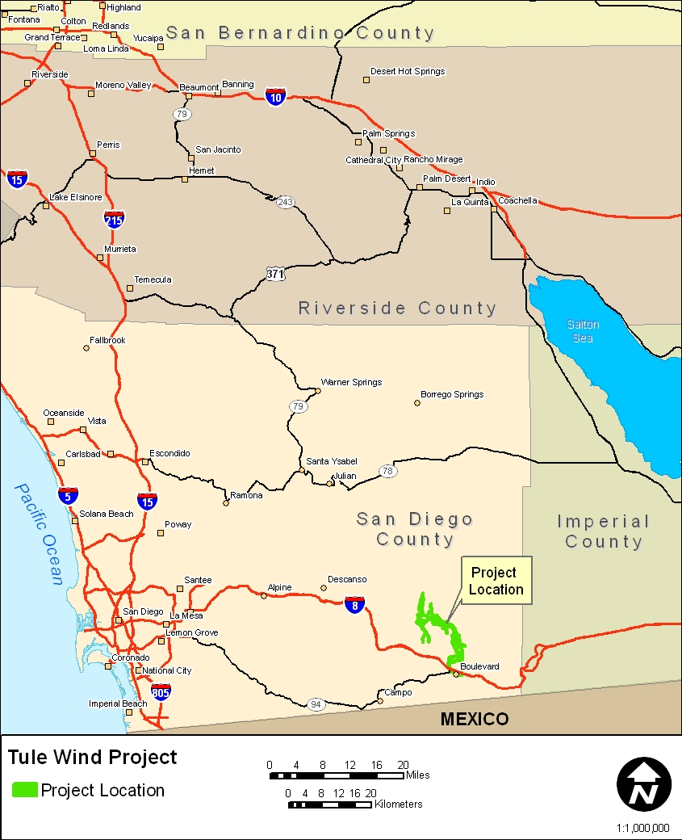

Figure 1.1 Project location map.
ASM conducted a Class III cultural resources inventory of the proposed project Area of Potential Effects (APE) to identify cultural resources that are eligible or are potentially eligible for listing on the National Register of Historic Places (NRHP) or California Register of Historic Resources (CRHR). This inventory included an intensive pedestrian survey providing 100-percent coverage of the APE (not including 381 acres on private land). A Class I records search was completed by Tetra Tech in 2008 for the preferred project alternative. An additional records search was conducted by ASM for portions of two alternative alignments that were not covered by the Tetra Tech records search. Additionally, ASM conducted a Class II cultural resources inventory of the non-APE areas within the project ROW. This Class II sample survey was conducted to comply with guidelines provided by the BLM, California Desert District Office relating to wind energy projects, and was a subjective sample of areas within the ROW considered to have high potential for cultural resources. As noted in Chapter 3, the methods used to complete the Class II sample survey were identical to the Class III intensive inventory.

The records search by Tetra Tech (2008) covered a one-mile buffer around the project ROW, as defined in 2008, and identified a total of 190 previously recorded archaeological sites: 39 previously recorded archaeological sites are within the 2008 ROW, and 151 previously recorded archaeological sites are outside the ROW but within a one-mile buffer of the 2008 ROW. The supplemental records search conducted by ASM in 2009 at the South Coastal Information Center (SCIC) resulted in the identification of an additional 21 archaeological sites: seven within the Class III footprint and 14 outside the footprint but within a one-mile radius.

The Class III pedestrian survey of the APE covered approximately 3,159 acres, and the Class II sample survey of the proposed ROW covered another 1,741 acres, for a total of 4,900 acres. A total of 381 acres in the Class III footprint remain to be surveyed. In all, 151 cultural resources (not including isolated finds) were documented during the survey. Aside from Highway 80, recorded as a historic road, the remaining 150 cultural resources include small scatters of prehistoric and historic artifacts to large prehistoric habitations or historic home sites. The majority of these sites (n = 108), including Highway 80, were identified in the Class III inventory while 43 others were identified in the Class II sample inventory. Newly discovered sites far outnumbered previously recorded sites. In the Class III inventory, 68 archaeological sites were newly discovered (40 were previously recorded, including Highway 80), and in the Class II sample inventory, 34 archaeological sites are newly discovered and nine are previously recorded.

To facilitate future planning, ASM provided preliminary NRHP eligibility assessments for each archaeological site. Except in rare circumstances, making recommendations of NRHP eligibility for archaeological sites includes a formal evaluation phase that typically involves more intensive recording and excavation. As such, the preliminary NRHP assessments provided herein are not formal recommendations but estimations based on surface observations of site character and the potential for buried deposits. These preliminary assessments provide a measure of potential future work that may be required at archaeological sites documented in the proposed project area. To this end, within the Class III inventory APE, 15 archaeological sites have been identified as likely to meet NRHP eligibility criteria. Of the remaining 93 sites within the APE, 91 are not likely to be eligible and two are classified as uncertain. Considering just the Class II sample survey, 10 archaeological sites are likely to be eligible for NRHP listing and 33 sites are likely ineligible. A detailed justification for these eligibility assessments is provided in Chapter 5.

The following sections describe the regulatory context of the proposed project, the project Area of Potential Effects (APE), ASM’s key personnel, and the structure of this report.

1.2 PROJECT APE
The APE is the geographic area or areas, regardless of land ownership, within which an undertaking may directly or indirectly cause alterations in the character or use of historic properties, if any such properties exist. For the current proposed project, the APE consists of an approximate 3,540-acre footprint, including a new 3.6- to 4.1-mi. transmission line.

The current project APE is shown on Figures 1.2 and 1.3; the APE will act as the survey corridor requiring 100-percent survey coverage. The APE varies in extent relative to the various project components as described below:

- A 400-ft. corridor along linear turbine strings with the option of expanding the corridor to 800-ft. to avoid potentially eligible cultural resources;
- A 150-ft. corridor along access roads, transmission lines (overhead and underground), and collector lines;
- A 100-ft. buffer around staging areas, substations, and other project related parcels.
The general APE parameters are different for lands under San Diego County jurisdiction. For county lands, all transmission lines will be surveyed with a 1,000-ft. corridor to allow for movement of the lines during project construction as needed.

The APE includes several alternative alignments for turbine strings and transmission lines. All alignments—i.e., the preferred alternative and secondary alternatives—are included in this Class III inventory and were covered by the records search and a pedestrian survey. The turbine string alignments are somewhat flexible. Each turbine string survey corridor will be 400 ft. wide. However, if a potentially eligible cultural resource is identified within the 400-ft. corridor, the survey corridor in the area of the site will be expanded to 800 ft. Covering areas adjacent to potentially eligible resources allows for the assessment of alternative turbine locations along the same string without having to re-mobilize survey crews at a later date when the project design has been modified for avoidance.

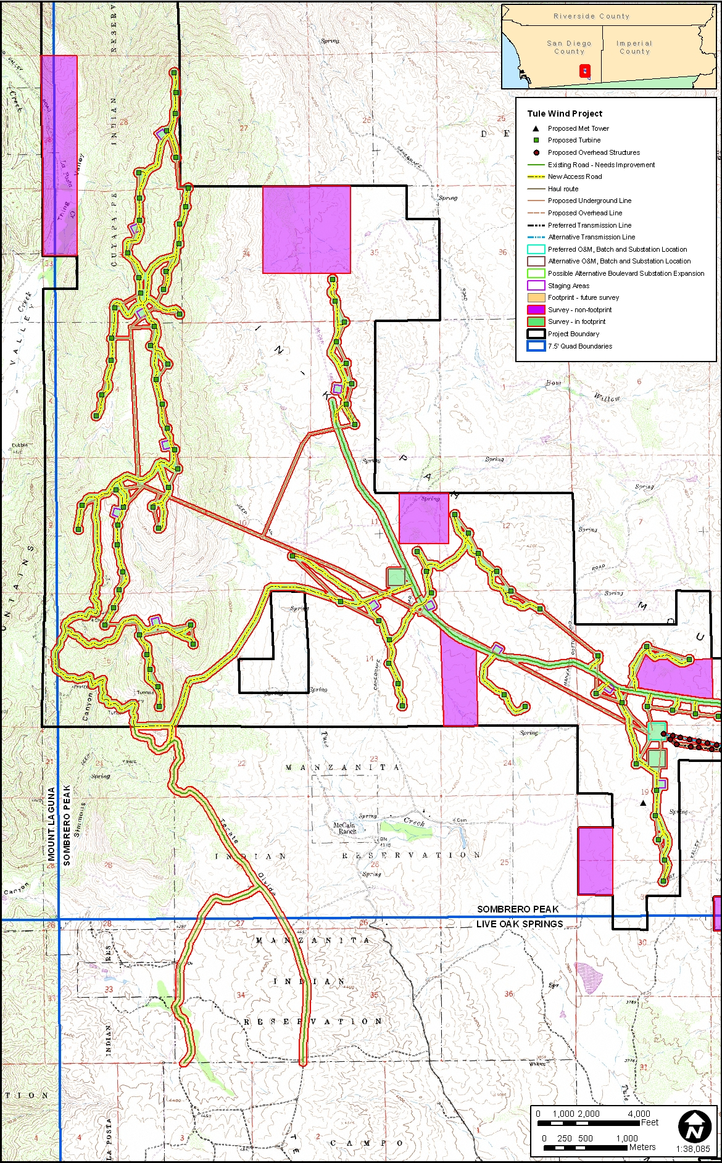

Figure 1.2 Project location map showing the project APE and Class II survey Areas.

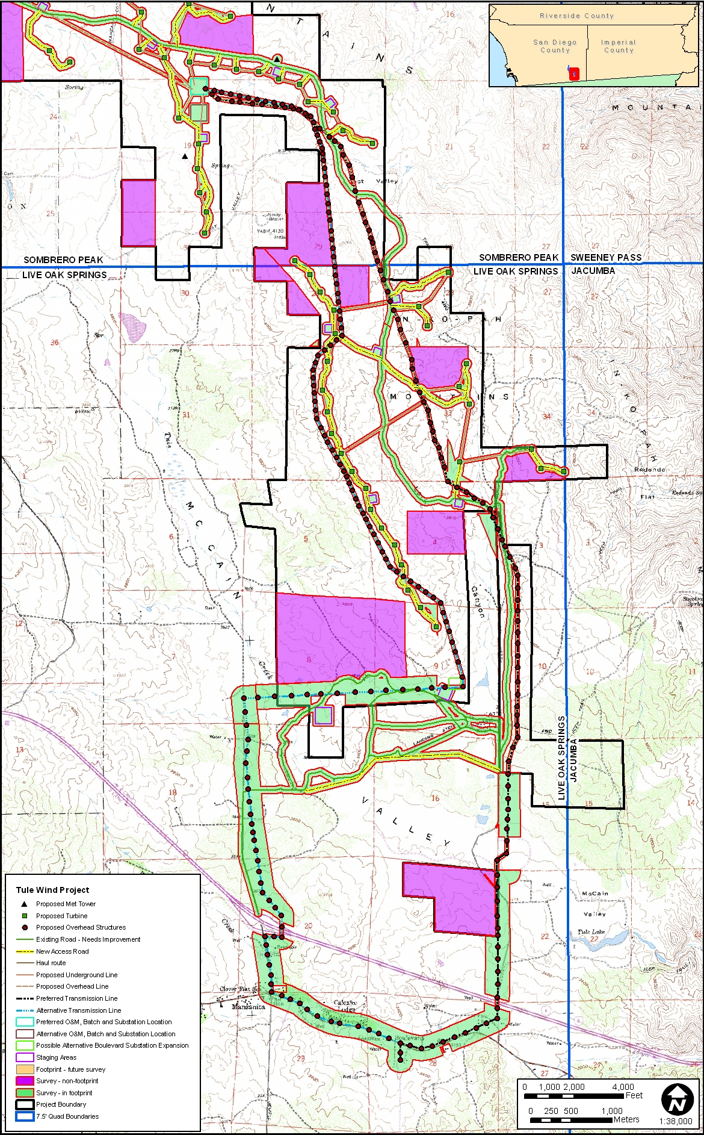

Figure 1.3 Project location map showing the project APE and Class II survey areas.

1.3 PROJECT RIGHT OF WAY
The project ROW is depicted in Figures 1.2 and 1.3 (identified as “project boundary”). Recently, the BLM and California State Historic Preservation Office (SHPO) revised the guidelines for archaeological inventories related to wind energy projects. A large amount of land remains under the granted ROW that will not be covered by the APE Class III inventory, since the ROW is typically much larger than the actual project footprint (APE). To remedy this, the revised BLM guidelines require that a Class II sample survey be conducted of the non-APE ROW in areas with higher probability for containing cultural resources (Appendix C). Areas selected for the Class II inventory were based on previous research, the results of Native American Consultation to a limited extent, and the results of the Class III inventory of the project APE.

1.4 REGULATORY CONTEXT
The project APE encompasses Federal, state, and private land, thus requiring compliance with regulations set forth in CEQA and the National Historic Preservation Act (NHPA) governing the discovery and treatment of cultural resources.

1.4.1 California Environmental Quality Act (CEQA)
CEQA requires that all private and public activities not specifically exempted be evaluated for the potential to impact the environment, including effects to historical resources. Historical resources are recognized as part of the environment under CEQA. The law defines historical resources as “any object, building, structure, site, area, or place, which is historically significant in the architectural, engineering, scientific, economic, agricultural, educational, social, political, military, or cultural annals of California” (Division I, Public Resources Code, Section 5021.1(b)).

Lead agencies have a responsibility to evaluate historical resources against the CRHR criteria prior to making a finding as to a proposed project’s impacts to historical resources. Mitigation of adverse impacts is required if the proposed project will cause substantial adverse change. Substantial adverse change includes demolition, destruction, relocation, or alteration such that the significance of a historical resource would be impaired. While demolition and destruction are fairly obvious significant impacts, it is more difficult to assess when change, alteration, or relocation crosses the threshold of substantial adverse change. The CEQA guidelines provide that a project that demolishes or alters those physical characteristics of a historical resource that convey its historical significance (i.e., its character-defining features) can be considered to materially impair the resource’s significance.

The CRHR is used in the consideration of historic resources relative to significance for purposes of CEQA. The CRHR includes resources listed in, or formally determined eligible to be a California State Landmarks and Points of Historical Interest. Properties of local significance that have been designated under a local preservation ordinance (local landmarks or landmark districts), or that have been identified in a local historical resources inventory may be eligible for listing in the CRHR and are presumed to be significant resources for purposes of CEQA unless a preponderance of evidence indicates otherwise.

Generally, a resource shall be considered by the lead agency to be “historically significant” if the resource meets the criteria for listing on the California Register of Historical Resources (Pub. Res. Code SS5024.1, Title 14 CCR, Section 4852) consisting of the following:

- It is associated with events that have made a significant contribution to the broad patterns of local or regional history, or the cultural heritage of California or the United States; or,
- It is associated with the lives of persons important to local, California, or national history; or,
- It embodies the distinctive characteristics of a type, period, region, or method of construction, or represents the work of a master, or possesses high artistic values; or,
- It has yielded, or has the potential to yield, information important to the prehistory or history of the local area, California, or the nation.

1.4.2 National Historic Preservation Act (NHPA)
The NHPA established the NRHP and the President’s Advisory Council on Historic Preservation (ACHP), and provided that states may establish SHPOs to carry out some of the functions of the NHPA. Most significantly for federal agencies responsible for managing cultural resources, Section 106 of the NHPA directs that “[t]he head of any Federal agency having direct or indirect jurisdiction over a proposed Federal or federally assisted undertaking in any State and the head of any Federal department or independent agency having authority to license any undertaking shall, prior to the approval of the expenditure of any Federal funds on the undertaking or prior to the issuance of any license, as the case may be, take into account the effect of the undertaking on any district, site, building, structure, or object that is included in or eligible for inclusion in the NRHP.” Section 106 also affords the ACHP a reasonable opportunity to comment on the undertaking (16 USC 470f).

36 Code of Federal Regulations, Part 800 (36 CFR 800) implements Section 106 of the NHPA. It defines the steps necessary to identify historic properties (those cultural resources listed in or eligible for listing in the NRHP), including consultation with federally recognized Native American tribes to identify resources with important cultural values; to determine whether or not they may be adversely affected by a proposed undertaking; and the process for eliminating, reducing, or mitigating the adverse effects.

The content of 36 CFR 60.4 defines criteria for determining eligibility for listing in the NRHP. The BLM evaluates the significance of cultural resources identified during inventory phases in consultation with the California SHPO to determine if the resources are eligible for inclusion in the NRHP. Cultural resources may be considered eligible for listing if they possess integrity of location, design, setting, materials, workmanship, feeling, and association. The criteria for determining eligibility are essentially the same in content and order as those outlined under CEQA, but the criteria under NHPA are labeled A through D (rather than 1-4 under CEQA).

Regarding criteria A through D of Section 106, the quality of significance in American history, architecture, archaeology, engineering, and culture is present in districts, cultural resources, buildings, structures, and objects that possess integrity of location, design, setting, materials, workmanship, feeling, and association, and that:

- are associated with events that have made a significant contribution to the broad patterns of our history; or
- are associated with the lives of persons significant in our past; or
- embody the distinctive characteristics of a type, period, or method of construction, or that represent the work of a master, or that possess high artistic values, or that represent a significant and distinguishable entity whose components may lack individual distinction; or
- have yielded or may be likely to yield, information important in prehistory or history [36 CFR 60.4].

To facilitate the evaluation of cultural resources in California, the BLM has devised guidelines for inventory and determining the eligibility of prehistoric and historic sites. The guidelines supplement the NRHP criteria for evaluation and provide consistency on BLM lands across the state. These “Cultural Resource Inventory General Guidelines” have been revised to keep pace with current guidance in the field of cultural resource management.

The current proposed Class III inventory is not designed to generate enough data to make eligibility determinations on previously recorded or newly discovered cultural resources; such determinations are typically made during a subsequent evaluation phase (e.g., excavations at prehistoric sites). However, the inventory will generate enough data to offer management assessments of the eligibility of cultural resources recorded during the inventory. These assessments will help guide the development of evaluation and mitigation plans to determine site eligibility and the significance of project impacts.

1.5 KEY PERSONNEL
John Cook, ASM President, served as the Project Manager with ultimate project oversight and budget management. Micah Hale, Ph.D., was the Principal investigator (PI) responsible for development and execution of field procedures, data collection, site interpretations, significance evaluations, and management recommendations. The PI also directed the preparation of draft and final reports and was responsible for maintaining schedules, budgets, and coordination with HDR. Mr. Brad Comeau was the overall field director with assistance from Mr. Chad Willis, M.A., as crew chief. The crew consisted primarily of experienced ASM personnel but included several individuals from outside the company that have worked on previous projects in the region, including ASM’s recent cultural resources inventory for SDG&E—some alignments for the SDG&E project cut through McCain Valley and the current project APE. All field directors and crew chiefs assisted the PI in mobilizing field crews and dealing with logistics. ASM also coordinated with appropriate Native American tribes to identify tribal representatives that accompanied field crews during the pedestrian survey.

1.6 REPORT STRUCTURE
This report is divided into five chapters. Following this introduction, Chapter 2 provides a project context, describing natural environments and the general culture history of the region from an archaeological, ethnographic, and historic perspective, along with a research design that can be used to direct further work with archaeological resources. Chapter 2 also includes a brief summary of Tetra Tech’s (2008) records search. The survey design and methods are described in Chapter 3. Chapter 4 summarizes the results of the pedestrian survey while Chapter 5 reviews the survey data with respect to research themes and management considerations. Several appendices contain site forms and site location maps (Confidential Appendix A), the sample survey letter report and maps submitted in advance of the draft Environmental Impact Statement (EIR) (Confidential Appendix B), BLM guidelines for cultural resources inventories that relate to wind energy generation projects (Appendix C), the Health and Safety Plan (Appendix D), and Resumes of key personnel (Appendix E), Native American consultation notes (Confidential Appendix F), and the results from Tetra Tech’s (2008) and ASM’s (2009) records searches (Confidential Appendix G).

2. PROJECT CONTEXT
This chapter reviews the environmental setting of the survey area, along with prehistoric, ethnohistoric, and historic contexts. Previous archaeological research conducted in the area is also included. The discussion that follows is a summary describing how pertinent investigations in the general region have contributed to the current constructions of past cultural history, and is not intended to be an exhaustive account of all research conducted in the area.

2.1 NATURAL SETTING
The project area lies within the mountains province of eastern San Diego County, California (Bowman 1973). The foothills province lies about 10 km to the west, while the coastal plains province is approximately 30 km to the west. Specifically, the project area overlaps McCain Valley, situated between Tecate Divide to the west and Inkopah Mountain to the east. McCain Valley is drained by Tule Creek and its tributaries.

Geologically, the project area is underlain by pre-Cretaceous rock, which outcrop as granite and gneiss (similar to granite), with other patches of exposed quartz diorite and granodiorite (Strand 1962). Much of the surrounding area contains Mesozoic granitic rocks. Metamorphic and granitic rocks provided material for milling tools used by the prehistoric inhabitants of the region, and quartz dikes within the granitic rocks provided a local material for manufacturing flaked stone tools. The region’s prime source of material for flaked stone tools was the metavolcanic rock of the Santiago Peak formation, which is available in streambeds in low-lying areas approximately 20 km to the southwest. The valley floor is composed of Quaternary non-marine alluvium characterized by coarse loamy sand derived from granodiorite. Coarse granitic sand with low organic content typifies archaeological site deposits. These deposits are well-drained, failing to contain anthropogenic sediments from short term occupations for long periods of time. At the more substantial archaeological sites, however, sufficient organic residue was generated such that midden soils can still be observed.

The climate is classified as Mediterranean Hot Summer, or Csa in the Köppen classification (Pryde 2004). Rainfall is about 33 cm per year, falling primarily between December and March. The average January daily minimum temperature is 4°C (39°F), and the average July daily maximum is 32°C (90°F). The climate would have imposed few constraints on prehistoric hunter-gatherers in the region.

The predominant natural vegetation community of the region is chaparral, although perhaps mixed with coastal sage scrub (Pryde 2004). Typical plant species include laurel sumac (Rhus laurina), black sage (Salvia mellifera), manzanita (Arctostaphylos spp.), redshank (Adenostoma sparsifolium), oak (Quercus spp.), chamise (Adenostoma fasciculatum), and California lilac (Ceanothus sp.), along with various grasses and legumes. Riparian species are associated with drainages. Mammals, birds, and reptiles within these communities provided potential food resources to prehistoric inhabitants. Much of the natural vegetation in low-lying areas has been displaced by modern land uses for grazing, and orchards. However, the steep mountain slopes harbor relatively intact, dense chaparral and Oak communities. These vegetation communities have been in place since the early Holocene, by at least 7500 B.P., when the climate became noticeably warmer and drier (Axelrod 1978).

2.2 CULTURAL CONTEXT
Evidence for continuous human occupation in the San Diego region spans the last 10,000 years. Various attempts to parse out variability in archaeological assemblages over this broad time frame have led to the development of several cultural chronologies; some of these are based on geologic time, most are based on temporal trends in archaeological assemblages, and others are interpretive reconstructions. Each of these reconstructions describes essentially similar trends in assemblage composition in more or less detail. This research employs a common set of generalized terms used to describe chronological trends in assemblage composition: Paleoindian (pre-5500 B.C.), Archaic (8000 B.C.-A.D. 500), Late Prehistoric (A.D. 500-1750), and Ethnohistoric (post-A.D. 1750).

2.2.1 Paleoindian (pre-5500 B.C.)
Evidence for Paleoindian occupation in coastal southern California is tenuous, especially considering the fact that the oldest dated archaeological assemblages look nothing like the Paleoindian artifacts from the Great Basin. One of the earliest dated archaeological assemblages in coastal southern California (excluding the Channel Islands) derives from SDI-4669/W-12, in La Jolla. A human burial from SDI-4669 was radiocarbon dated to 9590-9920 years before present (B.P.) (95.4 percent probability) (Hector 2007). The burial is part of a larger site complex that contained more than 29 human burials associated with an assemblage that fits the Archaic profile (i.e., large amounts of ground stone, battered cobbles, and expedient flake tools). In contrast, typical Paleoindian assemblages include large stemmed projectile points, high proportions of formal lithic tools, bifacial lithic reduction strategies, and relatively small proportions of ground stone tools. Prime examples of this pattern are sites that were studied by Emma Lou Davis (1978) on Naval Air Weapons Station China Lake near Ridgecrest, California. These sites contained fluted and unfluted stemmed points and large numbers of formal flake tools (e.g., shaped scrapers, blades). Other typical Paleoindian sites include the Komodo site (MNO-679)—a multicomponent fluted point site, and MNO-680—a single component Great Basin Stemmed point site (see Basgall et al. 2002). At MNO-679 and -680, ground stone tools were rare while finely made projectile points were common.

Turning back to coastal southern California, the fact that some of the earliest dated assemblages are dominated by processing tools runs counter to traditional notions of mobile hunter-gatherers traversing the landscape for highly valued prey. Evidence for the latter—that is, typical Paleoindian assemblages—may have been located along the coastal margin at one time, prior to glacial desiccation and a rapid rise in sea level during the early Holocene (pre-7500 B.P.) that submerged as much as 1.8 km of the San Diego coastline. If this were true, however, it would also be expected that such sites would be located on older landforms near the current coastline. Some sites, such as SDI-210 along Agua Hedionda Lagoon, contained stemmed points similar in form to Silver Lake and Lake Mojave projectile points (pre-8000 B.P.) that are commonly found at sites in California’s high desert (see Basgall and Hall 1990). SDI-210 yielded one corrected radiocarbon date of 8520-9520 B.P. (see Warren et al. 2004). However, sites of this nature are extremely rare and cannot be separated from large numbers of milling tools that intermingle with old projectile point forms.

Warren et al. (2004) claimed that a biface manufacturing tradition present at the Harris site complex (SDI-149) is representative of typical Paleoindian occupation in the San Diego region that possibly dates between 10,365 and 8200 B.C. (Warren et al. 2004:26). Termed San Dieguito (see also Rogers 1945), assemblages at the Harris site are qualitatively distinct from most others in the San Diego region because the site has large numbers of finely made bifaces (including projectile points), formal flake tools, a biface reduction trajectory, and relatively small amounts of processing tools (see also Warren 1964, 1968). Despite the unique assemblage composition, the definition of San Dieguito as a separate cultural tradition is hotly debated. Gallegos (1987) suggested that the San Dieguito pattern is simply an inland manifestation of a broader economic pattern. Gallegos’ interpretation of San Dieguito has been widely accepted in recent years, in part because of the difficulty in distinguishing San Dieguito components from other assemblage constituents. In other words, it is easier to ignore San Dieguito as a distinct socioeconomic pattern than it is to draw it out of mixed assemblages.

The large number of finished bifaces (i.e., projectile points and non-projectile blades), along with large numbers of formal flake tools at the Harris site complex, is very different than nearly all other assemblages throughout the San Diego region, regardless of age. Warren et al. (2004) made this point, tabulating basic assemblage constituents for key early Holocene sites. Producing finely made bifaces and formal flake tools implies that relatively large amounts of time were spent for tool manufacture. Such a strategy contrasts with the expedient flake-based tools and cobble-core reduction strategy that typifies non-San Dieguito Archaic sites. It can be inferred from the uniquely high degree of San Dieguito assemblage formality that the Harris site complex represents a distinct economic strategy from non-San Dieguito assemblages.

If San Dieguito truly represents a distinct socioeconomic strategy from the non-San Dieguito Archaic processing regime, its rarity implies that it was not only short-lived, but that it was not as economically successful as the Archaic strategy. Such a conclusion would fit with other trends in southern California deserts, wherein hunting-related tools are replaced by processing tools during the early Holocene (see Basgall and Hall 1990).

2.2.2 Archaic (8000 B.C.-A.D. 500)
The more than 2,500-year overlap between the presumed age of Paleoindian occupations and the Archaic period highlights the difficulty in defining a cultural chronology in the San Diego region. If San Dieguito is the only recognized Paleoindian component in the San Diego region, then the dominance of hunting tools implies that it derives from Great Basin adaptive strategies and is not necessarily a local adaptation. Warren et al. (2004) admitted as much, citing strong desert connections with San Dieguito. Thus, the Archaic pattern is the earliest local socioeconomic adaptation in the San Diego region (see Hale 2001, 2009).

The Archaic pattern is relatively easy to identify (albeit hard to define) with assemblages that consist primarily of processing tools: millingstones, handstones, battered cobbles, heavy crude scrapers, incipient flake-based tools, and cobble-core reduction. These assemblages occur in all environments across the San Diego region, with little variability in tool composition. Low assemblage variability over time and space among Archaic sites has been equated with cultural conservatism (see Byrd and Reddy 2002; Warren 1968; Warren et al. 2004). Despite enormous amounts of archaeological work at Archaic sites, little change in assemblage composition occurs until the bow and arrow is adopted at around A.D. 500, as well as ceramics at approximately the same time (Griset 1996; Hale 2009). Even then, assemblage formality remains low. After the bow is adopted, small arrow points appear in large quantities and already low amounts of formal flake tools are replaced by increasing amounts of expedient flake tools. Similarly, shaped millingstones and handstones decrease in proportion relative to expedient, unshaped ground stone tools (Hale 2009). Thus, the terminus of the Archaic period is equally as hard to define as its beginning because basic assemblage constituents and patterns of manufacturing investment remain stable, complemented only by the addition of the bow and ceramics.

2.2.3 Late Prehistoric (A.D. 500-1750)
The interval following the Archaic and prior to ethnohistoric times (A.D. 1750) is commonly referred to as the Late Prehistoric (M. Rogers 1945; Wallace 1955; Warren et al. 2004). However, several other subdivisions continue to be used to describe various shifts in assemblage composition, including the addition of ceramics and cremation practices. In northern San Diego County, the post-A.D. 1450 period is called the San Luis Rey Complex (True 1980), while the same period in southern San Diego County is called the Cuyamaca Complex and is thought to extend from A.D. 500 until ethnohistoric times (Meighan 1959). Rogers (1929) also subdivided the last 1,000 years into the Yuman II and III cultures, based on the distribution of ceramics. Despite these regional complexes, each is defined by the addition of arrow points and ceramics, and the widespread use of bedrock mortars. Vagaries in the appearance of the bow and arrow and ceramics make the temporal resolution of the San Luis Rey and Cuyamaca complexes difficult. For this reason, the term Late Prehistoric is well suited to describe the last 1,500 years of prehistory in the San Diego region.

Temporal trends in socioeconomic adaptations during the Late Prehistoric are poorly understood. This is partly due to the fact that the fundamental Late Prehistoric assemblage is very similar to the Archaic pattern, but includes arrow points, large quantities of fine debitage from producing arrow points, ceramics, and cremations. The appearance of mortars and pestles is difficult to place in time because most mortars are on bedrock surfaces; bowl mortars are actually rare in the San Diego region. Some argue that the ethnohistoric intensive acorn economy extends as far back as A.D. 500 (Bean and Shipek 1978). However, there is no substantial evidence that reliance on acorns, and the accompanying use of mortars and pestles, occurred prior to A.D. 1400. True (1980) argued that acorn processing and ceramic use in the northern San Diego region did not occur until the San Luis Rey pattern emerged after approximately A.D. 1450. For southern San Diego County, the picture is less clear. The Cuyamaca Complex is the southern counterpart to the San Luis Rey pattern, however, and is most recognizable after A.D. 1450 (Hector 1984). Similar to True (1980), Hale (2009) argued that an acorn economy did not appear in the southern San Diego region until just prior to ethnohistoric times, and that when it did occur, a major shift in social organization followed.

2.2.4 Ethnohistoric (post-A.D. 1750)
Early descriptions of the lifeways of San Diego County ethnohistoric groups were provided by explorers, missionaries, administrators, and other travelers, who gave particular attention to the coastal populations (Boscana 1846; Fages 1937; Geiger and Meighan 1976; Harrington 1934; Laylander 2000). Subsequent ethnographers in the early twentieth century were able to give much more objective, detailed, and penetrating accounts. Most of the ethnographers attempted to distinguish between observations of the customs of surviving Native Americans and orally transmitted or inferred information concerning the lifeways of native groups prior to European intrusion into the region. The second of these subjects provides a terminal baseline for discussing the cultures of the region’s prehistory. Despite the relatively rich ethnographic record, attempts to distinguish between the archaeological residues that were produced by the linguistically unrelated but culturally similar Luiseño and Ipai/Kumeyaay have been largely unsuccessful (Pigniolo 2004; True 1966).

The project area lies within the territory usually ascribed to speakers of the Kumeyaay language, but near their boundary were speakers of the very closely related Ipai language to the north. Kumeyaay and Ipai are Yuman languages, with ties to other groups in northern Baja California, on the lower Colorado River, and in western Arizona. The separation of the Ipai and Kumeyaay languages from their closest relative, Cocopa in the Colorado River delta, may date back about 1,000-1,200 years, and the separation from other Yuman groups may have occurred around 1,500-2,000 years ago (Laylander 1985).

Aboriginal subsistence in the region was based largely on acquiring natural plants and animals, rather than the cultivation of agricultural crops. Acorns were a staple for the western groups, as were agave and mesquite for eastern groups. Numerous other plants were valued for their dietary contributions from their seeds, fruit, roots, stalks, or greens, and a still larger number of species had known medicinal uses. Game animals included deer first and foremost, but mountain sheep and pronghorn antelope were also present, as well as bears, mountain lions, bobcats, coyotes, and other medium-sized mammals. Small mammals were probably as important in aboriginal diets as larger animals, with jackrabbits and cottontails being preeminent, but woodrats and other rodents were commonly exploited. Various birds, reptiles, and amphibians were consumed as well; food taboos were few in number and inconsistent, judging from the surviving ethnographic record. The only precontact domesticated animal was the dog. It is not clear whether marine fish and shellfish were a mainstay for some coastal groups or merely provided supplemental or emergency food sources for groups that were oriented primarily toward terrestrial resources. Interregional exchange systems are known to have linked the coast with areas to the east in particular, but exchange may have been concerned more with facilitating social and ceremonial matters than with meeting material needs (Shipek 1982).

The Kumeyaay had developed a varied material culture that functioned well but was not highly elaborated, at least by global standards. A variety of tools was made from stone, wood, bone, and shell, and these served to procure and process the resources of the region. Needs for shelter and clothing were minimal, but considerable attention was devoted to personal decoration in the form of ornaments, painting, and tattooing. The local pottery was well made, although infrequently decorated. Basketry was a craft that was particularly refined (Shipek 1982).

The Kumeyaay were subdivided into essentially sovereign local communities or tribelets. Community membership was generally inherited from the male line. In practice, however, some degree of intermixing of these patriclans was certainly present during the historic period, and this may have reflected a considerable degree of flexibility in community membership during prehistoric times as well. Later descriptions of the settlement systems have been inconsistent, and there may have been considerable variability in practice (cf., Laylander 1991, 1997; Owen 1965; Shipek 1982; Spier 1923). In some areas, substantially permanent, year-round villages seem to have existed, with more remote resources beyond the daily foraging range being acquired by special task groups. In other areas, communities appear to have followed an annual circuit among seasonal settlements, or to have oscillated between summer and winter villages, often with the group splitting up into its constituent families during certain seasons. Some differences in settlement strategies may have reflected local differences in resource availability or cyclical effects of variability between times of plenty and times of stress. Rights of ownership over the land and its various resources were vested both in individual families and in the clans or communities as a whole. Leadership within communities had at least a tendency to be hereditary, but it was relatively weak; authority was more ceremonial and advisory than administrative or judicial. Headmen had assistants, and shamans exerted an important influence in community affairs, beyond their role in curing individual illness.

2.2.5 Historic (post-A.D. 1542)
European activity in the region began as early as A.D. 1542, when Juan Rodríguez Cabrillo landed in San Diego Bay (Carrico 1993). Sebastián Vizcaíno returned in 1602, and it is possible that there were subsequent contacts that went unrecorded. These brief encounters made the local native people aware of the existence of other cultures that were technologically more complex than their own. Epidemic diseases may also have been introduced into the region at an early date, either by direct contacts with the infrequent European visitors or through waves of diffusion emanating from native peoples farther to the east or south (Preston 2002). It is possible, but as yet unproven, that the precipitous demographic decline of native peoples had already begun prior to the arrival of Gaspar de Portolá and Junípero Serra in 1769.

Spanish colonial settlement was initiated in 1769, when multiple expeditions arrived in San Diego by land and sea, and then continued northward through the coastal plain toward Monterey. A military presidio and a mission to deal with the local Kumeyaay and Ipai were soon firmly established at San Diego, despite violent resistance to them from a coalition of native communities in 1776 (Carrico 1993). Private ranchos subsequently established by Spanish and Mexican soldiers, as well as other non-natives, appropriated much of the remaining coastal or near-coastal locations (Pourade 1960-1967).

Mexico’s separation from the Spanish empire in 1821 and the secularization of the California missions in the 1830s caused further disruptions to native populations in western San Diego County. Some former mission neophytes were absorbed into the work forces on the ranchos, while others drifted toward the urban centers at San Diego and Los Angeles or moved to the eastern portions of the county where they were able to join still largely autonomous native communities. In 1843, the small (28-acre) Cañada de Los Coches rancho in Lakeside was granted to Apolinaria Lorenza, and in 1845, the 48,000-acre El Cajon rancho was granted to María Antonia Estudillo (Carrico 1993).

United States conquest and annexation, together with the gold rush in northern California, brought many additional outsiders into the region. Development during the following decades was fitful, undergoing cycles of boom and bust. Small-scale settlement of El Cajon and Lakeside began in the late 1800s, including the construction of the San Diego-Cuyamaca Eastern Railroad and the flume from Cuyamaca Reservoir in the 1880s and 1890s. These developments supported small-scale exploratory mining. However, it was not until the second half of the twentieth century that the urbanization of the region exploded.

The Campo-Jucumba region, including McCain Valley was largely considered unsettled southern California territory—a fact that drew to the region a few prominent ranchers such as the McCain family. Originally from Arkansas and Texas, the McCain family began ranching in California as early as 1858 in the Mendocino region, and after an aborted return trip to Arkansas, decided to settle in what is now known as McCain Valley in 1868 (Ní Ghabhláin et al. 2010; Wade et al. 2008). With the McCain family alongside several small sheep and cattle ranching outfits tied to the Laguna Mountain area (just northwest of McCain Valley), ranching thrived until the mid-twentieth century. After this time, ranching dwindled in productivity due to several reasons, including more productive cattle outfits to the north, a collapse in the demand for wool, and the appropriation of some prime pasturelands (such as Laguna Meadows) by the National Parks Service for watershed protection and conservation (see Wade et al. 2008). In its heyday, cattle ranching associated with McCain Valley spread as far south as the lower portions of northern Baja (Wade et al. 2008). Not surprisingly, the intensification of ranching and homesteading in the McCain Valley area lead to conflicts with local Kumeyaay inhabitants. One such conflict, recounted by Tom Lucas, a local Kwaayimii Indian, was the apparent last stand of some Kumeyaay families in conflict with the McCain family that took place near McCain Valley in Campo or Jacumba in the 1880s (Carrico 1983, 1987). However, it is also true that many of the Native American inhabitants were employed by local ranchers, including Tom Lucas (Carrico 1983). Wade et al. (2008) provide a region-wide overview of ranching in San Diego County including eligibility considerations, and Ní Ghabhláin et al. (2010) provide a detailed historic context that covers part of the current Project area, including a NRHP evaluation of the built environment near Boulevard and historic Highway 80.

2.3 RECORDS SEARCH RESULTS
Tetra Tech completed a records search and literature review for the Tule Wind Project in 2008. This records search, conducted at the SCIC at San Diego State University, covered most of the current project APE. The southernmost extent of the current project APE was not included in the original Tetra Tech records search, thus requiring an additional records search for the current study.

Tetra Tech’s (2008) records search covered a one-mile buffer around the project ROW, as defined in 2008. The records search identified 39 cultural resources within the 2008 ROW, and another 151 cultural resources outside the ROW but within a one-mile radius of the 2008 ROW (Table 2.1). Of the 190 cultural resources identified by Tetra Tech (2008), 13 are recommended eligible for NRHP listing, three as not eligible for CRHR listing, and the rest (n = 177) are listed as eligibility status unknown or not evaluated (see Table 2.1). The supplemental records search conducted by ASM resulted in the identification of an additional 21 archaeological sites that have not been evaluated; seven of these within the Class III footprint and 14 outside the footprint but within a one-mile radius (Table 2.2). The results of Tetra Tech’s (2008) study, and ASM’s supplemental records search, including a tabulation of previous cultural resource studies and previously recorded cultural resources, are provided in Appendix G.

SDG&E is in the environmental review process for the construction of its Sunrse-Powerlink transmission line, a portion of which (Link 1, Section 9B) passes through McCain Valley overlapping the Tule Wind project footprint in some places. The Sunrse-Powerlink cultural resources inventory documented a number of cultural resources that also fall within the Tule Wind Class III and Class II inventory areas, but were not identified during records searches due to the recency of their recordation. With permission from the BLM and SDG&E, ASM was able to obtain information on the cultural resources recorded during the Sunrise-Powerlink survey and integrate those results in the current Tule Wind inventory. This integration was based on thorough field checks of each previously recorded site. In all, the cultural resources that overlap the Sunrise-Powerlink and Tule Wind inventories include seven prehistoric archaeological sites and one site with both historic and prehistoric components (Table 2.3).

Table 2.1 Tetra Tech (2008) Records Search Results

Trinomial | Last update  to record | NRHP Status | Age | Type | In ROW or  1-Mile Radius | Description
CA-SDI-118 | 1950'S | Not evaluated | Prehistoric (of Roger's  Yuma II and III) | Pottery scatter | 1-Mile Radius | Pottery scatter.
CA-SDI-10123 | 1983 | Not evaluated | Prehistoric | Artifact scatter | 1-Mile Radius | Sparse pottery scatter and lithic material.
CA-SDI-10125 | 1979 | Not evaluated | Prehistoric | Lithic scatter | 1-Mile Radius | Lithic scatter.
CA-SDI-10328 | 1979 | Not evaluated | Prehistoric (Late Period) | Artifact scatter | ROW | Lithic and Tizon Brown pottery scatter (4 items)
CA-SDI-10329 | 1979 | Not evaluated | Prehistoric (Late Period) | Artifact scatter | ROW | Lithic and Tizon Brown pottery scatter (4 items)
CA-SDI-10335 | 1979 | Not evaluated | Prehistoric | Habitation site | 1-Mile Radius | Rock shelter with lithic and pottery scatter.
CA-SDI-10359 | 1979 | Not evaluated | Prehistoric | Milling feature, artifact scatter | 1-Mile Radius | Bedrock milling feature with lithic and pottery scatter
CA-SDI-10360 | 1979 | Not evaluated | Prehistoric | Milling feature and artifact scatter | ROW | Bedrock milling station with lithic and pottery scatter
CA-SDI-10595 | 1986 | Not evaluated | Prehistoric | Milling feature, artifact scatter | 1-Mile Radius | Bedrock milling feature with lithic and pottery scatter
CA-SDI-10596 | 1986 | Not evaluated | Prehistoric | Milling feature, artifact scatter | 1-Mile Radius | Bedrock milling feature with lithic and pottery scatter
CA-SDI-10597 | 1987 | Not evaluated | Prehistoric | Milling feature | 1-Mile Radius | Bedrock milling feature.
CA-SDI-10651 | 2006 | Not evaluated | Prehistoric | Habitation site | 1-Mile Radius | Large temporary camp.
CA-SDI-10653 | 2006 | Not evaluated | Historic | Historic trash scatter | 1-Mile Radius | Historic refuse scatter.
CA-SDI-10654 | 1986 | Not evaluated | Prehistoric | Habitation site | 1-Mile Radius | Habitation/ethnographic village site.
CA-SDI-10655 | 1986 | Not evaluated | Prehistoric | Habitation site | 1-Mile Radius | Temporary camp, milling feature.
CA-SDI-10656  (CA-SDI-7157) | 2006 | Not evaluated | Prehistoric | Habitation site | 1-Mile Radius | Large temporary camp with milling features, stone circle, lithic and pottery scatters.
CA-SDI-10974 | 1995 | Not evaluated | Prehistoric | Habitation site | 1-Mile Radius | Habitation site with milling station, lithic scatter and pottery scatter.
CA-SDI-10975 | 1995 | Not evaluated | Prehistoric | Milling feature, artifact scatter | 1-Mile Radius | Milling feature with lithic and pottery scatter.
CA-SDI-10976 | 1995 | Not evaluated | Prehistoric | Milling feature, artifact scatter | 1-Mile Radius | Milling feature with lithic and pottery scatter.
CA-SDI-10977 | 1995 | Not evaluated | Prehistoric | Milling feature | 1-Mile Radius | Bedrock milling feature.
CA-SDI-10978 | 1995 | Not evaluated | Prehistoric | Milling feature | 1-Mile Radius | Bedrock milling feature.
CA-SDI-10979 | 1995 | Not evaluated | Prehistoric | Milling feature | 1-Mile Radius | Bedrock milling feature.
CA-SDI-10980 | 1995 | Not evaluated | Prehistoric | Milling feature | 1-Mile Radius | Bedrock milling feature.
CA-SDI-10981 | 1995 | Not evaluated | Prehistoric | Milling feature | 1-Mile Radius | Bedrock milling feature.
CA-SDI-10982 | 1995 | Not evaluated | Prehistoric | Milling feature | 1-Mile Radius | Bedrock milling feature.
CA-SDI-10983 | 1995 | Not evaluated | Prehistoric | Milling feature | 1-Mile Radius | Bedrock milling feature.
CA-SDI-10984 | 1995 | Not evaluated | Prehistoric | Milling feature | 1-Mile Radius | Bedrock milling feature.
CA-SDI-10985 | 1995 | Not evaluated | Prehistoric | Milling feature | 1-Mile Radius | Bedrock milling feature.
CA-SDI-1150 | 1969 | Not evaluated | Prehistoric (Late Period) | Milling stations and lithic scatter | ROW | Bedrock milling features and lithic scatter
CA-SDI-12866 | 1983 | Not evaluated | Prehistoric | Artifact scatter | 1-Mile Radius | Lithic and pottery scatter.
CA-SDI-12867 | 2007 | Not evaluated | Prehistoric | Milling feature | 1-Mile Radius | Milling feature.
CA-SDI-12868 | 2007 | Not evaluated | Historic | Historic mining features | 1-Mile Radius | Historic mine features.
CA-SDI-15188 | 1999 | Not evaluated | Historic | Historic dam | 1-Mile Radius | Breached dam.
CA-SDI-15189 | 1999 | Not evaluated | Prehistoric | Lithic scatter | 1-Mile Radius | Lithic scatter.
CA-SDI-15190 | 1999 | Not evaluated | Prehistoric | Artifact scatter | 1-Mile Radius | Lithic and pottery scatter.
CA-SDI-16007 | 1999 | Not evaluated | Prehistoric | Habitation site | 1-Mile Radius | Temporary camp with hearth feature.
CA-SDI-16037 | 1999 | Not evaluated | Prehistoric | Milling feature, lithic scatter | 1-Mile Radius | Bedrock milling feature and lithic scatter.
CA-SDI-16038 | 1999 | Not evaluated | Prehistoric | Milling feature | 1-Mile Radius | Bedrock milling feature.
CA-SDI-16038 | 1999 | Not evaluated | Prehistoric (Late Period) | Milling station | ROW | Bedrock milling feature
CA-SDI-16039 | 2003 | Not evaluated | Prehistoric | Rock cairn, lithic scatter | 1-Mile Radius | Rock cairn and lithic scatter.
CA-SDI-16040 | 2003 | Not evaluated | Prehistoric | Lithic scatter | 1-Mile Radius | Lithic scatter.
CA-SDI-16041 | 2003 | Not evaluated | Prehistoric | Rock cairn, lithic scatter | 1-Mile Radius | Rock cairn and lithic scatter.
CA-SDI-16042 | 2003 | Not evaluated | Prehistoric | Lithic scatter, rock features | 1-Mile Radius | Lithic scatter and rock features.
CA-SDI-16044 | 2003 | Not evaluated | Prehistoric | Rock cairn, lithic scatter | 1-Mile Radius | Lithic scatter and rock cairn.
CA-SDI-16045 | 2003 | Not evaluated | Undetermined | Rock cairn | 1-Mile Radius | Rock cairn.
CA-SDI-16046 | 2003 | Not evaluated | Undetermined | Rock cairn | 1-Mile Radius | Rock cairn.
CA-SDI-16047 | 2003 | Not evaluated | Undetermined | Rock cairn | 1-Mile Radius | Rock cairn.
CA-SDI-16048 | 2003 | Not evaluated | Undetermined | Rock cairn | 1-Mile Radius | Rock cairn.
CA-SDI-16049 | 2003 | Not evaluated | Undetermined | Rock cairn | 1-Mile Radius | Rock cairn.
CA-SDI-16050 | 2003 | Not evaluated | Undetermined | Rock cairn | 1-Mile Radius | Rock cairn.
CA-SDI-16051 | 2003 | Not evaluated | Undetermined | Rock cairn | 1-Mile Radius | Rock cairn.
CA-SDI-16052 | 2003 | Not evaluated | Historic | Historic fence | 1-Mile Radius | Historic fence line.
CA-SDI-16053 | 2003 | Not evaluated | Undetermined | Rock features | 1-Mile Radius | Rock ring feature and rock cairn.
CA-SDI-16054 | 2003 | Not evaluated | Undetermined | Rock cairn | 1-Mile Radius | Rock cairn.
CA-SDI-16055 | 2003 | Not evaluated | Undetermined | Rock cairn | 1-Mile Radius | Rock cairn.
CA-SDI-16364 | 2001 | Not evaluated | Prehistoric | Lithic scatter | 1-Mile Radius | Lithic scatter.
CA-SDI-16365 | 2004 | Not evaluated | Prehistoric | Lithic scatter | 1-Mile Radius | Lithic scatter.
CA-SDI-16366 | 2001 | Not evaluated | Prehistoric | Artifact scatter | 1-Mile Radius | Lithic and pottery scatter.
CA-SDI-16367 | 2001 | Not evaluated | Prehistoric | Artifact scatter | 1-Mile Radius | Lithic and pottery scatter.
CA-SDI-16373 | 2001 | Not evaluated | Prehistoric | Artifact scatter | 1-Mile Radius | Lithic and pottery scatter and ground stone.
CA-SDI-16374 | 2001 | Not evaluated | Historic | Historic trash scatter | 1-Mile Radius | Historic refuse.
CA-SDI-16385 | 2002 | Not evaluated | Historic | Historic trash scatter | 1-Mile Radius | Historic refuse.
CA-SDI-16394 | 2002 | Not evaluated | Historic | Historic trash scatter | 1-Mile Radius | Historic refuse.
CA-SDI-164 | 1940'S | Not evaluated | Prehistoric | Pottery scatter | 1-Mile Radius | Pottery scatter.
CA-SDI-16786 | 2003 | Not evaluated | Historic | Historic trash scatter | 1-Mile Radius | Historic refuse.
CA-SDI-16823 | 2003 | Not evaluated | Historic | Historic trash scatter | 1-Mile Radius | Historic refuse.
CA-SDI-16825 | 2003 | Site tested, eligibility determination not available | Historic | Historic trash scatter | 1-Mile Radius | Historic refuse. Site was tested but results and eligibility not provided on site form.
CA-SDI-16826 | 2003 | Not evaluated | Historic | Historic trash scatter | 1-Mile Radius | Historic refuse.
CA-SDI-16827 | 2003 | Not evaluated | Historic | Historic trash scatter, historic foundation | 1-Mile Radius | Historic refuse and foundations.
CA-SDI-17116 | 2004 | Not evaluated | Prehistoric | Lithic scatter | 1-Mile Radius | Lithic scatter with bulldozer tracks.
CA-SDI-17118 | 2006 | Not evaluated | Prehistoric (Late Period) | Artifact scatter | ROW | Sparse lithic and pottery scatter
CA-SDI-17135 | 2004 | Not evaluated | Prehistoric | Lithic scatter | 1-Mile Radius | Lithic scatter.
CA-SDI-17816 | 2005 | Not evaluated | Prehistoric (Late Period) | Artifact scatter | ROW | Sparse lithic and pottery scatter. Site condition is poor due to OHV traffic and illicit surface collection.
CA-SDI-17821 | 2005 | Not evaluated | Prehistoric | Historic trash scatter | ROW | Historic refuse dumps
CA-SDI-17822 | 2005 | Not evaluated | Prehistoric | Lithic scatter | 1-Mile Radius | Lithic scatter.
CA-SDI-17827 | 2005 | recommended eligible | Prehistoric | Habitation site | 1-Mile Radius | Temporary camp with milling feature, lithic and pottery scatter.
CA-SDI-17828 | 2005 | Not evaluated | Prehistoric/Historic | Lithic scatter, historic trash scatter | 1-Mile Radius | Lithic scatter and historic glass.
CA-SDI-17844 | 2006 | Not evaluated | Prehistoric/Historic | Habitation site | 1-Mile Radius | Seasonal camp with milling feature, lithic and pottery scatter.
CA-SDI-17845 | 2006 | Not evaluated | Prehistoric/Historic | Artifact scatter and historic feature | 1-Mile Radius | Lithics and groundstone; livestock corral
CA-SDI-17869 | N/A | Not evaluated | Prehistoric | Pictographs | 1-Mile Radius | Pictographs.
CA-SDI-18048 | 2006 | Not evaluated | Historic | Historic structure, historic features | 1-Mile Radius | Collapsed historic structure and associated features.
CA-SDI-18049 | 2006 | Not evaluated | Historic | Artifact scatter | 1-Mile Radius | Lithic and pottery scatter.
CA-SDI-18050 | 2005 | Not evaluated | Prehistoric (Late Period) | Artifact scatter | ROW | Sparse lithic and pottery scatter and a mano.
CA-SDI-18051 | 2006 | Not evaluated | Historic | Artifact scatter | 1-Mile Radius | Lithics and one milling slab.
CA-SDI-18827 | 2007 | Not evaluated | Historic | Datum marker | 1-Mile Radius | General Land Office survey datum.
CA-SDI-18850 | 2007 | Not evaluated | Historic | Datum marker | 1-Mile Radius | General Land Office survey datum.
CA-SDI-18851 | 2007 | Not evaluated | Historic | Milling features | 1-Mile Radius | Milling features.
CA-SDI-18921 | 2008 | Not evaluated | Historic | Historic trash scatter | 1-Mile Radius | Historic refuse dump.
CA-SDI-2535 | 1977 | recommended eligible | Prehistoric  (E. Diegueno  of the Yuman III) | Rock shelter, pictographs | ROW | Rock shelter and pictographs
CA-SDI-2704 | 2003 | Not evaluated | Prehistoric | Habitation site | 1-Mile Radius | Rock shelter with pictographs and FAR, ground stone, lithic and pottery scatters.
CA-SDI-2729 | 1976 | recommended eligible | Prehistoric | Seasonal camp | ROW | Seasonal camp
CA-SDI-2730 | 1975 | Not evaluated | Prehistoric | Possible rock shelter, lithic scatter | ROW | Potential rock shelter with some lithics
CA-SDI-2731 | 2006 | Not evaluated | Prehistoric | Lithic scatter | ROW | Lithic scatter
CA-SDI-2732 | 2006 | Not evaluated | Prehistoric | Large village site | ROW | Originally recorded as a large village site. A 2006 attempt to relocate was unsuccessful. Authors suggest site is actually CA-SDI-4009 located several hundred meters to the southwest.
CA-SDI-3997 | 1975 | recommended eligible | Prehistoric | Habitation site | 1-Mile Radius | Milling station and midden.
CA-SDI-3998 | 1975 | recommended eligible | Prehistoric | Habitation site | 1-Mile Radius | Milling station and midden.
CA-SDI-3999 | 2006 | recommended eligible | Prehistoric | Habitation site | 1-Mile Radius | Milling station, midden and lithic scatter.
CA-SDI-4000 | 1975 | recommended eligible | Prehistoric (Late Period) | Habitation site | 1-Mile Radius | Milling station, midden and lithic scatter.
CA-SDI-4001 | 1975 | Not evaluated | Prehistoric | Milling station | 1-Mile Radius | Milling station.
CA-SDI-4002 | 2006 | Not evaluated | Prehistoric | Habitation site | 1-Mile Radius | Seasonal village site.
CA-SDI-4003 | 1975 | Not evaluated | Prehistoric | Artifact scatter | 1-Mile Radius | Lithic scatter and pottery scatter.
CA-SDI-4004 | 1975 | Not evaluated | Prehistoric (Late Period) | Habitation site | 1-Mile Radius | Rock shelter, milling station, lithic and pottery scatter.
CA-SDI-4006 | 1975 | Not evaluated | Prehistoric | Milling feature, lithic scatter | 1-Mile Radius | Milling slick and lithic scatter.
CA-SDI-4007 | 1975 | Not evaluated | Prehistoric | Lithic scatter | 1-Mile Radius | Lithic scatter.
CA-SDI-4009 | 2006 | Not evaluated, potentially eligible | Prehistoric (Late Period) | Seasonal village site | ROW | Seasonal village site and surrounding sattelite sites with several bedrock milling features and a lithic and ceramic scatter
CA-SDI-4010 | 2006 | recommended eligible | Prehistoric | Large village site | 1-Mile Radius | Large complex habitation site with midden and milling features.
CA-SDI-4343 | 1975 | Not evaluated | Prehistoric | Milling feature, lithic scatter | 1-Mile Radius | Milling feature and lithic scatter.
CA-SDI-4344 | 1975 | Not evaluated | Prehistoric | Milling feature, lithic scatter | 1-Mile Radius | Milling feature and lithic scatter.
CA-SDI-4345 | 1975 | Not evaluated | Prehistoric | Milling feature, lithic scatter | 1-Mile Radius | Milling feature and lithic scatter.
CA-SDI-4346 | 1975 | Not evaluated | Prehistoric | Milling feature, pottery scatter | 1-Mile Radius | Milling feature and pottery scatter.
CA-SDI-4473 | N/A | Not evaluated | Historic | Artifact scatter | 1-Mile Radius | Lithic and pottery scatter.
CA-SDI-4788 | 1986 | Not evaluated | Prehistoric | Milling feature, pottery scatter | 1-Mile Radius | Milling feature and pottery scatter.
CA-SDI-4788 | 2005 | Not evaluated | Prehistoric | Lithic scatter | ROW | Lithic scatter.
CA-SDI-5058 | 1979 | Not evaluated | Prehistoric | Milling feature, lithic scatter | 1-Mile Radius | Milling features and lithic scatter.
CA-SDI-5059 | 1979 | Not evaluated | Prehistoric | Artifact scatter | 1-Mile Radius | Lithic scatter and pottery scatter.
CA-SDI-5060, 10333,  10334, 10407 | 1979 | Not evaluated | Prehistoric | Milling feature, artifact scatter | 1-Mile Radius | Milling feature with lithic and pottery scatter.
CA-SDI-5162 | N/A | N/A | Prehistoric | Habitation site | ROW | Rock shelter and lithic and pottery scatter
CA-SDI-5171 | N/A | N/A | Prehistoric | Habitation site | ROW | Rock shelter and lithic and pottery scatter
CA-SDI-5417 | 2005 | Not evaluated | Prehistoric | Artifact scatter | 1-Mile Radius | Lithic and pottery scatter.
CA-SDI-5418 | 2005 | Not evaluated | Prehistoric | Artifact scatter | 1-Mile Radius | Lithic and pottery scatter.
CA-SDI-5430 | 1978 | Not evaluated | Prehistoric | Milling feature, artifact scatter | 1-Mile Radius | Milling features and lithic , pottery scatters.
CA-SDI-5933 | 2003 | Not eligible for CRHP, not evaluated NRHP | Prehistoric | Habitation site | 1-Mile Radius | Temporary camp with milling feature. Site tested and determined not eligible for listing on the California Register of Historic Resources.
CA-SDI-6779 | 1976 | Not evaluated | Prehistoric | Milling stations | ROW | Bedrock milling features
CA-SDI-6884 | 1979 | Not evaluated | Prehistoric | Lithic scatter | 1-Mile Radius | Lithic scatter.
CA-SDI-6884, 10126, 10128 | 1979 | recommended eligible | Prehistoric | Habitation site | 1-Mile Radius | Rock shelter with lithic and pottery scatter.
CA-SDI-6885 | 1978 | Not evaluated | Prehistoric | Milling feature, artifact scatter | 1-Mile Radius | Bedrock milling station with lithic and pottery scatter
CA-SDI-6893 | 2003 | Not evaluated | Prehistoric | Milling feature | 1-Mile Radius | Milling slick.
CA-SDI-6894 | 1979 | Not evaluated | Prehistoric | Habitation site | 1-Mile Radius | Large temporary camp.
CA-SDI-6895 | 1979 | Not evaluated | Prehistoric | Habitation site | 1-Mile Radius | Large temporary camp.
CA-SDI-6896 | 1979 | Not evaluated | Prehistoric | Habitation site | 1-Mile Radius | Small temporary camp.
CA-SDI-6897 | 1979 | Not evaluated | Prehistoric | Habitation site | 1-Mile Radius | Small temporary camp.
CA-SDI-6898 | 1979 | Not evaluated | Historic | Historic camp | 1-Mile Radius | Possible historic US Army Camp.
CA-SDI-6899 | 2003 | Not evaluated | Prehistoric | Milling feature | 1-Mile Radius | Milling slick.
CA-SDI-6901 | 2003 | Not eligible for CRHP, not evaluated NRHP | Prehistoric | Habitation site | 1-Mile Radius | Temporary camp with milling feature. Site tested and determined not eligible for listing on the California Register of Historic Resources.
CA-SDI-6902 | 2003 | Not eligible for CRHP, not evaluated NRHP | Prehistoric | Milling feature | 1-Mile Radius | Bedrock milling feature. Site tested and determined not eligible for listing on the California Register of Historic Resources.
CA-SDI-6978 | 1978 | Not evaluated | Prehistoric | Artifact scatter | 1-Mile Radius | Lithic scatter and tool.
CA-SDI-6995 | 1978 | Not evaluated | Prehistoric | Habitation site | 1-Mile Radius | Several bedrock milling surfaces (50+), lithic and pottery scatter and midden.
CA-SDI-6996 | 2007 | Not evaluated | Prehistoric | Lithic scatter | 1-Mile Radius | Lithic scatter. ECORP unable to relocate in 2007.
CA-SDI-7135 | 1979 | Not evaluated | Historic | Historic trash scatter and historic features | 1-Mile Radius | Historic refuse and features.
CA-SDI-7136 | 1979 | Not evaluated | Prehistoric | Milling feature | 1-Mile Radius | Bedrock milling station.
CA-SDI-7137 | 1979 | Not evaluated | Prehistoric | Possible lithic quarry | 1-Mile Radius | Possible quartz and diorite quarry.
CA-SDI-7138 | 2005 | Not evaluated | Prehistoric | Habitation site | 1-Mile Radius | Rock shelter with lithic debitage. Site not relocated during a 2005 attempt.
CA-SDI-7139 | 2005 | Not evaluated | Historic/Prehistoric | Artifact scatter | 1-Mile Radius | Originally recorded as a historic site with a ceramic scatter. During a 2005 revisit the historic refuse and features associated with grazing were relocated but the ceramic scatter was not.
CA-SDI-7140 | 1979 | Not evaluated | Prehistoric | Milling station | 1-Mile Radius | Bedrock milling station.
CA-SDI-7141 | 1979 | Not evaluated | Historic | Historic trash scatter and historic features | 1-Mile Radius | Historic refuse and features.
CA-SDI-7142 | 1979 | Not evaluated | Prehistoric | Artifact scatter | 1-Mile Radius | Lithic and pottery scatter.
CA-SDI-7143 | 1979 | Not evaluated | Prehistoric | Habitation site | 1-Mile Radius | Rock shelter and lithic scatter.
CA-SDI-7144 | 1979 | Not evaluated | Prehistoric/Historic | Milling features, artifact scatter | 1-Mile Radius | Milling features with lithic and pottery scatter and historic refuse associated with cattle grazing.
CA-SDI-7145 | 1979 | Not evaluated | Prehistoric | Milling features, artifact scatter | 1-Mile Radius | Milling features with lithic and pottery scatter.
CA-SDI-7146 | 1979 | Not evaluated | Prehistoric/Historic | Milling features, artifact scatter | 1-Mile Radius | Milling features with lithic and pottery scatter and historic refuse.
CA-SDI-7148 | 1979 | Not evaluated | Prehistoric | Artifact scatter | 1-Mile Radius | Lithic and pottery scatter.
CA-SDI-7149 | 1979 | Not evaluated | Prehistoric | Milling feature | 1-Mile Radius | Milling station.
CA-SDI-7150 | 2006 | Not evaluated | Prehistoric (Late Period) | Habitation site | ROW | Rock shelter with a midden, lithic and pottery scatter
CA-SDI-7151 | 2006 | Not evaluated | Prehistoric | Habitation site | 1-Mile Radius | Habitation site.
CA-SDI-7151 | 2006 | Unknown | Prehistoric (Late Period) | Habitation site | ROW | Rock shelters, habitation site with midden, lithic and pottery scatter. Site heavily impacted by OHV traffic.
CA-SDI-7152 | 1979 | Not evaluated | Prehistoric | Artifact scatter | 1-Mile Radius | Lithic and pottery scatter.
CA-SDI-7153 | 1979 | Not evaluated | Prehistoric/Historic | Habitation site | 1-Mile Radius | Rock shelter with stone enclosure with wodden arch, glass and shell casings. Sparse lithic and pottery.
CA-SDI-7154 | 1979 | Not evaluated | Prehistoric | Lithic scatter | 1-Mile Radius | Lithic scatter.
CA-SDI-7154 | 1979 | Not evaluated | Prehistoric | Lithic scatter | ROW | Lithic scatter
CA-SDI-7157  (aka CA-SDI-10656) | 2006 | Not evaluated | Prehistoric | Habitation site | 1-Mile Radius | Large temporary camp with milling features, stone circle, lithic and pottery scatters.
CA-SDI-7158 | 1979 | Not evaluated | Prehistoric | Lithic scatter | 1-Mile Radius | Lithic scatter of 5 flakes.
CA-SDI-7159 | 1979 | Not evaluated | Prehistoric | Milling feature and historic trash scatter | 1-Mile Radius | Milling feature and historic refuse.
CA-SDI-7161 | 1979 | Not evaluated | Prehistoric | Lithic scatter | 1-Mile Radius | Lithic scatter of 5 flakes.
CA-SDI-7162 | 2006 | Not evaluated | Prehistoric | Milling feature, pottery scatter | 1-Mile Radius | Bedrock milling features and pottery scatter
CA-SDI-7163 | 1979 | Not evaluated | Prehistoric | Milling feature, artifact scatter | 1-Mile Radius | Milling station with lithic and pottery scatter.
CA-SDI-7164 | 1979 | recommended eligible | Prehistoric | Habitation site | ROW | Rock shelter with a lithic and pottery scatter
CA-SDI-778 | 1961 | Not evaluated | Prehistoric | Milling feature | 1-Mile Radius | Bedrock mortar.
CA-SDI-8093 | 1978 | Not evaluated | Prehistoric | Habitation site | 1-Mile Radius | Temporary camp and lithic and pottery scatter.
CA-SDI-82 | 1949 | Not evaluated | Prehistoric | Pottery scatter | 1-Mile Radius | Pottery scatter.
CA-SDI-8353 | 1980 | Not evaluated | Prehistoric | Milling feature, artifact scatter | 1-Mile Radius | Milling station with lithic and pottery scatter.
CA-SDI-8355 | 1980 | Not evaluated | Prehistoric | Habitation site | 1-Mile Radius | Habitation site with milling station, lithic scatter and pottery scatter.
CA-SDI-8372/8375 | 2000 | Not evaluated | Prehistoric/Historic | Milling feature, artifact scatter | 1-Mile Radius | Milling feature with lithic and pottery scatter and the Historic McCain Ranch (SDI-8375)
CA-SDI-8388 | 2006 | recommended eligible | Prehistoric | Temporary camp | ROW | Originally recorded as a temporary camp with lithics and pottery. This site was not relocated during ASM's 2006 survey and relocation efforts.
CA-SDI-84 | 2005 | Not evaluated | Prehistoric (Late Period) | Pottery scatter | 1-Mile Radius | Originally recorded as a lithic and pottery scatter. Site was not relocated during an attempt in 2005.
CA-SDI-8683 | 1995 | Not evaluated | Prehistoric | Artifact scatter | 1-Mile Radius | Lithic and pottery (Tizon) scatter and ground stone.
CA-SDI-8684 | 1981 | Not evaluated | Prehistoric | Milling station | ROW | Milling station
CA-SDI-8702 | 1981 | Not evaluated | Prehistoric | Lithic scatter, pottery scatter | ROW | Lithic scatter and pottery scatter
CA-SDI-8703 | 1981 | recommended eligible | Prehistoric | Habitation site | ROW | Temporary camp, possible fire pit, lithic scatter and pottery scatter
CA-SDI-8704 | 1981 | Not evaluated | Prehistoric | Artifact scatter | ROW | Lithic scatter and pottery scatter
CA-SDI-8705 | 1981 | recommended eligible | Prehistoric | Habitation site | ROW | Rock shelters and associated lithic scatter and pottery scatter
CA-SDI-8707 | 1981 | Not evaluated | Prehistoric | Habitation site | ROW | Temporary camp, lithic scatter and pottery scatter
CA-SDI-8708 | 1981 | Not evaluated | Prehistoric | Milling feature | ROW | Cupule
CA-SDI-8709 | 1981 | Not evaluated | Prehistoric | Milling feature | ROW | Milling station
CA-SDI-8710 | 1981 | Not evaluated | Prehistoric | Milling feature, artifact scatter | 1-Mile Radius | Milling feature, midden and pottery.
CA-SDI-8710 | 1981 | Not evaluated | Prehistoric | Habitation site | ROW | Milling station, midden, and pottery scatter
CA-SDI-8711 | 1981 | Not evaluated | Prehistoric | Milling station | ROW | Milling station
CA-SDI-8712 | 1981 | Not evaluated | Prehistoric | Habitation site | ROW | Temporary camp, lithic scatter
CA-SDI-8717 | 1981 | Not evaluated | Prehistoric | Milling feature | 1-Mile Radius | Milling station.
CA-SDI-9028 | 2006 | Not evaluated | Prehistoric | Milling features, artifact scatter | 1-Mile Radius | Milling features with lithic and pottery scatter.
CA-SDI-9029 | 2006 | Not evaluated | Prehistoric | Milling features, artifact scatter | 1-Mile Radius | Milling features with lithic and pottery scatter.
CA-SDI-9223 | 2005 | Not evaluated | Prehistoric (Late Period) | Habitation site | ROW | Temporary camp with milling features and a lithic and pottery scatter
CA-SDI-9224 | 1982 | Not evaluated | Prehistoric (Late Period) | Artifact scatter | ROW | Lithic scatter, projectile points, and ground stone
CA-SDI-9228 | 2005 | Not evaluated | Prehistoric (Late Period) | Habitation site | ROW | Pottery scatter (Tizon Brown sherds)
CA-SDI-9540 | 1981 | Not evaluated | Prehistoric | Habitation site | 1-Mile Radius | Temporary camp with midden.
CA-SDI-9540 | 1981 | Not evaluated | Prehistoric (Late Period) | Habitation site | ROW | Temporary camp site with midden, lithics and pottery fragments.
CA-SDI-9715 | 1983 | Not evaluated | Historic | Historic structure, historic trash scatter | 1-Mile Radius | Historic structure and refuse.
P-37-24023 | 2000 | Not evaluated | Historic | Historic road | 1-Mile Radius | Old US 80 (paved highway).
P-37-28936 | N/A | Not eligible | Prehistoric | Pottery isolate | ROW | Isolated pottery fragment

Table 2.2 ASM (2009) Records Search Update

Trinomial | Last update  to record | NRHP Status | Age | Type | Class III APE or  1-Mile Radius | Description
CA-SDI-00087 | 2005 | Not Evaluated | Prehistoric | Prehistoric pottery and seed cache | 1-Mile Radius | 3 ollas and a cooking pot with seeds of various plants, possibly dating to 1850. 4m² area.
CA-SDI-08217 | 1980 | Not Evaluated | Prehistoric | Artifact scatter | 1-Mile Radius | quartz and andesite porphyry flakes, core, scraper. 15000m² area.
CA-SDI-08218 | 1980 | Not Evaluated | Prehistoric | Artifact scatter | 1-Mile Radius | quartz and andesite porphyry flakes, 1 mano, 1 scraper. 2000m² area.
CA-SDI-09225 | 1982 | Not Evaluated | Prehistoric | Large habitation | Class III | rock shelter, 3 milling stations, artifact scatter, handstone, millingstone, steatite fragment, hammerstone. 30 x 15m.
CA-SDI-09226 | 2006 | Not Evaluated | Prehistoric | Temporary camp | 1-Mile Radius | light lithic and ceramic scatte with 2 handstones and one possible slick. 17 x 12m.
CA-SDI-13670 | 1994 | Not Evaluated | Prehistoric | Habitation site | 1-Mile Radius | 6 milling features w/ 113 elements, 200+ flakes, 100+ debitage, 2 cores, 17 groundstone, 1 pestle, 6 hammerstones, 300+ ceramics. 110 x 100m.
CA-SDI-13671 | 1994 | Not Evaluated | Historic | Historic trash dump | 1-Mile Radius | household and kitchen items, building materials, automotive items; dates to early 1900s. 21 x 10m.
CA-SDI-16786 | 2003 | Not Evaluated | Historic | Historic trash scatter | Class III | Ironstone, metal, galss and bottle fragments. Tested in 2003 and found not significant under CEQA. 106 x 45m.
CA-SDI-16824 | 2005 | Not Evaluated | Historic | Historic homestead | Class III | 3 foundations, well, trash scatter which includes purple glass, ironstone, glass, metal cans. 300 x 250ft.
CA-SDI-17731 | 2005 | Not Evaluated | Historic | Historic trash dump and wooden trough | 1-Mile Radius | wooden trough, ~150 cans/bottles spread between one dump location and an associated scatter, possibly dating to 1914. 47 x 32m.
CA-SDI-17732 | 2005 | Not Evaluated | Historic | Historic trash dump | 1-Mile Radius | 350+ cans, 50+ glass frags, 25+ ceramic frags, battery cases and othe rdomestic household refuse possibly dating to 1915. 60 x 45m.
CA-SDI-17733 | 2005 | Not Evaluated | Historic | Historic trash dump; isolated flalke | 1-Mile Radius | household refuse scatter in dating to earkly 1900s, one prehistoric flake. 90 x 45m.
CA-SDI-18993 | 2008 | Not Evaluated | Historic | Historic trash dump | Class III | 25-50 cans, 1 ceramic frag, 1-5 glass fragments; likely dating as early as the 1930s
CA-SDI-18994 | 2008 | Not Evaluated | Historic | Historic trash dump | Class III | 25-50 cans, 1 ceramic frag, 25-50 glass fragments; likely dating as early as the 1930s. 82x42ft
CA-SDI-19019 | 2007 | Not Evaluated | Historic | Historic trash scatter | 1-Mile Radius | 120+ cans, glass fragments, paint can, rubber tire. Likely dating to 1940s-50s. 222 x 45m
CA-SDI-19020 | 2007 | Not Evaluated | Historic | Historic trash scatter | 1-Mile Radius | disassociated scatter of cans, bicycle wheel, spark plugs, glass, barbed wire, etc. 35 x 29m
CA-SDI-19042 | 2009 | Not Evaluated | Prehistoric | Lithic scatter | 1-Mile Radius | 2 quartz flakes, 2 metavolcanic flakes, 1 chert flake. 16 x15m.
CA-SDI-19045 | 2009 | Not Evaluated | Prehistoric | Lithic scatter | 1-Mile Radius | 9 flakes, 2 cores, 1 ceramic sherd. 49 x 19m.
CA-SDI-19225 | 2007 | Not Evaluated | Prehistoric | Milling station | 1-Mile Radius | 1 bedrock milling station with 1 slick. 7 x 5m.
CA-SDI-19256 | 2007 | Not Evaluated | Prehistoric | Milling station | 1-Mile Radius | 2 milling stations with 3 mortars and 4 slicks. 18 x 18m.
CA-SDI-19277 | 2008 | Not Evaluated | Historic | Historic trash dump | Class III | 10 glass fragments (including SCA, aqua and milk) , 12 ceramic fragmens, one wood stove leg; possibly dating to the late 1800s. 48 x 18m.
CA-SDI-19278 | 2008 | Not Evaluated | Prehistoric | Lithic scatter | Class III | 3 metavolcanic flakes. 19 x 13m.

Table 2.3 Archaeological Sites in the Tule Wind Footprint that were Recorded During the SDG&E Sunrise-Powerlink Survey

Site Designation | Class III or II | Landholder | Source | Age | Site Type | NHRP Status
SDI-19854/  SDGE-BC-6 | Class III | BLM | SDG&E | Both | Lithic Scatter and HPRD | Not Evaluated
SDI-19857/  SDGE-BC-9 | Class III | Private | SDG&E | Prehistoric | Lithic Scatter | Not Evaluated
SDI-19860  SDGE-BC-13 | Class III | BLM | SDG&E | Prehistoric | Bedrock Milling Station | Not Evaluated
SDI-19849  SDGE-BC-37 | Class III | BLM | SDG&E | Prehistoric | Artifact Scatter | Not Evaluated
SDI-19868  SDGE-BW-83 | Class III | BLM | SDG&E | Prehistoric | Artifact Scatter | Not Evaluated
SDI-19869  SDGE-BW-84 | Class III | BLM | SDG&E | Prehistoric | Artifact Scatter | Not Evaluated
SDI-19935  SDGE-BW-128 | Class III | BLM | SDG&E | Prehistoric | Artifact Scatter | Not Evaluated
SDI-19872  SDGE-BW-130 | Class III | Private | SDG&E | Prehistoric | Lithic Scatter | Not Evaluated

2.4 RESEARCH DESIGN
While innumerable concepts and theoretical perspectives have been used to interpret archaeological findings in the San Diego region, several broad themes can be outlined that generally guide interpretations. These themes include site formation processes, chronology, settlement and site function, and subsistence. Though general, the research themes are designed to provide information that can be used at the survey level to generate assessments of NRHP eligibility. However, should avoidance of an archaeological site be impossible, these themes are detailed enough to direct Phase II evaluation with the goal of determining NRHP eligibility. Finally, this research design does not address Traditional Cultural Properties (TCP) that may be present in or near the project APE. Research regarding TCPs may become an issue at a later phase of the project. ASM generated little information during survey from Native American monitors and informants regarding the general vicinity of specific TCPs, despite both direct and indirect questioning conducted on the phone and during field visits.

2.4.1 Site Formation Processes
Prehistoric sites vary in complexity and duration of use, and both social and natural factors contribute to the formation and composition of their deposits. The nature of site occupation (e.g., food procurement and/or processing, other types of resource procurement, social events, and short-term or seasonal occupation) can lead to spatial patterning of artifacts, food remains, and site features. Sites with bedrock milling facilities commonly exhibit horizontal stratification of activity areas. Midden constituents near the bedrock milling stations sometimes vary from those in adjacent parts of the site. From the records search results, it is clear that known and potential project sites will contribute to a greater understanding of site formation processes as they relate to aboriginal occupation over time.

Postdepositional processes can alter the character of prehistoric sites (Gross 1993; Schiffer 1987; Waters 1992). Bioturbation, erosion, alluvial deposition, and historic and modern land use can affect the integrity of prehistoric archaeological sites. These disturbances complicate archaeological interpretation, particularly of complex, multicomponent sites. The current study will benefit from a strong understanding of local geology and landform development. To the extent that site integrity enhances or deflates the interpretive potential of a cultural deposit, it may contribute to or detract from its scientific value:

- Do inclusive chronometric data from project sites permit the identification and definition of temporally and/or spatially discrete prehistoric occupations or historic dumps?
- Are the definitions of discrete components supported by multiple, independent chronological controls, and if so how similar are their age estimates?
- Is there substantial evidence of occupational “overprinting”? How has this affected the temporal integrity of habitation components or refuse deposits?
- What kinds of impacts are affecting sites in different parts of the study area and how extensive are they?
- How pervasive is evidence of looting? Is it more prevalent and/or visible at prehistoric or historic sites?
- Have adverse impacts affected the data potential of each evaluated site?

2.4.2 Chronology and Dating
Chronological issues are basic to any archaeological research design, as they provide the primary framework of prehistory. Previous research in the southern San Diego region has documented a range of prehistoric sites dating to both the Archaic (6000 B.C. to A.D. 500) and Late Prehistoric periods (post-A.D. 500). To the southeast near Jamul, Yohe and Chace (1995) documented a late La Jollan (i.e., Millingstone) deposit dominated by millingstones, handstones, cobble tools, and other items. Rodent protein residue was collected from a basin millingstone in a buried context, implying the functional generality of these tools. In the eastern foothills and valley floors to the southeast (e.g., Otay Mesa), a strong record that postdates A.D. 1000 has been documented. These sites have assemblages with large numbers of arrow points, small flake-based tools, and ceramics, but also include sizeable amounts of millingstones and handstones relative to mortars and pestles. The distribution of such artifacts is uneven at many sites in the region and there may be temporal patterning in how sites were occupied, leaving differential traces of assemblage constituents. Along these lines, potential research issues derived from this basic problem include:

- How did the transition from the Archaic period to the Late Prehistoric period occur? This transition is characterized by shifts in food storage and cooking technology with the inception of ceramics, and possibly a shift in hunting technology with the addition of the bow and arrow. These shifts did not occur simultaneously (cf. McDonald et al. 1993), and their implications for local population expansion in the Late Prehistoric period are unknown.
- Was there a shift in emphasis of acorn use during the Late Prehistoric period? The mortar and pestle appear to have been added to the repertoire of food processing tools during the Late Prehistoric period, but only in small numbers. Is there evidence for earlier use of bedrock mortars? Is the addition of the mortar and pestle correlated to the inception of ceramics in the region and/or intensified use of a particular resource?

Because chronological controls are essential to any archaeological investigation, several other basic questions concerning the temporal data potential of evaluated sites pertain to the current study, including:

- Can the chronological placement of project sites be determined?
- What kinds of chronometric data can project sites provide? Of those obtained during survey, how well do they correlate in terms of the age estimates they provide (e.g., projectile point types vs. obsidian hydration dates).
- Are there data indicating the presence of multiple occupation episodes at project sites?
- Do marker artifacts appear to fit with temporal patterns recognized in the surrounding region? Are there any unique diagnostic items present?
- Can chronometric data from project sites help to refine dating schemes in the local region?

2.4.3 Settlement and Site Function
Cook’s (1985) inventory work in McCain Valley documented widespread occupation during the Late Prehistoric, particularly during the last 1,000 years based on large amounts of ceramic sherds. Additionally, work by Meighan (1959), Hector (1984) and others has documented substantial occupation of the Peninsular Ranges during the last 500 years. The Late Prehistoric is a time when significant shifts in settlement and subsistence may have occurred. While several important prehistoric sites and ethnohistoric villages are known for the broader region, the character of settlement and subsistence shifts has not been fully explored. A key variable in understanding social organization during this time is to determine the kinds of socioeconomic shifts that occurred after adoption of the bow and arrow and the subsequent widespread use of ceramics. Sites from the McCain Valley region may have the potential to generate important data for addressing this issue, particularly the presence of arrow points and abundant amounts of pottery. Specific data requirements include information on arrow point manufacture and general patterns of lithic reduction, and raw material use—including exotic stone. Was arrow point production occurring at sites in the project area or were they discarded in exhausted condition? What does the debitage assemblage imply about the production and/or maintenance of stone tools at project sites?

Information on ceramic vessel form, function, and the diversity therein is also critical for determining whether residential occupation was brief or prolonged. How many kinds of vessels are indicated in the assemblage and for what purposes were they used? The latter is particularly important for understanding intensification in the exploitation of plant foods (see Eerkens 2001). Is there evidence, in the form of clay daub and other manufacturing tools, that clay vessels were being manufactured at sites in the project area? Finally, the manufacture and use of groundstone implements in conjunction with the ubiquitous milling elements known for the project area can help clarify the nature of site occupation and settlement duration. Shaping of handstones and pestles can be an indication that populations are somewhat mobile, implying use in off-site contexts—the idea being that shaping can reduce mass thereby reducing transport costs (Hale 2001).

2.4.4 Subsistence
Subsistence orientation and settlement patterns are interwoven and dependent on the availability of resources, together creating a system of decisions regarding settlement locations, desired faunal and vegetal resources, seasonal movements, food processing techniques, and storage habits. Subsistence strategies of the Kumeyaay have been described as bipolar, but dependent upon where the lineage home area was located. In reality though, most subsistence strategies were much more complex, and can be described as systems of “fission and fusion.”

Milling implements occur at numerous sites in the project area, and both macroscopic and microscopic vegetal remains (primarily seeds) may be present. Several questions that can be addressed using data from project sites are: What vegetal and faunal remains are present? How specialized was the subsistence strategy (i.e., were any species a focus of exploitation)? In particular, what role did acorns play versus small seeds and tubers? What types of “exotic” food resources are present? Can faunal/vegetal remains be correlated to types of milling stations at site loci? Can seasonal and/or diachronic changes be discerned in the subsistence emphasis? If diachronic change is detected, can this be related to technological changes such as the introduction of ceramics, arrow points, and the mortar and pestle?

Answers to such questions typically involve collection of data during excavation, and by flotation of column samples. However, evidence from the surface can also be used to address such research questions. Recent work with bedrock milling stations on Camp Pendleton focused on the extraction of food residues from tiny cracks or pits in bedrock mortar and basined millingstone surfaces (Becker 2009). Becker successfully recovered plant and animal residue from bedrock milling stations, generating strong implications for settlement and subsistence.

Regarding historic resources, issues of subsistence are typically addressed from refuse deposits while settlement relates to land patents, ranching activity, etc. Refuse deposits typically contain a variety of different food and beverage containers that not only speak to the kinds of resources consumed, but also whether luxury or high-end items were purchased for consumption—a reflection of the socioeconomic context of local inhabitants. It is typical for refuse deriving from miners or other somewhat transient occupants to consist of basic food cans and liquor containers, while household refuse deposits tend to be more diverse, including cosmetics, cleaners, etc. Thus, historic refuse deposits have the potential to add to our understanding of the historical occupation of the region beyond basic titleholder information.

3. SURVEY DESIGN AND METHODS
This chapter reviews the regulatory framework and field methods of the Class III inventory of the project footprint and transmission lines, and for the Class II sample inventory of the ROW.

The Secretary of the Interior has issued standards and guidelines for the identification and evaluation of historic properties (The Secretary of the Interior’s Standards and Guidelines for Archeology and Historic Preservation [48 FR 44720–44726]), which are used to ensure that the procedures are adequate and appropriate. The identification and evaluation of historic properties are dependent upon the relationship of individual properties to other similar properties (NPS and ACHP 1998:18-20). Information about properties regarding their prehistory, history, architecture, and other aspects of culture must be collected and organized to define these relationships (NPS 2009), which is the intent of the current Class III cultural resources inventory.

As noted in the BLM Manual, Section 8100, Subsection .01, “Managing cultural resources is viewed as an integrated system of identifying and evaluating cultural resources, deciding on their appropriate uses, and administering them accordingly” (BLM 2004). This system recognizes that cultural resources are “fragile, irreplaceable resources with potential public and scientific uses, representing an important and integral part of our Nation’s heritage” (BLM 2004: Subsection .06A). As such, any survey design needs to take such considerations into account.

Survey techniques are loosely grouped into two categories, reconnaissance and intensive (BLM 2004; NPS 2009). The choice of survey category depends on the level of effort required for a particular project, which can vary depending on the nature of the properties or property types, the possible adverse effects on such properties, and agency requirements (NPS and ACHP 1998:18). The selection of field survey techniques and level of effort must be responsive to the management needs and preservation goals that direct the survey effort. For any survey, it is important to consider the full range of historic properties that may be affected, either directly or indirectly, and consider strategies that will minimize any adverse effects and maximize beneficial effects on those properties (BLM 2004; NPS 2009; NPS and ACHP 1998).

The current Class III and Class II inventories are classified as intensive to ensure that cultural resources identified in the field were adequately documented to support subsequent evaluation and treatment plans. Intensive surveys entail the documentation of the types of properties that are present, the precise locations and boundaries of all identified properties, the method of survey (including the extent of survey coverage), and data on the appearance, significance, and integrity of each property (NPS 2009). For the current Class III and Class II inventories, full coverage (100 percent), systematic pedestrian surveys with 20-m transect intervals were performed.

The APE for the project has been defined as encompassing (a) a minimum corridor of 400 ft./120 m (200 ft./60 m on each side of centerline) for the turbine strings, (b) a minimum corridor of 150 ft./50 m (75 ft./25 m each side of centerline) for new and existing access roads, and overhead and buried transmission lines, and (c) a 100-ft./30 m buffer around the footprints of staging areas, borrow areas, substations, and other transmission infrastructure. An additional 1,000 ft./300 m (500 ft./150 m each side of centerline) was allocated for alternative transmission line corridors south of the project ROW, spanning Interstate 8. Together, the APE encompasses 3,570 acres, including 3.6 to 4.1 miles/5.8 to 6.6 km of transmission line.

3.1 FIELD METHODS
For the current Class III and Class II intensive inventories, each survey crew consisted of a field director/crew chief plus one to four crewmembers, all of whom met the applicable Secretary of the Interior Qualification standards. Local Native American monitors accompanied ASM personnel during the survey. Standard transect spacing was 20 m, although spacing was reduced to 3 to 5 m within identified archaeological sites in order to adequately define the site character. The systematic 20-m transects were interrupted to do judgmental inspections of locations such as potential milling stations on exposed bedrock outcrops within the APE. The survey transects generally followed the APE orientation to maintain survey efficiency, or, for the Class II sample survey areas, transects followed major topographic routes.

Areas with a low potential for cultural resources due to slopes greater than 25 percent were addressed by a mixed strategy survey. This focused on ridges, midslope terraces, rock outcrops that were likely to contain rockshelters, caches, or rock art, and watercourses where isolated milling stations and task-specific sites may have been located. Areas covered by standard systematic 20-m transects and those covered using a mixed strategy were distinguished on project maps. Slopes and other small areas with brush that could not be penetrated by survey personnel are clearly defined on maps in the next chapter.

Daily survey forms on the progress, condition, and findings of the survey were completed. These forms included a description of vegetation cover (including contextual photos), as well as estimates of ground surface visibility, rated as poor (0-25 percent), fair (26-50 percent), good (51-75 percent), or excellent (76-100 percent).

Evidence for buried cultural deposits was opportunistically sought through inspection of natural or artificial erosion exposures and the spoils from rodent burrows. In the daily survey notes, the field director and/or crew chief assessed the potential for buried sites on the basis of geomorphology. For instance, large alluvial valleys tend to have higher potential for buried sites, and areas with shallow bedrock (such as McCain Valley) have lower potential for buried sites.

BLM was kept informed of archaeological site findings on a regular basis and coordinated to ensure that interested parties, such as Tribes, are also informed of this information. Several field visits were conducted with Native Americans outside of daily survey work to keep the Tribes informed and to facilitate the early implementation of measures to avoid potentially significant sites.

Standard global positioning systems (GPS) aided navigation. Together with hard-copy field maps, GPS was used to keep the field crew aware at all times of the limits of the APE, and areas of different land ownership. GPS was also used to record the datums of archaeological sites to decimeter-level accuracy. This information was downloaded with the Microsoft ActiveSync program and converted to GIS shape files using Pathfinder software. A GIS specialist created digital maps to accompany the site forms and report and provided copies of project shape files to the BLM as needed.

This was a non-collection survey. ASM archaeologists recorded artifacts in the field, using appropriate descriptions, drawings and photos, to facilitate interpretations of site character. All new prehistoric and historic sites were recorded, and records for previously recorded sites in the survey area were updated, confirming or correcting information on their locations, spatial extent, general characteristics, and likely eligibility status. Sites were defined as any concentration of three or more artifacts, with at least two different artifact classes represented (i.e., debitage and ground stone, or debitage and a biface), in a 25-m² area. Site boundaries were defined when over 50 m of space separated cultural materials. Isolated artifacts were defined as three or fewer artifacts (two artifacts if different classes were present, three artifacts of the same class—i.e., three pieces of debitage) in a 25-m² area. Isolated artifacts were recorded and numbered separately from sites. ASM personnel assigned a temporary site number to all cultural resources that met the definition of an archaeological site. Site recording included definition of site boundaries, features, and formed artifacts. Detailed sketch maps demonstrated the relationship of the location of each site to topographic features and other landmarks. Digital photographs documented the environmental associations and the specific features of all sites, as well as the general character of the survey area. If a site extended beyond the APE or sample survey area limits, and if access to the area beyond the APE was available, the entire site as visible on the surface was recorded. It was not uncommon, however, for sites to be separated by natural landscape features, such as large drainages.

3.1.1 Sampling Approach
As discussed in Chapter 1, the cultural resources inventory for the Tule Wind project includes the footprint (approximately 3,540 acres) as well as a 10-percent sample (approximately 1,741 acres) of the non-footprint ROW. In order to facilitate completion of a draft EIS/EIR in March, 2010, the BLM requested that a 25-percent sample of the total acreage covered by the project footprint and non-footprint ROW be inventoried for cultural resources to facilitate project planning and the initiation of consultation with the SHPO. In general, no attempt was made to randomize the non-footprint ROW to select sample survey areas. Instead, sample survey areas were chosen that had a high probability of containing cultural resources and that could provide survey coverage in parts of the ROW that were not affected by the current project footprint. Based on previous studies in the region, especially Cook (1985), areas of high probability included the margins of major drainages and valleys, or near springs, and tended to be located at relatively lower elevations in the study area. More details of the sampling design are summarized in the Work Plan for this project (Hale et al. 2009).

The results of this sample inventory were documented in a letter report dated March 8, 2010. However, rather than a 25-percent sample, ASM was able to complete a 55-percent sample that included 2,524 acres within the project footprint and 400 acres of the Class II sample survey areas. The results of the sample inventory were sufficient for the BLM to proceed with the draft EIS/EIR in March, 2010. The sample survey letter report is provided in Appendix B.

3.2 SITE CLASSIFICATION
The primary objective of the survey was to provide descriptive information on the resources present, while at the same time, providing enough information to consider the potential significance of the archaeological sites in relation to one another in terms of settlement and subsistence. To this end, a basic typological framework was used to characterize the sites.

Prehistoric site types include:

  - Habitation Sites. These are relatively substantial deposits, typically including at least three different types of cultural evidence, such as multiple bedrock milling stations, flaked lithics, ground stone, ceramics, faunal remains, hearth or cooking features, cremations, and midden deposits. These sites are thought to represent more substantial occupations, whether resulting from serial occupation or from sedentary year-round occupation.
  - Artifact Scatter. These consist of at least two different kinds of artifacts (i.e., lithics and ground stone), but tend to lack evidence of more extensive habitation, such as faunal material and substantial midden deposits. Artifact scatters typically result from a variety of daily economic tasks performed at a single location for a limited duration. Artifact scatters can also have milling stations.
  - Bedrock Milling Stations. These primarily consist of bedrock milling stations (mortars, basins, and/or slicks). They are interpreted as work stations used to process a variety of foods and other materials, probably in most cases plant materials (i.e., seeds, roots, nuts), but also including animals. These stationary features can be incipient and include a limited number of ephemeral milling surfaces, or they can be representative of planned reoccupation. The latter typically include mortars that are difficult and time consuming to manufacture. In an intensively occupied landscape, it is common to find solitary milling stations deriving from opportunistic processing needs.
  - Lithic Scatters. These consist exclusively of flaked lithic materials, such as debitage, cores, and tools. They represent areas where tools were manufactured or reworked, ranging from heavily used workshops to flaking stations where activity was more casual and transient.
  - Ceramic Scatters. These consist exclusively of ceramic potsherds. They may range from pot drops, where pieces from a single vessel were discarded or found at the point of original breakage, to extensive, multiple-vessel scatters that may represent habitation, resource processing, or pottery manufacturing.
  - Isolates. Occurrences of three or fewer artifacts of the same kind (i.e., three pieces of debitage), or two or fewer artifacts of different type within a 25-m² area will be classified as isolates. As a rule, such remains are not eligible for listing on the NRHP and do not require formal recordation or further consideration within the planning process.

Historic period sites are likely to be both functionally more diverse and more readily interpretable. Among the types that may occur in the study area are residential sites, refuse deposits, transportation routes and facilities, mining sites, and historical isolates. Remains that are not recognizably more than 45 years old were not documented.

Historical resource types include:

- Homesites. These are residential sites typically characterized by a residential building or remnants thereof, associated outbuildings, and facilities associated with the historic occupation, such as barns, corrals, fence lines, agricultural features, wells, refuse deposits, etc. It is often necessary to conduct archival research to get information on chain of title, land patents, or homestead claims to determine affiliation with certain individuals or families.

- Refuse Deposits. These are historical archaeological sites consisting of disposed rubbish that may have originated from a variety of sources, including homesites, temporary encampments, cattle camps, or mining explorations, to name a few. Refuse deposits may represent a single dump episode and could derive from occupations in the immediate vicinity or more remote locations. It is often true that large refuse deposits derive from multiple dumping episodes from different time periods.

- Travel Corridors. Improved and unimproved roads and railroads can be historical resources despite use into current times. It is more difficult to demonstrate that an unimproved road is a historical resource because these are more easily moved. Improved roads, however, and railroads are often documented as to dates of construction.

- Mining Sites. These include concentrations of mining features such as adits, tailings piles, mine shafts, and associated equipment or structures. Mining sites may also contain refuse deposits and buildings associated with the mining operation.

- Isolates. Historical isolated finds are three or fewer of the same kind of artifact (i.e., three oil cans), or isolated features such as water troughs, mining prospect pits, or mining claim cairns. Historic isolates are not considered eligible for NRHP listing and do not require formal evaluation.

3.3 DOCUMENTATION
Documentation of sites complies with the reporting specifications outlined in the BLM 8100 Manual, as stipulated in the BLM Cultural Resources Use Permit and Field Authorizations for this Undertaking, and to every reasonable extent with the Secretary of the Interior’s Standards and Guidelines for Archaeology and Historic Preservation (48 FR 44716-44740), and the California Office of Historic Preservation Planning Bulletin Number 4(a), December 1989, Archaeological Resource Management Reports (ARMR): Recommended Contents and Format (ARMR Guidelines) for the Preparation and Review of Archaeological Reports. All prehistoric and historic sites identified during this inventory were recorded on California Department of Parks and Recreation Form DPR 523 (Series 1/95), using the Instructions for Recording Historical Resources (Office of Historic Preservation 1995).

3.4 NATIVE AMERICAN PARTICIPATION
As noted, local Native Americans from different tribes participated in the field survey. ASM contacted all tribes with which the BLM is conducting government-to-government consultation to solicit participation in the survey as monitors, and information on potential sacred sites or traditional cultural properties within or near the project area. With their consent, Native American input during the survey was documented in the daily survey log (although such input was rare). A Native American monitor accompanied each of ASM’s survey crews. Native American monitors included those from Manzanita (Dave Elliot Jr., Dave Elliot Sr.), La Posta (Cody Elliot, Lance Conway), Ewiiaapaayp (James “Sonny” Robertson), and Santa Ysabel (monitors provided by Clint Linton of Red Tail Monitoring). The participating Native American monitors walked along with crews, including difficult terrain, during the pedestrian survey and were explicitly requested to provide ASM with information regarding TCPs or specific areas of tribal concern encountered during survey. Additionally, ASM conducted two field visits to date with Native American representatives to better inform them of the kinds of resources ASM crews were documenting, as well as to familiarize the Native American community at large with the physical extent of the project and IBR’s efforts to achieve avoidance of impacts to cultural resources. To date, the consultation process with Native American groups is incomplete and ASM has not generated any specific information on TCPs or other areas of Native American interest.

Native American consultants were either hired as ASM employees (ASM handles payroll, transportation in the field and insurance) or arranged with ASM to be subcontractors (Tribe handles payroll, transportation in the field and insurance). The hiring arrangement was made as per the preference of each tribe or individual representative.

3.5 TREATMENT OF HUMAN REMAINS
It is typically very difficult to positively identify human bone located on the ground surface since weathering and other taphonomic processes greatly reduce bone size and the chances of locating diagnostic bone elements. Nonetheless, the presence of bone was recorded and a tentative assessment of the bone origin was made. Most often, bone found on the surface was clearly non-human. However, some archaeological sites contained calcined bone fragments that could derive from human cremations. The presence of calcined bone was clearly noted and mapped, cautioning that human remains may be present to facilitate project planning and ensure preservation of those areas. No positive identifications of human bone were made that would have warranted notification of the San Diego County Medical Examiner.

3.6 ASSISTANCE WITH TRIBAL CONSULTATION
ASM assisted HDR in coordinating the various aspects of tribal consultation required by the BLM, Bureau of Indian Affairs (BIA), County of San Diego, and those tribes directly involved in the project via land ownership. General notes on such coordination are provided in Appendix F. ASM made initial contacts with tribes to identify key people, then provided background information about the project through meetings and site visits. ASM also met with the Kumeyaay Cultural Repatriation Committee (KCRC) to introduce the project and discuss any concerns about human remains and objects of cultural patrimony that may be identified as a result of the field surveys. ASM coordinated these meetings with the BLM, HDR, and IBR (the applicant). Additionally, ASM actively sought Native American monitors to participate in the survey to observe our work and have an opportunity to examine the archaeological resources identified during the inventory.

The California Native American Heritage Commission (NAHC) was contacted on September 10, 2009 to conduct a search of their files for any recorded Sacred Lands or Native American heritage sites located within one mile of the project property. The NAHC responded to ASM with a letter indicating that the NAHC has on file numerous Native American cultural resources within one-half mile of the project area, although these sites were not specified. Additionally, the NAHC response letter provided a listing of all Native American tribal representatives that may have further knowledge of such sites within the project area. ASM provided the NAHC response letter to the BLM to facilitate the BLM’s government-to-government consultation with Native American tribes. Tribes were invited into consultation via letter on December 19, 2008 and December 9, 2009. ASM then followed up on the BLM consultation initiation with a series of phone calls to request information about the project area.

All tribes were informed that survey-level data collection is adjunct to, but not a substitute for, Government-to-Government consultation on this proposed undertaking. ASM activities included field visits with tribal elders and assisting BLM in Government-to-Government consultation. All Native American communications are documented in a contact diary and the results are included as Appendix F (omitting confidential information). Any confidential information was conveyed directly to BLM to maintain privacy.

4. SURVEY RESULTS: PROJECT FOOTPRINT
This chapter documents the results of the Class III cultural resources inventory of the project footprint APE, as well as the results of the Class II sample inventory. Together, the Class III and Class II inventories identified 151 cultural resources (Table 4.1, Figure 4.1a-4.1d – [See Appendix A]). Of these, 108 archaeological sites were identified during the Class III inventory and another 43 were identified in Class II sample survey areas. These numbers include a total of six archaeological sites—three each in Class III and Class II inventories—that were identified outside of the APE and survey areas, respectively, but were recorded nonetheless because their location was in close proximity to the survey areas.

Table 4.1 Cultural Resources Identified in the Class III and Class II Inventories

Site | Survey | Landholder | New or Existing? | Age | Site Type* | Potential Eligibility  NRHP Status
Class III Eligible Sites (n = 15)
37-024023 | Class III | Intersects BIA, Private, BLM | Existing | Historic | Highway 80 | Segments of road are contributing elements to NRHP listing
SDI-10359 | Class III | BLM, Private | Existing | Prehistoric | Large Habitation | Potentially Eligible
SDI-17817 | Class III | BLM | Existing | Prehistoric | Large Habitation | Potentially Eligible
SDI-19001/ 19003 | Class III | BLM, Private | Existing | Prehistoric | Large Habitation | Potentially Eligible
SDI-19018 | Class III | BLM | Existing | Prehistoric | Small Habitation | Potentially Eligible
SDI-7150 | Class III | BLM | Existing | Prehistoric | Small Habitation | Potentially Eligible
SDI-9223/ 17816 | Class III | BLM | Existing | Prehistoric | Large Habitation | Potentially Eligible
SDI-19364/ SPBB-S-1 | Class III | BLM | Existing | Prehistoric | Large Habitation | Potentially Eligible
Tule-BC-35 | Class III | Private | New | Prehistoric | Large Habitation | Potentially Eligible
Tule-BC-54 | Class III | State, Private | New | Prehistoric | Small Habitation | Potentially Eligible
Tule-CW-11 | Class III | Private | New | Prehistoric | Small Habitation | Potentially Eligible
Tule-CW-12 | Class III | BLM, Private | New | Prehistoric | Small Habitation | Potentially Eligible
Tule-CW-17 | Class III | BLM, Private | New | Prehistoric | Small Habitation | Potentially Eligible
Tule-CW-25 | Class III | Private | New | Historic | Home Site | Potentially Eligible
Tule-EP-08 | Class III | Private | New | Both | Large Habitation and Historic Homesite | Potentially Eligible
Class III Ineligible Sites and Sites with Uncertain Eligibility (n = 93)
SDI-1151 | Class III | BLM | Existing | Prehistoric | Artifact Scatter | Likely Ineligible
SDI-4788 | Class III | BLM, State, Private | Existing | Prehistoric | Artifact Scatter | Likely Ineligible
SDI-6897 | Class III | Private | Existing | Prehistoric | Artifact Scatter | Likely Ineligible
SDI-6900 | Class III | Private | Existing | Both | BMS and HPRD | Likely Ineligible
SDI-9225 | Class III | BLM | Existing | Prehistoric | Large Habitation | Likely Ineligible
SDI-16786 | Class III | Private | Existing | Historic | HPRD | Likely Ineligible
SDI-16824 | Class III | Private | Existing | Historic | HPRD and foundations | Likely Ineligible
SDI-16827 | Class III | Private | Existing | Historic | HPRD and structural remains | Uncertain
SDI-17118 | Class III | BLM | Existing | Prehistoric | Artifact Scatter | Likely Ineligible
SDI-17119 | Class III | BLM | Existing | Prehistoric | Ceramic Scatter | Likely Ineligible
SDI-17815 | Class III | BLM | Existing | Prehistoric | Lithic Scatter | Likely Ineligible
SDI-17822 | Class III | BLM | Existing | Prehistoric | Lithic Scatter | Likely Ineligible
SDI-17829 | Class III | BLM | Existing | Prehistoric | Lithic Scatter | Likely Ineligible
SDI-17830 | Class III | BLM | Existing | Prehistoric | Artifact Scatter | Likely Ineligible
SDI-18050 | Class III | BLM | Existing | Prehistoric | Artifact Scatter | Likely Ineligible
SDI-18054 | Class III | BLM | Existing | Prehistoric | Ceramic Scatter | Likely Ineligible
SDI-18993 | Class III | Private | Existing | Historic | HPRD | Likely Ineligible
SDI-18994 | Class III | Private | Existing | Historic | HPRD | Likely Ineligible
SDI-19000 | Class III | BLM | Existing | Prehistoric | Artifact Scatter | Likely Ineligible
SDI-19002 | Class III | BLM | Existing | Prehistoric | Large Habitation | Likely Ineligible
SDI-19045 | Class III | BLM | Existing | Prehistoric | Artifact Scatter | Likely Ineligible
SDI-19291 | Class III | BLM | Existing | Prehistoric | Ceramic Scatter | Likely Ineligible
SDI-19301 | Class III | BLM | Existing | Prehistoric | Small Habitation | Likely Ineligible
SDI-19854  SDGE-BC-6 SPED-S-1 | Class III | BLM | Existing | Both | Lithic Scatter and HPRD | Likely Ineligible
SDI-19857  SDGE-BC-9 | Class III | Private | Existing | Prehistoric | Lithic Scatter | Likely Ineligible
SDI-19860  SDGE-BC-13 | Class III | BLM | Existing | Prehistoric | Bedrock Milling Station | Likely Ineligible
SDI-19849  SDGE-BC-37 | Class III | BLM | Existing | Prehistoric | Artifact Scatter | Likely Ineligible
SDI-19868  SDGE-BW-83 | Class III | BLM | Existing | Prehistoric | Artifact Scatter | Likely Ineligible
SDI-19869  SDGE-BW-84 | Class III | BLM | Existing | Prehistoric | Artifact Scatter | Likely Ineligible
SDI-19935  SDGE-BW-128 | Class III | BLM | Existing | Prehistoric | Artifact Scatter | Likely Ineligible
SDI-19872  SDGE-BW-130 | Class III | Private | Existing | Prehistoric | Lithic Scatter | Likely Ineligible
SDI-19851  SPED-S-5 | Class III | BLM | Existing | Prehistoric | Artifact Scatter | Likely Ineligible
Tule-BC-01 | Class III | BLM | New | Prehistoric | Bedrock Milling Station | Likely Ineligible
Tule-BC-02 | Class III | BLM | New | Prehistoric | Small Habitation | Likely Ineligible
Tule-BC-03 | Class III | BLM | New | Prehistoric | Artifact Scatter | Likely Ineligible
Tule-BC-04 | Class III | BLM | New | Prehistoric | Bedrock Milling Station | Likely Ineligible
Tule-BC-09 | Class III | Private | New | Prehistoric | Artifact Scatter | Likely Ineligible
Tule-BC-10 | Class III | Private | New | Prehistoric | Artifact Scatter | Likely Ineligible
Tule-BC-12 | Class III | Private | New | Prehistoric | Artifact Scatter | Likely Ineligible
Tule-BC-13 | Class III | BLM | New | Prehistoric | Artifact Scatter | Likely Ineligible
Tule-BC-14 | Class III | BLM | New | Prehistoric | Artifact Scatter | Likely Ineligible
Tule-BC-15 | Class III | BLM | New | Prehistoric | Bedrock Milling Station | Likely Ineligible
Tule-BC-16 | Class III | BLM | New | Prehistoric | Lithic Scatter | Likely Ineligible
Tule-BC-17 | Class III | BLM | New | Prehistoric | Lithic Scatter | Likely Ineligible
Tule-BC-18 | Class III | Private | New | Prehistoric | Artifact Scatter | Likely Ineligible
Tule-BC-19 | Class III | Private | New | Historic | HPRD | Likely Ineligible
Tule-BC-20 | Class III | Private | New | Historic | HPRD | Likely Ineligible
Tule-BC-21 | Class III | Private | New | Historic | HPRD | Likely Ineligible
Tule-BC-22 | Class III | Private | New | Prehistoric | Lithic Scatter | Likely Ineligible
Tule-BC-23 | Class III | BLM | New | Prehistoric | Ceramic Scatter | Likely Ineligible
Tule-BC-24 | Class III | BLM | New | Prehistoric | Artifact Scatter | Likely Ineligible
Tule-BC-25 | Class III | BLM | New | Prehistoric | Lithic Scatter | Likely Ineligible
Tule-BC-27 | Class III | BLM | New | Prehistoric | Bedrock Milling Station | Likely Ineligible
Tule-BC-28 | Class III | BLM | New | Prehistoric | Ceramic Scatter | Likely Ineligible
Tule-BC-29 | Class III | BLM | New | Prehistoric | Artifact Scatter | Likely Ineligible
Tule-BC-30 | Class III | BLM | New | Prehistoric | Ceramic Scatter | Likely Ineligible
Tule-BC-31 | Class III | Private | New | Prehistoric | Artifact Scatter | Likely Ineligible
Tule-BC-32 | Class III | Private | New | Prehistoric | Artifact Scatter | Likely Ineligible
Tule-BC-33 | Class III | Private | New | Prehistoric | Artifact Scatter | Likely Ineligible
Tule-BC-34 | Class III | Private | New | Both | Large Habitation and Historic Homesite | Likely Ineligible
Tule-BC-36 | Class III | Private | New | Prehistoric | Lithic Scatter | Likely Ineligible
Tule-BC-39 | Class III | Private | New | Prehistoric | Artifact Scatter | Likely Ineligible
Tule-BC-40 | Class III | BLM | New | Prehistoric | Bedrock Milling Station | Likely Ineligible
Tule-BC-41 | Class III | BLM, Private | New | Prehistoric | Artifact Scatter | Likely Ineligible
Tule-BC-42 | Class III | State, Private | New | Prehistoric | Artifact Scatter | Likely Ineligible
Tule-BC-56 | Class III | BLM | New | Prehistoric | Ceramic Scatter | Likely Ineligible
Tule-BC-57 | Class III | Private | New | Prehistoric | Bedrock Milling Station | Likely Ineligible
Tule-BC-58 | Class III | Private | New | Prehistoric | Artifact Scatter | Likely Ineligible
Tule-BC-66 | Class III | BIA | New | Prehistoric | Artifact Scatter | Likely Ineligible
Tule-BC-67 | Class III | BIA | New | Prehistoric | Artifact Scatter | Likely Ineligible
Tule-BC-68 | Class III | BLM | New | Prehistoric | Bedrock Milling Station | Likely Ineligible
Tule-BC-69 | Class III | State | New | Historic | Mining Site | Likely Ineligible
Tule-BC-72 | Class III | BLM | New | Prehistoric | Bedrock Milling Station | Likely Ineligible
Tule-BC-73 | Class III | BLM | New | Prehistoric | Artifact Scatter | Likely Ineligible
Tule-BC-74 | Class III | State | New | Historic | Mining Site | Likely Ineligible
Tule-CW-01 | Class III | BLM | New | Prehistoric | Bedrock Milling Station | Likely Ineligible
Tule-CW-02/ LD-S-2 | Class III | State | New | Prehistoric | Artifact Scatter | Likely Ineligible
Tule-CW-04 | Class III | BLM | New | Prehistoric | Bedrock Milling Station | Likely Ineligible
Tule-CW-05 | Class III | BLM | New | Prehistoric | Bedrock Milling Station | Likely Ineligible
Tule-CW-07 | Class III | Private | New | Historic | HPRD | Likely Ineligible
Tule-CW-10 | Class III | Private | New | Prehistoric | Artifact Scatter | Likely Ineligible
Tule-CW-15 | Class III | Private | New | Prehistoric | Artifact Scatter | Likely Ineligible
Tule-CW-16 | Class III | BLM | New | Prehistoric | Lithic Scatter | Likely Ineligible
Tule-CW-19 | Class III | BLM | New | Prehistoric | Artifact Scatter | Likely Ineligible
Tule-CW-20 | Class III | State | New | Prehistoric | Artifact Scatter | Likely Ineligible
Tule-CW-21 | Class III | Private | New | Historic | HPRD | Likely Ineligible
Tule-CW-22 | Class III | Private | New | Prehistoric | Small Habitation | Likely Ineligible
Tule-CW-23 | Class III | Private | New | Prehistoric | Lithic Scatter | Likely Ineligible
Tule-CW-24 | Class III | Private | New | Prehistoric | Artifact Scatter | Likely Ineligible
Tule-EP-01 | Class III | Private | New | Prehistoric | Bedrock Milling Station | Likely Ineligible
Tule-EP-02 | Class III | Private | New | Historic | Home Site | Uncertain
Tule-EP-03 | Class III | Private | New | Prehistoric | Small Habitation | Likely Ineligible
Tule-EP-07 | Class III | Private | New | Historic | HPRD | Likely Ineligible
Class II Sample Eligible Sites (n = 10)
SDI-4009 | Class II | BLM | Existing | Prehistoric | Large Habitation | Potentially Eligible
SDI-4010 | Class II | BLM | Existing | Prehistoric | Large Habitation | Potentially Eligible
SDI-7151 | Class II | BLM, Private | Existing | Prehistoric | Large Habitation | Potentially Eligible
SDI-7154 | Class II | BLM | Existing | Prehistoric | Small Habitation | Potentially Eligible
SDI-8434 | Class II | BIA | Existing | Prehistoric | Large Habitation | Potentially Eligible
SDI-15746 | Class II | BLM | Existing | Prehistoric | Large Habitation | Potentially Eligible
Tule-BC-43 | Class II | BLM | New | Prehistoric | Large Habitation | Potentially Eligible
Tule-BC-63 | Class II | BLM | New | Prehistoric | Artifact Scatter | Potentially Eligible
Tule-CW-03 | Class II | BLM | New | Prehistoric | Artifact Scatter | Potentially Eligible
Tule-CW-43 | Class II | Private | New | Prehistoric | Small Habitation | Potentially Eligible
Class II Sample Ineligible Sites (n = 33)
SDI-5162 | Class II | Private | Existing | Prehistoric | Small Habitation | Likely Ineligible
SDI-5171 | Class II | Private | Existing | Prehistoric | Small Habitation | Likely Ineligible
SDI-9224 | Class II | BLM | Existing | Prehistoric | Small Habitation | Likely Ineligible
Tule-BC-05 | Class II | BLM | New | Prehistoric | Lithic Scatter | Likely Ineligible
Tule-BC-06 | Class II | BLM | New | Historic | HPRD | Likely Ineligible
Tule-BC-07 | Class II | BLM | New | Prehistoric | Artifact Scatter | Likely Ineligible
Tule-BC-11 | Class II | BLM, Private | New | Prehistoric | Artifact Scatter | Likely Ineligible
Tule-BC-44 | Class II | BLM | New | Prehistoric | Small Habitation | Likely Ineligible
Tule-BC-46 | Class II | BLM | New | Prehistoric | Small Habitation | Likely Ineligible
Tule-BC-47 | Class II | BLM | New | Prehistoric | Bedrock Milling Station | Likely Ineligible
Tule-BC-48 | Class II | BLM | New | Prehistoric | Bedrock Milling Station | Likely Ineligible
Tule-BC-49 | Class II | BLM | New | Prehistoric | Small Habitation | Likely Ineligible
Tule-BC-50 | Class II | BLM | New | Prehistoric | Artifact Scatter | Likely Ineligible
Tule-BC-51 | Class II | BLM | New | Prehistoric | Artifact Scatter | Likely Ineligible
Tule-BC-52 | Class II | Private | New | Prehistoric | Ceramic Scatter | Likely Ineligible
Tule-BC-53 | Class II | Private | New | Prehistoric | Bedrock Milling Station | Likely Ineligible
Tule-BC-55 | Class II | BLM | New | Prehistoric | Bedrock Milling Station | Likely Ineligible
Tule-BC-59 | Class II | BLM | New | Prehistoric | Artifact Scatter | Likely Ineligible
Tule-BC-60 | Class II | BLM | New | Prehistoric | Artifact Scatter | Likely Ineligible
Tule-BC-61 | Class II | Private | New | Prehistoric | Artifact Scatter | Likely Ineligible
Tule-BC-62 | Class II | BLM | New | Prehistoric | Artifact Scatter | Likely Ineligible
Tule-BC-64 | Class II | BIA | New | Prehistoric | Artifact Scatter | Likely Ineligible
Tule-BC-65 | Class II | BIA | New | Prehistoric | Ceramic Scatter | Likely Ineligible
Tule-CW-30 | Class II | BLM | New | Prehistoric | Bedrock Milling Station | Likely Ineligible
Tule-CW-31 | Class II | BLM | New | Prehistoric | Ceramic Scatter | Likely Ineligible
Tule-CW-33 | Class II | BLM | New | Prehistoric | Ceramic Scatter | Likely Ineligible
Tule-CW-34 | Class II | BLM | New | Prehistoric | Artifact Scatter | Likely Ineligible
Tule-CW-35 | Class II | Private | New | Historic | HPRD | Likely Ineligible
Tule-CW-36 | Class II | Private | New | Historic | HPRD | Likely Ineligible
Tule-CW-40 | Class II | BLM | New | Prehistoric | Artifact Scatter | Likely Ineligible
Tule-CW-41 | Class II | Private | New | Historic | Home Site | Likely Ineligible
Tule-CW-42 | Class II | Private | New | Prehistoric | Artifact Scatter | Likely Ineligible
Tule-CW-44 | Class II | Private | New | Prehistoric | Artifact Scatter | Likely Ineligible
NOTE: *, Site Type is defined in Chapter 3; BMS, Bedrock Milling Station; HPRD, Historic Period Refuse Deposit.

The identified archaeological sites are both previously recorded and newly documented. Within the Class III footprint, a total of 40 identified sites were previously recorded and the rest (n = 68) were newly documented. In the Class II sample survey, nine identified sites were previously recorded and 34 were newly documented.

The Class I records search conducted for this project provided details on previously recorded archaeological sites within a one-mile radius of the project right of way. Every effort was made to relocate previously recorded sites during the survey. All but six previously recorded archaeological sites (SDI-7164, SDI-8388, SDI-8705, SDI-9228, SDI-10331, and SDI-10596) were relocated and updated, if necessary. No trace of cultural material could be found at the reported locations of the six sites not relocated, despite intensive searching in the general vicinity. In no case were any of the six sites thought to be buried or obscured by vegetation. In fact, reported cultural deposits at the non-relocated sites were ephemeral and several different factors can account for their disappearance, including erosion, illicit collecting, and misidentification of cultural material. The six sites that could not be found are discussed in more detail, below.

The following sections describe general field conditions and survey constraints, followed by brief descriptions of each site, separated by Class III and Class II inventories. More detailed information on each site is available on the site forms provided in Appendix A. Cultural resources inventories are not designed to provide formal evaluations of archaeological sites. However, it is possible to estimate a site’s potential eligibility for listing on the National Register of Historic Places (NRHP) based on surface evidence. To this end, each site description includes a statement about its potential NRHP eligibility. Of the 108 archaeological sites within the Class III inventory, 15 are likely to meet the criteria for NRHP eligibility—13 of these are prehistoric sites, one is historic Highway 80, and another is a historic home site (see Table 4.1). Of the 43 archaeological sites identified in the Class II sample inventory, 10 are likely to meet the criteria for NRHP eligibility—all of these are prehistoric sites. The potential eligibility of each site is also codified on the site location maps (see Figures 4.1a-4.1d in Appendix A).

4.1 SURVEY CONDITIONS
Due to access limitations, some areas within the APE were not surveyed. These areas are delineated on Figures 4.1a-4.1d. In particular, the eastern leg of the 1000-ft transmission line corridor, some small parcels within the same corridor but on the western alignment, and the access roads leading south onto the Manzanita and Campo reservations were not surveyed because crews did not have permission to access those parcels.

Survey conditions often pose unique constraints on an archaeologist’s ability to identify and record archaeological materials. Vegetation cover is often one of the most limiting factors on the discovery of archaeological deposits and features. Figures 4.2a and 4.2b characterize ground visibility throughout the APE and Class II survey areas. The following scale was used to rate visibility: poor (0-25 percent), fair (26-50 percent), good (51-75 percent), or excellent (76-100 percent). This scale is not absolute but is intended to adequately characterize relative ground visibility to aid management considerations for areas that were heavily vegetated and that may contain archaeological deposits that were undetected. It is clear from the maps that ground visibility varied widely throughout the entire APE and all Class II survey parcels (Figures 4.3 and 4.4). It was not uncommon to have patches of good visibility interspersed among areas of poor visibility. However, dense vegetation tends to cluster on slopes, while valley floors tended to have less dense shrubs and more grass. Regardless of visibility constraints, surveyors were able to inspect the ground at their feet in all surveyed areas, reducing the potential of substantial archaeological deposits having gone unnoticed between crew member survey transects. It is more likely that isolated milling stations or ephemeral flake scatters, if present, went undetected between transects in areas with dense vegetation.

As stated in the description of field methods (Chapter 3), excessively steep slopes were not systematically surveyed (Figure 4.5). Instead, steep slopes were sampled using individual forays up ridgelines if less steep, potentially habitable areas were located mid-slope. In general, steep slopes—and ridgelines isolated between such slopes—are considered to have very low potential for containing substantial cultural deposits. This presumption was confirmed during the current survey, in that efforts failed to identify anything more than a few ephemeral artifact scatters on the ridge in the northwestern corner of the project area (see Figure 4.1a).

The project area was strewn with boulder fields and granite monoliths. Often, habitation debris (i.e., midden, artifacts, etc.) was found to be concentrated around granite outcrops, and these outcrops commonly contained milling surfaces (i.e., mortars, milling slicks, etc.). In fact, milling surfaces are some of the most common cultural constituents in the entire project area. Rock shelters are also a common cultural feature. Typically, spaces created by large boulders leaning against one another were used as campsites (see Figure 4.6). Thus, while the boulder fields were somewhat of an obstacle to surveyors, they were also magnet locations of human occupation during prehistoric, historic, and recent times.

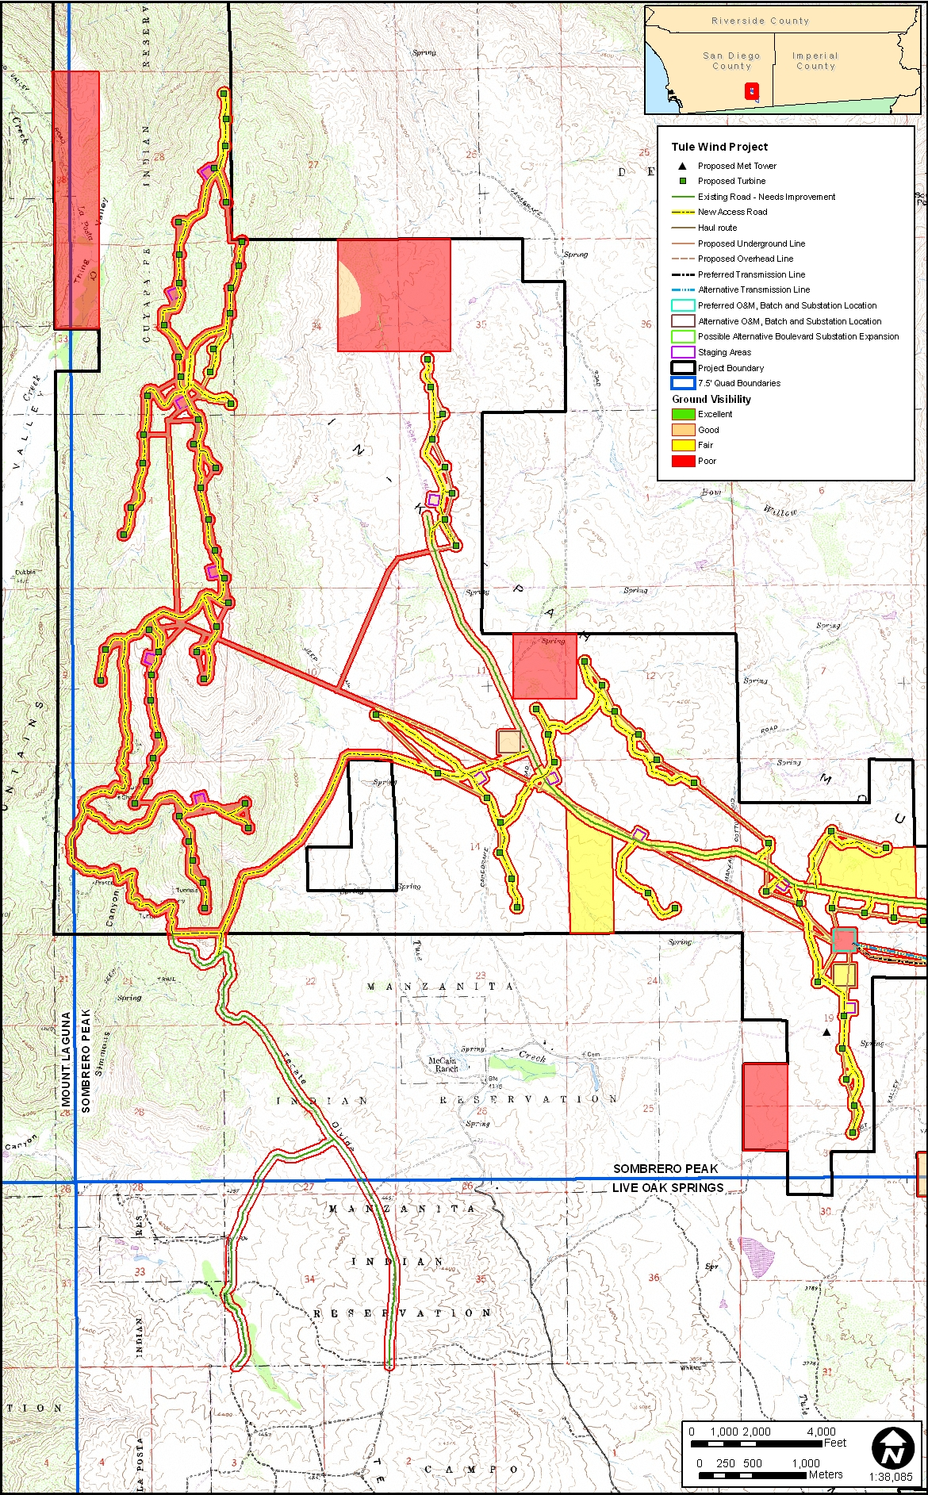

Figure 4.2a Map characterizing ground visibility and showing the locations of areas not surveyed.

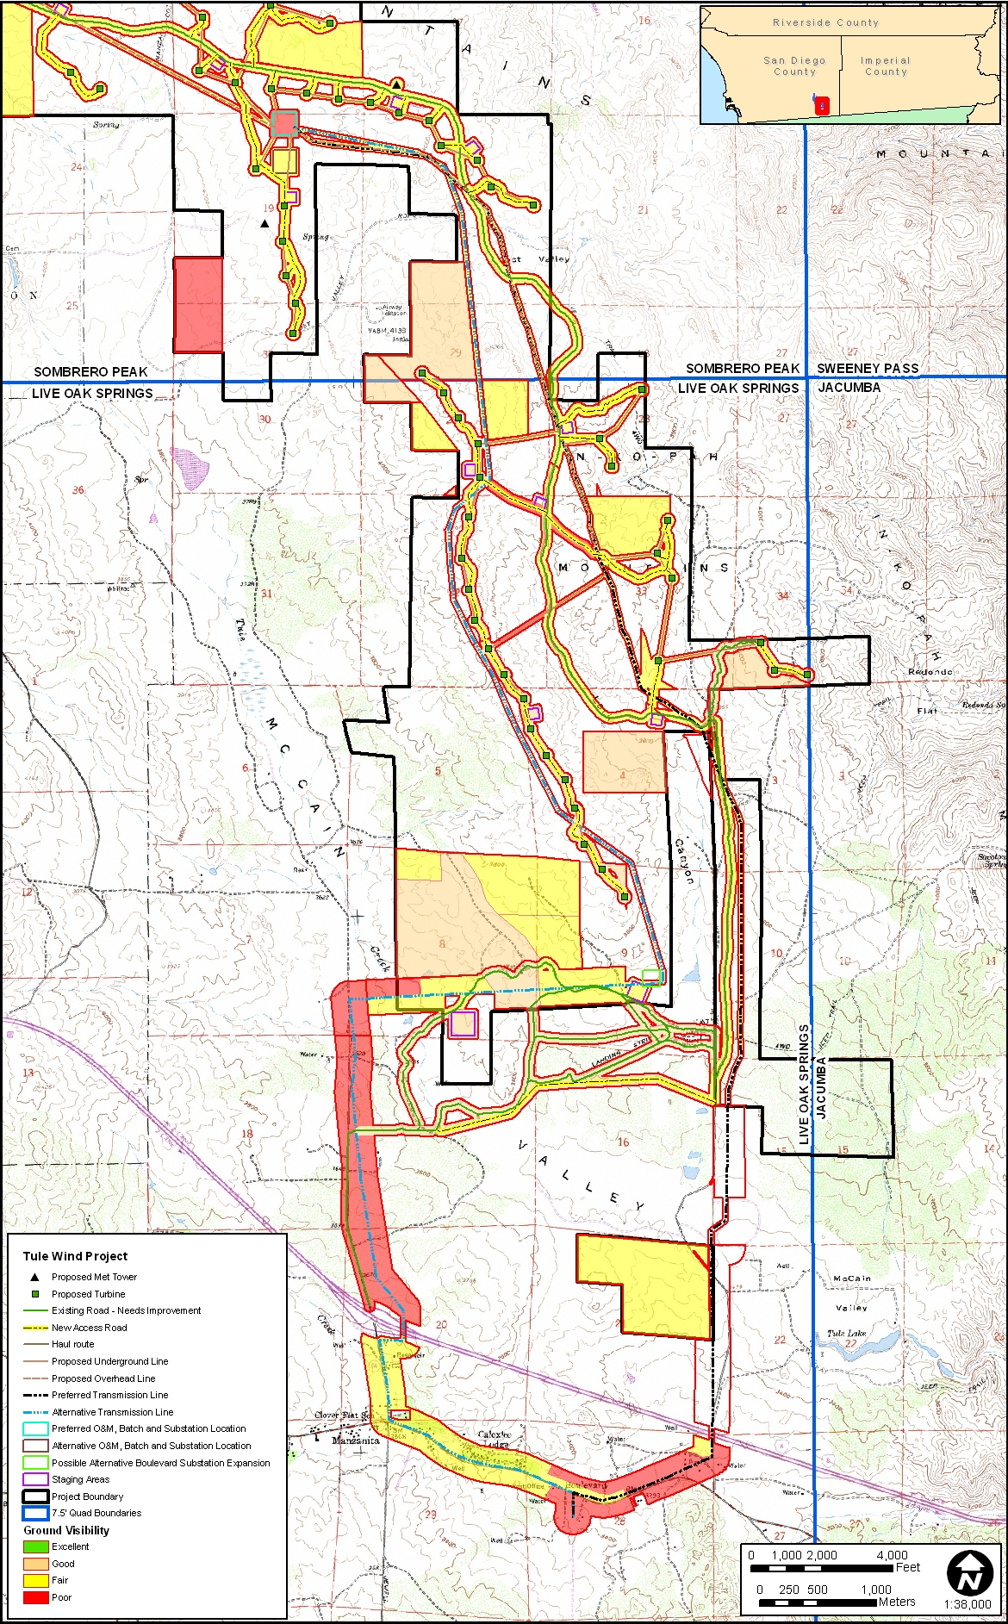

Figure 4.2b Map characterizing ground visibility and showing the locations of areas not surveyed (continued).

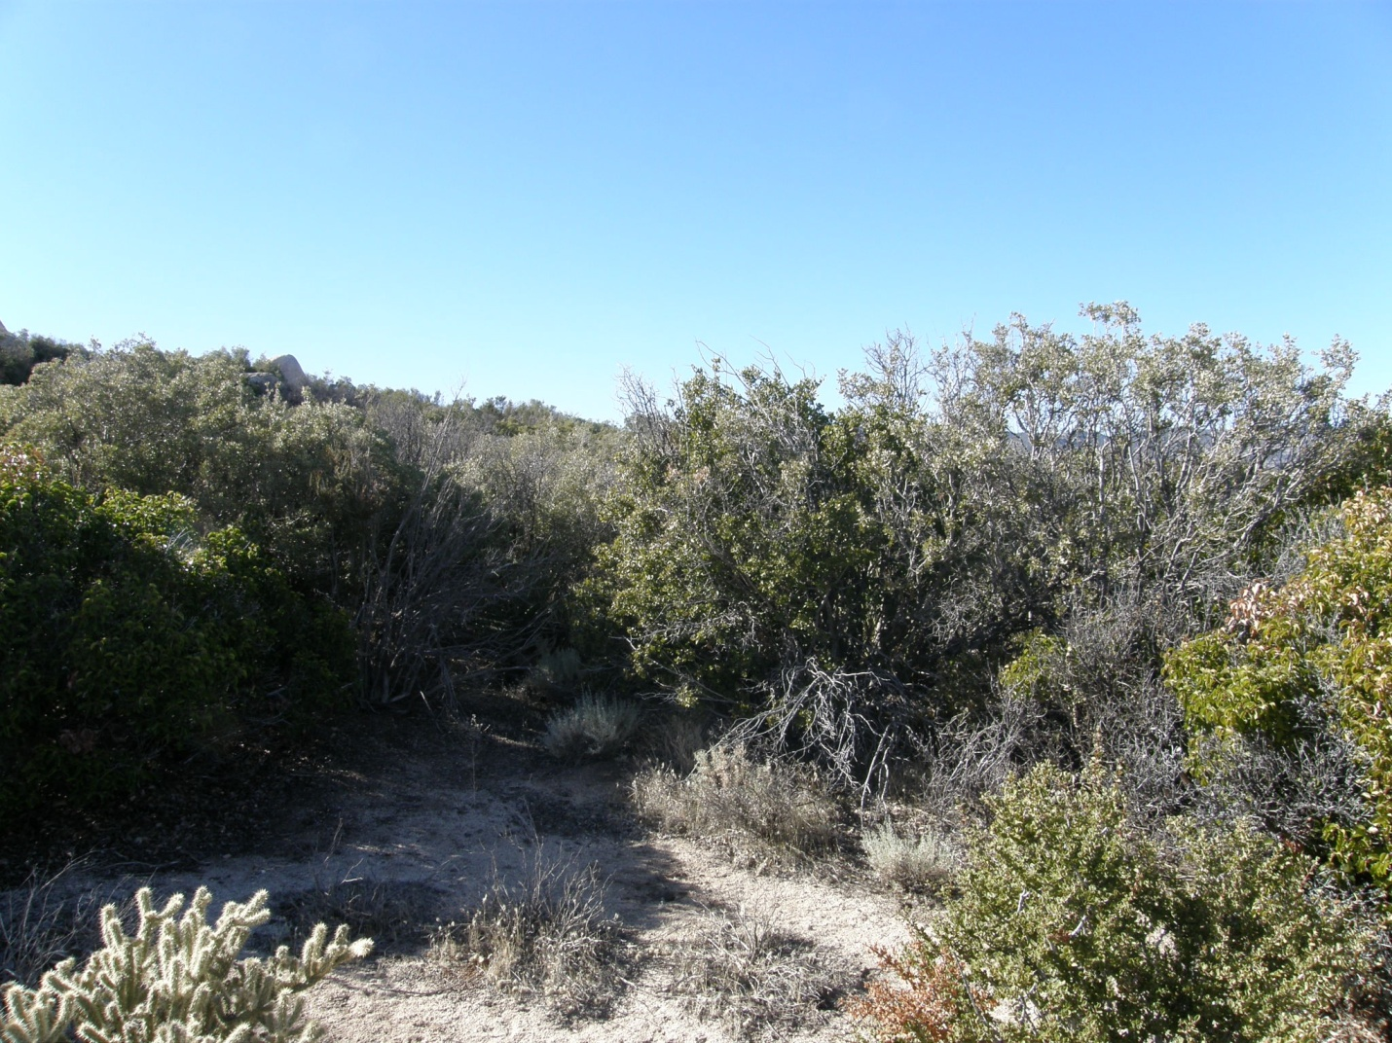

Figure 4.3 Overview of survey area with dense vegetation.
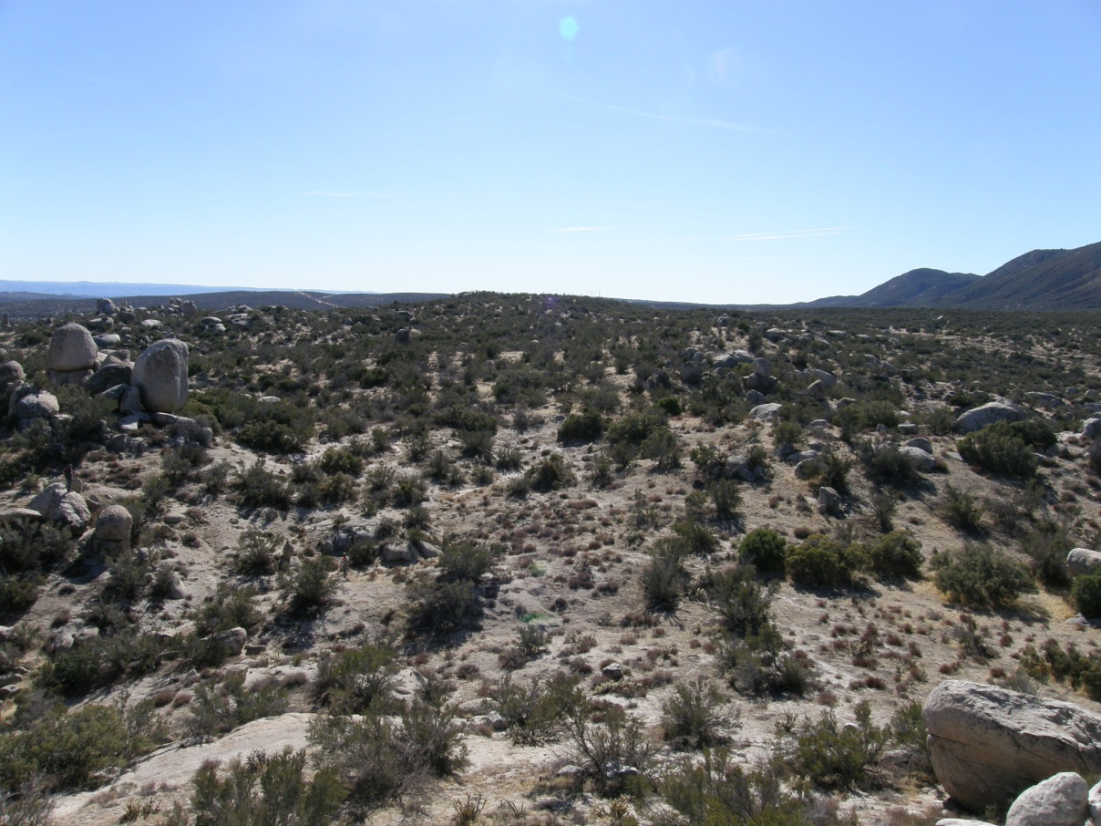

Figure 4.4 Overview of survey area showing typical field conditions and fair visibility.
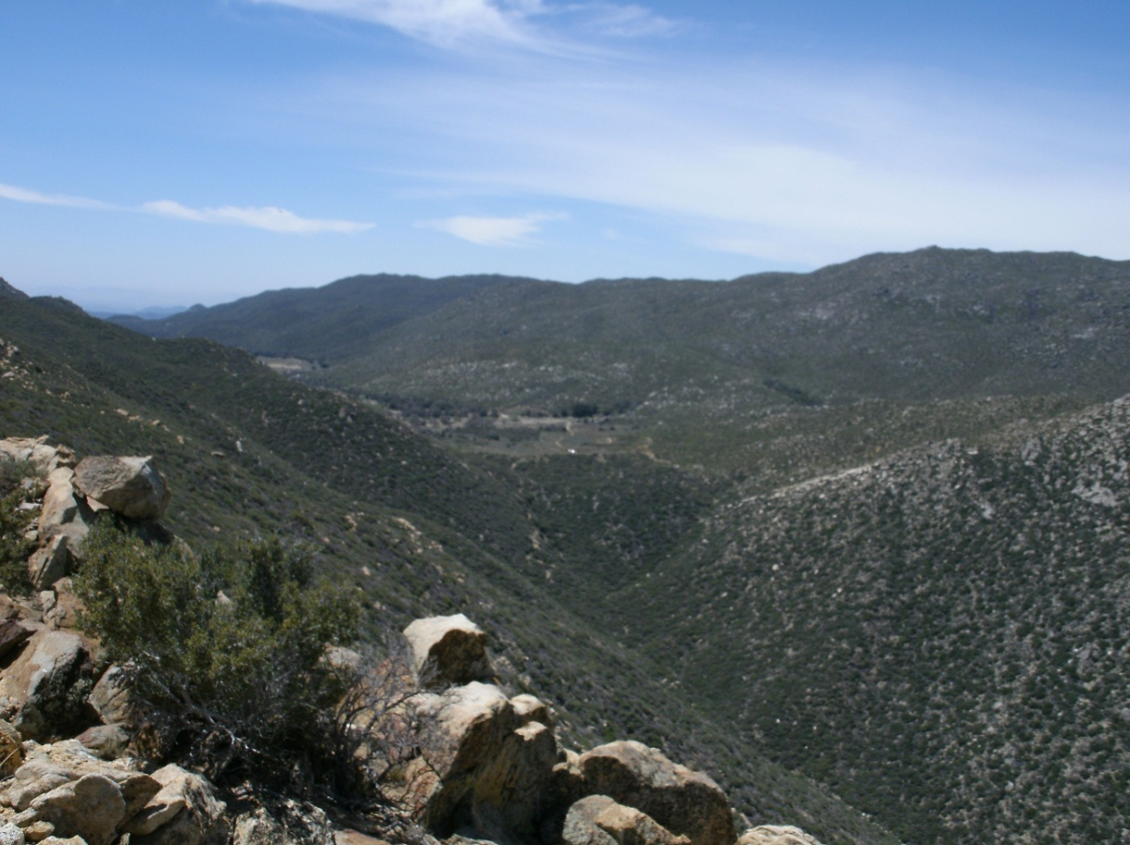

Figure 4.5 Overview of steep slopes with dense vegetation in northwest ROW.
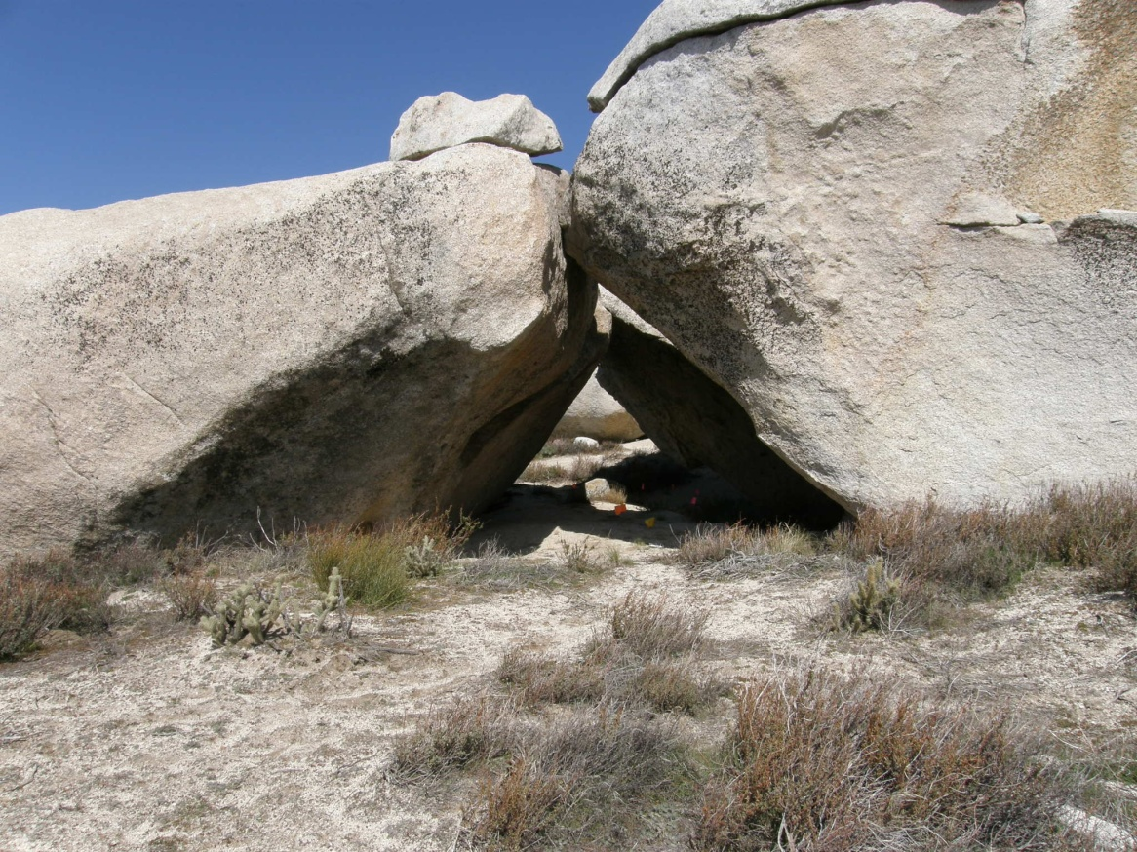

Figure 4.6 Overview of a rock shelter from SDI-7154; these are common features in the project APE.

4.2 SITE DESCRIPTIONS: CLASS III INVENTORY
The Class III inventory resulted in the documentation of 108 archaeological sites, of which, 68 are newly recorded. Some of the larger sites span Class III and Class II inventory areas (see Figures 4.1a-4.1d).

4.2.1 Class III: Previously Recorded Archaeological Sites

SDI-1151
This site is located near McCain Valley Road. It was originally recorded in 1969 by the Pacific Coast Archaeological Society and later updated by ASM in 2006. The site contains at least five milling stations and a small scatter of lithics and ceramics. Previous records indicate that the site has been subject to significant illicit collecting over the years. The current survey noted an area of potential midden soil with a small artifact scatter at the east end of the site beyond the original site boundary. Newly recorded artifacts include eight flakes (five metavolcanic, three quartz) and five brownware ceramic sherds. The newly recorded artifacts were found in a circular area surrounded on all sides by dirt roads. The site is presently recorded to cover a 50-x-27-m area. This site has low data potential due to its condition and remaining attributes and does not appear to meet the criteria for NRHP eligibility.

SDI-4788
This site was first recorded and surface collected in 1973 by the BLM. It has been updated several times since then. The site reportedly covers a 670-x-160-m area along McCain Valley Road. Currently the site is defined by a light lithic scatter and a milling station as reported in 2009 by ASM. It is unclear whether or not the distribution of artifacts is part of the original deposit or if it is due to road construction/maintenance and/or other modern activity in the area. Given the high frequency of road maintenance, it is more likely that artifacts have been redistributed several times along the shoulder of McCain Valley Road. As such, formal evaluation would likely result in a determination that the site does not meet the criteria for NRHP listing due to poor integrity and meager cultural deposits.

SDI-6897
This site was originally recorded by Chase in 1979 as containing four ceramics and eight basalt flakes located on the east slope of a small hill. During the current survey ASM updated the site to include 14 metavolcanic flakes, three quartz flakes, eight ceramics and one grey chert cottonwood projectile point. The site boundary was also extended to the south to incorporate the additional flakes. The site now covers a 90-x-50-m area. However, no midden soil was identified during any of the recording phases and little potential for substantial buried deposits exists. The site has low data potential and is not likely to meet NRHP eligibility criteria.

SDI-6900
This site was originally recorded by Chase in 1979 as a single bedrock milling station with two mortars. Brian F. Smith and Associates (BFSA) relocated the site in the same condition and location in 2003. During the current survey, ASM recorded one additional slick and a possible abandoned mortar on the same milling station. In addition, a historic component was also recorded. Although the site forms make no mention of it, there is a historic can and glass dump adjacent to the milling station and a possible prospecting pit about 20 m to the south. Cans include hole-in-top, rotary-opened sanitary, oblong knife-cut and key-strip, oval internal friction, and rotary-opened hole-in-top, among others. One sun-colored amethyst glass fragment, one bottle base and 400+ glass shards were also observed. The site is currently recorded as covering a 60-x-55-m area. No evidence of midden soil or the potential for substantial buried deposits was identified. The site has low data potential does not appear to meet the criteria for NRHP eligibility.

SDI-7150
This site was originally recorded in 1979 by Jackson Underwood as a 4-x-4-m rock shelter with a scatter of ceramic sherds and debitage. This site was revisited and updated in 2006 by ASM and at this time they noted that the site had been impacted by off-highway vehicle (OHV) use and that a weakly developed and highly disturbed midden was present along with a single flake and Tizon brownware sherd. The site was again revisited by ASM for the current survey and the site was found to be in the same disturbed condition as described in 2006. However, there were no artifacts visible on the surface during the current survey. The presence of midden soil indicates that the site has relatively moderate to high data potential and may meet the criteria for NRHP eligibility under Criterion D.

SDI-8388 (Not Relocated)
This site was originally recorded by Vernon in 1974 as a light density artifact scatter including ceramics and lithic debitage. In 2006 ASM was unable to relocate the site and determined that Vernon probably misidentified the location of the site. During the current survey, ASM was again unable to relocate the site.

SDI-8705 (Not Relocated)
This site was recorded by Tom Cable in 1981 as an artifact scatter consisting of one pot sherd, nine flakes, and one handstone fragment spread over a 200-x-175-m area. During the current survey, ASM was unable to relocate this site. It is possible that OHV activity in the area may have impacted the site as there is extensive evidence of off-road traffic within the vicinity of this site. It is also possible that this site may have been mapped incorrectly.

SDI-9223/17816
This site consists of two separate previously recorded sites. SDI-9223 was originally recorded by Pat Welch in 1982 for the BLM. It includes 100+ ceramics, 60+ flakes, one hammerstone, one projectile point and one milling station with two slicks. SDI-17816 was originally recorded in 2006 by ASM as a small lithic and ceramic scatter. During the current survey ASM relocated both of these sites and updated them to include additional milling stations at each site and a dispersed lithic and ceramic between them, subsequently uniting the two sites into one over a 480-x-90-m area. Overall, the combined site SDI-9223/17816 now contains a total of nine milling stations. An ephemeral drainage runs west-to-east through the site at the northern edge of the original boundary of SDI-9223. SDI-9223 is now recorded as Locus B. The original artifact counts were generally accurate, however while expanding the site to include additional milling stations to the east additional artifacts were observed. These include: 59 brownware ceramics and nine lithic debitage. Locus A (SDI-17816) is located immediately north of Locus B on the north side of the drainage. Locus B includes 23 brownware fragments, three buffware fragments, four quartz debitage and 15 metavolcanic debitage. Newly recorded non-locus artifacts north of the drainage include 21 ceramics, 41 metavolcanic debitage, 23 quartz debitage and three obsidian flakes. A dirt road/OHV trail runs north-south through the center of the site. The vast majority of artifacts are located west of the dirt road. Patches of midden soils were observed in several places. Based on surface data alone, this site does appear to have enough data potential to be considered eligible for NRHP listing under Criterion D and may contain buried cultural deposits.

SDI-9225
This site was originally recorded by Pat Welch of the BLM in 1982 as containing a rock shelter, two milling stations and an artifact scatter of flakes, ceramics, handstones, millingstones, a hammerstone, a core, retouched flakes and burned bone. The majority of artifacts were reported to be located south of the rock shelter, between two large bedrock outcrops. During the current survey, the rock shelter and milling stations were relocated, as was the dense artifact scatter to the south. Two additional milling stations and a light, dispersed artifact scatter were also recorded. The newly recorded artifact scatter extends the site boundary to the north onto the south and east slopes of the next hill. Artifacts recorded at the site consist of 28 brownware ceramics, 42 metavolcanic flakes, 22 quartz flakes, a millingstone and three handstones. In all, the site measures approximately 200 x 150 m. OHV activity is an ongoing disturbance to the site and it is possible that this site is actively looted. The site appears to be in similar condition as previously reported, even though some of the tools were not relocated. This site is considered to have relatively low data potential given the low probability for substantial buried cultural deposits. As such, the site is not likely to meet the criteria for NRHP eligibility following formal evaluation.

SDI-9228 (Not Relocated)
This site was originally recorded by Pat Welch in 1982 for the BLM as including approximately 20 Tizon brownware ceramic sherds. During the current survey, no ceramics could be found at either the mapped location nor the UTMs listed in the site form. A single metavolcanic flake was found in the mapped location.

SDI-10331 (Not Relocated)
This site was originally recorded in 1979 by the BLM as consisting of one core, three scrapers, flakes, brownware and buffware ceramics, and milling slicks in an approximate 100-x-150-m area. While revisiting the site for the current survey, only two brownware sherds and three flakes were observed in an approximate 100-x-100-m area, meaning that it fails to qualify as an archaeological site. For this reason, the site is considered not relocated. In fact, no cultural material was discovered within the project APE.

SDI-10359
This site was originally recorded by the BLM in 1979. Cultural constituents recorded in 1979 included flakes, ceramics, a handstone, two basins and a slick. During the current survey the site was relocated and expanded. Newly recorded cultural constituents include five new milling stations (one mortar and four slicks), 13 metavolcanic flakes, eight pieces of quartz debitage and two brownware sherds. The site now covers a 325-x-150-m area. The site expansion extends down slope to the west and south. The majority of the site is located on top of a large hill overlooking Tule Creek and McCain Valley. Numerous large granitic outcrops are present on top of the hill. Vegetation includes cholla, scrub oak, sage brush, chamise and grass. Live oak trees are present about 100-150 m southwest of the site. The southern portion of the site contains light brown alluvial silty sand and may have patches of midden deposit. Decomposing granite makes up the soil matrix on top of the hill. This site has relatively high data potential and appears to be eligible under Criterion D for NRHP listing.

SDI-10596 (Not Relocated)
This site was originally recorded by CRM Center at SDSU in 1986. The site consists of one bedrock milling station with two slicks and a light artifact scatter covering a 250-x-125-m area. No midden soil was found at the site. Although a small portion of the mapped site boundary crosses into the current project APE, ASM did not locate any artifacts within the APE during the current survey. It is possible that the actual site boundary is north of the mapped area as the site record mentions that the site dimensions are only approximate.

SDI-16786
This site is a historic trash scatter with glass and ironstone that was tested by BFSA in 2003 and recommended as not eligible for NRHP listing. In 2010, ASM relocated the trash scatter but only a few glass fragments were observed on the ground surface. Presumably, the evaluation conducted by BFSA removed most cultural material from the surface. The site covers a 106-x-45-m area. The previous evaluation by BFSA apparently exhausted the site’s research potential and ASM found no evidence during the current survey that additional cultural deposits remain at the site. This site has low data potential and does not appear to meet the criteria for NRHP listing.

SDI-16824
This site was originally recorded in 2003 by BFSA. The site contains a historic foundation in poor condition, a well, and a dispersed scatter of ironstone, glass, and cans covering a 100-x-80-m area. ASM relocated the site in 2010 in the same general condition and location as previously recorded and no evidence was found of substantial buried cultural deposits. Pending formal evaluation, this site is not likely to meet the criteria for NRHP eligibility due to low data potential.

SDI-16827
This was originally recorded by BFSA in 2003 to include a historic trash scatter, a concrete trough and a concrete foundation. During the current survey ASM relocated the site and found it to be in the same general location and condition as previously reported. However, the size and shape of the site were updated to reflect its current condition. The trough and foundation are located adjacent to each other near the northwest corner of the site. The artifact scatter, which is very light and highly dispersed, spreads out to the south and east. The site extends east to within about 20 m of McCain Valley Road. Artifacts include dozens of small amethyst and cobalt glass fragments, barbed wire fencing, a mattress spring, sanitary cans, fuel cans and unidentifiable metal. There is also a small disarticulated pile of milled wood which likely is the remains of a windmill. An abandoned dirt road runs through the site in a U-shape. Vegetation at the site consists of oak trees, sagebrush, sugarbush, scrub oak, grass, buckwheat and yucca. Soil consists of alluvial light brown silty sand and decomposing granite and is unlikely to contain a buried cultural deposit. This site has low data potential and does not appear to meet NRHP eligibility criteria.

SDI-17118
This site was originally recorded in 2004 by Tierra Environmental Services as containing two ceramic sherds and one flake covering a 10-x-30-m area. In 2006 ASM relocated the site and suggested that the site should have been recorded as two isolates. During the current survey the site was relocated and found to be in the same location and condition as reported in 2006. There is no indication of buried cultural deposits or midden soil. Based upon the current criteria for site definition, this artifact scatter is considered an archaeological site, but it has low data potential and does not appear to meet the criteria for NRHP eligibility.

SDI-17119
This site was originally recorded in 2004 by Tierra Environmental Services to include four ceramic fragments. ASM updated the site in 2006 to include two additional ceramics. During the current survey ASM found the site to be in the same condition as in 2006, however the mapped location was updated slightly. Given that the site only contains a small number of pot sherds, it does not appear to meet NRHP eligibility criteria.

SDI-17815
This site was originally recorded by ASM in 2006 to include 11 pieces of debitage in a 11-x-7-m area. The site was relocated during the current survey and found to be in the same location and condition. The dearth of cultural material and lack of evidence for subsurface deposits means that this site is not likely to be eligible for NRHP listing.

SDI-17817
This complex habitation site was recorded by ASM in 2006 as covering a 270-x-150-m area and containing approximately 100 milled surfaces, approximately 150 pottery fragments, and 70 pieces of lithic debitage. The site is noted as having poor integrity as portions of it have been disturbed by heavy equipment used to build a campground, likely exposing archaeological deposits to looting. In 2009, ASM recorded a small expansion to the site that was confirmed during the current survey. Despite the fact that soils are limited in most areas, patches of midden soil were observed in various places across the site and there is a moderate potential for the presence of substantial buried deposits, indicating that the site is likely to be eligible for NRHP listing based on Criterion D.

SDI-17822
This site contains one bedrock milling station with seven slicks associated with 12 metavolcanic flakes, two ceramics, and one handstone, covering 35-x-30-m area. The site boundary is within 10 m of McCain Valley Road. Due to abundance of exposed bedrock in the site limits, a subsurface deposit unlikely. ASM recently recorded the site in 2005, and it was relocated and updated for the current survey. This site has low data potential it does not appear to meet the criteria for NRHP listing.

SDI-17829
This site was originally recorded in 2005 by ASM and then relocated in 2009 by ASM for the current survey. The site includes eight metavolcanic flakes and one obsidian projectile point (unknown type) covering a 13-x-11-m area along the edge of McCain Valley Road. No midden soils were identified and, given exposed bedrock on the surface it is unlikely that subsurface cultural deposits are present. This site has low data potential and does not appear to meet the criteria for NRHP listing.

SDI-17830
This site was originally recorded by ASM in 2005 to include four ceramics sherds, four flakes and a Cottonwood projectile point covering a 22-x-6-m area. In 2009 ASM revisited the site and was able to identify five ceramic sherds but none of the lithic artifacts. During the current survey ASM relocated the ceramic sherds but was again unable to relocate the debitage. Recent installation of a drainage pipe under McCain Valley Road may have impacted the site. A subsurface deposit at this site is unlikely and the site is considered to have low data potential. This site has low data potential and does not appear to meet the NRHP eligibility criteria.

SDI-18050
This site, originally recorded in 2006 by ASM, and relocated during the current survey, was determined to be in similar condition as it was originally described. The site contains a light artifact scatter consisting of one handstone, one hammerstone and 10 buffware ceramic fragments covering a 10-x-3-m area. The site is located on deflated coarse granitic sand with shallow bedrock exposed in various places near the site. No midden soil was identified and it is unlikely that substantial buried cultural deposits are present at the site. This site has low data potential and does not appear to meet the criteria for NRHP eligibility.

SDI-18054
This site was originally recorded in 2006 by ASM to include 16 Tizon brownware ceramic fragments in a 15-x-12-m area. During the current survey, the site was found to be in the same general condition and location. This site is not likely to be eligible for NRHP listing due to the dearth of cultural material and because the site has a low potential for substantial subsurface cultural deposits.

SDI-18993
This site was originally recorded in 2008 by the US Army Corps of Engineers (USACE). The site consists of a historic-period refuse deposit, including 25-50 metal cans and fragments, one ceramic sherd, and five amethyst glass fragments which date as early as 1930. The site covers a 15-x-11-m area. During the current survey ASM relocated the site and found it to be in the same location and condition as previously reported. This site has low data potential and does not appear to meet the NRHP eligibility criteria.

SDI-18994
This site is a historic-period refuse deposit dating as early as 1930’s to 1950’s. This site was originally recorded by the USACE in 2008 and it consists of less than 50 metal cans and fragments, 50 clear glass fragments, and one white ceramic dishware sherd covering a 27-x-13-m area. During the current survey ASM relocated the site and found it to be in the same location and general condition as previously reported. This site has low data potential and does not appear to meet NRHP eligibility criteria.

SDI-19000
This site was originally recorded by SWCA in 2007 for the Sunrise Powerlink Project. The site consists of a dispersed artifact scatter covering a 56-x-35-m area. During the current survey ASM found the site to be in the same location and general condition as previously reported. Artifacts include 29 brownware ceramic sherds, five metavolcanic flakes, and five quartz flakes. The only change observed at the site was that a few of the ceramics were observed to have been washed down slope to the east. A few vehicle tracks were also observed to have crossed the site, but appear to have only caused minor damage. Vegetation includes scrub oak, mountain mahogany, sugarbush, cholla, yucca whipplei, grass and buckwheat. Soil at the site consists primarily of decomposing granite with some light brown silty sand with low potential for a buried cultural deposit. This site ha slow data potential and does not appear to meet the NRHP eligibility criteria.

SDI-19001/19003
SDI-19001 and SDI-19003 were originally recorded by SWCA for the Sunrise Powerlink Project in 2007. According to the site form, at SDI-19001 there are nine milling stations containing 17 milling surfaces (slicks and mortars), approximately 1,000 pieces of lithic debitage (quartz and metavolcanic), one core, two bifaces, three handstones, one pestle, and ~1000 ceramic sherds. Midden soil may be present in at least two areas, with the entire site covering a 280-x-170-m area. Currently, the site was found to extend beyond the recorded site boundary to the northeast; however that portion of the site is located on private property to which SWCA did not have access at the time. The property line, as delineated by a barbed wire fence, was used as an arbitrary boundary for the site. ASM updated the site while surveying for the Sunrise Powerlink Project in 2009 (Figure 4.7 and 4.8). A light lithic and ceramic scatter was recorded that extends the site boundary to the southeast. SWCA also recorded SDI-19003 as including three rock shelters, and a small lithic and ceramic scatter. For the current project, ASM recorded an additional update to SDI-19001 which united the two sites into one. This expansion includes a small area south of the barbed wire fence and a large area north of the fence on the private land. This expansion includes 16 milling stations, one rock circle and one rock shelter. Newly recorded artifacts include 1,000+ceramics (dozens of which are burned), three etched brownware ceramics, 1,000+ flakes (primarily metavolcanic and quartz with small amounts of obsidian, basalt and chert), two side-notched projectile points, one biface, 15+ handstones, and nine millingstones. Two new concentrations and three new loci were delineated.

Concentration 1 is a small, 30-x-30-m concentration of flakes and ceramics in a small clearing on the east side of the site. Artifacts in the concentration include 25+ ceramics, 40+ flakes and one millingstone fragment. Although the density of artifacts in this concentration is not particularly high compared to most of the site, it is significantly higher than in the immediate surrounding area.

Concentration 2 is located along the north side of the fence at the bottom of the hill below a rock shelter. Concentration 2 is a very dense ceramic scatter (400+ sherds) with 100+ lithics, burned bone fragments and a chert Desert Side-notched projectile point. This concentration covers an approximate 40-x-30-m area.

Locus A comprises the northeast portion of the site. A large granite ridge runs north south through the center of the locus. The majority of the artifacts are split between a small, 30-x-70-m clearing in the middle of the ridge to the bottom of the slope to the southeast. Artifact densities drop significantly on the west and northeast sides of the ridge. Artifacts in this locus include 250+ flakes, seven handstone fragments, two cores and one side-notched projectile point.

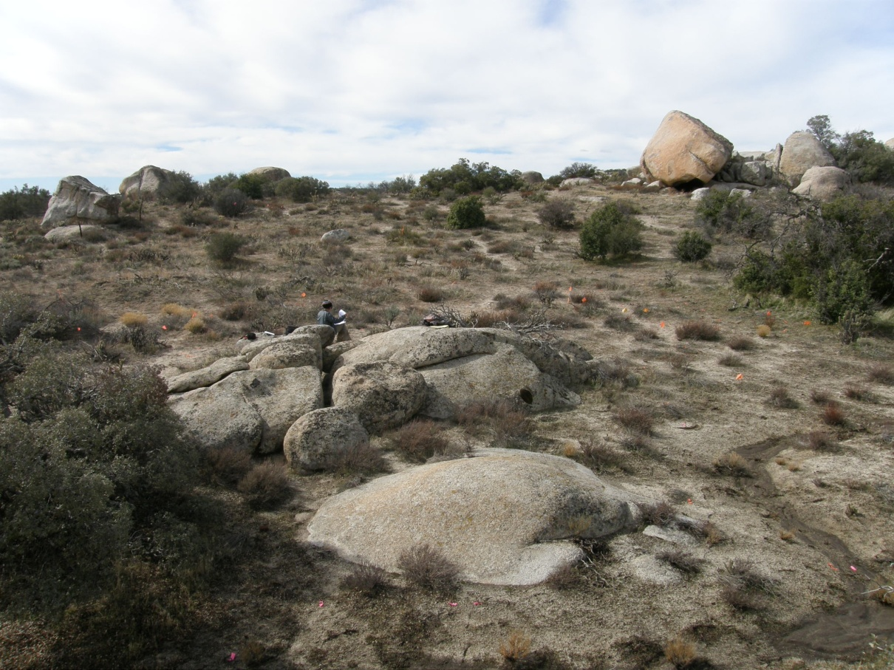

Figure 4.7 Overview of SDI-19001/19003 with a rock shelter in the background.
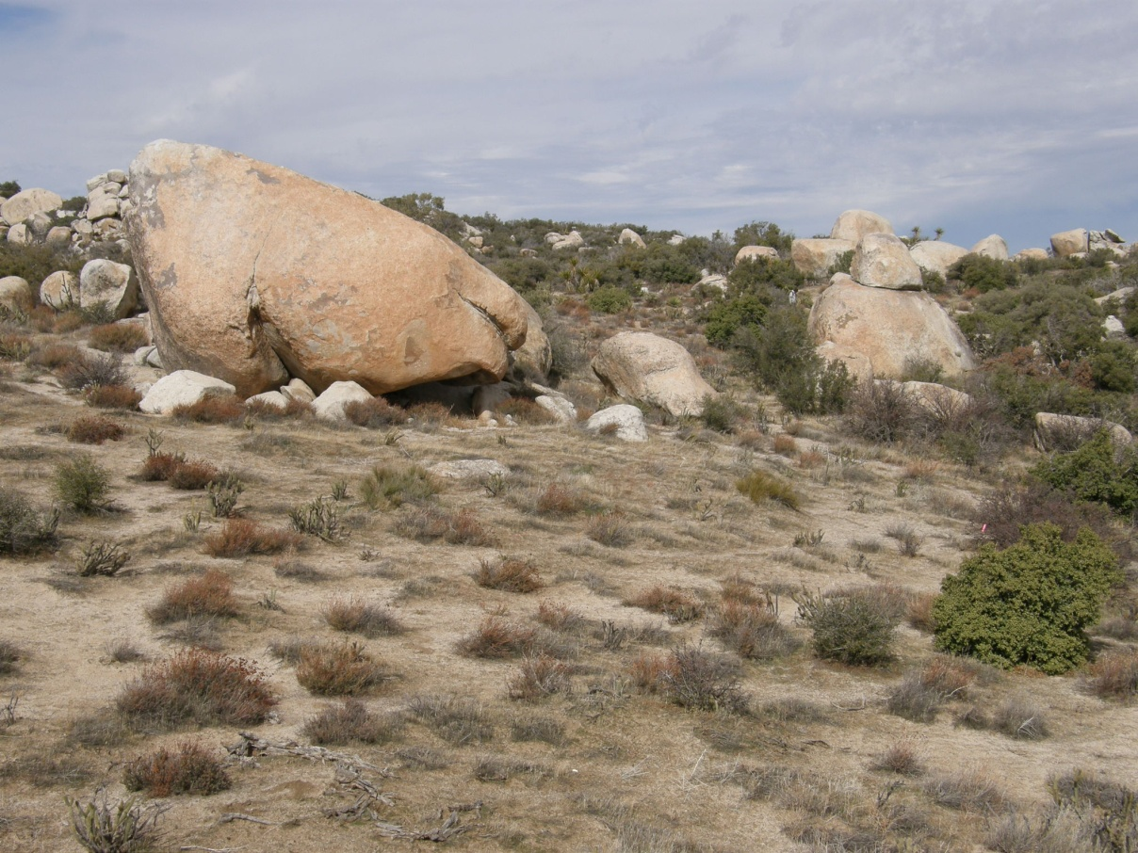

Figure 4.8 Overview of rock shelter in Concentration 3 at SDI-19001/19003.
Locus B comprises the northwest corner of the site. It is situated on an east-facing slope above a large creek. Bedrock outcrops are present at the east and west sides of the locus, but only one milling station was identified (#25). The locus consists of 100+ flakes, and three handstone fragments.

The newly recorded rock shelter is a small opening underneath a single large granite boulder (Figure 4.9). The roof and walls of the cave have been heavily charred, particularly in the rear of the cave. Dark brown midden soil is present in the cave and extends down the slope for at least 20 m. Five calcined large mammal bone fragments were also recorded approximately 20 m east of the rock shelter, however due to their small size none could be positively identified as to species. These calcined bone fragments may be cremated human remains.

In all, with SDI-19001 and SDI-19003 combined, the site now covers an approximate 850-x-370-m area. The soil at the site is predominately light brown silty sand with decomposing granite. Large, granite bedrock outcrops and boulders are present throughout the site. Two large drainages run north/south through the site with numerous smaller tributary washes. Aside from rodent burrowing and erosion, disturbances to the site have been minimal; only one dirt bike track was observed through the southeast portion of the site. However, illicit artifact collection has occurred at the site, as indicated by a sifting screen located adjacent to the rock shelter. The dense cultural deposits at this site have high data potential and this site appears to be eligible for NRHP listing under Criterion D.
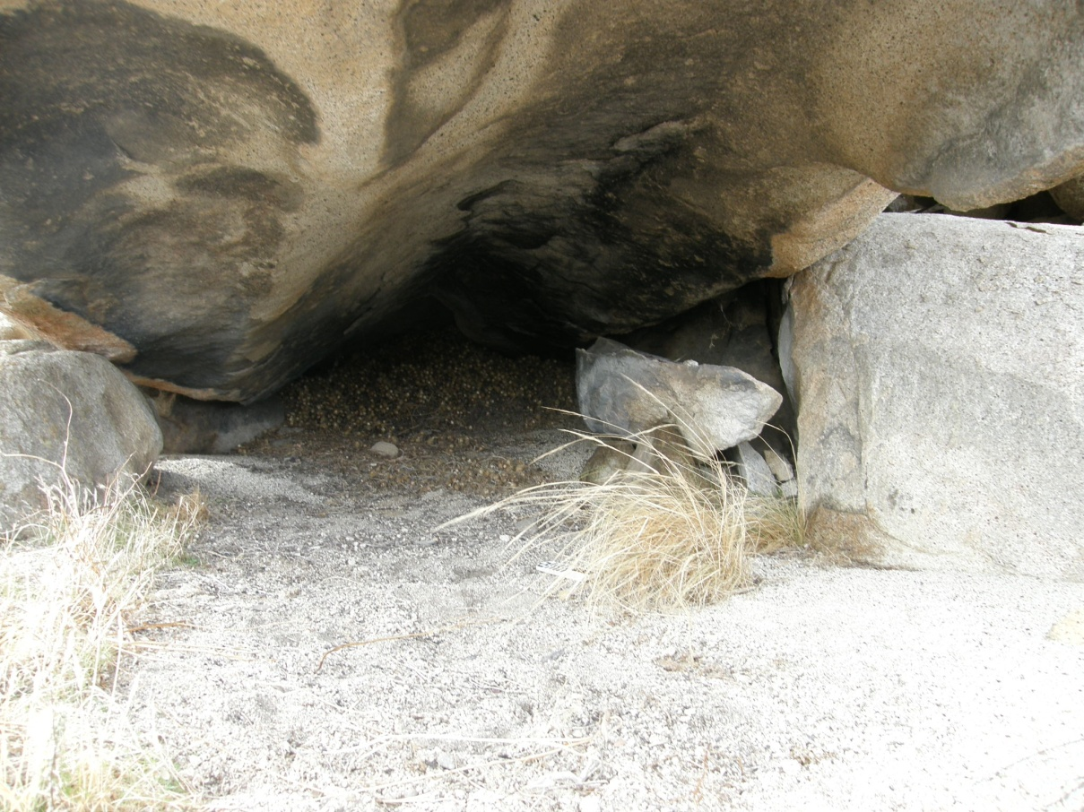

Figure 4.9 Close-up of rock shelter in Concentration 3 at SDI-19001/19003, note soot on rock ceiling.

SDI-19002
This artifact scatter was originally recorded by SWCA in 2007 as including 11 brownware ceramics, 13 flakes, and one quartz biface. During the current survey ASM expanded the site to the east and south. Most original items were relocated and newly recorded artifacts include three handstones, 14 quartz debitage, 11 metavolcanic debitage and one brownware ceramic fragment. The majority of the expansion extends down slope to the south, crossing a small drainage and continuing to the ridge of small hill. To the east, the site extends about 20 m beyond the originally recorded boundary. Nine of the newly recorded debitage in this area (seven quartz and two metavolcanic) are located in a small concentration near the southwest corner of the site. The remaining debitage are evenly distributed throughout the site. Soil consists of alluvial light brown silty coarse sand. No midden soil was observed and there is little potential for substantial buried cultural deposits. SWCA’s inference regarding buried deposits, based on the presence of a partially buried ceramic fragment, is not strong evidence and is countered by the presence of shallow and exposed bedrock outcrops within and surrounding the site. The site is sparsely vegetated with ephedra, cholla, buckwheat, scrub oak, cacti and grass, allowing for good visibility. The site now covers a 130-x-750-m area. Despite its size, this diffuse artifact scatter is not likely to yield substantial data on cultural deposits and will not likely meet the criteria for NRHP eligibility.

SDI-19018
This site was originally recorded in 2007 by SWCA, and later updated in 2009 by ASM for the Sunrise Powerlink Project. The site contains seven milling stations with 18 slicks, two mortars and 13 cupules, thousands of flakes and hundreds of ceramics covering an area 120-x-90-m. During the current survey ASM relocated the site and found it to be in the same location and condition as previously recorded. Although no midden soils were identified, there are pockets of soil associated with relatively higher surface artifact densities, indicating that there is moderate potential for buried cultural deposits. For this reason, the site may meet the criteria for NRHP eligibility.

SDI-19045
This site was originally recorded in 2007 by SWCA and later updated in 2009 by ASM for the Sunrise Powerlink project. It consists of a light artifact scatter of nine flakes, two cores, and one brownware ceramic fragment covering an approximate 140-x-75-m area. During the current survey ASM found the site to be in the same location and condition as previously reported. This sparse artifact scatter is spread over an area with shallow and exposed bedrock overlain by coarse granitic sand. No midden soil was identified nor were areas with a high potential for substantial buried cultural deposits. This site is not likely to meet the criteria for NRHP eligibility due to low data potential.

SDI-19291
This site was recorded in 2008 by Gallegos and Associates for the Sunrise Powerlink project as a low-density scatter of three brownware ceramic sherds in a 5-x-5-m area. During the current survey this site was relocated in the same location and condition as previously reported. The low density of this site, and because no evidence was found for midden soil or buried cultural deposits, indicates that this site does not appear to meet the criteria for NRHP eligibility.

SDI-19301
This site was originally recorded and later updated for the Sunrise Powerlink Project by ASM. The site consists of one milling station and a dispersed lithic and ceramic scatter covering a 130-x-45-m area. During the current survey ASM relocated the site and found it to be in the same location and condition as most recently reported, but artifacts were found to be spread over a 155-x-50-m area. In all, less than 50 pieces of ceramic and 25 pieces of debitage were identified. No evidence of midden soils was identified and the general vicinity has low potential for substantial buried cultural deposits. This site has low data potential and does not appear to meet the criteria for NRHP eligibility.

SDI-19364 (SPBB-S-1)
This site was originally recorded in 2009 for the Sunrise Powerlink Project as containing a dispersed lithic scatter, three projectile points and one handstone. During the current survey ASM relocated the site and discovered additional cultural material along the west side of McCain Valley Road spread over a 237-x-117-m area. Artifacts observed in the newly recorded area include one chert biface, one quartz serrated projectile point, one metavolcanic flake with battering, 110 quartz debitage (83 interior flakes, 26 shatter, one secondary), one basalt secondary flake, and 12 metavolcanic flakes (three secondary, eight interior, one shatter). A small deposit of whitish clay soil is present at the west end of the site on the north side of a confluence of two small drainages. This soil covers an area approximately 15-x-15-m and may be a source material for locally made ceramics. Approximately 20 m northeast of the clay is a small area of dark brown silty sand that may be a midden deposit spread over an approximate 20-x-20-m area. Including all areas, the site is currently recorded as covering a 280-x-237-m area. Vegetation is very dense chaparral including chamise, yucca, cholla, sugar bush, scrub oak, buckwheat and grass. Disturbances to the site appear limited to the construction of McCain Valley Road and brush clearing along the edge of the road for a fire break. The eligibility of this site is questionable, given that surface deposits are relatively diffuse. However, formal evaluation may find that this site is eligible for NRHP listing under Criterion D.

SDI-19849 (SDG&E-BC-37)
This site was originally recorded by ASM in 2009 for the Sunrise Powerlink Project. Artifacts recorded at the site include 34 brownware ceramic sherds and one quartz flake covering a 59-x-32-m area. During the current survey ASM relocated the site in the same location and condition. Bedrock is shallow in the immediate vicinity, covered with a thin layer of granitic sand and precluding the possibility of substantial subsurface cultural deposits, and indicating that this site has low data potential and does not appear to meet the criteria for NRHP.

SDI-19851 (SPED-S-5)
This site was originally reported by Laguna Environmental in 2004 (thought not recorded) and ASM recorded the site for the Sunrise Powerlink Project in 2009. The site consists of a light lithic and ceramic scatter on the south side of McCain Valley Road. Artifacts recorded at the site include nine pieces of lithic debitage, one scraper and one brownware ceramic covering an 84-x-24-m area. During the current survey ASM relocated the site in the same location and condition as previously reported. The site does not contain midden soil and no areas with the potential for buried cultural deposits were identified. The site has low data potential and does not appear to meet the criteria for NRHP eligibility.

SDI-19854 (SDG&E-BC-6, SPED-S-1)
This multi-component site was originally recorded in 2009 by ASM for the Sunrise Powerlink project. The site contains a lithic scatter and a possible historic can scatter covering a 39-x-25-m area. The site was revisited in 2010 by ASM and found to be in the same condition and location. No midden soil or areas with a high potential for buried deposits were identified. The site does not appear to meet the criteria for NRHP listing.

SDI-19857 (SDG&E-BC-9)
This site was originally recorded by ASM in 2009 for the Sunrise Powerlink Project. The site consists of one quartzite flake and two quartz shatter in a 2-x-1-m area. During the current survey ASM relocated the site and found it to be in the same location and condition as previously reported. No evidence of midden soils or areas that could contain substantial buried deposits was identified. The site has low data potential and does not appear to meet the criteria for NRHP eligibility.

SDI-19860 (SDG&E-BC-13)
This site was originally recorded by ASM in 2009 for the SDG&E Sunrise Powerlink Project. The site consists of a single milling station with five slicks covering a 3-x-3-m area. During the current survey ASM relocated the site in the same location and condition. No midden soil or areas that may contain substantial buried cultural deposits were identified. This site has low data potential does not appear to meet the criteria for NRHP eligibility.

SDI-19868 (SDG&E-BW-83)
This is a small, 40-x-20-m scatter of 14 metavolcanic flakes and one core that was originally recorded by ASM in 2009 for the Sunrise Powerlink Project. During the current survey, ASM relocated the site in the same location and condition as previously reported. No midden soils or evidence of buried deposits was identified. The site does not appear to meet the criteria for NRHP eligibility.

SDI-19869 (SDG&E-BW-84)
This site is an artifact scatter consisting of 19 flakes, two cores, one hammerstone and five brownware ceramic sherds spread diffusely over a 219-x-55-m area. The site was originally recorded by ASM for the Sunrise Powerlink Project and relocated during the current survey. The site was found to be in the same condition as it was originally recorded. No buried deposits or midden soils are indicated from surface deposits. The site is not likely to meet the criteria for NRHP listing.

SDI-19872 (SDG&E-BW-130)
This small scatter of 16 quartz flakes covers a 31-x-20-m area and was originally recorded by ASM in 2009 for the Sunrise Powerlink Project. The current survey found the site to be in the same location and condition as previously reported, and confirmed the lack of evidence for midden soil or buried cultural deposits. The site does not appear to meet the criteria for NRHP eligibility.

SDI-19935 (SDG&E-BW-128)
This site was originally recorded in 2009 by ASM for the Sunrise Powerlink Project. The site is a moderate density artifact scatter including 140 flakes, a hammerstone, a piece of polished bone, four handstones and two reworked flakes covering a 129-x-95-m area. During the current survey ASM relocated the site in the same condition and location as previously reported. The site did not exhibit signs of midden soil or buried cultural deposit, given the shallow bedrock underlying a thin veneer of granitic sands. The site has low data potential and is not likely to meet the criteria for NRHP eligibility.

37-024023
This is the historic Highway 80, which is listed on the NRHP. The highway runs through the southern margin of the Class III footprint, through the town of Boulevard. Survey crews noted the presence of the road but no updated mapping or description was necessary. Highway 80 was discussed and evaluated in a historic context prepared for the SDG&E Sunrise Powerlink project (see Ni Ghablain et al. 2010), finding that some segments of the highway are contributing elements to NRHP listing.

4.2.2 Class III: Newly Discovered Archaeological Sites

Tule-BC-01
This site consists of a single milling station on a small granite boulder with two slicks, measuring 3.4 x 1.9 m. No artifacts were found associated with the milling station. The site is located on a moderately sloping saddle between two hills. The saddle contains a few other small outcrops and boulders, all of which are highly exfoliated. Soils are light brown silty sand riddled with small rodent burrows. No midden soil was observed. No drainages are present in the immediate area. Vegetation in the area includes chamise, holly-leaf redberry, scrub oak, grass, buckwheat and cholla. The site has low data potential and does not appear to meet NRHP eligibility criteria.

Tule-BC-02
This site, covering an area of 60 x 40 m, contains one rock shelter with one milling station and a small artifact scatter. The rock shelter is likely a wind and or sun shelter as it does not have a roof. The floor of the shelter is a large, flat granite rock that also contains the milling station. The milling station consists of five slicks. Artifacts recorded at the site include one brownware ceramic, two metavolcanic flakes and one granite handstone. Large ephemeral drainages are located to the north and south of the shelter. The site is situated on the top of a hill marked by numerous granite boulders within a north-south trending ridgeline. Soils at the site consist of decomposing granite with some light brown silty sand. Vegetation includes red shank, cholla, buckwheat, scrub oak, and grass. The site has low data potential and does not appear to meet NRHP eligibility criteria.

Tule-BC-03
This site is a light artifact scatter with one milling station containing four slicks. The site dimensions are 69-x-45-m. Artifacts observed at the site include one metavolcanic core, two granite handstones, six metavolcanic interior flakes and one metavolcanic secondary flake. The milling station is located along the north bank of a wide, shallow ephemeral drainage. The artifacts are located about 30 m to the north of the milling station on a small, flat terrace. Highly exfoliated granitic outcrops and boulders are present throughout the surrounding area. Approximately half of the granitic bedrock has decomposed into coarse sand. The site is situated on a generally flat terrace on top of a north-south trending ridgeline. Light brown silty sand with decomposing granite is present at the north end of the site. This site has low data potential and does not appear to meet NRHP eligibility criteria.

Tule-BC-04
This site consists of a single milling station and one brownware ceramic sherd. The site is situated on the south-facing slope of a small hill on the east side of McCain Valley Road. Soil at the site consists of gravelly silt and decomposing granite. No midden soil was observed. Ground surface visibility was limited by dense vegetation and leaf duff, although intensive surface inspection did not reveal additional cultural material. Vegetation in the area consists of chamise, cholla, holly-leaf redberry, scrub oak and grass. The site is 5.4-x-1-m in size. This site has low data potential and does not appear to meet NRHP eligibility criteria.

Tule-BC-09
This site is a light artifact scatter contained in a 34-x-5-m area, located in the town of Boulevard. Artifacts observed include two quartz shatter, one chert shatter, one obsidian interior flake and one brownware ceramic sherd. The entire area surrounding the site has been highly disturbed by OHV activity, modern trash, and brush piles. Small, highly weathered bedrock outcrops are located about 20 m north of the site. Soil at the site is comprised of light brown sand underneath a thin layer of granitic sand. Vegetation in the area consists of sagebrush, grass, Mojave yucca and scrub oak. Live oak trees are also in the vicinity, primarily to the west. This site has low data potential and does not appear to meet the criteria for NRHP eligibility.

Tule-BC-10
This site is a light artifact scatter covering a 15-x-10-m area located between two earthen berms along State Route 94. Artifacts observed include one metavolcanic secondary flake, one quartz interior flake, one granite handstone and one brownware ceramic. The earthen berms are comprised of dark brown silty sand, suggesting that an intact cultural deposit may have been present at one time, although little evidence of remnant soils exists. The southern berm was likely created by the excavation of a drainage ditch which is located between State Route 94 and the southern berm. Vegetation includes sage brush and grass growing in coarse granitic sand. Numerous live oak trees are also located about 40 m north of the site. This site has low data potential and does not appear to meet NRHP eligibility criteria.

Tule-BC-12
This site consists of a dispersed artifact scatter and one milling station covering a 62-x-49-m area. The site is situated within a large granitic outcrop on the south slope of a small hill. A small east-west trending drainage is located on the south side of the site. Artifacts include three brownware fragments, two quartz shatter, one metavolcanic shatter, one quartzite interior flake, one metavolcanic planer and one metavolcanic hammerstone. Soil at the site is light brown coarse sandy silt combined with decomposing granite. All of the artifacts are located to the south of the milling station with the exception of two flakes that are located to the east. An OHV trail runs north-south on the east side of the hill at the edge of the site. Vegetation includes yucca, cholla, scrub oak, ephedra, buckwheat and chamise. The site has low data potential and does not appear to meet NRHP eligibility criteria.

Tule-BC-13
This site is a light, dispersed artifact scatter covering a 110-x-40-m area, located about 50 m west of McCain Valley Road. The ground surface is mostly flat, with a slight slope to the east. No bedrock outcrops are present in the immediate vicinity. The nearest drainage is located on the east side of McCain Valley Road. Artifacts recorded at the site include two millingstone fragments, one handstone fragment, 25 quartz flakes, four metavolcanic flakes and one chalcedony flake. Visibility was limited due to dense chaparral so additional artifacts may be present in the general vicinity, but it is unlikely that subsurface cultural deposits exist at the site due to extensive deflation. This site has low data potential and does not appear to meet NRHP eligibility criteria.

Tule-BC-14
This site is comprised of a light artifact scatter of 11 pieces of debitage and a granite millingstone covering a 30-x-30-m area. Lithics include chert, quartz and metavolcanic flakes. The site is situated on the top and west slope of a hill within a north-south trending ridgeline. A few small, highly exfoliated granitic outcrops are present in the surrounding area, particularly to the west. The soil matrix at the site is comprised of decomposing granitic sand covered by chamise, sage, cholla, and other cacti. The deflated context likely precludes the presence of subsurface cultural deposits. A large OHV trail runs north-south along the east side of the site, but little modern disturbance was evident. The site has low data potential and is not likely to meet NRHP eligibility criteria.

Tule-BC-15
This site is comprised of a single milling station with one slick on a highly exfoliated granitic outcrop that measures 12 x 6.7 m. The milling station is located on the west slope of a north-south trending ridgeline. Ephemeral drainages are present on both the north and south sides of the milling station. OHV tracks are present throughout the surrounding area. The soil matrix at the site is deflated, decomposing granite and vegetation is limited to shiny leaf yerba, sugar bush, grass, cholla and yucca. This site has low data potential and does not appear to meet NRHP eligibility criteria.

Tule-BC-16
This site is a dispersed lithic scatter with one possible biface. The site is situated on the eastern slope of a large hill, within a north-south trending ridgeline. Most of the artifacts are located in a small clearing with occasional granite outcrops located primarily to the west and north. Artifacts include one possible quartz biface, 50 pieces of quartz debitage and eight pieces of metavolcanic debitage. Soil at the site is light brown fine sand and decomposing granite; midden soils are not present. Site dimensions are 71 x 61 m. Vegetation in the area is classified as desert chaparral and includes cholla, buckwheat, shiny leaf yerba, scrub oak and red shank. No water sources are present in the immediate area. This site has low data potential and does not appear to meet NRHP eligibility criteria.

Tule-BC-17
This site is a light, dispersed lithic scatter with one biface covering an area of 94 x 71 m. The site is located on a mostly flat terrace below a large granite outcrop peak. No drainages are present in the immediate vicinity. The head of an east-trending ephemeral drainage begins about 80 m to the south. No bedrock outcrops are located in the site, however numerous outcrops and boulders are located to the north and west. Artifacts recorded at the site include one chert mid-stage biface, 25 pieces of quartz debitage, and three pieces of metavolcanic debitage. Light brown coarse sand and decomposed granite define the site matrix; no midden soils were identified and there is little potential for buried deposits. Vegetation includes cholla, scrub oak, sugar bush, red shank and grass. This site has low data potential and does not appear to meet NRHP eligibility criteria.

Tule-BC-18
This artifact scatter consists of two brownware fragments and one quartz shatter in a 33-x-8-m area; just enough cultural material to qualify as a site. The site is located on the eastern slope of a small hill defined by weathered granite bedrock overlain by a thin mantle of coarse granitic sand. No midden soils were observed and it is unlikely that buried cultural deposits are present. Vegetation is thin, but consists of chamise, cholla, and scrub oak with minimal understory. No drainages were observed in the vicinity of the site. This site has low data potential and does not appear to meet NRHP eligibility criteria.

Tule-BC-19
This site is a historic bottle and can dump dating to the early 1950’s and prior. The site is contained in a 15-x-15-m area and appears to represent a single dumping episode that has since been dispersed. Artifacts include 20+ beer bottles, wine bottles, food jars, a ketchup bottle, 40+ sanitary beer cans, five internal screw cylindrical cans, one fuel can, one meat can, five hole-in-top cans, and five oil cans. Almost all of the artifacts are whole. They have likely been preserved because a sugar bush has completely overgrown the deposit, except for a few cans that have been pushed or washed down slope. Maker’s marks on the bottles include Owens-Illinois (1953), Anchor-Hawking, Latchford Marble (1953), E&J Gallo (1952), Owens-Illinois (1951), and GC (1952). The site has low data potential and does not appear to meet NRHP eligibility criteria.

Tule-BC-20
This site is a historic can and glass dump dating to the 1950’s and prior, covering a 29-x-13-m area. The site is located 20 m east of Ribbonwood Road on the east slope of a small hill. Glass artifacts include 11 E&J Gallo wine bottle bases (1954/1955), one Owens-Illinois beer bottle base (1955), two Owens-Illinois beverage bottle bases (1956), and one NW bottle base (1952). Cans recorded at the site include 200+ sanitary fruit/vegetable cans, one paint can, five coffee cans, 80+ sanitary beverage cans, and 80+ hole-in-cap milk cans. The glass artifacts are predominately clustered in one pile and the cans in a separate pile 4 m to the north, suggesting two separate dumping events. Soil at the site is decomposing granite. Contexts for buried cultural material were not observed and the site does not appear to meet the criteria for NRHP eligibility.

Tule-BC-21
This site is a historic refuse scatter covering a 23-x-10-m area situated on the east slope of a low hill covered with very dense chaparral. It is located east of Ribbonwood Road. The deposit contains primarily household goods including one Heinz ketchup bottle, one Best Foods mayonnaise jar, one sun-colored amethyst wine bottle (pre-1920), 10+ milk cans, 10+ hole-in-top cans, 10+ flat top fruit/vegetable cans, four sanitary fish cans, indistinguishable glass bottle fragments and one earthenware ceramic fragment. This concentrated deposit appears to be associated with a single dump episode. The site has low data potential and is not likely to meet NRHP eligibility criteria.

Tule-BC-22
This site is a small, light lithic scatter situated on the west slope of a low hill approximately 150 m north of a seasonal drainage. No bedrock outcrops are present in the immediate area; however an abundance of bedrock is present on the hill to the east. Artifacts include three metavolcanic interior flakes and one quartz interior flake covering an 11-x-9-m area. This site may be associated with and/or connected to SDI-10331, but vegetation between the two sites was too dense to formalize the association. Soil at the site is alluvial silty sand with decomposing granite, which is unlikely to contain midden deposits. The site has low data potential and does not appear to meet the criteria for NRHP eligibility.

Tule-BC-23
This site likely represents a single pot drop. Four brownware ceramic fragments were found in 6-x-2-m area on a slight east-facing slope on the south side of McCain Valley Road. Ground visibility was inhibited by dense chaparral so it is possible more artifacts may be present. However, soil in this area is alluvial sand and silt with decomposing granite and holds little potential for substantial buried cultural deposits. Neither bedrock outcrops nor drainages are present in the immediate area. This limited artifact scatter has low data potential and does not appear to meet the criteria for NRHP listing.

Tule-BC-24
This site comprises a light artifact scatter with one milling station contained in an 80-x-55-m area. The site is located on a flat terrace between two hilltops on top of a north-south trending ridgeline characterized by highly exfoliated granitic bedrock outcrops. The milling station contains one slick, and artifacts include 11 metavolcanic flakes and seven brownware fragments. All of the ceramics are located in a small cluster near the southwest corner of the site. No midden soils were observed and none are likely to be present, given that the site matrix is comprised of decomposing granitic sand. OHV trails bisect the east and north sides of the ridge. This site has low data potential and does not appear to meet NRHP eligibility criteria.

Tule-BC-25
This site is a light lithic scatter situated within and between two shallow, parallel drainages. Two flakes are located in the southern wash and five other flakes are in the northern wash. Together, the artifacts include four metavolcanic interior flakes, two chert interior flakes and one metavolcanic secondary flake contained in a 51-x-40-m area. No midden soils or signs of buried cultural deposits were identified. A dense red shank stand is located between the washes limiting visibility. Additional artifacts may be present beneath the leaves and branches of the trees. A few highly exfoliated granite boulders area located within the tree stand. This site has low data potential and does not appear to meet the criteria for NRHP eligibility.

Tule-BC-27
This site consists of a single milling station with two slicks located along its northern edge. No artifacts or midden soils were identified, despite the fact that vegetation in the immediate and surrounding area is sparse. This low-lying granite bedrock measures approximately 8 x 3 m in size and is highly exfoliated. The site has low data potential and does not appear to meet NRHP eligibility criteria.

Tule-BC-28
This small ceramic scatter consists of nine brownware body sherds and one brownware rim sherd spread over a 22-x-12-m area. The site is located on the gentle slope of a low hill, south of McCain Valley Road. One ephemeral wash is located approximately 15 m to the northeast of the site. The site matrix is light brown coarse silty sand with decomposing granite; no midden soils were observed and none are likely to be present. Vegetation, which is quite dense, includes chamise, Mojave yucca, scrub oak and sugar bush. The site has low data potential and is not likely to be eligible for NRHP listing.

Tule-BC-29
This is a light artifact scatter covering a 98-x-61-m area situated at the top of a small hill covered with numerous outcrops of weathered bedrock. Multiple small ephemeral drainages run off the peak in all directions. The artifacts are concentrated in two loci on either side of the peak of the hill. Locus A is located on the east side of the hill. It covers an area 24 x 27 m and contains 56 ceramic sherds, one handstone fragment, one retouched flake, six pieces of metavolcanic debitage and one quartz shatter. Locus B is located on the west side of the peak. It covers an area 24 x 10 m and contains 29 ceramic fragments and four quartz shatter. One quartz flake and two ceramic fragments were found outside of each locus but within the site boundaries. Soil consists of light brown alluvial silt and coarse sand with no midden soil identified and very little chance of midden being present given the shallow depth of bedrock. The site has low data potential and is not likely to meet the criteria for NRHP eligibility.

Tule-BC-30
This site is a small ceramic scatter of six sherds in a concentrated, 10-x-4-m area, likely representing a pot drop. The site is located on a flat, alluvial hilltop/terrace on the south side of McCain Valley Road. Soil at the site consists of brown coarse sand covered with moderately dense chamise, cholla and scrub oak. No evidence of buried deposits or midden soils was identified. The site has low data potential and is not likely to meet the criteria for NRHP eligibility.

Tule-BC-31
This site consists of a light artifact scatter situated on the east slope of a low hill at the edge of a small valley. Artifacts include one handstone fragment and nine pieces of metavolcanic debitage and one quartz flake contained in a 30-x-7-m area. All of the artifacts are scattered in and along the edge of two dirt roads. Vehicle traffic associated with the roads has contributed to accelerated deflation and exposure of cultural material. Very dense vegetation, including red shank trees, limited ground visibility almost exclusively to the road surfaces. Given the exposure of granite bedrock and decomposing granite sediments in the roadbed, it is unlikely that substantial buried cultural deposits are present within the site. The site has low data potential and does not appear to meet criteria for NRHP eligibility.

Tule-BC-32
This site contains a dispersed artifact scatter with two loci situated at the transition from a valley floor into foothills. Numerous flat, weathered granite outcrops line the edge of the valley and two small drainages run through the center of the site from north to south. One dirt road runs north-south along the west edge of the site. Both loci and all non-locus artifacts are contained in a 130-x-78-m area. Locus A is located towards the north half of the site and measures 22-x-12-m, and Locus B is situated at the south end of the site, covering a 15-x-15-m area. Dispersed flakes and ceramics are located to the east of the loci connecting the two loci in to one site. Locus A contains 12 flakes (quartz, metavolcanic, obsidian). Locus B contains one biface fragment, one possible hammerstone, nine metavolcanic flakes and 21 quartz flakes. Non-locus artifacts include one brownware ceramic fragment, one handstone fragment, 13 pieces of metavolcanic debitage, eight pieces of quartz debitage and one basalt flake. The soil matrix consists of light brown sandy silt. Live oak trees are present at Locus B and to the north of Locus A, while sagebrush, red shank, and grass constitute a moderately-dense understory. This area has also been used for extensive cattle grazing. No evidence of midden soils was identified and substantial buried cultural deposits are unlikely to be present. The site has low data potential and does not appear to meet the criteria for NRHP eligibility.

Tule-BC-33
This site contains a light artifact scatter and one milling station contained in a 93-x-37-m area. The site is located at the edge of a steep cliff overlooking a small valley. Highly exfoliated bedrock covers the site, with a thin mantle of coarse granitic sand. As such, there is limited potential for buried cultural deposits and no midden soils were observed. Vegetation is moderately dense, consisting of chamise, yucca, scrub oak, holly leaf redberry, and grass. Artifacts include two handstone fragments, 19 pieces of metavolcanic debitage and three pieces of quartz debitage. Disturbances to the site are limited to an SDG&E distribution line that runs east-west along the northern edge of the site. This site has low data potential and is not likely to meet NRHP eligibility criteria.

Tule-BC-34
This is a large, 465-x-210-m multi-component site that includes historic structures/ruins and artifacts along with a prehistoric habitation (Figure 4.10). The site is structured around a small natural spring located at the base of a series of small hills at the edge of a valley. The spring surfaces at the base of a large bedrock outcrop contain a milling station. A concrete catch basin is built around the spring. Numerous oak trees are present at the bottom of the hill adjacent to the drainage. Other plants observed in the area include sugar bush, holly-leaf redberry, cholla, grass, buckwheat, and yucca. The prehistoric component of the site consists of multiple loci spread primarily over a series of small hills and drainages. A portion of the lithic scatter is also located on the valley floor to the south of the hills. Prehistoric artifacts observed include 10 handstone fragments, one obsidian biface, one hammerstone, one rhyolite possible hammerstone, 170+ ceramics, 250+ pieces of debitage, and 10 milling stations. The historic component of the site consists of one house ruin, one outbuilding, the catch basin at the spring, concrete footings at the spring that may have been used for a water tank, concrete footings and a wood pile which may be the ruins of a windmill, a historic road, two mining pits/prospecting pits, a refuse dump of household goods (beverage cans, salt shaker, etc.), wooden ruins of what may have been a corral, and a wooden trough. A deep drainage runs between the base of the hills and the valley. Small ephemeral drainages run down slope through the site from west to east. Disturbances include cattle grazing and other contemporary ranching activities. Light brown silt sand alluvial soil is present throughout most of the site and there is strong potential for buried cultural deposits. Despite its size and complexity, the overall data potential at this site is such that, following a formal evaluation program, it is unlikely to retain enough data potential and historic significance to be considered eligible for NRHP listing.
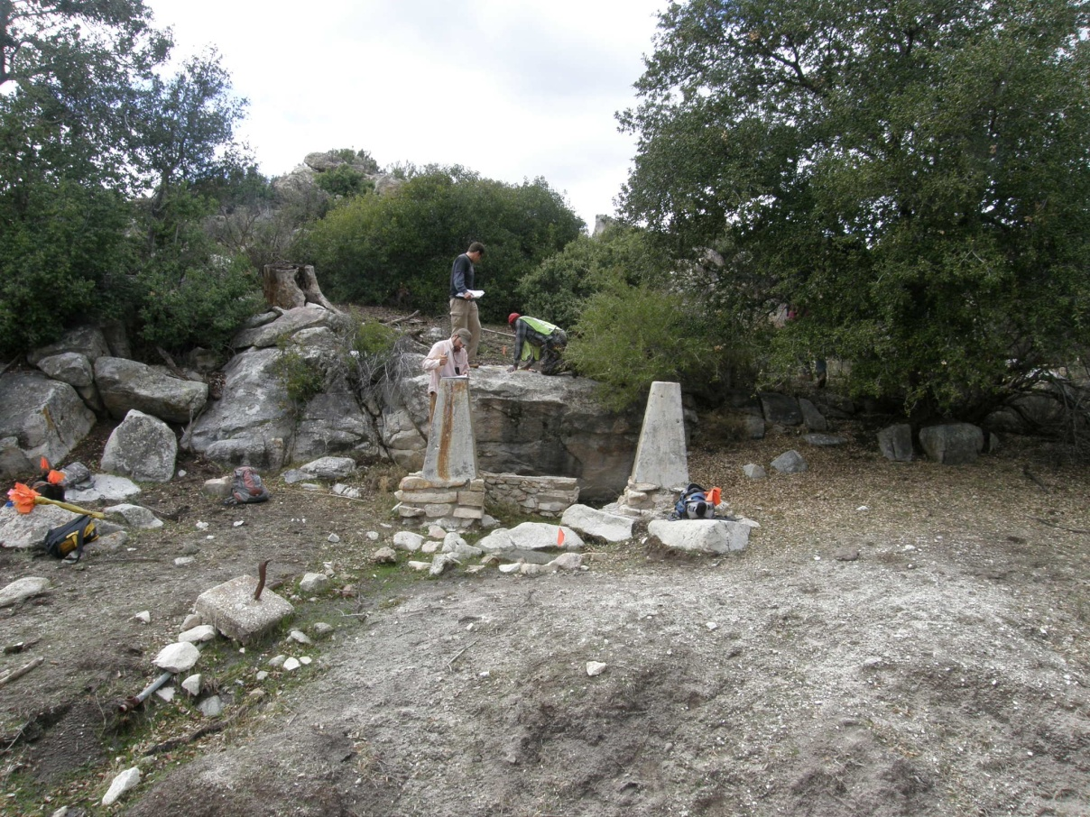

Figure 4.10 Overview to the west of Tule-BC-34 with concrete footings located at the spring in the background.

Tule-BC-35
This is a large prehistoric site covering a 435-x-220-m area with 10 milling stations, ceramics, lithic debitage, flaked stone tools and groundstone tools. Three loci and one concentration were delineated (Figure 4.11).

Locus A, measuring 190 x 90 m, contains one milling station with three basins and four slicks, 238 metavolcanic flakes, 68 quartz flakes, one obsidian flake, two handstones, one millingstone, one core and one metavolcanic Elko projectile point base. Locus B covers a 150-x-135-m area and contains seven milling stations with 12+ slicks and two saucer mortars, 45 metavolcanic flakes, 23 quartz flakes, three brownware sherds, seven handstones, and one millingstone. Locus A is bounded by dirt roads to the south and west, and a small drainage to the north. Locus B is immediately south of Locus A. A dirt road marks the western edge of Locus B and its southern extent is situated on top of a small, east-west trending, granitic outcrop.
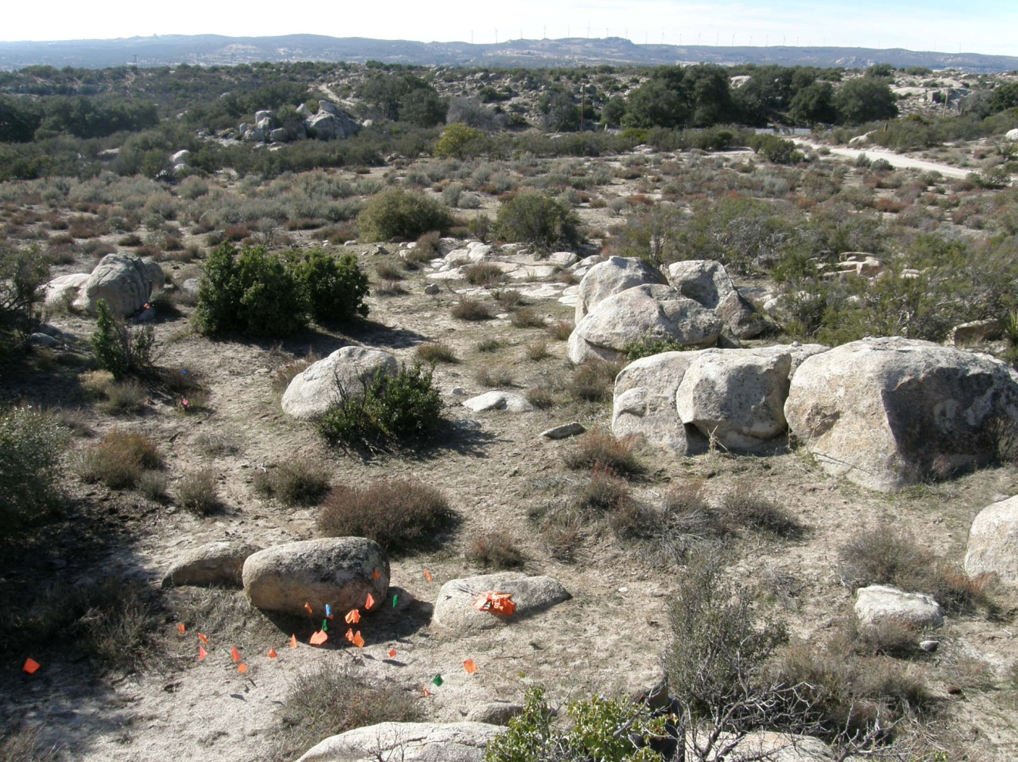

Figure 4.11 Overview of Tule-BC-35.

Concentration 1 is a 5 x 5 m dense ceramic scatter of 30+ brownware sherds located on the east side of Locus B. Additional cultural constituents southeast of Locus B include one milling station with one conical mortar, one millingstone, five metavolcanic flakes, two quartz shatter and one brownware sherd.

Locus C, which covers a 225-x-180-m area, comprises the remaining portion of the site north of Locus A. This locus contains several bedrock outcrops that are highly exfoliated, possibly obscuring previous milling surfaces. The northeastern portion of this area has been disturbed by what appears to have been vegetation removal via bulldozer. Resources observed in Locus C include 250 flakes, 500 potsherds, two manos, two projectile points, one scraper, three cores, and one milling station with two milling slicks.

A deep wash and a natural spring are located approximately 50 m west of the site. Disturbances to the site include cattle grazing, two dirt roads, a modern outhouse and a small campground which is located along the west side of Locus A. There also appears to be a plow scar that runs northeast-southwest through Locus B. Soil at the site consists primarily of light brown alluvial silty sand. No midden soil was observed, though there is potential for substantial buried cultural deposits. This site has relatively high data potential and is likely to be considered eligible for NRHP listing.

Tule-BC-36
This site is a small lithic scatter containing eight pieces of metavolcanic debitage (seven interior flakes, one shatter) and one quartz interior flake spread over a 26-x-19-m area. The site is located on a small terrace at the bottom of the south-facing slope of a small hill. A seasonal drainage runs west-to-east at the south edge of the site. Numerous highly exfoliated bedrock outcrops are located to the east of the site on a larger hill. Vegetation in the area consists of scrub oak, buckwheat, chamise, cholla, live oak and grass. Chamise is very thick to the north of the site, possibly obscuring additional artifacts. Bedrock in the site vicinity is shallow and there is little potential for substantial buried cultural deposits. This site has low data potential and does not appear to meet the criteria for NRHP eligibility.

Tule-BC-39
This site is a light artifact scatter and two milling stations contained in a 45-x-25-m area. The site is located on top of a small hill overlooking the valley floor to the south and west. The hill is covered with exfoliated bedrock outcrops. All artifacts are located up slope, to the east of the milling stations. No drainages are present in the immediate vicinity; the nearest drainage is a deep wash/creek, about 150 m to the west. Artifacts include two handstones and two metavolcanic interior flakes and four metavolcanic secondary flakes. The milling stations contain a total of three slicks. An SDG&E distribution line runs east-west along the northern edge of the site and cattle grazing in the vicinity is common. Vegetation includes cholla, chamise, buckwheat, sage brush and grass. Soils are consists of brown silty coarse sand and have a low potential for buried cultural deposits. The site has low data potential and does not appear to meet NRHP eligibility criteria.

Tule-BC-40
This site contains a single milling station with two slicks on exfoliated bedrock measuring 2.8-x-2.1-m in size. No artifacts were observed at the site. The milling station is located at the edge of a large field that is used for cattle grazing. The field has been cleared and may have been disked or plowed. Currently, only small cholla, buckwheat and scrub oak grow in the area. Two other bedrock outcrops are situated near the milling station; both of those are also exfoliated. The nearest drainage is located approximately 60 m to the east. Soil at the site consists of light brown coarse sand and silt alluvium, however, no artifacts were found in the vicinity and it is unlikely that buried cultural deposits exist. The site has low data potential and is not likely to meet the criteria for NRHP eligibility.

Tule-BC-41
This site is a light artifact scatter with two milling stations contained in a 171-x-50-m area. The two milling stations, all of the ceramics and about half of the lithics are located at the base of a small hill on the west side of a valley that is cut from north-south by a small drainage. The other half of the lithics are located at the top of the hill, about 40 m to the east. Total artifacts include 36 metavolcanic flakes, 12 quartz flakes, one quartzite flake, four obsidian flakes, 13 brownware ceramics, two buffware ceramics and one quartzite hammerstone. A total of four slicks are present on the two milling stations. The area surrounding the site has been used extensively for cattle grazing. A large pile of construction materials (primarily concrete culverts) is located about 25 m east of the site. Vegetation includes cholla, chamise, live oak, scrub oak, Manzanita and grass while site soils are composed of light brown silty sand with a veneer of decomposing granite. No midden soils were identified and it is unlikely that buried cultural deposits are present. The site does not appear to meet the criteria for NRHP eligibility.

Tule-BC-42
This site is a light lithic scatter with one milling station contained in a 76-x-75-m area, spread over a small hill at the west edge of a valley. The site was recorded in two loci with a small drainage as the arbitrary boundary between them. Loci designations were only used to facilitate site recording. Locus A (55 x 40 m in size) contains 43 metavolcanic flakes (one primary, 11 secondary, 31 interior) and one metavolcanic groundstone. Locus B covers a 58-x-25-m area and contains four quartz secondary flakes, one metavolcanic secondary flake and 12 metavolcanic interior flakes. A granite handstone fragment is located between the two loci. The milling station, located in the southeast corner of Locus A, contains four slicks. A deep drainage runs north-south at the eastern edge of the site, at the bottom of the hill. The hill itself contains numerous large granitic outcrops that are highly exfoliated. Vegetation includes chamise, buckwheat, cholla, grass, scrub oak and one four-leaf Pinyon Pine tree. Multiple oak trees are present along the creek. Soil at the site is composed of light brown silty sand. Numerous trees have been cut down in the immediate vicinity and the area has been used for cattle grazing. This site has low data potential and does not appear to meet the criteria for NRHP eligibility.

Tule-BC-54
This habitation site covers a 125-x-92-m area and includes three milling stations with three slicks and one saucer mortar, six millingstones, eight handstones, one core, one chopper, and 111 pieces of debitage. The site is situated on top of a low, flat hill that overlooks McCain Valley to the west and south (Figure 4.12). The hill contains numerous flat, low-lying granite outcrops. A large, north-south trending creek forms the eastern site boundary. Smaller creeks are present on the west and south sides of the site. Milling stations 2 and 3 are both located at the western edge of the site on adjacent outcrops. Concentration 1 was delineated to the east of Feature 2 and north of Feature 3. It contains both the highest density of flakes and probable midden soil (dark brown to black sandy loam) covering an 18-x-12-m area. The remainder of the site contains silty sand and decomposing granite. The handstones and millingstones are dispersed evenly across the site. Disturbances to the site include ground surface water erosion and cattle grazing. Vegetation is very sparse and includes shiny leaf yerba, scrub oak, sugar bush, yucca, buckwheat, cholla, holly leaf redberry and grass. Concentration 1 probably contains subsurface cultural deposits, as does the area immediately east of the concentration, near the middle of the site. Given that this site has high data potential, it is likely to meet the criteria for NRHP eligibility.

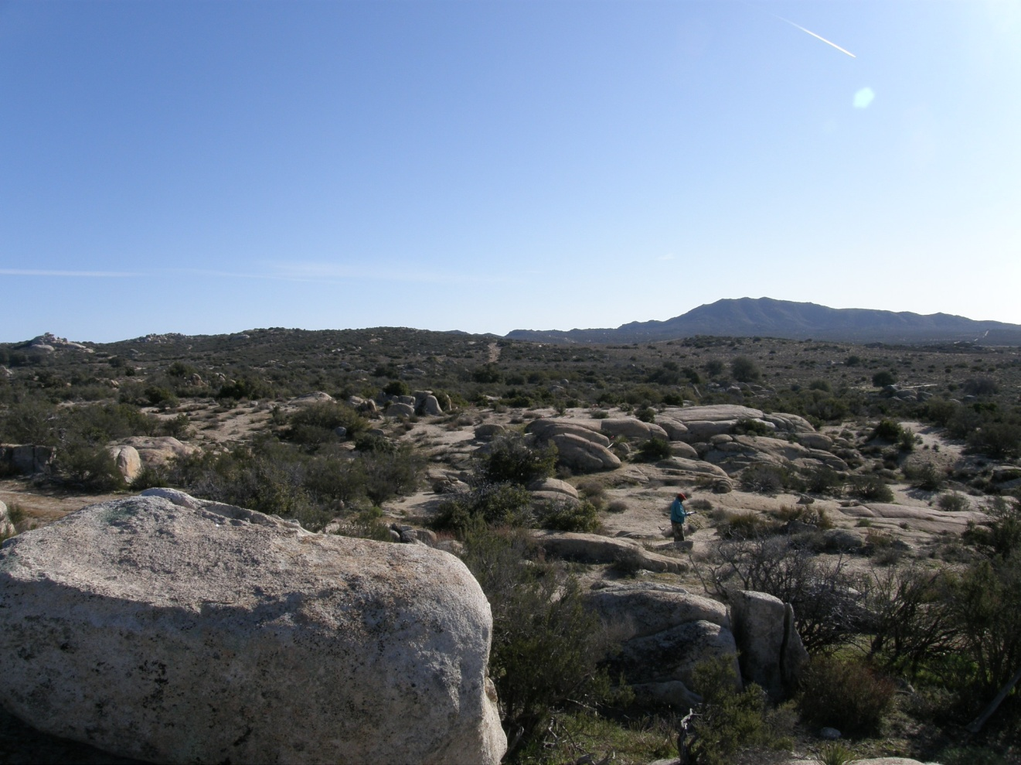

Figure 4.12 Overview of Tule-BC-54.

Tule-BC-56
This site consists of a possible pot drop containing 22 brownware sherds in a 4-x-3-m area. The site is located on the north edge of a seasonal stream on the east side of a large north-south trending ridgeline. Most of the sherds are situated on a large, flat granite outcrop. A few of the sherds are located adjacent to the bedrock and in the drainage. Water erosion is the only disturbance observed at the site. Vegetation includes scrub oak, chamise, cholla, grass, Manzanita and buckwheat. Soils are comprised of alluvial silty sand with decomposing granite. There is low potential for subsurface deposits. This site has low data potential and does not appear to meet the criteria for NRHP eligibility.

Tule-BC-57
This site contains a single bedrock milling station with one slick and one piece of metavolcanic shatter. The site is located on the eastern slope of a large north-south trending ridgeline. The milling station is a small, flat, tabular rock measuring 3 x 1 m in size, and located at the east end of a small bedrock outcrop. All of the rocks in the outcrop are similar in size and shape to the milling station. No drainages are present in the immediate vicinity. Vegetation is very dense surrounding the outcrop, effectively reducing visibility to near-zero percent. Plants observed include scrub oak, cholla, buckwheat, holly leaf redberry and grass. Soil at the site is decomposing granite indicating that a subsurface deposit is unlikely. This site has low data potential and does not appear to meet NRHP eligibility criteria.

Tule-BC-58
This site is a light artifact scatter which includes one possible metavolcanic scraper, one metavolcanic shatter and two metavolcanic interior flakes in an 18-x-5-m area. The site is located on the east side of a small hill within a large north-south trending ridgeline below a large, spherical monolith. Additional granite outcrops and boulders are present near the top of the hill. Soil at the site is alluvial light brown silty sand and decomposing granite. A subsurface deposit is highly unlikely. No drainages are present in the immediate area, however due to the slope of the hill (10 degrees), erosion has been exacerbated. The surrounding area is occasionally used for cattle ranching. The vegetation, which includes mountain mahogany, scrub oak, cholla, holly leaf redberry and grass, is very sparse. This site has low data potential and does not appear to meet the criteria for NRHP eligibility.

Tule-BC-66
This site is a light lithic scatter covering a 6-x-5-m area. The site is situated at the confluence of a small seasonal drainage and a semi-permanent creek within the north-south trending mountain ridge between McCain Valley and Thing Valley. No bedrock outcrops are present at the site, although some may be obscured by the dense vegetation. Artifacts at the site include two metavolcanic interior flakes, one chert interior flake, one quartz interior flake and one quartz shatter. Disturbances to the site include immigrant foot traffic and water erosion from the creek. Vegetation includes chamise, scrub oak, cholla, mountain mahogany, sugarbush and grass. The soil matrix consists of decomposing granite and has a low potential for buried cultural deposits. This site has low data potential and does not appear to meet NRHP eligibility criteria.

Tule-BC-67
This site contains a light artifact scatter covering a 31-x-20-m area. The site is situated on a gently sloping saddle between two mountain peaks overlooking McCain Valley to the east. There is a large creek located about 70 m south of the site, below the saddle. Artifacts observed at the site include four pieces of quartz debitage, one quartz retouched flake and 12 brownware ceramic sherds (one rim). No disturbances were noted at the site. Vegetation includes chamise, mountain mahogany, manzanita, sugarbush and yucca. Soil at the site consists of decomposing granite and has a low potential for buried cultural deposits. This site has low data potential and does not appear to meet NRHP eligibility requirements.

Tule-BC-68
This site consists of a bedrock milling station with two metavolcanic flakes, covering a 27-x-17-m area. The site is located along the western bank of a seasonal creek in the middle of a large north-south trending mountain ridge. The milling station is a large, highly exfoliated granite outcrop which contains one highly exfoliated oval mortar. No disturbances were noted at the site. Decomposing granitic sediments characterize site deposits and there is a low potential for buried cultural deposits. This site has low data potential and does not appear to meet NRHP eligibility criteria.

Tule-BC-69
This is a historic mining site covering a 45-x-18-m area. The site is located approximately half way up the western slope of a very steep mountain. Features observed at the site include a mine shaft, two adits, a small tailings pile and a small road which connects the two adits. The road appears to have been built from the tailings of the two pits. Based upon the tailings, this site appears to be an iron mining location. No disturbances were noted at the site. Dense vegetation includes chamise, sugarbush, Manzanita, and yucca. Very little soil is present at the site; the ground surface is primarily granite and quartz bedrock with some decomposing granite. No diagnostic artifacts were identified to help place this site in time. This site has low data potential and does not appear to meet NRHP eligibility criteria.

Tule-BC-72
This site consists of a bedrock milling station with two pieces of debitage contained in a 25-x-7-m area. The site is situated on a flat terrace overlooking McCain Valley and Imperial Valley to the east. No drainages are present in the immediate vicinity of the site; however a large creek runs northwest-southeast approximately 190 m to the north of the site. Artifacts include one quartz shatter and one retouched quartz flake. The milling station is a large, flat granite outcrop with one slick. Several basins may also be present on the outcrop. However, due the extreme exfoliation no other milling elements could be positively identified. No disturbances, other than the exfoliation, were observed at the site. The decomposed granitic sediments hold little potential for buried cultural deposits. This site has low data potential and does not appear to meet NRHP eligibility requirements.

Tule-BC-73
This site is a light artifact scatter covering a 17-x-10-m area. The site is situated on gently sloping, south facing terrace on the top of a mountain ridge. A seasonal creek, which trends north-south, is located about 150 m to the west. Artifacts include two brownware ceramic sherds, four quartz interior flakes, and one metavolcanic interior flake. Vegetation is very dense, and additional artifacts may be present underneath the vegetation. No disturbances were noted at the site. The soil matrix at the site consists of decomposing granite with a small amount of alluvial silty coarse sand. A subsurface cultural deposit is unlikely. The site has low data potential and does not appear to meet the NRHP eligibility criteria.

Tule-BC-74
This site is a historic mining site which covers a 210–x-95-m area. The site is situated on the steep, south-facing slope of a mountain peak within the Inkopah Mountain Range. Mining features at the site include a quarry, a prospecting pit, two tailings piles and two sorting areas. Artifacts include two hinge-lid tobacco tins, one rotary-opened coffee can, and two sanitary cans. The presence of multiple flowering and flowered yucca growing in the quarry and in the sorting areas, as well as the 1930-1950’s age of the metal cans, indicates that this mining site was occupied during historic times. This site is unlikely to contain a buried refuse deposit and does not appear to meet the NRHP eligibility criteria.

Tule-CW-01
The site consists of two bedrock milling stations, one containing one mortar and the other containing two slicks. The site is located on the top of a ridge with a commanding view of the Anza Borrego Desert. There are no midden soils or artifacts present on the surface; however, the ground surface is covered by a layer of dead vegetation. The two features are contained in an approximate 15-x-15-m area. This site has low data potential and does not appear to meet the criteria for NRHP eligibility.

Tule-CW-02
This site consists of four brownware potsherds and one metavolcanic flake contained in a 10-x-10-m area. It is located near the top of a knoll that is marked out for development of a windmill and helicopter pad. There is a small drainage to the northwest of the site that is actively eroding the site surface. There is low potential for subsurface deposits, as there is no midden soil present. The site does not appear to meet the criteria for NRHP eligibility.

Tule-CW-04
This site consists of a single bedrock milling station containing two slicks. The slicks are situated on a large granite boulder that has some moderate exfoliations. The site is located approximately 30 m east of McCain Valley Road in an area of high bedrock density. The site covers an area of approximately 10 x 8 m. There is low potential for subsurface deposits, as no midden soil is present. The site does not appear to meet the criteria for NRHP eligibility.

Tule-CW-05
This is a small site covering an approximate 8-x-8-m area, consisting of a single bedrock milling station containing two slicks, and two metavolcanic flakes. The site is located approximately 35 m west of McCain Valley Road. An intermittent drainage is located adjacent to the site. There is low potential for subsurface deposits, as no midden soil is present. The site does not appear to meet the criteria for NRHP eligibility.

Tule-CW-07
This site is a historic trash dump spread over a 15-x-10-m area and consisting of 100+ cans, (sanitary, milk, oil, paint, and beer), and clear and brown broken glass. The concentrated nature of this assemblage indicates that it derives from a single dump event. The assemblage is typical of a historic refuse deposit that dates to the 1950’s. It is located on the north side of a long dirt driveway. The deposit is confined to the surface and it is unlikely that artifacts are buried, given that surface deposits are comprised of coarse granitic sand over shallow bedrock. This site has low data potential and does not appear to meet the criteria for NRHP eligibility.

Tule-CW-10
This site is located at the top of a knoll with expansive views to both the east and west. The site consists of 40+ brownware potsherds, 10+ metavolcanic flakes, and one handstone fragment contained in a 20-x-25-m area. The site deposit is characterized by coarse granitic sand with a low potential for subsurface deposits. No midden soil was identified. Vegetation is sparse, including sage, yucca, grass, and scrub oak. The site does not appear to meet the criteria for NRHP eligibility.

Tule-CW-11
This site is located at the top of a knoll that has several large granite boulders providing shelter from prevailing winds. The site consists of one rock shelter with a dry stacked stone windbreak at one end and approximately five brownware sherds within it. There are also five milling stations, which contain five conical mortars, one basin, and one milling slick. Another 50 brownware sherds and 15 metavolcanic flakes were found on the surface outside of the shelter. The site covers an area of approximately 30 x 50 m and has a moderate potential for subsurface deposits. The nearest water source is an unnamed intermittent drainage located approximately 100 m south of site. This site has at least moderate data potential and it is likely to meet the criteria for NRHP eligibility.

Tule-CW-12
This site covers a 230-x-150-m area at the top of a ridge with a view to the south. The deposit is sparse over most of the site, but slightly more concentrated at the center. In all, the site contains 70 brownware sherds and 350 pieces of debitage, along with two handstones, one hammer stone, one millingstone, one quartz biface, and one milling station containing one mortar. Debitage consists of quartz, chert, obsidian, and green metavolcanic flakes. There is a moderate potential for subsurface deposits, and midden soil may be present in the concentration. This site appears to meet the eligibility criteria for NRHP listing.

Tule-CW-15
This site is situated on and around a large bedrock outcrop, which provides an excellent wind break. The site consists of one bedrock milling station with one mortar and three slicks, three handstone fragments, and one brownware sherd. The site covers an area of approximately 15-x-30-m and has a low potential for subsurface deposits. No midden soil was identified. This site has low data potential and does not appear to meet the criteria for NRHP eligibility.

Tule-CW-16
This site is a small lithic scatter located on a hillside, consisting of five metavolcanic flakes and one quartz flake in a 15-x-15-m area. No midden soil was identified and there is low potential for buried cultural deposits, given that the site matrix consists of granitic sand over shallow bedrock. This site has low data potential and does not appear to meet the criteria for NRHP eligibility.

Tule-CW-17
This small habitation site is located on the top of a knoll and along its eastern slope (Figure 4.13). The site contains three milling stations with a total of two mortars and two slicks. There are also 100 brownware sherds, 50 flakes, one millingstone, two handstone fragments, one projectile point, and one rock shelter. The site covers an area of approximately 50 x 50 m. The deposit at the site is sparse over much of the area; however, there is a moderate potential for subsurface deposits near the milling stations and within the rock shelter. Gray discoloration near the milling stations and rock shelter indicate that midden soils may be present. The site is likely to meet the eligibility criteria for NRHP listing under Criterion D.
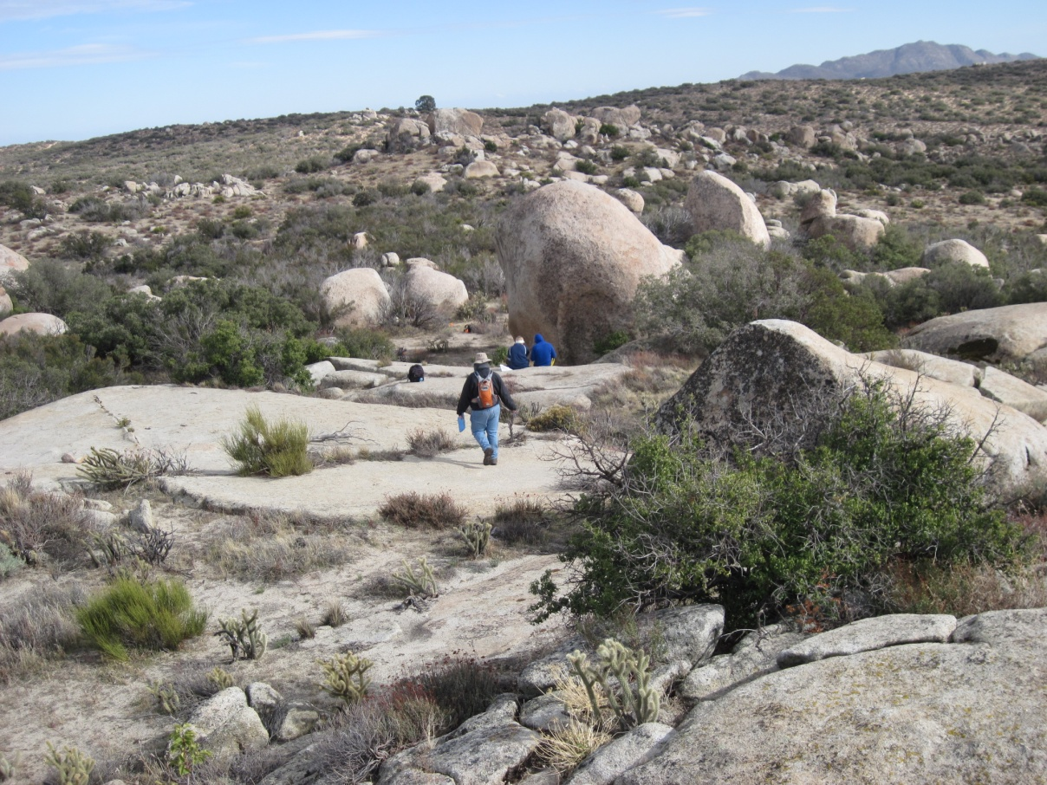

Figure 4.13 Overview of Tule-CW-17

Tule-CW-19
This site is located in an area of dense granite bedrock and boulders. The site consists of 38 brownware sherds, 10 flakes, and two bedrock-milling stations contained in a concentrated 30-x-10-m area. One milling station contains one slick while the other contains four slicks. The site has low potential for subsurface deposits; no midden soil was identified. This site has low data potential and does not appear to meet the criteria for NRHP listing.

Tule-CW-20
This site is located in an area of dense granite boulders and bedrock. The site contains 25 potsherds, five green metavolcanic flakes, one millingstone fragment, one handstone, one core and five slicks on a single boulder. The site boundary covers an area of approximately 30 x 30 m. The site is located at the base of a foothill and has low to moderate potential for subsurface deposits. However, coarse granitic sand forms a thin veneer over shallow bedrock and any subsurface deposits, if present, are not likely to contain substantial cultural material. This site has low data potential and does not appear to meet the criteria for NRHP listing.

Tule-CW-21
This site is located along the roadside within the Rough Acres Ranch. The site is a trash dump used by the ranch and covers an area of 20 x 40 m that has been dug down approximately 3 m and filled with refuse. The bulk of the material appears to date to the 1950’s, however, there is modern debris mixed in. The site contains 100+ sanitary cans, miscellaneous metal fragments, and a large quantity of wood and is considered to have low data potential and does not appear to meet the criteria for NRHP listing.

Tule-CW-22
This site is a rock shelter containing four brownware sherds. It covers a 6-x-6-m area located adjacent to a dirt road within Rough Acres Ranch. The roof of the shelter is blackened by soot, and likely contained a hearth at some point in the past. No evidence of midden soil or buried deposits was identified at this incipient shelter. The site does not appear to meet the criteria for NRHP eligibility.

Tule-CW-23
This site is a small, 20-x-20-m lithic scatter located adjacent to a dirt road within Rough Acres Ranch. Artifacts include 10 metavolcanic flakes and one core. The site has a low potential for subsurface deposits because granitic sand and shallow bedrock give no indication that midden soils or substantial amounts of buried cultural material could be present. The site does not appear to meet the criteria for NRHP eligibility.

Tule-CW-24
This is a sparse artifact scatter associated with five milling stations covering a 90-x-60-m area located on either side of a dirt road within Rough Acres Ranch. The five milling stations contain six slicks, and are associated with 10 metavolcanic flakes, one brownware sherd, and two handstones. The site has been impacted by the placement of a water tower for an adjacent home site, and given extensive historic and modern habitation, the site may have been scavenged for prehistoric artifacts. No midden soil or areas likely to contain buried cultural deposits were identified. The site has low data potential and is not likely to meet the criteria for NRHP eligibility.

Tule-CW-25
This is a historic home site that is located within Rough Acres Ranch, and is believed to be one of the original homes on the ranch (Figure 4.14). The home is constructed on wood floor beams without a concrete foundation. The lumber within the home is dimensional, but is held together with various styles of wire nails. The siding consists of 6-in planks painted white with green trim. The roof of the home consists of wood and corrugated tin. In the area surrounding the home there is a mixture of modern and historic debris, as well as a minor prehistoric component. The debris consists of several horseshoes, sanitary cans, clear and brown glass, as well as modern plastic. The prehistoric component consists of one handstone fragment, one handstone used as fill in a concrete footer, and one green metavolcanic flake. There are several granite boulders to the south of the home, one of which has a historic petroglyph that reads “JD 1933.” The site covers a 50-x-40-m area. Given the strong integrity of the structure, and the possible historic context, this site is probably eligible for NRHP listing under criterion A and/or D.
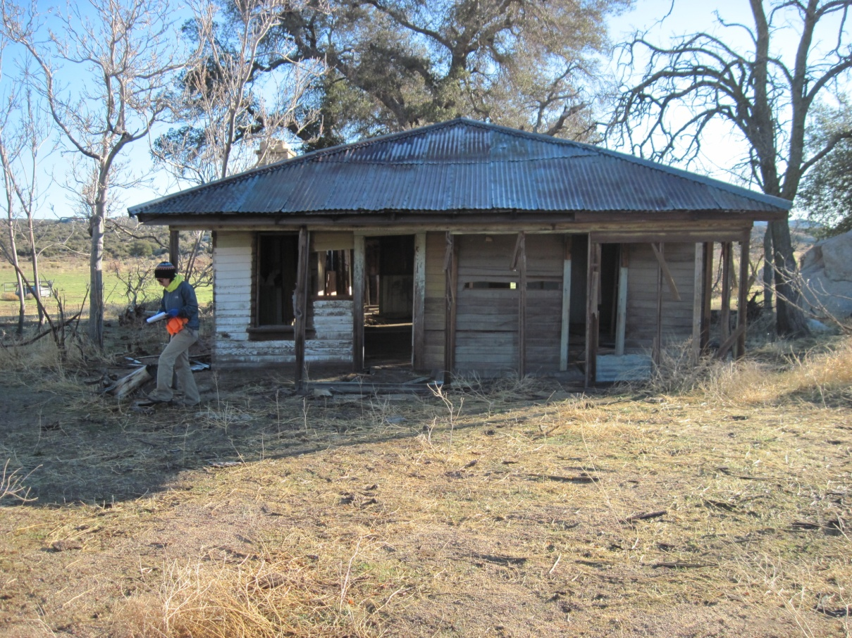

Figure 4.14 Overview of Tule-CW-25.

Tule-EP-01
This is a bedrock rock-milling site containing one feature with two milling slicks. The site is located in the town of Manzanita on private land. The site is approximately 12-x-12-m (36-x-26-ft) in size. There is a low probability for subsurface deposits given that granitic sands form just a thin mantle over shallow bedrock. This site has low data potential, and it is not likely to meet the criteria for NRHP eligibility.

Tule-EP-02
This is a historic site consisting of the remnants of a stone masonry building with granite stone and mortar construction. A chimney still stands inside the structure with an emblem of the Freemason Society. Wooden frames remain around some windows in the building. The site is contained in an approximate 25-x-29-m area. It is located on State Route 94 in Boulevard. Some historic subsurface deposits may be present. The NRHP eligibility of this site is uncertain; more research needs to be done to place this structure in a historic context.

Tule-EP-03
This is a prehistoric site consisting of 17 pottery sherds, eight interior metavolcanic flakes, two steatite fire affected rocks, three pieces of animal bone and four features (boulders) with a total of eight milling slicks and dispersed midden soil. The site measures 101 x 42 m and is located south of State Route 94 on a private parcel. The presence of subsurface cultural deposits was not confirmed but pockets of buried archaeological material may be present. If present, it is not likely that buried material would yield substantial or different kinds of data. As such, and given the extensive historic and modern occupation of the area, it is not likely that this site would meet the criteria for NRHP eligibility.

Tule-EP-07
This is a historic site that contains 10 hole-in-top metal cans, one cream colored ceramic vessel base, one amethyst glass jar fragment, and a metal spoon. All artifacts are contained in a 10-x-35-m area located on private land north of State Route 94 near Rose Avenue. The ceramic fragment has a makers mark bearing the Howard Laughlin USA logo. The site is not likely to contain significant buried cultural deposits and probably derives from a single dump episode. It does not appear to meet the criteria for NRHP eligibility.

Tule-EP-08
This is a multi-component prehistoric and historic site covering an approximate 270-x-270-m area located north of State Route 94. The prehistoric component contains 33 milling stations (boulders) with a total of 165 milling surfaces, three portable grinding stones, one handstone fragment, 13 brownware pottery sherds, two chert flakes, 10 metavolcanic flakes, 10 quartz flakes one chert core and patches of midden soil among the boulders (Figures 4.15 and 4.16). The presence of midden soil indicates that there is at least a moderate probability of discovering subsurface cultural deposits with high data potential. The historic aspect of the site contains two remnants of historic structures, and one privy. However, there is nothing particularly distinctive about any of the structural remains. Overall, the prehistoric component has high data potential and would probably be eligible for NRPH listing under criterion D. This historic component generally lacks strong integrity and uniqueness and would probably not meet any of the criteria for NRHP listing.

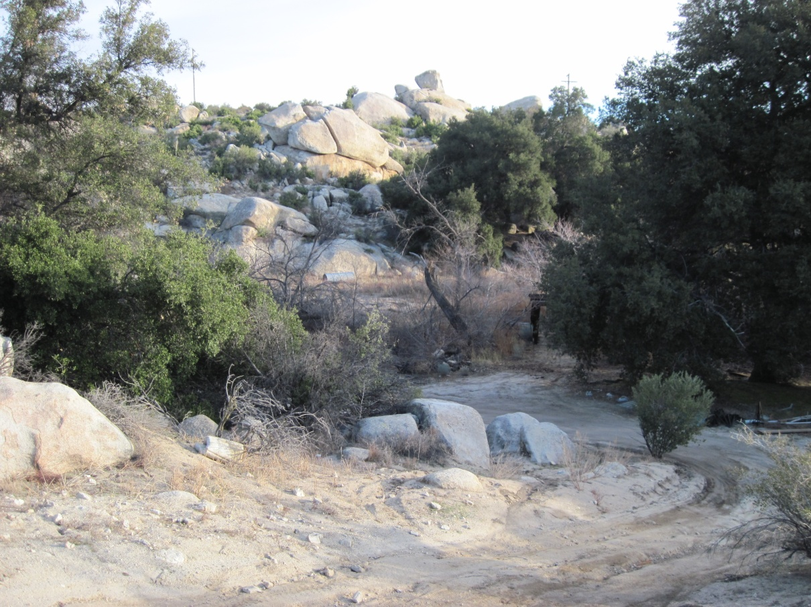

Figure 4.15 Overview of the prehistoric component at Tule-EP-08.
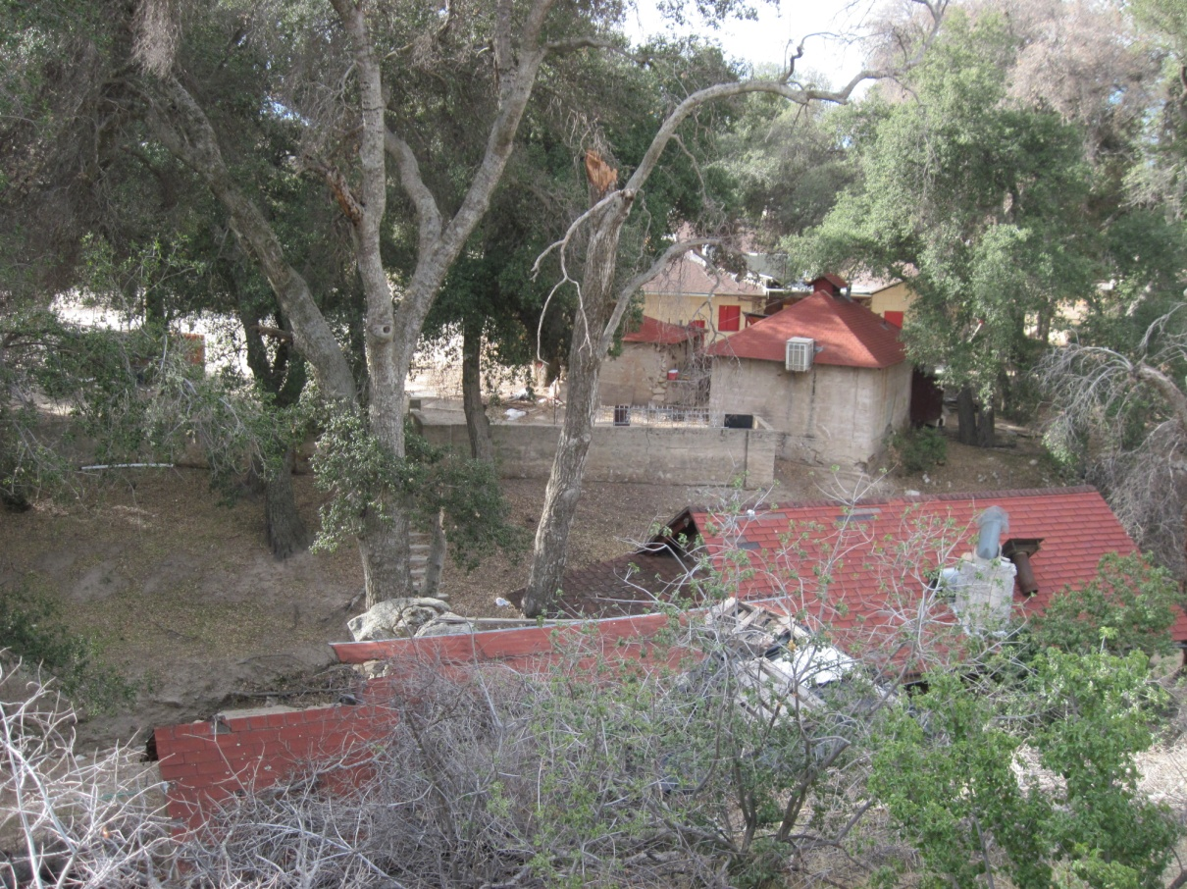

Figure 4.16 Overview of the historic component at TuleEP-08.

4.3 SITE DESCRIPTIONS: CLASS II SAMPLE INVENTORY
The Class II inventory covered approximately 1,741 acres across 14 discontiguous parcels, and resulted in the documentation of 43 archaeological sites, including nine previously recorded sites, and 34 newly discovered sites.

4.3.1 Class II: Previously Recorded Archaeological Sites

SDI-4009
This site was originally recorded in 1975 by the BLM, and then later updated in 2006 by ASM as a large habitation site with numerous bedrock milling stations and thousands of flakes and potsherds. In 2010, ASM revisited this site and generally confirmed the 2006 records. However, the current effort focused only on the western boundary of the site that extended into the current project area. This resulted in the extension of the western site boundary by approximately 50 m to the west to include more than 100 brownware ceramic sherds, 30 metavolcanic flakes, and three milling stations containing 10 slicks. This site may be eligible for NRHP listing under Criterion D.

SDI-4010
This site is a large habitation site that was originally recorded in 1975 by the Imperial Valley College Museum (IVCM) and has been updated multiple times since then (see Appendix G). Previous documentation at the site reported multiple loci which include bedrock milling stations, midden deposits, artifact scatters and human remains scattered about low-lying areas interspersed with large granite outcrops (Figure 4.17). During the current survey ASM relocated portions of the recorded site and also recorded an update to the site boundary.
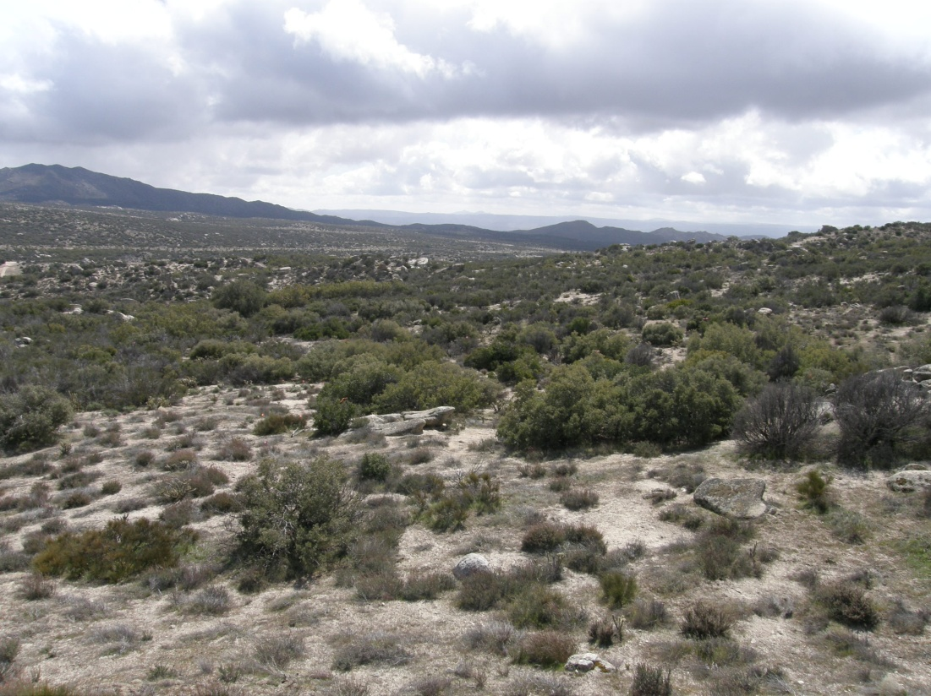

Figure 4.17 Overview of SDI-4010.
Three new bedrock milling stations with a total of eight slicks and a dispersed artifact scatter extend west/southwest from the reported boundary over a wide terrace up to the base of the large north-south trending ridgeline. Artifacts in this area include more than 100 flakes, 50 ceramics, nine handstones, three millingstones, two pieces of incised brownware rim sherds, one chert biface, one petrified wood biface and a drilled brownware ceramic handle. This expansion to the site covers a 200-x-120-m area, with the overall site now covering an expansive 600-x-425-m area. Patches of midden soil can be found in large and small areas throughout the current recorded site boundary and there is a strong potential for buried subsurface deposits. Although site records indicate that looting has occurred, no evidence of such activity was observed in the newly recorded areas. OHV activity, both on and off existing trails, continues to impact the site. A small drainage runs west-east along the southern boundary of this new area. Vegetation in the area consists of chamise, sugar bush, grass, cholla, holly-leaf redberry and scrub oak. Numerous live oak trees are present in the area. This site does appear to meet the criteria for NRHP eligibility.

SDI-5162
This site was originally recorded in 1975 by the BLM as a prehistoric site with a rock shelter and a brownware ceramic scatter. In 2010 ASM relocated this site finding it to be in generally the same condition that it was in when originally recorded. However, the site boundary was extended 70 m to the east to include an additional 50 brownware ceramic fragments and more than 10 green metavolcanic interior flakes. No cultural deposits were identified within the rock shelter. The site now covers a 99-x-75-m area. The artifacts at this site are sparsely scattered over coarse sand with little potential for substantial buried cultural deposits. Due to low data potential, it is unlikely that this site would meet NRHP eligibility criteria following a formal evaluation.

SDI-5171
This site was originally recorded in 1975 by the BLM as a possible rock shelter with associated cultural material. The current survey relocated the site in generally the same condition. However, the site boundary was extended to the southwest to include an additional 30 brownware ceramic sherds and eight green metavolcanic flakes. The site now covers a 274-x-230-m area. No midden soil was identified inside the rock shelter or across the site. The coarse granitic sand is only a thin mantle over the shallow and often exposed granite bedrock. There is little potential for substantial buried cultural deposits. Low data potential indicates that this site is not likely that this site would meet NRHP eligibility criteria.

SDI-7151
This site was originally recorded in 1979 by Dominici and Johnson as containing an extensive ceramic and lithic scatter, three rock shelters, one biface, a scraper, and a brownware ceramic figurine. The site record was updated in 2006 by ASM, noting that the site has been previously documented, tested, and evaluated for NRHP eligibility; however, the site record was not updated after these studies. ASM’s update noted that the site appears to have been extensively surface collected, but maintains much of the material as described in the original site record. The current survey relocated the site and found that there are three milling stations, three rock shelters, a large lithic and ceramic scatter, and several handstones and millingstones present. The site appears to be unchanged from the last update in 2006 but is now recorded as covering a 500-x-400-m area. This site appears to meet the criteria for NRHP eligibility under Criterion D, given relatively high data potential.

SDI-7154
This site was originally recorded in 1979 by the BLM as a habitation site containing a rock shelter, three oval slicks, two bifaces, one hammerstone, one core/scraper, one core, flakes and ceramics in a 3-x-8-m area. During the current survey, it was determined that the original mapped location of the site was inaccurate, and that additional features were present but not recorded, including two milling stations and a rock circle, expanding the site boundary significantly. The rock shelter is located on the top of a small hill within a large north-south trending ridgeline. The two new milling stations are located to the north of the rock shelter. The rock circle/hearth is located on the east side of the boulder that forms the east side of the rock shelter. The soil in the rock shelter is primarily decomposing granite. However, there appears to be alluvial silty sand covering a 2-x-4-m area in the northeast corner of the shelter that may contain midden deposits. The lithic and ceramic scatter extends down slope in all directions from the rock shelter to cover an area of 113-x-105-m. None of the previously recorded tools were relocated; however two handstones and one millingstone were recorded. Also recorded were 44 metavolcanic flakes, five quartzite flakes, 56 quartz flakes, one rhyolite flake, 30 brownware sherds and seven buffware sherds. The site has been subject to numerous disturbances. An OHV trail is present about 40 m west of the site and the surface is littered with bullet shells from extensive target shooting. A small number of modern beverage cans was also observed. The dense cultural deposits have high data potential, indicating that this site is likely to meet the criteria for NRHP eligibility under Criterion D.

SDI-7164 (Not Relocated)
This site was originally recorded in 1979 by the BLM to include a rock shelter, four milling stations, and one core/chopper. During the current survey no cultural resources were observed at either the mapped location or the UTM coordinates given in the site form. It is likely that this site is on private property east of the current project ROW. ASM did not have access to the private land for the current survey.

SDI-8434
This site was originally recorded by Westec in 1980 to cover an area 408-x-360-m. Tierra Environmental Services revisited the site in 2004 and found the site to be in generally the same condition but made a few updates to the site map. The site is situated along both the north and south sides of a creek where the creek exits the mountains and enters Thing Valley. During the current Class II sample survey ASM relocated the site and determined that the location of the site was slightly mis-mapped. To re-map the site ASM recorded milling stations, rock shelters, caches, loci boundaries and major landscape features. Five loci were delineated instead of the 11 originally recorded. However, due to time constraints, ASM was only able to record in detail the northern half of the site, north of the creek bed, but the southern boundary was delineated. The Class II inventory only required that site boundaries and basic descriptions be completed; a much less intensive enterprise than Class III inventory efforts. However, this was the only archaeological site that was recorded to the minimum Class II requirements during the Class II sample inventory. Overall, this site contains multiple rock shelters, one rock shelter with pictograph rock art, dozens of bedrock milling stations spread over multiple granite outcrops, dense artifact concentrations containing lithics, ceramics, and groundstone, and large patches of midden soil.

Loci A, B, D and E are located on the north side of the creek; Locus C is on the south side. Locus A is located on a small bedrock covered hill at the east end of the site, approximately 25 m west of Thing Valley Road. This locus includes the original loci 1, 2, 3, 5, and 6. Locus A contains two rock shelters and 31 milling stations with a total of 54+ slicks, 34+ basins and three saucer mortars. Locus B is located on the west, south and east sides of the large hill/ridge to the west of Locus A and includes the original Loci 9 and 10. Locus B contains five rock shelters (one of which has 11 pictographs on the interior), one handstone cache with three handstones and 63 milling stations with a total of 175+ slicks, 42+ basins, four basins with collars, and two conical mortars with collars. There is also a large vertical boulder which may contain a ground surface on the south facing vertical face (Feature #134). Locus D, located on top of the ridge to the north of Locus B, contains three milling stations with two basins and four slicks. Locus D corresponds to the original Locus 8. Locus E, which includes the original Locus 4, is located on a small knoll to the north of Locus A. Locus E contains 24 milling stations with 50+ slicks, 24+ basins and three mortars. Seven additional non-locus milling stations were recorded which contain a total of eight slicks and two basins. Many of the milling stations throughout the site are covered with soil and vegetation; additional features are likely at all loci.

Locus C was only briefly examined to confirm boundaries and basic assemblage characteristics. According to the original site record there are no milling stations in that area. During the current project two milling stations were observed. This area contains dark brown alluvial silty sand; midden soil may be present. The ground surface is covered with thick vegetation and leaf duff significantly limiting visibility.

Locus 11 in the original site record was not examined in detail, but was visited during the current survey. According to the site update from 2004, Locus 11 was recorded in detail and is located south of the creek, southwest of Locus B. This locus contains six milling stations.

Hundreds of lithic and ceramic artifacts are scattered throughout the site with the highest densities on the west side of Locus A and the southeast side of Locus B. The only areas of the site which do not contain artifact scatters are the steep portions of the eastern slope and the south/west slope of Locus B. The lack of observed artifacts may be due to the severity of the slopes and/or the dense vegetation in these areas, particularly on the south/west side. Two small, dense ceramic concentrations were also noted. Concentration 1 is located at the north end of Locus E. It contains 51 brownware sherds (one is decorated), and 20 buffware sherds. Concentration 2 contains 58 brownware sherds in a 1-x-2-m area. One polished bone fragment was found on the west side of Locus A. The bone is a non-human cranium fragment which may have a drilled hole.

A sample of additional artifacts observed at the site include at least three retouched flakes, two hammerstones, two cores, two incised brownware ceramics, three millingstones, and six handstones.

Midden soil is present throughout loci A and B except at the peaks of each hill where decomposing granite is a thin veneer over bedrock. The soil matrix at Locus D consists of decomposing granite with no evidence of buried deposits. The soil at Locus E consists of brown silty sand alluvium with decomposed granite and may contain midden. The original site record lists seven hearth features, none of which were observed during the current survey. Disturbances to this site appear limited to the construction of Thing Valley Road and erosion. Vegetation at the site includes numerous oak trees, scrub oak, manzanita, sugarbush, grass, cacti, and chamise. This site has a high probability for buried cultural deposits and appears to be eligible for NRHP listing based on Criterion D; a presumption also mentioned by Westec on their 1980 site form.

SDI-9224
This site was originally recorded in 1982 as an artifact scatter containing approximately 20 flakes, three projectile point fragments, one biface, one core, and six handstones covering a 30-x-15-m area. During the current survey, ASM relocated the site in the same general condition as previously reported. However, the mapped location was inaccurate, as was the site boundary, which was expanded to the north onto the next hill to include additional flakes and handstones. Two new milling stations with two basins and three slicks were also recorded; one is located within the originally recorded site and one is located at the north end of the site on top of the adjacent hill. Currently, artifacts include 46 flakes, one quartz biface tip, one quartz Cottonwood projectile point, six handstones, one metavolcanic core, one chalcedony biface, and one metavolcanic hammerstone. Lithic materials represented include chalcedony, quartz, obsidian, metavolcanic and quartzite. Additionally, seven small burned mammal bone fragment were also recorded; neither the type nor species could be determined on any of the bones in the field. The site now covers a 177-x-66-m area. No midden soil or evidence of substantial buried cultural deposits was identified. Despite the diversity of artifacts, This site has low data potential and does not appear to be eligible for NRHP listing due to low data potential.

SDI-15746
This site was originally recorded in 2000 by Cooley as a light lithic scatter of 10 flakes, two ceramic sherds and one flake tool, covering a 200-x-50-m area. Many of the flakes were observed to be located in the road. In 2006, ASM was only able to relocate two flakes along the road. At that time ASM suggested that the site be considered “background noise” and not an actual site. During the current survey, the site was expanded and updated to reflect its current condition, which included significantly altering the original site boundary. The site should now be considered a very large habitation site consisting of six loci and two concentrations. The disparity in records between 2006 and the current survey is likely due to recent erosion that may have uncovered cultural deposits, and due to less dense ground cover (i.e., grass, annuals, etc.).

Locus A is situated at the end of the road and contains a light lithic scatter that represents the majority of the original site boundary. This locus covers a 100-x-100-m area that has been extensively disturbed by modern vehicular traffic, camping, target practice, and other off-road activities.

Locus B is located on the east side of the original site boundary. This locus is a large habitation area with six milling stations and an abundance of ceramic sherds. There is an obvious lack of formed artifacts on the surface of this locus, and given its close proximity to McCain Valley Road and modern camping refuse visible at the site, it has likely been surface collected by looters. The area covered by this locus is 310-x-100 m. The assemblage contains 1,300 brownware and 100 buffware ceramic sherds, one green metavolcanic side notched projectile point, one obsidian projectile point base, one millingstone fragment, and 65 flakes. There are six milling stations with 40 milling surfaces present. The vegetation on the north-eastern boundary of the locus is extremely dense, making a full accounting of the assemblage difficult. There is midden soil present near the milling stations, and there is a moderate to high potential for subsurface deposits.

Loci C, D and E are situated on top of the first terrace of the mountain slope on the west side of the site; each locus sits along the edge of large, steep drainages.

Locus C, located at the northwest corner of the site, contains two milling stations (Features 15 and 16) and a very light artifact scatter. This locus covers a 35-x-35-m area.

Locus D, which covers a 100-x-50-m area, is located approximately halfway between Loci C and E. It contains a possible rock shelter (Feature 13; no cultural material was observed in the cave, however it would have been a very suitable shelter given its location and size) and three milling stations (Features 10-12). A fairly dense lithic and ceramic scatter is also present at the eastern end of the locus along the north side of the drainage.

Locus E, located at the southwest corner of the site, contains three rock shelters (Features 28-30) (Figure 4.18), four milling stations (Features 17, 18, 19, and 26) and a moderately dense artifact scatter comprised primarily of brownware ceramics with lesser quantities of lithic debitage. Locus E covers a 67-x-50-m area.

Locus F is located at the bottom of the steep portion of the slope on a small terrace. This locus contains four milling stations (Features 22-25) and dense artifact scatter that includes Concentration 2. Concentration 2, situated on the north side of the milling stations, covers a 25-x-14-m area and consists of 62 brownware sherds, one obsidian biface, one handstone, one millingstone, four metavolcanic shatter and 10 quartz shatter.
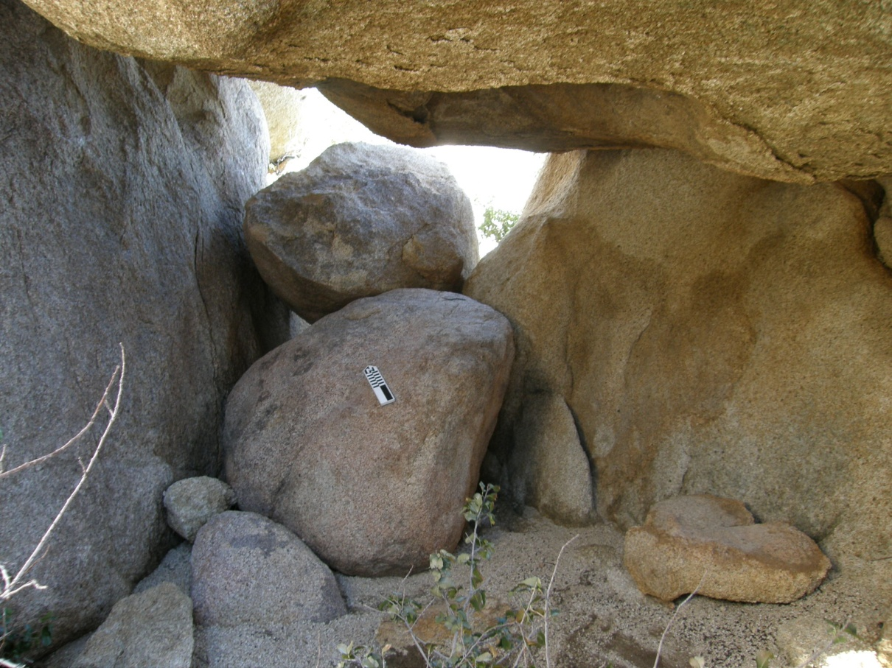

Figure 4.18 Overview of rock shelter (Feature 28) at SDI-15746.

Concentration 1, located near the northern end of the site, consists of a small dense scatter of brownware sherds (37 body, six rim) and two quartz shatter. This concentration covers a 15-x-6-m area.

Throughout the remainder of the western half of the site, artifacts are generally lightly dispersed with densities decreasing towards the center of the site. Two large creeks pass through the site from west to east and form the majority of the northern and southern site boundaries. Numerous additional smaller drainages run down slope between the various loci on the western half of the site and feed into the larger creeks. Additional artifacts observed on the western third of the site include more than 200 brownware sherds, 45 buffware sherds, 100 lithic debitage, one quartz hammerstone, two handstones, and one millingstone. Overall, this site has high data potential and appears to be eligible for NRHP listing under Criterion D.

4.3.2 Class II: Newly Discovered Archaeological Sites

Tule-BC-05
This site is a small, light lithic scatter of four flakes in a 26-x-4-m area located on the southwest side of a slightly sloping hill. All of the artifacts were found in small clearings within very dense chaparral. Additional artifacts may be present underneath the vegetation and leaf duff. Soil at the site is brown silty sand alluvium and decomposing granite. No bedrock outcrops are present in the immediate area, but the deposit indicates that bedrock is immediately subsurface. It is unlikely that substantial subsurface cultural deposits are present. This site has low data potential and does not appear to meet the criteria for NRHP eligibility.

Tule-BC-06
This site is a small (8-x-5-m) historic trash scatter consisting primarily of household goods. All glass and ceramic artifacts are small fragments. Two meat cans, five sanitary beverage cans, one paint can, and one paint thinner can are also present. The site was determined to be historic based on the presence of one cobalt glass shard and one sun colored amethyst glass fragment. This site is located on the south side of a small wash that is now used as a horse and dirt bike trail. The trail is the remnant of Lost Valley Road. The soil matrix consists of coarse decomposing granite with low silt content. This site has low data potential and does not appear to meet the criteria for NRHP eligibility.

Tule-BC-07
This site is a light lithic scatter with one milling station situated on a small terrace on an east facing slope of a north-south trending ridgeline. Highly exfoliated granitic outcrops are common in the surrounding area. Small, shallow, ephemeral drainages run through the site from east to west. The milling station contains three slicks. Artifacts observed include six metavolcanic secondary flakes and two quartzite secondary flakes. Soil at the site consists of decomposing granite and light brown sand; no midden soils were identified. The site covers a 22-x-22-m area. Vegetation, which is fairly sparse, includes cholla, buckwheat, grass, yucca and scrub oak. The site does not appear to meet the criteria for NRHP eligibility.

Tule-BC-11
This artifact scatter covers a 185-x-74-m area situated on a ridge top terrace overlooking McCain Valley to the west. The site is comprised of a single milling station at the edge of the terrace and a dispersed artifact scatter that covers the terrace and the top of the hill. The milling station contains five slicks. The artifact scatter consists of two handstones, one millingstone, two quartz biface fragments, one retouched obsidian flake, 16 metavolcanic flakes, 13 quartz flakes, three obsidian flakes, one rhyolite flake, one edge-ground brownware ceramic (three pieces), 33 brownware sherds, and four buffware sherds. The majority of the flakes and ceramics are located in a small clearing covering an approximate 20-x-20-m area on the east side of the milling station. Most of the tools are scattered further to the east near the top of the hill. The soil matrix at the site consists of light brown silt and fine sand with a layer of decomposing granitic sand on top. No midden soil was observed. Vegetation is generally sparse, consisting of cholla, scrub oak, yucca, grass and buckwheat. Large granitic outcrops are present throughout the area, particularly along the edge of the terrace adjacent to the milling station. Ephemeral drainages are located to the north and south sides of the site. This site has low data potential and does not appear to meet the criteria for NRHP eligibility.

Tule-BC-43
This site is a habitation site consisting of five milling stations and a dispersed artifact scatter contained in a 191-x-90-m area. It is located north of McCain Valley Road, and only a medium-sized drainage separates it from another very large, potentially eligible site, SDI-15746. Artifacts observed at Tule-BC-43 include more than 100 flakes, 150 ceramics, three handstones and one millingstone. One of the ceramics is an olla rim sherd. The site is situated on two small hills bisected by a shallow drainage with a low lying terrace to the east (Figure 4.19). Both peaks and the surrounding area contain highly exfoliated granite outcrops and boulders interspersed with a veneer of coarse granitic sand. A large creek runs along the southwest and south sides of the site. Vegetation at the site consists of extremely dense chaparral including chamise, cholla, sugar bush, Mojave yucca, laurel sumac, scrub oak, mountain mahogany, holly leaf redberry, buckwheat and grass. Due to the density of the vegetation, artifacts were observed primarily in small clearings (see map for locations of clearings). Dark brown silty sand (midden soil) surrounds Feature 1 near the northwest corner of the site and extends about 5 m around the feature to the north, west and east. The midden extends to the southeast nearly 50 m into a small clearing. This area contains the highest density of artifacts and is the most likely portion of the site to contain a subsurface deposit. Soil throughout the remainder of the site consists of light brown alluvial silty sand and decomposing granite. The site is located approximately 100 m north of McCain Valley Road. Near the east end of the site there are two large boulders that form a small cave. No cultural artifacts/features were observed inside, suggesting it was not used as a shelter. The southern third of the site contains very few artifacts—nearly all of these being ceramic fragments. Considering the relatively high data potential at this site, it is likely to be eligible for NRHP listing under Criterion D.
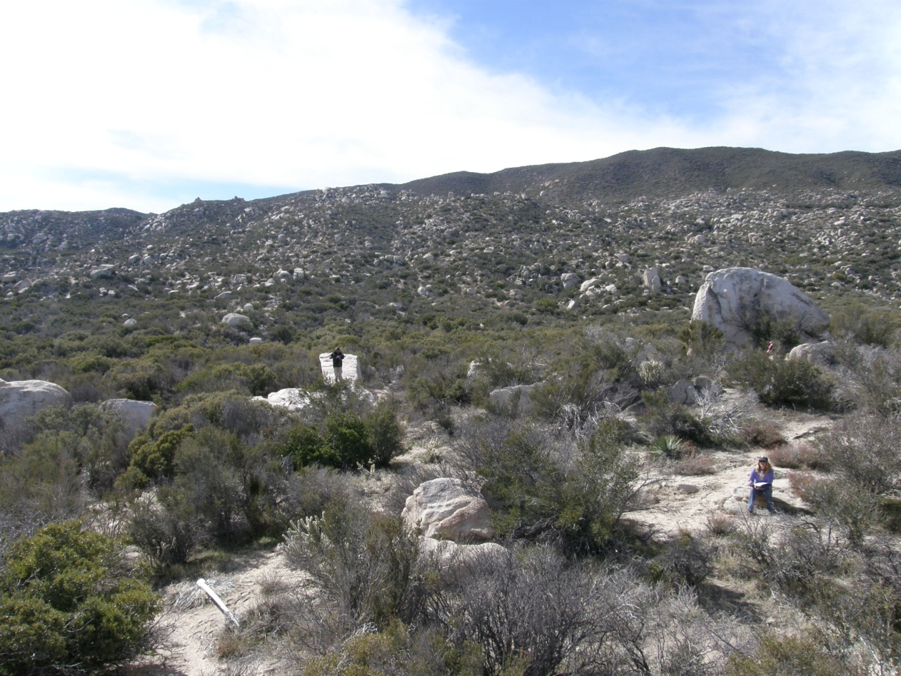

Figure 4.19 Overview of Tule-BC-43.

Tule-BC-44
This habitation site is contained in a 104-x-92-m area that includes nine milling stations with a total of 13 features, more than 75 ceramics, 18 pieces of lithic debitage, three handstones, one millingstone and one incised brownware ceramic sherd. Milling surfaces include one conical mortar, one conical mortar with a collar and 10 slicks. The site is located at the base of the Inkopah Mountains on a shelf of two west-east trending ridges separated by a small wash to the south. A second creek, trending northwest to southeast, merges with this drainage to the east of the site. Highly exfoliated granite outcrops are present throughout the area. Vegetation is very dense in the eastern half of the site along the creeks, almost completely obscuring the ground surface. The vegetation is significantly less dense in the western half of the site. Plant species observed include mountain mahogany, live oak, scrub oak, cholla, yucca, sugar bush, buckwheat, holly leaf redberry, and grass. Many of the plants, specifically the mountain mahogany, sugar bush and scrub oak, have grown abnormally large and robust compared to the surrounding area. Soil at the site consists of a thin layer of decomposing granite on top of brown silty coarse sand. No midden soil was observed. This site has low data potential and does not appear to meet the criteria for NRHP eligibility.

Tule-BC-46
This habitation site covers a 114-x-50-m area and has 15 milling surfaces (14 slicks, one saucer mortar) on seven different milling stations, two handstones, two millingstones, one hammerstone, 24 pieces of lithic debitage and 37 ceramics sherds. The majority of artifacts were observed along the wash and in small clearings. The highest density of artifacts is in an approximate 10-x-10-m clearing immediately north of Features 1, 2 and 3. The site is situated near the base of the Inkopah Mountains on a generally flat alluvial fan. A small wash runs west-to-east through the middle of the site and feeds a larger creek running along the southern edge of the site. Ground visibility is severely limited due to very dense vegetation which includes chamise, scrub oak, sugar bush, cholla, yucca, manzanita, grass, holly-leaf redberry, mountain mahogany and shiny leaf yerba. Most of the bedrock outcrops in the area are small to medium-sized (i.e., less than 1.5 m in diameter), and all bedrock is highly exfoliated. A subsurface deposit is unlikely at this site since bedrock is exposed or shallow, covered with a thin layer of coarse granitic sand. Disturbances appear to be limited to a single barbed wire fence that runs west-east through the middle of the site, along with erosion and deflation. This site has low data potential and does not appear to meet the criteria for NRHP eligibility.

Tule-BC-47
This site is a single milling station with one slick located 15 m north of a large west-to-east trending creek at the base of the Inkopah Mountains. The bedrock outcrop that defines the feature is 1.5 x 1.4 m in size. A barbed wire fence runs east-west approximately 12 m to the north of the milling station. Highly exfoliated granite boulders are present throughout the immediate area. Vegetation is very dense along the creek. Soil at the site is light brown alluvial silty coarse sand and decomposing granite. This site has low data potential and does not appear to meet the criteria for NRHP eligibility.

Tule-BC-48
This site consists of three milling stations contained in a 19-x-19-m area located at the edge of a large creek. The site is situated midway up a steep slope on the east side of the Inkopah Mountains in an area filled with large granite boulders and dense vegetation. Ground visibility was limited to less than 30 percent. A barbed wire fence runs west-east approximately 10 m to the north of Feature 1. Course granitic sand mixes with sandy alluvium on the surface and patches of exposed bedrock are prevalent. No evidence for midden soil or buried cultural deposits was identified. This site has low data potential and does not appear to meet the criteria for NRHP eligibility.

Tule-BC-49
This is a habitation site with four milling stations and a light artifact scatter contained in a 53-x-38-m area. Artifacts include one granite handstone fragment, five brownware ceramic sherds and two quartz shatter. The site is situated on a mid-slope mountain terrace on the east side of the Inkopah Mountains with a commanding view of the Salton Sea and Chocolate Mountains. Disturbances are limited to ground erosion and deflation, and a small, seasonal drainage runs down slope at the south end of the site. Vegetation is sparse in this area, with more prominent plants including mahogany, cholla, scrub oak, and grass. Soil consists of light brown silty sand and decomposing granite. Patches of exposed bedrock can be found throughout the vicinity and the presence of a subsurface cultural deposit is unlikely. This site is not likely to meet the criteria for NRHP eligibility due to low data potential.

Tule-BC-50
This is a small artifact scatter limited to a 17-x-14-m area located on an alluvial terrace that slopes down to the north. Artifacts include two handstones, five metavolcanic interior flakes and two quartz interior flakes. All of the artifacts are scattered in two small adjacent clearings where ground visibility is excellent. Ground visibility surrounding the clearings is poor due to dense vegetation, including chamise, scrub oak, yucca, cholla, sugar bush, mountain mahogany and buckwheat. Soil at the site consists of silty sand and coarse decomposed granite. There is no evidence of midden soil or areas likely to contain buried cultural deposits. This site is does not appear to meet the criteria for NRHP eligibility.

Tule-BC-51
This artifact scatter consists of one milling station with four milling slicks, one piece of red chert shatter and one metavolcanic shatter, included in a 19-x-15-m area. The site is situated on the small, east facing slope of an alluvial terrace. The site is surrounded by numerous highly exfoliated bedrock outcrops within a coarse granitic sandy matrix. Two small west-east trending creeks merge together approximately 20 m southeast of the site. The larger creek to the south contains multiple large live oak trees. Ground visibility is poor due to very dense vegetation, particularly along the drainages. The surrounding area has been used extensively for OHV activity and for target shooting, although little evidence of these activities was observed within the site limits. This site has low data potential and does not appear to meet the criteria for NRHP eligibility.

Tule-BC-52
This is a dense brownware ceramic scatter contained in a 42-x-18-m area located on a small hill covered with bedrock that overlooks McCain Valley. The vast majority of ceramics (87 body, two rim) are located in Concentration 1 (21 x 16 m in size) on the west side of the hilltop, below a small outlet in the bedrock. Above the concentration is a large opening formed by three very large boulders. Two ceramic sherds were observed in an opening formed by three large boulders. Concentration 2 (10 x 10 m in size) is located on the southeast side of the hill; it contains 13 ceramic sherds and one large olla rim sherd. A seasonal creek runs east-west along the south side of the site. Multiple large live oak trees are present in the drainage. Disturbances to the site include cattle grazing and deflation, along with a dirt road that has been graded along the west and north sides of the hill. Vegetation is very dense on the west side of the hill at Concentration 1 (chamise) and along the drainage on the south side of the hill (redshank, scrub oak, shiny leaf yerba, cholla, sugar bush). Soil consists of coarse decomposed granite mixed with a small amount of silt closer to the drainage. There is no evidence of midden soil or areas likely to contain buried cultural deposits. This site has low data potential and does not appear to meet the criteria for NRHP eligibility.

Tule-BC-53
This site contains two milling stations within a small bedrock outcrop covering a 14-x-3-m area. Both milling stations are on flat, low (10-20-cm-high) rock outcrops covered with lichen and sand. The site is situated in a flat alluvial fan. Two small, shallow drainages are located to the southeast of the milling stations. The first drainage is 11 m southeast of Feature 2 and the second is 35 m southeast of Feature 2. No artifacts were identified near the milling stations. Soil at the site consists of light brown silty coarse sand with little potential for subsurface cultural deposits. Ground visibility is fair, partially obscured by fairly dense vegetation, including sugar bush, chamise, scrub oak, ephedra, cholla, yucca and grass. Feature 1 was covered with sand, resulting in relatively good preservation for each of its six milling slicks. The single slick on Feature 2 is identifiable by only four smooth high points; the rest of the slick has exfoliated off. Disturbances to the site appear to be limited to cattle traffic surrounding the site. This site has low data potential and does not appear to meet the criteria for NRHP eligibility.

Tule-BC-55
This site contains a single bedrock milling station with five highly exfoliated slicks, contained in a 9-x-7-m area. The site is situated on top of a large hill on a north-south trending ridgeline. Numerous large bedrock outcrops are exposed in the area, owing to a veneer of coarse granitic sand. A small seasonal drainage begins approximately 15 m south of the milling station and heads east down the hillside. Disturbances include cattle grazing in the vicinity and a small amount of modern trash, indicating some recent activity in the area. Vegetation is moderately dense and includes cholla, chamise, scrub oak, mountain mahogany, yucca and buckwheat. No midden soils were identified, nor were areas that are likely to contain substantial buried cultural deposits. This site has low data potential and does not appear to meet the criteria for NRHP eligibility.

Tule-BC-59
This is a light artifact scatter contained in a 54-x-39-m area consisting of 38 flakes, three metavolcanic cores and one milling station with one slick. The site is situated on a mostly flat mid-slope terrace formed by large granitic outcrops on the northeast side of a large hill. A seasonal creek runs south-north on the east side of the site at the base of the terrace. Multiple small tributary drainages run down the hill from the site to the creek. Lithic debitage includes 35 metavolcanic flakes (eight secondary, 27 interior) and three interior quartz flakes. Light brown silty sand with some decomposing granite forms a veneer over shallow bedrock; the presence of a subsurface cultural deposit is unlikely. Surface visibility is excellent due to very sparse vegetation, including cholla, scrub oak, mountain mahogany, shiny leaf yerba, yucca, ephedra, holly leaf redberry, buckwheat and grass. Live oak trees are present in the drainage about 40 m northeast of the site. Two dilapidated barbed wire fences cross through the area and meet near the northeast corner of the site. One runs east-west and the other north-south. No other disturbances were observed. This site has low data potential and does not appear to meet the criteria for NRHP eligibility.

Tule-BC-60
This artifact scatter is dispersed over a 42-x-32-m area and contains brownware ceramics, debitage, one projectile point, and one milling station with one slick. The site is situated on a southeast facing slope with a small south-north trending seasonal stream that runs along the eastern end of the site. Four smaller drainages run through the site into the stream. Artifacts include 31 brownware body sherds, four flakes (one metavolcanic secondary, two obsidian interior, one quartz interior), one metavolcanic core/hammerstone and one quartz Desert Side-Notched projectile point. Light brown silty coarse sand covers the surface amidst exposed bedrock and has little potential for subsurface cultural deposits. Ground visibility is excellent due to sparse vegetation. This site has low data potential and does not appear to meet the criteria for NRHP eligibility.

Tule-BC-61
This is a light artifact scatter containing ceramics, flakes and one millingstone spread over a 27-x-16-m area. The site is located on a slightly eastward sloping alluvial terrace at the top of a north-south trending ridgeline. Bedrock outcrops and boulders are sparsely scattered throughout the vicinity, including in the site limits. Coarse granitic silty sand covers the surface and has low potential for buried cultural deposits. Artifacts include one granite millingstone, nine brownware ceramic sherds, three metavolcanic interior flakes and one metavolcanic secondary flake. Vegetation is sparse and includes mountain mahogany, scrub oak, buckwheat, chamise, sugar bush and grass. This site has low data potential and does not appear to meet the criteria for NRHP eligibility.

Tule-BC-62
This site consists of a small artifact scatter covering a 25-x-21-m area. Specific artifacts include one metavolcanic interior flake and 18 brownware ceramic sherds (two rim, 16 body). Large granite outcrops and boulders cover the top of the small hill on which the site sits. The artifacts are generally concentrated in the center of the site near the base of the hill. The ground surface is extensively deflated due to wind and water erosion A small seasonal drainage runs east-west approximately 30 m south of the site. Vegetation partially reduced ground visibility. There is little potential for a buried cultural deposit. This site has low data potential and does not appear to meet the criteria for NRHP eligibility.

Tule-BC-63
This site consists of a dispersed artifact scatter containing lithic debitage, ceramics, one core, two projectile points and four pieces of mammal bone contained in a 79-x-52-m area. The site is situated on the east facing slope of a small hill (Figure 4.20). A shallow, seasonal creek runs south-to-north along the east side of the site. The hilltop contains a few large granite outcrops.

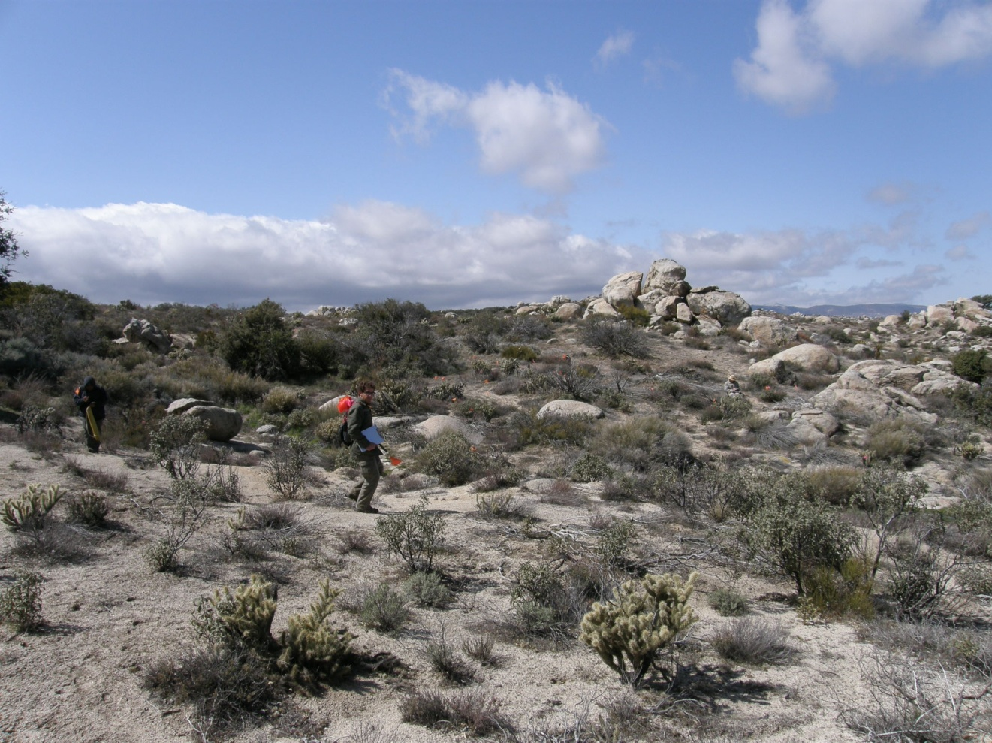

Figure 4.20 Overview of Tule-BC-63.
Artifacts include 27 brownware sherds (25 body, two rim), one metavolcanic core, four metavolcanic interior flakes, one chert interior flake, one interior quartz flake, two quartz shatter, one quartz Desert Side-notched projectile point and one chert Elko projectile point. All four of the bone fragments are located near the drainage towards the bottom of the slope. Three of the bones are calcined (two are indeterminate, one may be a clavicle) and one does not appear to be burned (cranium). None of the bones could be identified in the field as human or non-human but it is possible that they derive from a human cremation. The Elko projectile point was found at the south end of the site in the dry bed of the drainage. Vegetation is sparse in the site but is very dense in portions of the drainage and on the east side of the drainage. Soil at the site consists of coarse granitic sand and light brown silt. Some areas of the site have the potential to contain buried cultural deposits, including an area near the bottom of the slope alongside the drainage. However, no midden soils were identified. The relatively higher data potential at this site indicates that it may meet the criteria for NRHP eligibility.

Tule-BC-64
This site is an artifact scatter covering a 70-x-48-m area. The site is located at the end of a dirt road at the northeast end of Thing Valley at the edge of a steep canyon. A large drainage begins at the north edge of the site at the mouth of the canyon which leads down to the desert floor. Artifacts at the site include eight metavolcanic flakes, five quartzite shatter, three quartz shatter, one metavolcanic core, one granite handstone, two granite millingstone fragments and seven brownware ceramic sherds. Disturbances to the site include extensive vegetation clearing, as evidenced by brush piles, and the dirt road. A few small, moderately exfoliated boulders are present at the site. Vegetation includes chamise, buckwheat, sugarbush, manzanita, yucca and grass. The soil matrix consists of light brown silty decomposing granite and has a low potential for buried cultural deposits. This site has low data potential and does not appear to meet NRHP eligibility criteria.

Tule-BC-65
This site consists of a small ceramic scatter of 12 brownware sherds covering a 4-x-4-m area. The site is situated on a mid-slope shelf on the eastern slope of a large mountain, overlooking Thing Valley. The nearest water source is a seasonal drainage in a steep canyon approximately 250 m to the east. Numerous small, highly exfoliated granite boulders are present in the surrounding area. Vegetation includes chamise, yucca, scrub oak and holly-leaf redberry. Soil at the site consists of decomposing granite and has a low potential for buried deposits. This site has low data potential and does not appear to meet NRHP eligibility criteria.

Tule-CW-03
This small habitation site covers a 50-x-50-m area located at the top of a small knoll with a commanding view of McCain Valley and a partial view of the Anza Borrego Desert. The site contains one milling station with two mortars, more than 100 flakes, 40 brownware potsherds, two handstones, and one hammerstone. There is one chipping station that contains a concentration of approximately 40 flakes. There is an abundance of exfoliating bedrock that may be obscuring previous milling stations. The site is in good condition; however, there is modern debris present, indicating some recent occupation. Much of the site matrix is decomposing granitic sand. However, there is slight discoloration to a small patch of silty sand near the milling station that may indicate midden development. The presence of these deposits indicates that this site may meet the criteria for NRHP eligibility pending a formal evaluation.

Tule-CW-30
This is a single bedrock milling station with one milling slick located on a small hillside bordered by two small streams. The boulder containing the feature measures 2-x-3-m in size. There is an abundant amount of exposed bedrock in the area; however, no other boulders contain milling surfaces. There are no associated artifacts or midden soil. This site has low data potential and does not appear to meet the criteria for NRHP eligibility.

Tule-CW-31
This small ceramic scatter is located on the top of a small ridgeline. The ceramic scatter includes 42 brownware ceramic sherds in a 2-x-3-m area that probably derive from a single pot drop. No other artifacts or midden soil was found. This site has low data potential and does not appear to meet the criteria for NRHP eligibility.

Tule-CW-33
This is a ceramic scatter located on a small knoll northeast of McCain Valley Road. Ceramics consist of approximately 10 brownware potsherds in a 3-x-2-m area, likely representative of a single pot-drop event. There is no midden soil or other artifacts present. This site has low data potential and does not appear to meet the criteria for NRHP eligibility.

Tule-CW-34
This site is located approximately northeast of McCain Valley Road at the top of a small hill. This artifact scatter consists of a single bedrock milling station that contains one milling slick, 18 brownware potsherds, four buffware potsherds, and four green metavolcanic flakes covering a 30-x-90-m area. No midden soil was identified and there is low potential for subsurface cultural deposits. This site has low data potential and does not appear to meet the criteria for NRHP eligibility.

Tule-CW-35
This historic refuse deposit is located west of McCain Valley Road and south of a conservation camp. The refuse deposit measures 70 x 35 m in size and contains more than 200 cans, several broken glass bottles, and some fragments of china. The concentrated dump point contains 104 sanitary cans, four meat cans, one fuel can, more than 100 purple and clear glass fragments, as well as a few fragments of white improved earthenware. There is also what appears to be a concrete water catch basin that has a date of 20-7-1944 inscribed on it as well as a date of 10/52 on a repaired area. These dates appear to be consistent with the associated refuse. This site has low data potential and does not appear to have a subsurface cultural deposit other than the partly buried concrete feature. This site has low data potential and does not appear to meet the criteria for NRHP eligibility.

Tule-CW-36
This is a historic refuse deposit that covers a 30-x-30-m area. It is located west of McCain Valley Road and south of the conservation camp. The site consists of more than 200 cans (sanitary, paint, meat, coffee, baking powder, and fuel) and 75 bottles (clear, green, purple, and brown glass). Two bottles have maker’s marks that help to date the site, including the Illinois Pacific Glass Company (1902-1930) and ABGM Company (1904-1916). These dates imply an early twentieth century age for the dump episode. This site has low data potential and does not appear to meet the criteria for NRHP eligibility.

Tule-CW-40
This site is a small lithic and pottery scatter covering a 40-x-40-m area situated between two small intermittent streams. The scatter is sparse with 10 flakes and four brownware sherds. However, there are several lithic material types present, including chert, green metavolcanic, quartz, chalcedony, and obsidian. Several low-lying granite outcrops are highly exfoliated and it is possible that they may once have contained milling surfaces. No midden soil was identified and it is unlikely that buried cultural deposits are present. This site has low data potential and does not appear to meet the criteria for NRHP eligibility.

Tule-CW-41
This historic archaeological site is located within Rough Acres Ranch and consists of a windmill, several water tanks, and a water trough in a 20-x-30-m area. The large water tank had a wooden roof that has since collapsed. One of the other water tanks is round. No associated artifacts were identified and it is not likely that the site contains subsurface deposits. This site has low data potential and does not appear to meet the criteria for NRHP eligibility.

Tule-CW-42
This site is located within Rough Acres Ranch and consists of a sparse artifact scatter covering a 80-x-80-m area. The site contains approximately 17 green metavolcanic and quartz flakes, nine brownware sherds, one scraper, and one core. Most of the area has been disturbed by heavy equipment related to rubbish removal. Regardless of these disturbances, this site has a low potential for intact subsurface cultural deposits. This site has low data potential and does not appear to meet the criteria for NRHP eligibility.

Tule-CW-43
This small habitation site covers a 20-x-20-m area located within Rough Acres Ranch and consists of a rock shelter and a sparse lithic and potsherd scatter (Figure 4.21). The rock shelter has an interior area of approximately 1 x 2 m, and it contains several potsherds. Outside the rock shelter, the artifact scatter contains approximately six flakes, 11 brownware potsherds, and one buffware potsherd. The rock shelter has a thin mantle of midden soil; however, this could be due to modern occupation. The rock shelter appears to have been utilized recently as a camping area for migrants, based upon modern debris located in the shelter. The possibility of recovering cultural material from subsurface deposits in the rock shelter indicates that this site has relatively higher data potential and may meet the criteria for NRHP eligibility under Criterion D.
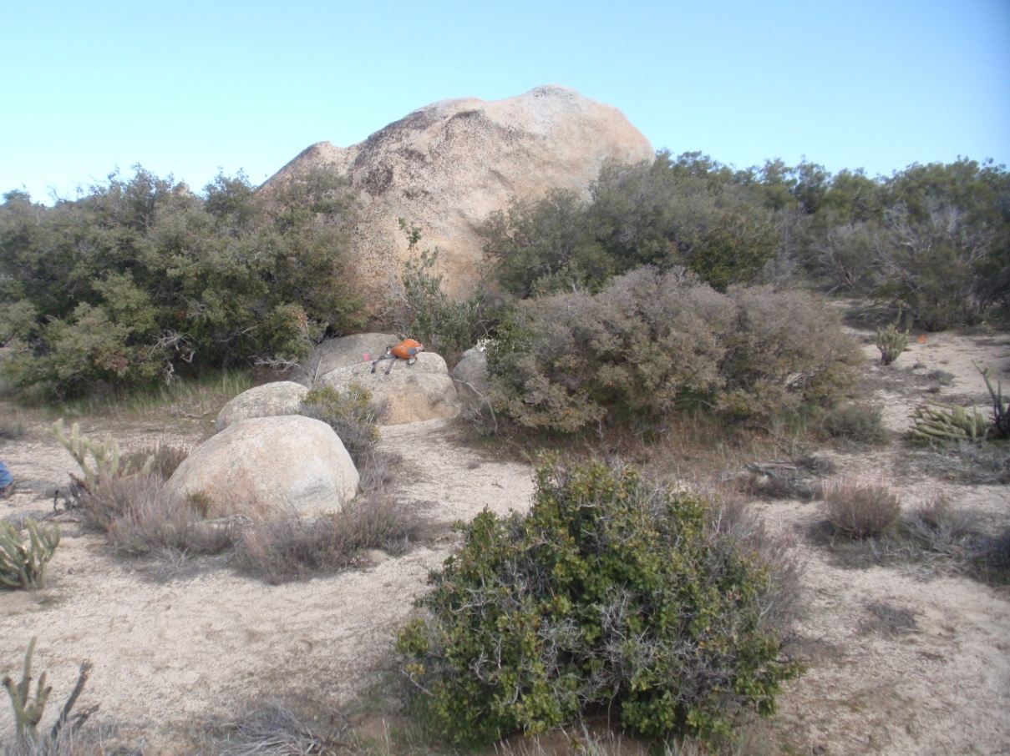

Figure 4.21 Overview of Tule-CW-43.

Tule-CW-44
This artifact scatter covers a small, 3-x-5-m area located in Rough Acres Ranch. The assemblage consists of approximately 48 potsherds, two metavolcanic flakes, and one broken handstone. No midden soil or other features were identified and no evidence was found to indicate that the site contains buried cultural material. This site has low data potential and does not appear to meet the criteria for NRHP eligibility.

4.4 ISOLATED FINDS
A total of 228 isolates were documented during the Class III and Class II inventories (Table 4.2; Figures 4.22a-4.22d [in Appendix A]). This includes 166 isolates documented in the Class III APE and 62 isolates documented in Class II sample survey areas. Of those isolates identified in the Class III APE, 143 are newly documented, and include 137 prehistoric isolates and six historic isolates. The remaining 23 previously recorded isolates in the Class III APE include 21 prehistoric isolates and two historic isolates. All 62 isolates in the Class II inventory are newly documented—60 of these are prehistoric and two are historic in age (see Table 4.2).
Table 4.2 Isolated Artifacts by Survey

Class III Newly  Documented Isolates | Survey | Description
Tule-BC-I-1 | Class III | 1 Green metavolcanic secondary flake
Tule-BC-I-2 | Class III | 1 Metavolcanic shatter
Tule-BC-I-3 | Class III | 2 Brownware ceramics
Tule-BC-I-4 | Class III | 1 Metavolcanic primary flake
Tule-BC-I-8 | Class III | 1 Metavolcanic biface thinning flake, 1 metavolcanic shatter
Tule-BC-I-9 | Class III | 1 Metavolcanic shatter
Tule-BC-I-10 | Class III | 1 Metavolcanic shatter
Tule-BC-I-12 | Class III | 4 Amethyst glass shards form 1 bottle w/ "PCGW" embossed on base
Tule-BC-I-13 | Class III | 1 Metavolcanic shatter
Tule-BC-I-14 | Class III | 1 Brown Duraglass bottle: Owens-Illinois, plant 20, year code 7.
Tule-BC-I-16 | Class III | 1 Brownware ceramic sherd
Tule-BC-I-19 | Class III | 1 Metavolcanic secondary flake
Tule-BC-I-20 | Class III | 1 Brownware ceramic
Tule-BC-I-21 | Class III | 1 Quartz flake
Tule-BC-I-22 | Class III | 1 Metavolcanic hammerstone/multidirectional core
Tule-BC-I-23 | Class III | 1 Metavolcanic flake
Tule-BC-I-24 | Class III | 1 Metavolcanic flake
Tule-BC-I-25 | Class III | 1 Metavolcanic flake
Tule-BC-I-26 | Class III | 1 Quartz flake
Tule-BC-I-27 | Class III | 1 Granite millingstone fragment
Tule-BC-I-28 | Class III | 1 Metavolcanic flake
Tule-BC-I-29 | Class III | 2 Quartz flakes
Tule-BC-I-30 | Class III | 1 Granite millingstone fragment
Tule-BC-I-31 | Class III | 1 Granite millingstone fragment
Tule-BC-I-32 | Class III | 2 Brownware ceramics
Tule-BC-I-33 | Class III | 1 Granite handstone
Tule-BC-I-34 | Class III | 1 Metavolcanic chopper
Tule-BC-I-35 | Class III | 1 Two-gallon metal fuel can
Tule-BC-I-36 | Class III | 1 Quartz flake
Tule-BC-I-37 | Class III | 1 Metavolcanic hammerstone
Tule-BC-I-38 | Class III | 1 Red & white chert flake
Tule-BC-I-39 | Class III | 1 Brownware ceramic, 1 metavolcanic debitage
Tule-BC-I-40 | Class III | 3 Brownware ceramics
Tule-BC-I-41 | Class III | 1 Metavolcanic flake
Tule-BC-I-42 | Class III | 1 Metavolcanic debitage
Tule-BC-I-43 | Class III | 1 Metavolcanic flake
Tule-BC-I-44 | Class III | 1 Metavolcanic flake
Tule-BC-I-45 | Class III | 1 Metavolcanic flake
Tule-BC-I-46 | Class III | 1 Metavolcanic flake
Tule-BC-I-47 | Class III | 1 Metavolcanic flake
Tule-BC-I-48 | Class III | 2 Quartz flakes
Tule-BC-I-49 | Class III | 1 Metavolcanic flake
Tule-BC-I-50 | Class III | 1 Metavolcanic flake
Tule BC-I-51 | Class III | 1 Quartz flake
Tule BC-I-52 | Class III | 3 Brownware ceramics
Tule-BC-I-53 | Class III | 1 Granite handstone frag; shaped, polished, bifacial, shouldered
Tule-BC-I-54 | Class III | 1 Quartz shatter
Tule-BC-I-55 | Class III | 1 Metavolcanic interior flake
Tule-BC-I-56 | Class III | 2 Brownware ceramics
Tule-BC-I-57 | Class III | 1 Metavolcanic shatter
Tule-BC-I-58 | Class III | 1 Metavolcanic shatter
Tule-BC-I-59 | Class III | 1 Metavolcanic secondary flake
Tule-BC-I-60 | Class III | 2 Metavolcanic interior flakes
Tule-BC-I-61 | Class III | 1 Metavolcanic shatter, 1 metavolcanic secondary flake
Tule-BC-I-62 | Class III | 1 Basalt secondary flake, 1 granite handstone
Tule-BC-I-63 | Class III | 1 Metavolcanic interior flake
Tule-BC-I-64 | Class III | 1 Metavolcanic shatter, 1 metavolcanic interior flake
Tule-BC-I-65 | Class III | 1 Metavolcanic shatter
Tule-BC-I-66 | Class III | 1 Metavolcanic shatter
Tule-BC-I-67 | Class III | 1 Multidirectional metavolcanic core
Tule-BC-I-68 | Class III | 1 Metavolcanic secondary flake
Tule-BC-I-69 | Class III | 1 Metavolcanic interior flake
Tule-BC-I-70 | Class III | 1 Metavolcanic secondary flake
Tule-BC-I-78 | Class III | 1 Metavolcanic secondary flake
Tule-BC-I-79 | Class III | 1 Metavolcanic secondary flake
Tule-BC-I-80 | Class III | 1 Metavolcanic interior flake
Tule-BC-I-81 | Class III | 1 Brownware ceramic
Tule-BC-I-83 | Class III | 1 Quartz interior flake. 1 metavolcanic interior flake
Tule-BC-I-84 | Class III | 2 Brownware ceramic sherds
Tule-BC-I-85 | Class III | 1 Metavolcanic shatter
Tule-BC-I-86 | Class III | 1 Metavolcanic interior flake, 1 metavolcanic shatter, 1 quartz shatter
Tule-BC-I-87 | Class III | 1 Brownware ceramic
Tule-BC-I-88 | Class III | 1 Quartz interior flake. 1 metavolcanic interior flake
Tule-BC-I-89 | Class III | 2 Metavolcanic interior flakes
Tule-BC-I-90 | Class III | 1 Metavolcanic interior flake
Tule-BC-I-91 | Class III | 1 Metavolcanic interior flake
Tule-BC-I-92 | Class III | 2 Metavolcanic interior flakes
Tule-BC-I-93 | Class III | 1 Metavolcanic interior flake
Tule-BC-I-94 | Class III | 1 Metavolcanic interior flake
Tule-BC-I-95 | Class III | 1 Metavolcanic secondary flake
Tule-BC-I-96 | Class III | 1 Metavolcanic shatter
Tule-BC-I-97 | Class III | 1 Metavolcanic shatter
Tule-BC-I-113 | Class III | 1 Granite handstone
Tule-BC-I-114 | Class III | 1 Metavolcanic interior flake
Tule-BC-I-115 | Class III | 1 Metavolcanic secondary flake
Tule-BC-I-116 | Class III | 1 Metavolcanic secondary flake
Tule-BC-I-117 | Class III | 1 Obsidian interior flake
Tule-BC-I-118 | Class III | 1 Metavolcanic interior flake
Tule-BC-I-119 | Class III | 1 Metavolcanic interior flake
Tule-BC-I-120 | Class III | 1 Metavolcanic interior flake
Tule-BC-I-123 | Class III | 1 Late-stage Quartz biface fragment
Tule-BC-I-124 | Class III | 1 Metavolcanic interior flake
Tule-BC-I-125 | Class III | 1 Metavolcanic interior flake
Tule-BC-I-126 | Class III | 1 brownware ceramic
Tule-BC-I-127 | Class III | 1919 USGLO survey marker with rock cairn and modern petroglyph
Tule-BC-I-128 | Class III | 1 brownware ceramic
Tule-BC-I-129 | Class III | 1 Mining adit and tailings pile
Tule-BC-I-131 | Class III | 1 Brownware ceramic
Tule-BC-I-132 | Class III | 1 Brownware ceramic
Tule-BC-I-133 | Class III | 1 Brownware ceramic
Tule-BC-I-134 | Class III | 1 Quartz flake
Tule-BC-I-135 | Class III | 3 Brownware ceramics
Tule-BC-I-136 | Class III | 6 Brownware sherds
Tule-BC-I-137 | Class III | 1 Quartz shatter, 1 metavolcanic interior flake
Tule-BC-I-138 | Class III | 1 Quartz Cottonwood projectile point
Tule-BC-I-139 | Class III | 1 Prospecting pit, tailings and a mining claim
Tule-CW-I-01 | Class III | 4 Brownware sherds
Tule-CW-I-02 | Class III | 4 Brownware sherds
Tule-CW-I-03 | Class III | Bifacial handstone fragment
Tule-CW-I-04 | Class III | Unifacial quartz handstone
Tule-CW-I-05 | Class III | Metavolcanic flake
Tule-CW-I-07 | Class III | Metavolcanic flake
Tule-CW-I-08 | Class III | 3 Brownware sherds
Tule-CW-I-09 | Class III | 1 Quartzite hammerstone
Tule-CW-I-14 | Class III | 2 Metavolcanic Flakes
Tule-CW-I-15 | Class III | 1 Metavolcanic flake
Tule-CW-I-16 | Class III | 1 Metavolcanic flake
Tule-CW-I-17 | Class III | 1 Metavolcanic flake
Tule-CW-I-18 | Class III | 1 Quartz flake
Tule-CW-I-19 | Class III | 3 Metavolcanic flakes
Tule-CW-I-20 | Class III | 1 Quartz flake
Tule-CW-I-21 | Class III | 2 Metavolcanic Flakes
Tule-CW-I-22 | Class III | 1 Metavolcanic flake
Tule-CW-I-23 | Class III | 3 Metavolcanic flakes
Tule-CW-I-24 | Class III | 2 Metavolcanic Flakes
Tule-CW-I-25 | Class III | 1 Quartz flake
Tule-CW-I-26 | Class III | 2 Brownware sherds
Tule-CW-I-27 | Class III | 2 Quartz flakes
Tule-CW-I-28 | Class III | Handstone fragment
Tule-CW-I-29 | Class III | 1 Chert flake
Tule-CW-I-30 | Class III | 2 brownware sherds, 1 flake
Tule-CW-I-31 | Class III | 1 Sandstone cobble handstone
Tule-CW-I-32 | Class III | 1 Green metavolcanic multidirectional core/handstone
Tule-CW-I-33 | Class III | 1 Green metavolcanic flake
Tule-CW-I-34 | Class III | 1 Green metavolcanic flake
Tule-CW-I-35 | Class III | 1 Brownware ceramic
Tule-CW-I-36 | Class III | 1 Green metavolcanic flake
Tule-CW-I-37 | Class III | 2 Green metavolcanic flakes
Tule-CW-I-38 | Class III | 2 Green metavolcanic flakes
Tule-CW-I-39 | Class III | 2 Green metavolcanic flakes, 1 brownware sherd
Tule-CW-I-60 | Class III | 1 metavolcanic interior flake, 1 quartz interior flake
Tule-EP-I-1 | Class III | 1 Metavolcanic secondary flake
Tule-EP-I-2 | Class III | 1 metavolcanic shatter

Class III Previously  Recorded Isolates | Survey | Description
BW-I-162 | Class III | historic can
BW-I-163 | Class III | historic can
BW-I-164 | Class III | historic can
BW-I-124 | Class III | 1 volcanic flake
BW-I-165 | Class III | 1 flake
BW-I-166 | Class III | 1 flake
BW-I-167 | Class III | 1 flake
BW-I-168 | Class III | 1 flake
BC-I-02 | Class III | 1 flake
BC-I-03 | Class III | 1 volcanic flake
BW-I-127 | Class III | 2 flakes
P-37-029736 | Class III | 2 brownware ceramics
P-37-029738 | Class III | 1 quartz flake
P-37-029745 | Class III | 1 metavolcanic secondary flake
P-37-029746 | Class III | 1 brown basalt secondary flake
P-37-030262 | Class III | No Information
P-37-030264 | Class III | No Information
P-37-030265 | Class III | No Information
P-37-030266 | Class III | 1 metavolcanic debitage
P-37-030356 | Class III | 1 metavolcanic debitage
P-37-030363 | Class III | 1 metavolcanic debitage
BC-I-17a | Class III | 1 flake
ISO-CC-20/BC-I-17b | Class III | 1 flake

Class II Newly  Documented Isolates | Survey | Description
Tule-BC-I-5 | Class II | 1918 USGLO survey marker with rock pile
Tule-BC-I-6 | Class II | 1918 USGLO survey marker with rock pile
Tule-BC-I-7 | Class II | 2 Granite handstones
Tule-BC-I-11 | Class II | 1 Metavolcanic secondary flake
Tule-BC-I-15 | Class II | 1 Metavolcanic interior flake
Tule-BC-I-17 | Class II | 1 Metavolcanic secondary flake
Tule-BC-I-18 | Class II | 1 Quartz interior flake
Tule-BC-I-71 | Class II | 1 Metavolcanic interior flake, 1 quartz flake
Tule-BC-I-72 | Class II | 1 Brownware ceramic
Tule-BC-I-73 | Class II | 1 Metavolcanic interior flake
Tule-BC-I-74 | Class II | 1 metavolcanic interior flake
Tule-BC-I-75 | Class II | 1 Metavolcanic secondary flake
Tule-BC-I-76 | Class II | 1 Metavolcanic hammerstone fragment
Tule-BC-I-77 | Class II | 1 Buffware ceramic
Tule-BC-I-98 | Class II | 1 Metavolcanic interior flake
Tule-BC-I-99 | Class II | 1 Metavolcanic interior flake
Tule-BC-I-100 | Class II | 1 Granite millingstone fragment
Tule-BC-I-101 | Class II | 1 Granite handstone
Tule-BC-I-102 | Class II | 1 Metavolcanic shatter, 1 metavolcanic interior flake
Tule-BC-I-103 | Class II | 1 metavolcanic interior flake
Tule-BC-I-104 | Class II | 1 Metavolcanic secondary flake
Tule-BC-I-105 | Class II | 1 Red chert shatter
Tule-BC-I-106 | Class II | 1 Metavolcanic interior flake
Tule-BC-I-108 | Class II | 1 Metavolcanic interior flake
Tule-BC-I-109 | Class II | 1 Metavolcanic interior flake
Tule-BC-I-110 | Class II | 1 Metavolcanic interior flake
Tule-BC-I-111 | Class II | 1 Obsidian interior flake
Tule-BC-I-112 | Class II | 1 Granite handstone fragment
Tule-BC-I-121 | Class II | 2 Brownware ceramics
Tule-BC-I-122 | Class II | 2 Quartz interior flakes
Tule-BC-I-130 | Class II | 1 Buffware ceramic
Tule-CW-I-06 | Class II | Metavolcanic flake
Tule-CW-I-10 | Class II | 2 Brownware sherds
Tule-CW-I-11 | Class II | 2 Metavolcanic Flakes
Tule-CW-I-12 | Class II | 3 Brownware sherds
Tule-CW-I-13 | Class II | 3 Brownware sherds
Tule-CW-I-40 | Class II | 1 Unidirectional green metavolcanic core
Tule-CW-I-41 | Class II | 2 Green metavolcanic flakes
Tule-CW-I-42 | Class II | 1 Dark grey basalt interior flake
Tule-CW-I-43 | Class II | 3 Buffware sherds
Tule-CW-I-44 | Class II | 1 Buffware sherd
Tule-CW-I-45 | Class II | 1 Brownware sherd, 1 green metavolcanic flake
Tule-CW-I-46 | Class II | 1 Brownware sherd, 1 green metavolcanic flake
Tule-CW-I-48 | Class II | 2 Brownware sherds
Tule-CW-I-49 | Class II | 2 Brownware sherds
Tule-CW-I-50 | Class II | 1 Green metavolcanic flake
Tule-CW-I-51 | Class II | 2 Brownware sherds
Tule-CW-I-52 | Class II | 4 Brownware sherds
Tule-CW-I-53 | Class II | 1 Green metavolcanic flake
Tule-CW-I-54 | Class II | 2 Brownware sherds
Tule-CW-I-55 | Class II | 1 Brownware sherd
Tule-CW-I-56 | Class II | 1 Green metavolcanic flake
Tule-CW-I-57 | Class II | 2 Brownware sherds
Tule-CW-I-61 | Class II | 1 Brownware ceramic
Tule-CW-I-62 | Class II | 1 Green metavolcanic flake
Tule-CW-I-63 | Class II | 1 Pink granite handstone fragment
Tule-CW-I-64 | Class II | 3 Green metavolcanic flakes
Tule-CW-I-65 | Class II | 1 Green metavolcanic core
Tule-CW-I-66 | Class II | 2 Green metavolcanic flakes, 1 quartz flake
Tule-CW-I-67 | Class II | 1 Green metavolcanic flake
Tule-CW-I-68 | Class II | 1 Green metavolcanic core
Tule-CW-I-69 | Class II | 1 millingstone fragment

Historic isolates are relatively rare. Of the two isolates in Class II survey areas, both are 1918 USGLO survey markers surrounded by a rock cairn. Historic isolates in the Class III APE (n = 9) include one 1919 USGLO survey marker, two fragmented bottles, two prospect pits with tailings piles, and three food cans.

Prehistoric isolates are relatively common and generally represent background noise from intensive occupation in the general vicinity. That is, prehistoric isolates are traces of common activities at nearby sites that left fragments of pottery, debitage, and pieces of groundstone and flaked stone tools (see Table 4.2). Debitage leftover from flakedstone tool manufacture was the most commonly recorded isolate, followed by pieces of aboriginal pottery, then groundstone, and the occasional flaked stone tool. Each of these items is commonly found at prehistoric sites recorded in both the Class III APE and Class II survey areas.
Isolated artifacts are defined by their isolation from more extensive artifact scatters and are not associated with cultural deposits. The inability to make associations between isolated finds and nearby cultural deposits further reduces the data potential of isolates, even when considering all isolated finds as one assemblage. For these reasons, isolates are not considered eligible for NRHP listing.

4.5 SUMMARY
In all, the pedestrian surveys of the Class III APE and Class II sample inventory areas resulted in the documentation of 151 cultural resources, including 108 within the Class III APE and 43 within the Class II sample inventory area. Of those resources in the Class III APE, one is the historic Highway 80 that was documented in an historic context for SDG&E’s Sunrise Powerlink project, finding that some road segments are contributing elements to its NRHP listing. The remaining Class III resources include 39 others that were previously recorded, and 68 newly documented sites. Within the Class II sample survey, 34 sites are newly documented and nine were previously recorded. Six previously recorded archaeological sites could not be found. Preliminary eligibility assessments for each resource were provided in the site descriptions. Those sites that likely meet the criteria for NRHP listing are discussed in further detail in Chapter 5.

5. SUMMARY AND CONCLUSIONS
The current Class III and Class II inventories were conducted to satisfy the requirements of CEQA and Section 106 of the NHPA. Important in such an endeavor is the development of an understanding of each identified resource in such a way that its historical significance can be assessed. CEQA and Section 106 of the NHPA mandate the consideration of the historical significance of a resource in an effort to gauge whether it has the potential to be listed on the CRHR or NRHP, respectively. As discussed in section 1.4 of Chapter 1, criteria 1-4 of CEQA and criteria A-D of Section 106 are similar sets of standards for determining the eligibility of a resource for CRHR or NRHP listing. The following sections discuss how survey-level data from the Class III and Class II inventories are integrated to develop eligibility assessments for each resource. However, in keeping with current BLM guidance, these assessments are not to be construed as formal eligibility recommendations but are provided to facilitate a project design that will eliminate or minimize impacts to the identified cultural resources. Further discussion with the BLM will help define the requirements for making formal eligibility recommendations, such that cultural resources with extremely low data potential (i.e., lithic scatters and ceramic scatters with no subsurface deposit) may then be recommended as not eligible for NRHP listing without further fieldwork evaluation efforts.

It is the intent of IBR to design the wind energy generation facility in such a way that project construction and maintenance will have no significant impact on known cultural resources. Should complete avoidance of impacts be achieved, a memorandum of understanding (MOU) will be developed between the BLM and IBR. Consistent with current BLM guidance, in the event that project construction cannot avoid impacts to cultural resources, formal evaluation of the potentially impacted resources will have to occur to make formal determinations of NRHP and CRHR eligibility. Eligible cultural resources will then have to be avoided or subject to data recovery. A programmatic agreement (PA) will be developed in place of an MOU if project construction and maintenance will have significant impacts to cultural resources. It is also the intent of the BLM to develop with IBR a Historic Properties Management Plan (HPMP) that will provide guidance for the future management of known cultural resources within the project area. The HPMP will include a monitoring plan and an inadvertent discovery plan that must be in place before the BLM will issue a notice to proceed (NTP) for project construction.

5.1 PRELIMINARY NRHP AND CRHR ELIGIBILITY ASSESSMENTS AND RESEARCH THEMES
The main goal of the current Class III and Class II sample inventories was to identify cultural resources located within the project APE, thereby facilitating efforts by IBR to achieve avoidance of impacts through project design. Efforts to avoid all impacts to cultural resources treat each cultural resource as potentially eligible for NRHP and CRHR listing. However, in the event that impacts to some cultural resources cannot be avoided, ASM’s survey was also designed to generate detailed information from surface deposits that could be used to provide preliminary assessments of NRHP and CRHR eligibility, with the idea that impacts to potentially eligible sites would be avoided.

Preliminary eligibility assessments were based solely on criterion D of Section 106, and criterion 4 of CEQA, since the inventory generated data that could be used to judge whether a particular cultural resource has yielded or may be likely to yield information important in prehistory or history. To date, no information has been generated through Native American consultation that could tie any of the aboriginal archaeological sites to particular place names or identify them as sacred sites. Additionally, some of the historic cultural resources that include structural remains will require archival research to determine possible associations with persons or events important in the region’s history. Thus, each cultural resource was assessed for eligibility based on the data potential of its general archaeological characteristics—i.e., assemblage integrity, size, diversity, defined chronology, and the potential for buried deposits.

The value of individual archaeological sites must be understood in a regional context wherein large numbers of small assemblages that are limited in size and diversity can inform on broad land use patterns. Some individual sites have large, diverse assemblages with buried, datable deposits and these typically hold enough data potential to be considered eligible for NRHP and CRHR listing in that they can refine local and regional occupational patterns. Sites that are generally not considered eligible are those with low data potential, typically offering information that is redundant within local and regional contexts. Physical integrity of a site is a major factor in determining data potential of an archaeological deposit. Sites with compromised integrity make it difficult to draw associations between assemblage constituents and complicate the chronology of site occupation. In this sense, sites that lack strong physical integrity are typically ineligible for NRHP and CRHR listing unless the cultural deposit is robust and diverse enough that salvage work would produce a particularly unique dataset.

While it is not possible to prepare formal, substantive eligibility recommendations based on surface inventory data alone, preliminary assessments from survey-level data are often effective in assessing eligibility where resources offer redundant data, have little to no potential for dating or for the presence of buried components, and have poor physical integrity. Essentially, it is often obvious from the surface if a resource is not likely to be eligible for NRHP or CRHR listing. Examples of such resources include sites with a low density and/or diversity of artifacts spread over areas that lack deposition. Even when some subsurface deposits exist, it is often easy to determine whether formal evaluation would exhaust the data potential of those deposits, rendering the site ineligible.

Table 5.1 lists sites identified in the current Class III and Class II inventories according to potentially eligibility for NRHP and CRHR listing. Considering historic Highway 80 (site # 37-024023), SDG&E commissioned a historic properties study that included the Highway 80 corridor finding certain segments to be contributing elements to its NRHP eligible status. In particular, sections of Old Highway 80 still remain as main streets in El Cajon, Alpine, Pine Valley, and Jacumba, having the old road surface, alignment, and width preserved.
Table 5.1 Attributes of Recorded Archaeological Sites by Eligibility

Site | Survey | Landholder | Site Type | Age | Site Size (m) | Lithics | Groundstone | Ceramics | Bedrock Milling | Rock Shelters | Potential Chronological Indicators | Midden or Buried Deposits | Historic Refuse | Historic Structures/ Features |  | Potential Eligibility  NRHP Status
Class III Eligible Sites (n = 15) |  |  |  |  |  | Prehistoric Attributes |  |  |  |  |  |  | Historic Attributes |  | Data Potential
37-024023 | Class III | Intersects BIA, Private, BLM | Highway 80 | Historic | NA | NA | NA | NA | NA | NA | Yes | NA | NA | NA | NA | Segments of road are contributing elements to NRHP listing
SDI-10359 | Class III | BLM, Private | Large Habitation | Prehistoric | 325 x 150 | Yes | - | Yes | Yes | - | Yes | Yes |  | - | High | Potentially Eligible
SDI-17817 | Class III | BLM | Large Habitation | Prehistoric | 270 x 150 | Yes | - | Yes | Yes | - | Yes | Yes | - | - | Moderate | Potentially Eligible
SDI-19001/ 19003 | Class III | BLM, Private | Large Habitation | Prehistoric | 280 x 170 | Yes | Yes | Yes | Yes | Yes | Yes | Yes | - | - | High | Potentially Eligible
SDI-19018 | Class III | BLM | Small Habitation | Prehistoric | 120 x 90 | Yes | - | Yes | Yes | - | Yes | Yes | - | - | Moderate | Potentially Eligible
SDI-7150 | Class III | BLM | Small Habitation | Prehistoric | 4 x 4 | Yes | - | Yes | - | Yes | Yes | Yes |  | - | Moderate | Potentially Eligible
SDI-9223/ 17816 | Class III | BLM | Large Habitation | Prehistoric | 480 x 90 | Yes | - | Yes | Yes | - | Yes | Yes |  | - | Moderate | Potentially Eligible
SDI-19364/  SPBB-S-1 | Class III | BLM | Large Habitation | Prehistoric | 280 x 237 | Yes | Yes | - | - | - | Yes | Yes | - | - | Moderate | Potentially Eligible
Tule-BC-35 | Class III | Private | Large Habitation | Prehistoric | 435 x 220 | Yes | Yes | Yes | Yes | - | Yes | Yes | - | - | High | Potentially Eligible
Tule-BC-54 | Class III | State, Private | Small Habitation | Prehistoric | 125 x 92 | Yes | Yes | - | Yes | - | Yes | Yes | - | - | High | Potentially Eligible
Tule-CW-11 | Class III | Private | Small Habitation | Prehistoric | 30 x 50 | Yes | - | Yes | Yes | Yes | Yes | Yes | - | - | High | Potentially Eligible
Tule-CW-12 | Class III | BLM, Private | Small Habitation | Prehistoric | 230 x 150 | Yes | Yes | Yes | Yes | - | Yes | Yes | - | - | Moderate | Potentially Eligible
Tule-CW-17 | Class III | BLM, Private | Small Habitation | Prehistoric | 50 x 50 | Yes | Yes | Yes | Yes | Yes | Yes | Yes | - | - | Moderate | Potentially Eligible
Tule-CW-25 | Class III | Private | Home Site | Historic | 50 x 40 (150 x 120 ft) | - | - | - | - | - | Yes | - | Yes | Yes | Moderate | Potentially Eligible
Tule-EP-08 | Class III | Private | Large Habitation and Historic Homesite | Both | 270 x 270 | Yes | Yes | Yes | Yes | - | Yes | Yes | Yes | Yes | Moderate | Potentially Eligible
Class III Ineligible Sites and Sites with Uncertain Eligibility (n = 94) |  |  |  |  |  | Prehistoric Attributes |  |  |  |  |  |  | Historic Attributes |  | Data Potential | Potential Eligibility NRHP Status
SDI-1151 | Class III | BLM | Artifact Scatter | Prehistoric | 50 x 27 | Yes | - | Yes | Yes | - | - | - | - | - | Low | Likely Ineligible
SDI-4788 | Class III | BLM, State, Private | Artifact Scatter | Prehistoric | 670 x 160 | Yes | - | - | Yes | - | - | - | - | - | Low | Likely Ineligible
SDI-6897 | Class III | Private | Artifact Scatter | Prehistoric | 90 x 50 | Yes | - | Yes | - | - | Yes | - | - | - | Low | Likely Ineligible
SDI-6900 | Class III | Private | BMS and HPRD | Both | 60 x 55 | - | - | - | Yes | - | Yes | - | Yes | - | Low | Likely Ineligible
SDI-9225 | Class III | BLM | Large Habitation | Prehistoric | 200 x 150 | Yes | Yes | Yes | Yes | Yes | - | - | Yes | - | Low | Likely Ineligible
SDI-16786 | Class III | Private | HPRD | Historic | 106 x 45 | - | - | - | - | - | Yes | - | Yes | - | Low | Likely Ineligible
SDI-16824 | Class III | Private | HPRD and foundations | Historic | 100 x 80 | - | - | - | - | - | Yes | - | Yes | Yes | Low | Likely Ineligible
SDI-16827 | Class III | Private | HPRD and structural remains | Historic | 100 x 75 | - | - | - | - | - | Yes | - | Yes | Yes | Low | Uncertain
SDI-17118 | Class III | BLM | Artifact Scatter | Prehistoric | 10 x 30 | Yes | - | Yes | - | - | - | - | - | - | Low | Likely Ineligible
SDI-17119 | Class III | BLM | Ceramic Scatter | Prehistoric | 5 x 12 | - | - | Yes | - | - | - | - | - | - | Low | Likely Ineligible
SDI-17815 | Class III | BLM | Lithic Scatter | Prehistoric | 11 x 7 | Yes | - | - | - | - | - | - | - | - | Low | Likely Ineligible
SDI-17822 | Class III | BLM | Lithic Scatter | Prehistoric | 35 x 30 | Yes | Yes | Yes | Yes | - | - | - | - | - | Low | Likely Ineligible
SDI-17829 | Class III | BLM | Lithic Scatter | Prehistoric | 13 x 11 | Yes | - | - | - | - | Yes | - | - | - | Low | Likely Ineligible
SDI-17830 | Class III | BLM | Artifact Scatter | Prehistoric | 22 x 6 | Yes | - | Yes | - | - | Yes | - | - | - | Low | Likely Ineligible
SDI-18050 | Class III | BLM | Artifact Scatter | Prehistoric | 10 x 3 | - | Yes | Yes | - | - | - | - | - | - | Low | Likely Ineligible
SDI-18054 | Class III | BLM | Ceramic Scatter | Prehistoric | 15 x 12 | - | - | Yes | - | - | - | - | - | - | Low | Likely Ineligible
SDI-18993 | Class III | Private | HPRD | Historic | 15 x 11 | - | - | - | - | - | Yes | - | Yes | - | Low | Likely Ineligible
SDI-18994 | Class III | Private | HPRD | Historic | 27 x 13 | - | - | - | - | - | Yes | - | Yes | - | Low | Likely Ineligible
SDI-19000 | Class III | BLM | Artifact Scatter | Prehistoric | 56 x 35 | Yes | - | Yes | - | - | - | - | - | - | Low | Likely Ineligible
SDI-19002 | Class III | BLM | Large Habitation | Prehistoric | 130 x 750 | Yes | Yes | Yes | - | - | Yes | - | - | - | Low | Likely Ineligible
SDI-19045 | Class III | BLM | Artifact Scatter | Prehistoric | 140 x 75 | Yes | - | Yes | - | - | - | - | - | - | Low | Likely Ineligible
SDI-19291 | Class III | BLM | Ceramic Scatter | Prehistoric | 5 x 5 | - | - | Yes | - | - | - | - | - | - | Low | Likely Ineligible
SDI-19301 | Class III | BLM | Small Habitation | Prehistoric | 155 x 50 | Yes | - | Yes | - | - | - | - | - | - | Low | Likely Ineligible
SDI-19854  SDGE-BC-6 SPED-S-1 | Class III | BLM | Lithic Scatter and HPRD | Both | 39 x 25 | Yes | - | - | - | - | Yes | - | Yes | - | Low | Likely Ineligible
SDI-19857  SDGE-BC-9 | Class III | Private | Lithic Scatter | Prehistoric | 2 x 1 | Yes | - | - | - | - | - | - | - | - | Low | Likely Ineligible
SDI-19860  SDGE-BC-13 | Class III | BLM | Bedrock Milling Station | Prehistoric | 3 x 3 | - | - | - | Yes | - | - | - | - | - | Low | Likely Ineligible
SDI-19849  SDGE-BC-37 | Class III | BLM | Artifact Scatter | Prehistoric | 59 x 32 | Yes | - | Yes | - | - | - | - | - | - | Low | Likely Ineligible
SDI-19868  SDGE-BW-83 | Class III | BLM | Artifact Scatter | Prehistoric | 40 x 20 | Yes | - | - | - | - | - | - | - | - | Low | Likely Ineligible
SDI-19869  SDGE-BW-84 | Class III | BLM | Artifact Scatter | Prehistoric | 219 x 55 | Yes | - | Yes | - | - | - | - | - | - | Low | Likely Ineligible
SDI-19935  SDGE-BW-128 | Class III | BLM | Artifact Scatter | Prehistoric | 129 x 95 | Yes | Yes | - | - | - | - | - | - | - | Low | Likely Ineligible
SDI-19872  SDGE-BW-130 | Class III | Private | Lithic Scatter | Prehistoric | 31 x 20 | Yes | - | - | - | - | - | - | - | - | Low | Likely Ineligible
SDI-19851  SPED-S-5 | Class III | BLM | Artifact Scatter | Prehistoric | 84 x 24 | - | - | Yes | - | - | - | - | - | - | Low | Likely Ineligible
Tule-BC-01 | Class III | BLM | Bedrock Milling Station | Prehistoric | 4 x 2 | - | - | - | Yes | - | - | - | - | - | Low | Likely Ineligible
Tule-BC-02 | Class III | BLM | Small Habitation | Prehistoric | 60 x 40 | Yes | Yes | Yes | Yes | Yes | - | - | - | - | Low | Likely Ineligible
Tule-BC-03 | Class III | BLM | Artifact Scatter | Prehistoric | 69 x 45 | Yes | Yes | - | Yes | - | - | - | - | - | Low | Likely Ineligible
Tule-BC-04 | Class III | BLM | Bedrock Milling Station | Prehistoric | 5 x 1 | - | - | Yes | Yes | - | - | - | - | - | Low | Likely Ineligible
Tule-BC-09 | Class III | Private | Artifact Scatter | Prehistoric | 34 x 5 | Yes | - | Yes | - | - | - | - | - | - | Low | Likely Ineligible
Tule-BC-10 | Class III | Private | Artifact Scatter | Prehistoric | 15 x 10 | Yes | Yes | Yes | - | - | - | - | - | - | Low | Likely Ineligible
Tule-BC-12 | Class III | Private | Artifact Scatter | Prehistoric | 62 x 49 | Yes | - | Yes | - | - | - | - | - | - | Low | Likely Ineligible
Tule-BC-13 | Class III | BLM | Artifact Scatter | Prehistoric | 110 x 40 | Yes | Yes | - | - | - | - | - | - | - | Low | Likely Ineligible
Tule-BC-14 | Class III | BLM | Artifact Scatter | Prehistoric | 30 x 30 | Yes | Yes | - | - | - | - | - | - | - | Low | Likely Ineligible
Tule-BC-15 | Class III | BLM | Bedrock Milling Station | Prehistoric | 12 x 7 | - | - | - | Yes | - | - | - | - | - | Low | Likely Ineligible
Tule-BC-16 | Class III | BLM | Lithic Scatter | Prehistoric | 71 x 61 | Yes | - | - | - | - | - | - | - | - | Low | Likely Ineligible
Tule-BC-17 | Class III | BLM | Lithic Scatter | Prehistoric | 94 x 71 | Yes | - | - | - | - | - | - | - | - | Low | Likely Ineligible
Tule-BC-18 | Class III | Private | Artifact Scatter | Prehistoric | 33 x 8 | Yes | - | Yes | - | - | - | - | - | - | Low | Likely Ineligible
Tule-BC-19 | Class III | Private | HPRD | Historic | 15 x 15 | - | - | - | - | - | - | - | Yes | Yes | Low | Likely Ineligible
Tule-BC-20 | Class III | Private | HPRD | Historic | 29 x 13 | - | - | - | - | - | - | - | Yes | Yes | Low | Likely Ineligible
Tule-BC-21 | Class III | Private | HPRD | Historic | 23 x 10 | - | - | - | - | - | - | - | Yes | Yes | Low | Likely Ineligible
Tule-BC-22 | Class III | Private | Lithic Scatter | Prehistoric | 11 x 9 | Yes | - | - | - | - | - | - | - | - | Low | Likely Ineligible
Tule-BC-23 | Class III | BLM | Ceramic Scatter | Prehistoric | 6 x 2 | - | - | Yes | - | - | - | - | - | - | Low | Likely Ineligible
Tule-BC-24 | Class III | BLM | Artifact Scatter | Prehistoric | 80 x 55 | Yes | - | Yes | Yes | - | - | - | - | - | Low | Likely Ineligible
Tule-BC-25 | Class III | BLM | Lithic Scatter | Prehistoric | 51 x 40 | Yes | - | - | - | - | - | - | - | - | Low | Likely Ineligible
Tule-BC-27 | Class III | BLM | Bedrock Milling Station | Prehistoric | 8 x 3 | - | - | - | Yes | - | - | - | - | - | Low | Likely Ineligible
Tule-BC-28 | Class III | BLM | Ceramic Scatter | Prehistoric | 22 x 12 | - | - | Yes | - | - | - | - | - | - | Low | Likely Ineligible
Tule-BC-29 | Class III | BLM | Artifact Scatter | Prehistoric | 98 x 61 | Yes | Yes | Yes | - | - | - | - | - | - | Low | Likely Ineligible
Tule-BC-30 | Class III | BLM | Ceramic Scatter | Prehistoric | 10 x 4 | - | - | Yes | - | - | - | - | - | - | Low | Likely Ineligible
Tule-BC-31 | Class III | Private | Artifact Scatter | Prehistoric | 30 x 7 | Yes | Yes | - | - | - | - | - | - | - | Low | Likely Ineligible
Tule-BC-32 | Class III | Private | Artifact Scatter | Prehistoric | 130 x 78 | Yes | Yes | Yes | - | - | - | - | - | - | Low | Likely Ineligible
Tule-BC-33 | Class III | Private | Artifact Scatter | Prehistoric | 93 x 37 | Yes | Yes | - | Yes | - | - | - | - | - | Low | Likely Ineligible
Tule-BC-34 | Class III | Private | Large Habitation and Historic Homesite | Both | 465 x 210 | Yes | Yes | Yes | Yes | - | Yes | - | Yes | Yes | Low | Likely Ineligible
Tule-BC-36 | Class III | Private | Lithic Scatter | Prehistoric | 26 x 19 | Yes | - | - | - | - | - | - | - | - | Low | Likely Ineligible
Tule-BC-39 | Class III | Private | Artifact Scatter | Prehistoric | 45 x 25 | Yes | Yes | - | Yes | - | - | - | - | - | Low | Likely Ineligible
Tule-BC-40 | Class III | BLM | Bedrock Milling Station | Prehistoric | 3 x 2 | - | - | - | Yes | - | - | - | - | - | Low | Likely Ineligible
Tule-BC-41 | Class III | BLM, Private | Artifact Scatter | Prehistoric | 171 x 50 | Yes | - | Yes | Yes | - | - | - | - | - | Low | Likely Ineligible
Tule-BC-42 | Class III | State, Private | Artifact Scatter | Prehistoric | 76 x 75 | Yes | Yes | - | Yes | - | - | - | - | - | Low | Likely Ineligible
Tule-BC-56 | Class III | BLM | Ceramic Scatter | Prehistoric | 4 x 3 | - | - | Yes | - | - | - | - | - | - | Low | Likely Ineligible
Tule-BC-57 | Class III | Private | Bedrock Milling Station | Prehistoric | 3 x 1 | Yes | - | - | Yes | - | - | - | - | - | Low | Likely Ineligible
Tule-BC-58 | Class III | Private | Artifact Scatter | Prehistoric | 18 x 5 | Yes | - | - | - | - | - | - | - | - | Low | Likely Ineligible
Tule-BC-66 | Class III | BIA | Artifact Scatter | Prehistoric | 6 x 5 | Yes | - | - | - | - | - | - | - | - | Low | Likely Ineligible
Tule-BC-67 | Class III | BIA | Artifact Scatter | Prehistoric | 31 x 20 | Yes | - | Yes | - | - | - | - | - | - | Low | Likely Ineligible
Tule-BC-68 | Class III | BLM | Bedrock Milling Station | Prehistoric | 27 x 17 | Yes | - | - | Yes | - | - | - | - | - | Low | Likely Ineligible
Tule-BC-69 | Class III | State | Mining Site | Historic | 45 x 18 | - | - | - | - | - | - | - | - | Yes | Low | Likely Ineligible
Tule-BC-72 | Class III | BLM | Bedrock Milling Station | Prehistoric | 25 x 7 | Yes | - | - | Yes | - | - | - | - | - | Low | Likely Ineligible
Tule-BC-73 | Class III | BLM | Artifact Scatter | Prehistoric | 17 x 10 | Yes | - | Yes | - | - | - | - | - | - | Low | Likely Ineligible
Tule-BC-74 | Class III | State | Mining Site | Historic | 210 x 95 | - | - | - | - | - | Yes | - | Yes | Yes | Low | Likely Ineligible
Tule-CW-01 | Class III | BLM | Bedrock Milling Station | Prehistoric | 15 x 15 | - | - | - | Yes | - | - | - | - | - | Low | Likely Ineligible
Tule-CW-02/  LD-S-2 | Class III | State | Artifact Scatter | Prehistoric | 10 x 10 | Yes | - | Yes | - | - | - | - | - | - | Low | Likely Ineligible
Tule-CW-04 | Class III | BLM | Bedrock Milling Station | Prehistoric | 10 x 8 | - | - | - | Yes | - | - | - | - | - | Low | Likely Ineligible
Tule-CW-05 | Class III | BLM | Bedrock Milling Station | Prehistoric | 8 x 8 | Yes | - | - | Yes | - | - | - | - | - | Low | Likely Ineligible
Tule-CW-07 | Class III | Private | HPRD | Historic | 15 x 10 | - | - | - | - | - | Yes | - | Yes | - | Low | Likely Ineligible
Tule-CW-10 | Class III | Private | Artifact Scatter | Prehistoric | 20 x 25 | Yes | Yes | Yes | - | - | - | - | - | - | Low | Likely Ineligible
Tule-CW-15 | Class III | Private | Artifact Scatter | Prehistoric | 15 x 30 | - | Yes | Yes | Yes | - | - | - | - | - | Low | Likely Ineligible
Tule-CW-16 | Class III | BLM | Lithic Scatter | Prehistoric | 15 x 15 | Yes | - | - | - | - | - | - | - | - | Low | Likely Ineligible
Tule-CW-19 | Class III | BLM | Artifact Scatter | Prehistoric | 30 x 10 | Yes | - | Yes | Yes | - | - | - | - | - | Low | Likely Ineligible
Tule-CW-20 | Class III | State | Artifact Scatter | Prehistoric | 30 x 30 | Yes | Yes | Yes | - | - | - | - | - | - | Low | Likely Ineligible
Tule-CW-21 | Class III | Private | HPRD | Historic | 20 x 40 | - | - | - | - | - | Yes | - | Yes | - | Low | Likely Ineligible
Tule-CW-22 | Class III | Private | Small Habitation | Prehistoric | 6 x 6 | - | - | Yes | - | Yes | - | - | - | - | Low | Likely Ineligible
Tule-CW-23 | Class III | Private | Lithic Scatter | Prehistoric | 20 x 20 | Yes | - | - | - | - | - | - | - | - | Low | Likely Ineligible
Tule-CW-24 | Class III | Private | Artifact Scatter | Prehistoric | 90 x 60 | Yes | Yes | Yes | Yes | - | - | - | - | - | Low | Likely Ineligible
Tule-EP-01 | Class III | Private | Bedrock Milling Station | Prehistoric | 12 x 12 | - | - | - | Yes | - | - | - | - | - | Low | Likely Ineligible
Tule-EP-02 | Class III | Private | Home Site | Historic | 25 x 29 (75 x 87 ft) | - | - | - | - | - | - | - | - | Yes | Low | Uncertain
Tule-EP-03 | Class III | Private | Small Habitation | Prehistoric | 101 x 42 | Yes | - | Yes | Yes | - | - | - | - | - | Low | Likely Ineligible
Tule-EP-07 | Class III | Private | HPRD | Historic | 10 x 35 | - | - | - | - | - | Yes | - | Yes | - | Low | Likely Ineligible
Class II Sample Eligible Sites (n = 10) |  |  |  |  |  | Prehistoric Attributes |  |  |  |  |  |  | Historic Attributes |  | Data Potential | Potential Eligibility NRHP Status
SDI-4009 | Class II | BLM | Large Habitation | Prehistoric | 1000 x 200 | Yes | Yes | Yes | Yes | - | Yes | Yes | - | - | High | Potentially Eligible
SDI-4010 | Class II | BLM | Large Habitation | Prehistoric | 600 x 425 | Yes | Yes | Yes | Yes | - | Yes | Yes | Yes | - | High | Potentially Eligible
SDI-7151 | Class II | BLM, Private | Large Habitation | Prehistoric | 500 x 400 | Yes | Yes | Yes | Yes | Yes | Yes | Yes | - | - | High | Potentially Eligible
SDI-7154 | Class II | BLM | Small Habitation | Prehistoric | 113 x 105 | Yes | Yes | Yes | Yes | Yes | Yes | Yes | - | - | High | Potentially Eligible
SDI-8434 | Class II | BIA | Large Habitation | Prehistoric | 408 x 360 | Yes | Yes | Yes | Yes | Yes | Yes | Yes | - | - | High | Potentially Eligible
SDI-15746 | Class II | BLM | Large Habitation | Prehistoric | 500 x 350 | Yes | Yes | Yes | Yes | - | Yes | Yes | - | - | High | Potentially Eligible
Tule-BC-43 | Class II | BLM | Large Habitation | Prehistoric | 190 x 90 | Yes | Yes | Yes | Yes | - | Yes | Yes | - | - | Moderate | Potentially Eligible
Tule-BC-63 | Class II | BLM | Artifact Scatter | Prehistoric | 79 x 52 | Yes | - | Yes | - | - | Yes | Yes | - | - | Moderate | Potentially Eligible
Tule-CW-03 | Class II | BLM | Artifact Scatter | Prehistoric | 50 x 50 | Yes | Yes | Yes | Yes | - | Yes | Yes | - | - | Moderate | Potentially Eligible
Tule-CW-43 | Class II | Private | Small Habitation | Prehistoric | 20 x 20 | Yes | - | Yes | - | Yes | Yes | Yes | - | - | Moderate | Potentially Eligible
Class II Sample Ineligible Sites (n = 33) |  |  |  |  |  | Prehistoric Attributes |  |  |  |  |  |  | Historic Attributes |  | Data Potential | Potential Eligibility NRHP Status
SDI-5162 | Class II | Private | Small Habitation | Prehistoric | 99 x 75 | Yes | - | Yes | Yes | Yes | - | - | - | - | Low | Likely Ineligible
SDI-5171 | Class II | Private | Small Habitation | Prehistoric | 274 x 230 | Yes | - | Yes | - | Yes | - | - | - | - | Low | Likely Ineligible
SDI-9224 | Class II | BLM | Small Habitation | Prehistoric | 177 x 66 | Yes | Yes | - | Yes | - | - | - | - | - | Low | Likely Ineligible
Tule-BC-05 | Class II | BLM | Lithic Scatter | Prehistoric | 26 x 4 | Yes | - | - | - | - | - | - | - | - | Low | Likely Ineligible
Tule-BC-06 | Class II | BLM | HPRD | Historic | 8 x 5 | - | - | - | - | - | Yes | - | Yes | - | Low | Likely Ineligible
Tule-BC-07 | Class II | BLM | Artifact Scatter | Prehistoric | 22 x 22 | Yes | - | - | Yes | - | - | - | - | - | Low | Likely Ineligible
Tule-BC-11 | Class II | BLM, Private | Artifact Scatter | Prehistoric | 185 x 74 | Yes | Yes | Yes | Yes | - | - | - | - | - | Low | Likely Ineligible
Tule-BC-44 | Class II | BLM | Small Habitation | Prehistoric | 104 x 92 | Yes | Yes | Yes | Yes | - | - | - | - | - | Low | Likely Ineligible
Tule-BC-46 | Class II | BLM | Small Habitation | Prehistoric | 114 x 50 | Yes | Yes | Yes | Yes | - | - | - | - | - | Low | Likely Ineligible
Tule-BC-47 | Class II | BLM | Bedrock Milling Station | Prehistoric | 1.5 x 1.5 | - | - | - | Yes | - | - | - | - | - | Low | Likely Ineligible
Tule-BC-48 | Class II | BLM | Bedrock Milling Station | Prehistoric | 19 x 19 | - | - | - | Yes | - | - | - | - | - | Low | Likely Ineligible
Tule-BC-49 | Class II | BLM | Small Habitation | Prehistoric | 53 x 38 | Yes | Yes | Yes | Yes | - | - | - | - | - | Low | Likely Ineligible
Tule-BC-50 | Class II | BLM | Artifact Scatter | Prehistoric | 17 x 14 | Yes | Yes | - | - | - | - | - | - | - | Low | Likely Ineligible
Tule-BC-51 | Class II | BLM | Artifact Scatter | Prehistoric | 19 x 15 | Yes | - | - | Yes | - | - | - | - | - | Low | Likely Ineligible
Tule-BC-52 | Class II | Private | Ceramic Scatter | Prehistoric | 42 x 18 | - | - | Yes | - | - | - | - | - | - | Low | Likely Ineligible
Tule-BC-53 | Class II | Private | Bedrock Milling Station | Prehistoric | 14 x 3 | - | - | - | Yes | - | - | - | - | - | Low | Likely Ineligible
Tule-BC-55 | Class II | BLM | Bedrock Milling Station | Prehistoric | 9 x 7 | - | - | - | Yes | - | - | - | - | - | Low | Likely Ineligible
Tule-BC-59 | Class II | BLM | Artifact Scatter | Prehistoric | 54 x 39 | Yes | - | - | Yes | - | - | - | - | - | Low | Likely Ineligible
Tule-BC-60 | Class II | BLM | Artifact Scatter | Prehistoric | 42 x 32 | Yes | - | Yes | Yes | - | Yes | - | - | - | Low | Likely Ineligible
Tule-BC-61 | Class II | Private | Artifact Scatter | Prehistoric | 27 x 16 | Yes | Yes | Yes | - | - | - | - | - | - | Low | Likely Ineligible
Tule-BC-62 | Class II | BLM | Artifact Scatter | Prehistoric | 25 x 21 | Yes | - | Yes | - | - | - | - | - | - | Low | Likely Ineligible
Tule-BC-64 | Class II | BIA | Artifact Scatter | Prehistoric | 70 x 48 | Yes | Yes | Yes | - | - | - | - | - | - | Low | Likely Ineligible
Tule-BC-65 | Class II | BIA | Ceramic Scatter | Prehistoric | 4 x 4 | - | - | Yes | - | - | - | - | - | - | Low | Likely Ineligible
Tule-CW-30 | Class II | BLM | Bedrock Milling Station | Prehistoric | 2 x 3 | - | - | - | Yes | - | - | - | - | - | Low | Likely Ineligible
Tule-CW-31 | Class II | BLM | Ceramic Scatter | Prehistoric | 2 x 3 | - | - | Yes | - | - | - | - | - | - | Low | Likely Ineligible
Tule-CW-33 | Class II | BLM | Ceramic Scatter | Prehistoric | 3 x 2 | - | - | Yes | - | - | - | - | - | - | Low | Likely Ineligible
Tule-CW-34 | Class II | BLM | Artifact Scatter | Prehistoric | 30 x 90 | Yes | - | Yes | Yes | - | - | - | - | - | Low | Likely Ineligible
Tule-CW-35 | Class II | Private | HPRD | Historic | 70 x 35 | - | - | - | - | - | Yes | - | Yes | Yes | Low | Likely Ineligible
Tule-CW-36 | Class II | Private | HPRD | Historic | 30 x 30 | - | - | - | - | - | Yes | - | Yes | - | Low | Likely Ineligible
Tule-CW-40 | Class II | BLM | Artifact Scatter | Prehistoric | 40 x 40 | Yes | - | Yes | - | - | - | - | - | - | Low | Likely Ineligible
Tule-CW-41 | Class II | Private | Home Site | Historic | 20 x 30 | - | - | - | - | - | Yes | - | Yes | Yes | Low | Likely Ineligible
Tule-CW-42 | Class II | Private | Artifact Scatter | Prehistoric | 80 x 80 | Yes | - | Yes | - | - | - | - | - | - | Low | Likely Ineligible
Tule-CW-44 | Class II | Private | Artifact Scatter | Prehistoric | 3 x 5 | Yes | Yes | Yes | - | - | - | - | - | - | Low | Likely Ineligible

Within the Tule Wind project APE, no such unimproved, preserved segments remain. Additionally, two historic sites could not be assessed for eligibility without further archival research, including SDI-16827—a historic period refuse deposit with associated structural remains, and Tule-EP-02—a historic home site with a standing structure. Of the other resources assessed as potentially eligible (n = 25), 15 are in the Class III APE and 10 are in the Class II sample survey areas (see Table 5.1). Aside from Highway 80, the 14 other potentially eligible resources in the Class III APE include six large habitations, six small habitations, one with both prehistoric (large habitation) and historic (home site) components, and one other historic home site. Within the Class II sample, all potentially eligible resources are prehistoric sites, including six large habitation sites, two small habitations, and two dense artifact scatters (see Table 5.1).

Sites assessed as potentially eligible either exhibited the presence of midden soils or buried deposits, with relatively rich or robust artifact assemblages (prehistoric sites), or had structures and other features that could add to regional historic occupation themes. For prehistoric sites, determining the presence—or potential thereof—for midden soils or buried artifact deposits was relatively easy since bedrock was often exposed on the surface, precluding the presence of cultural deposits. Potentially eligible resources also tended to have chronological indicators (i.e., time sensitive artifacts, or organic residues that could be radiocarbon dated). For instance, potentially eligible prehistoric habitation sites commonly had multiple time-sensitive artifacts on the surface, such as small Cottonwood Triangular arrow points that tend to post date A.D. 600 in the San Diego region (see Hale 2009). Potentially eligible historic sites often contain temporally diagnostic cans, bottles, and other items and are associated with land patent and chain-of-title information that can directly date each occupation. The relatively high data potential of potentially eligible sites was also based on site integrity and the ability to tie rich deposits with chronological indicators. Though some of these sites have been and continue to be impacted by OHV traffic, camping, and illicit artifact collection, the majority of deposits at potentially eligible sites tend to be intact enough to draw critical associations within and between artifacts and features.

Sites characterized as potentially eligible include resource categories with intrinsically high data potential, such as prehistoric habitation sites and historic home sites. A more complete picture is provided in Table 5.2 that tabulates sites by attribute (the presence of lithics, groundstone, ceramics, bedrock milling stations, midden soils/ buried deposits, chronological indicators, historic refuse, historic structures/ features, and data potential), and potential eligibility. Of the 16 prehistoric large habitations identified, only three in the Class III APE are listed as likely ineligible for reasons of poor integrity, low artifact density, and a lack of midden soils or buried cultural deposits (see Table 5.1). Large habitations are characterized by more intensive occupation and tend to have higher artifact densities, features, and midden. In contrast, small prehistoric habitations were occupied less intensively or for shorter durations, and as a result, have less robust assemblages and may not have midden soil. Of the 18 small habitations, the majority (n = 10) are classified as likely ineligible due to relatively low data potential. This is especially true if formal evaluations were to be conducted at small habitations, whereas the data potential of large habitations would not be exhausted following formal evaluation. Additionally, only two artifact scatters in the Class II sample inventory were assessed as potentially eligible, but these sites had the potential for buried deposits, and may very well turn out to meet the criteria for a habitation site if such buried deposits were discovered.

Table 5.2 Preliminary Eligibility by Resource Type and Survey (Class III and Class II)

 | Potentially Eligible | Likely Ineligible | Uncertain | Total
Class III
Large Habitation | 6 | 2 |  | 8
Large Habitation and Home Site | 1 | 1 |  | 2
Small Habitation | 6 | 4 |  | 10
BMS |  | 13 |  | 13
BMS and HPRD |  | 1 |  | 1
Artifact Scatter |  | 38 |  | 38
Lithic Scatter |  | 12 |  | 12
Lithic Scatter and HPRD |  | 1 |  | 1
Ceramic Scatter |  | 7 |  | 7
Home Site | 1 |  | 1 | 2
HPRD |  | 9 |  | 9
HPRD and Structural Remains |  | 1 | 1 | 2
Mining Site |  | 2 |  | 2
Road | 1 |  |  | 1
Class III Total | 15 | 91 | 2 | 108
Class II Sample
Large Habitation | 6 |  |  | 6
Small Habitation | 2 | 6 |  | 8
BMS |  | 5 |  | 5
Artifact Scatter | 2 | 13 |  | 15
Lithic Scatter |  | 1 |  | 1
Ceramic Scatter |  | 4 |  | 4
Home Site |  | 1 |  | 1
HPRD |  | 3 |  | 3
Class II Total | 10 | 33 |  | 43
Grand Total | 25 | 124 | 2 | 151
Note: HPRD, historic period refuse deposit; BMS, bedrock milling station.

Other resource types, such as bedrock milling stations, artifact scatters, lithic scatters, ceramic scatters, and historic period refuse deposits were all found to have low data potential. This is partly due to low artifact density, lack of integrity, and lack of subsurface deposits or the potential thereof. Bedrock milling stations that lacked associated cultural deposits were relatively common (n = 14) and are a signature of transient food processing. However, without chronological controls, it is difficult to place these sites in time and thus more difficult to associate their use to patterns of increasing or decreasing processing intensity. In fact, the isolated bedrock milling stations tend to be characterized by ephemeral milling slicks and lack the more costly to make mortar surfaces. This lack of investment in grinding surfaces is another indication of expedient processing.

Artifact scatters are typically more complex than lithic scatters and ceramic scatters since artifact scatters are defined by greater diversity containing a mixture of lithic tools and tool-making debris, groundstone, and ceramic sherds. The higher diversity is an indication that multiple economic activities were taking place on site. On the other hand, lithic scatters consist solely of lithic tools and tool manufacturing debris—evidence of tool production, and ceramic scatters are small concentrations of pottery sherds—evidence of a broken ceramic vessel. In that artifact scatters (n = 53) are four to five times more common than lithic scatters (n = 13) and ceramic scatters (n = 11), it can be assumed that settlement in McCain Valley was more geared toward local subsistence rather than task-specific hunting (lithic retooling) or gathering (ceramics used for storage and transport). Whether McCain Valley was occupied seasonally as a stopover between interior deserts and the coastal plain, or if it had stable resident populations, the dominance of artifact scatters indicates multiple economic activities per occupation that are likely to derive from a family unit rather than solitary foragers. That large habitations are relatively common on the landscape (n = 16) implies that there were stable occupations in McCain Valley, whether or not these were sedentary encampments.

Most artifact scatters, lithic scatters, and ceramic scatters are in areas where bedrock is either exposed or is covered by a veneer of coarse sand, inhibiting the accumulation of subsurface deposits. Additionally, ongoing erosion has deflated existing sediments, exposing artifacts on the surface. While it is likely that small, low density scatters derive from a single occupation, it is near impossible to identify separate occupations in these deflated contexts, reducing the value of these sites to regional discussions of settlement, subsistence and trade.

5.2 ADDITIONAL MANAGEMENT CONSIDERATIONS
As previously stated, the NRHP and CRHR eligibility assessments provided in this chapter are not formal eligibility recommendations. If an identified cultural resource will be impacted by project construction or maintenance activities, formal evaluation of that resource must occur. For resources with archaeological deposits, evaluation typically includes some combination of surface collection, excavation, mapping and special analyses that are designed to understand site formation and human habitation of that resource in a regional context. For historic sites that include standing structures and other evidence of a built environment, additional archival research is necessary to determine chain-of-title, a history of residents, and other such information. For this reason, if it is determined that project construction and/or maintenance will impact identified cultural resources, then each resource must be formally evaluated. If project construction will impact the margin of a known cultural resource, limited boundaries testing may be an option to determine the extent of subsurface cultural deposits, potentially reducing the overall site boundary—absent stationary surface features (i.e., rock shelters, bedrock milling stations, etc.), and allowing construction to proceed without evaluation of the entire resource. An archaeological and Native American monitor should be present during all ground disturbing activities. In this scenario, an MOU will be in place to guide the process for mitigation of potentially adverse effects to cultural resources.

If it can be determined that project construction and maintenance will not impact identified cultural resources, neither a Programmatic Agreement (PA) or MOU will be needed. In this scenario, it is recommended that one archaeological monitor and one Native American monitor be present for each construction crew during project construction when activities are within 100 ft/30 m of a known cultural resource to provide protection for unanticipated discoveries.

It is also the intent of BLM that a Historic Properties Management Plan (HPMP) will be in place to provide guidance on the treatment of existing cultural resources and unanticipated discoveries. These plans will formally delineate project buffers that must be maintained to achieve avoidance, such as the current proposed 50-ft buffer around all cultural resources during project construction and maintenance. As the project progresses, it is anticipated that IBR will realign aspects of the current APE, thus requiring additional survey and resource documentation. Supplemental survey reports will be prepared to document the results of surveys for new alignments, or for the remaining 381 acres on private property that require survey.

REFERENCES
Axelrod, Daniel I.
1978 Outline of History of California Vegetation. In Terrestrial Vegetation of California, edited by Michael G. Barbour and Jack Major, pp. 139-194. Wiley and Sons, New York.

Basgall, M.E. and M. Hall
1990 Adaptive Variation in the North-Central Mojave Desert. Paper Presented at the 55th Annual Meeting of the Society for American Archaeology, Las Vegas.

Basgall, M. E., L. Johnson, and M. Hale
2002 An Evaluation of Four Archaeological Sites in the Lead Mountain Training Area, Marine Corps Air Ground Combat Center, Twentynine Palms, California. Submitted to U.S. Army Corps of Engineers, Fort Worth, Texas.

Bean, Lowell J., and Florence C. Shipek
1978 Luiseño. In California, edited by Robert F. Heizer, pp. 550-563. Handbook of North American Indians, Vol. 8, W. C. Sturtevant, general editor. Smithsonian Institution, Washington, D.C.

Becker, M.
2009 A Residue Analysis of Bedrock Milling Features at MCB Camp Pendleton and the Implications for Investigating Acorn Use. Unpublished paper presented at the 2009 Society for California Archaeology annual meetings, Fresno, California.

Boscana, Gerónimo
1846 Chinigchinich; A Historical Account of the Origin, Customs, and Traditions of the Indians at the Missionary Establishment of St. Juan Capistrano, Alta California. In Life in California, by Alfred Robinson, pp. 227-341. Wiley & Putnam, New York.

Bowman, Roy H.
1973 Soil Survey: San Diego Area, California. U.S. Department of Agriculture, Washington, D.C.

BLM (Bureau of Land Management)
2004 The Foundations for Managing Cultural Resources. United States Department of the Interior, Bureau of Land Management Manual, Section 8100.

Byrd, Brian F., and Seetha N. Reddy
2002 Late Holocene Adaptations along the Northern San Diego Coastline: New Perspectives on Old Paradigms. In Cultural Complexity on the California Coast: Late Holocene Archaeological and Environmental Records, edited by Jon M. Erlandson and Terry L. Jones, pp. 41-62. University of California Los Angeles Press.

Carrico, Richard
1983 A Brief Glimpse of the Kumeyaay Past: An Interview With Tom Lucas, Kwaaymii, of Laguna Ranch. The Journal of San Diego History, Vol. 29, No. 2.

1993 Ethnohistoric Period, In Historic Properties Background Study for the City of San Diego, Clean Water Program. Prepared by ASM Affiliates for the City of San Diego, Water Utilities Department.

Cook, J.R.
1985 Archaeological Investigations at the Big Country Project in McCain Valley, California. Prepared for T.J. Bettes Company. Ms on file at the South Coast Information Center.

Davis, Emma Lou
1978 The Ancient Californians: Rancholabrean Hunters of the Mojave Lakes Country. Natural History Museum of Los Angeles County Science Series No. 29.

Eerkens, J. W.
2001 The Origins of Pottery among Late Prehistoric Hunter-Gatherers in California and the Western Great Basin. Unpublished Ph.D. dissertation, Department of Anthropology, University of California, Santa Barbara.

Fages, Pedro
1937 A Historical, Political, and Natural Description of California (1775). Translated by Herbert Ingram Priestly. University of California Press, Berkeley.

Gallegos, Dennis R.
1987 San Dieguito-La Jolla: Chronology and Controversy. San Diego County Archaeological Society Research Paper No. 1.

Geiger, Maynard, and Clement W. Meighan
1976 As the Padres Saw Them: California Indian Life and Customs as Reported by the Franciscan Missionaries, 1813-1815. Santa Barbara Mission Archive Library, Santa Barbara, California.

Griset, Suzanne
1996 Southern California Brown Ware. Unpublished Ph.D. dissertation, University of California, Riverside.

Gross, G. Timothy
1993 Settlement Pattern and Predictive Modeling of Site Locations. In Historic Properties Background Study for the City of San Diego Clean Water Program, pp. VIII-1-VIII-12. Brian F. Mooney Associates. Prepared for Clean Water Program for Greater San Diego.

Hale, Micah
2001 Technological Organization of the Millingstone Pattern in Southern California. Master’s thesis, California State University, Sacramento.
2009 San Diego and Santa Barbara: Socioeconomic Divergence in Southern California. Ph.D. dissertation, University of California, Davis.

Hale, Micah, John Cook, and David Iversen
2009 Work Plan for a Class III Cultural Resources Inventory for the Tule Wind Project, McCain valley, San Diego County, California. Prepared for Mark Brodbeck, HDR Engineering by ASM Affiliates.

Harrington, John P.
1934 A New Original Version of Boscana’s Historical Account of the San Juan Capistrano Indians of Southern California. Smithsonian Miscellaneous Collections 92(4). Washington, D.C.

Hector, Susan M.
1984 Late Prehistoric Hunter-Gatherer Activities in Southern San Diego County. Ph.D. dissertation, Department of Anthropology, University of California, Los Angeles.
2007 Archaeological Investigations at University House Meeting Center and Chancellor Residence, CA-SDI-4669 (SDM-W-12), University of California at San Diego, La Jolla, California. ASM Affiliates.

Laylander, Don
1985 Some Linguistic Approaches to Southern California’s Prehistory. San Diego State University Cultural Resource Management Center Casual Papers 2(1):14-58.
1991 Organización comunitaria de los yuhandstones occidentales: Una revisión etnográfica y prospecto arqueológico. Estudios Fronterizos 24/25:31-60.
1997 Inferring Settlement Systems for the Prehistoric Hunter-Gatherers of San Diego County, California. Journal of California and Great Basin Anthropology 19:179-196.
2000 Early Ethnography of the Californias, 1533-1825. Coyote Press Archives of California Prehistory No. 47, Salinas.

McDonald, A. Meg, Carol Serr, and Jerry Schaefer
1993 Phase II Archaeological Evaluation of CA-SDI-12,809: A Late Prehistoric Habitation Site in the Otay River Valley, San Diego County, California. Brian F. Mooney Associates, San Diego. Prepared for Caltrans, District 11.

Meighan, Clement W.
1959 California Cultures and the Concept of an Archaic Stage. American Antiquity 24:289-305.

NPS (National Park Service)
2009 Archeology and Historic Preservation: Secretary of the Interior’s Standards and Guidelines [As Amended and Annotated]. Electronic document, http://www.nps.gov/ history/local-law/arch_stnds_0.htm, accessed on March 19, 2009.

NPS and ACHP (National Park Service and the Advisory Council on Historic Preservation)
1998 The Secretary of the Interior’s Standards and Guidelines for Federal Agency Historic Preservation Programs Pursuant to the National Historic Preservation Act. Published jointly by the National Park Service of the U.S. Department of the Interior and the Advisory Council on Historic Preservation.

Office of Historic Preservation
1995 Instructions for Recording Historical Resources. Available Online at:
http://ohp.parks.ca.gov/?page_id=1069 (cited April 2009)

Owen, Roger C.
1965 The Patrilineal Band: A Linguistically and Culturally Hybrid Social Unit. American Anthropologist 67:675-690.

Pigniolo, Andrew R.
2004 Points, Patterns, and People: Distribution of the Desert Side-Notched Point in San Diego. Proceedings of the Society for California Archaeology 14:27-39.

Pourade, Richard F.
1960-1967 The History of San Diego. 6 vols. Union-Tribune Publishing Company, San Diego.

Preston, William L.
2002 Portents of Plague from California’s Protohistoric Period. Ethnohistory 49:69-121.

Pryde, Philip R.
2004 The Nature of the County: San Diego’s Climate, Soils, Vegetation, and Wildlife. In San Diego: An Introduction of the Region, by Philip R. Pryde, pp. 31-51. 4th ed. Sunbelt Publications, San Diego.

Rogers, Malcolm J.
1929 The Stone Art of the San Dieguito Plateau. American Anthropologist 31:454-467.
1945 An Outline of Yuman Prehistory. Southwestern Journal of Anthropology 1:167-198.
Schiffer, Michael, B.
1987 Formation Processes of the Archaeological Record. University of New Mexico Press, Albuquerque.

Shipek, Florence Connolly
1982 Kumeyaay Socio-Political Structure. Journal of California and Great Basin Anthropology 4:296-303.

Spier, Leslie
1923 Southern Diegueño Customs. University of California Publications in American Archaeology and Ethnology 20:295-358. Berkeley.

Strand, Rudolph G.
1962 San Diego-El Centro Sheet. Geologic Map of California. California Division of Mines and Geology, Sacramento.

Tetra Tech
2008 A Class I Cultural Resources Inventory for Pacific Wind Development (Iberdrola Renewables) Meteorological Installation and Tule Wind Project, San Diego County, California. Prepared by Jenna Farrell of Tetra Tech for BLM, El Centro.

True, D. L.
1966 Archaeological Differentiation of Shoshonean and Yuman Speaking Groups in Southern California. Unpublished Ph.D. dissertation, Department of Anthropology, University of California, Los Angeles.
1980 The Pauma Complex in Northern San Diego County: 1978. Journal of New World Archaeology 3(4):1-39.

Wallace, William J.
1955 A Suggested Chronology for Southern California Coastal Archaeology. Southwestern Journal of Anthropology 11:214-230.

Warren, Claude N.
1964 Cultural Change and Continuity on the San Diego Coast. Unpublished Ph.D. dissertation, Department of Anthropology, University of California, Los Angeles.
1968 Cultural Tradition and Ecological Adaptation on the Southern California Coast. In Archaic Prehistory in the Western United States, edited by Cynthia Irwin-Williams, pp. 1-14. Eastern New Mexico University Contributions in Anthropology No. 1. Portales.

Warren, Claude N., Gretchen Siegler, and Frank Dittmer
2004 Paleoindian and Early Archaic Periods. Chapter 2 in Prehistoric and Historic Archaeology of Metropolitan San Diego: A Historic Properties Background Study. ASM Affiliates, Encinitas, California. Prepared for the Metropolitan Wastewater Department, City of San Diego.

Waters, Michael R.
1992 Principles of Geoarchaeology: A North American Perspective. University of Arizona Press, Tucson.

Yohe, R., and P. Chace
1995 The archaeology of Las Montanas (CA-SDI-10246): A paleo-economic interpretation of a Millingstone Horizon site, San Diego County, California. Coyote Press Archives of California Prehistory, No. 42. G. Breschini and T. Haversat, eds.

APPENDICES

APPENDIX A

Site Location Maps and Site Forms

Confidential

APPENDIX B

End of Field Report for Sample Survey

Confidential

APPENDIX C

Class II Sample Survey Guidelines and Approach

APPENDIX D

Health and Safety Plan

APPENDIX E

Resumes of Key Personnel

APPENDIX F

Native American Coordination

Confidential

APPENDIX G

Records Search

Confidential

