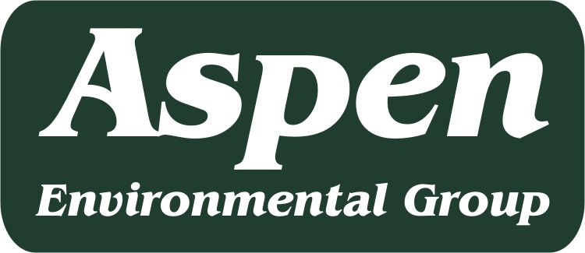
Valley South Subtransmission Line Project
PROJECT MEMORANDUM

To: Eric Chiang, CPUC Project Manager
From: Sandra Alarcón-Lopez, CEQA Project Manager
Aspen Environmental Group
Re: SCE’s PEA (December 2014)
Date: January 8, 2015

Aspen has reviewed SCE’s Proponent’s Environmental Assessment (PEA) dated December 2014 for the Valley South 115 kV Subtransmission Project and has considered SCE responses to previous data requests (#1 and #2) on draft versions of the PEA. In addition, Aspen considered the CPUC’s Working Draft PEA Checklist for Transmission Lines and Substations (November 2008), and the CPUC’s Information and Criteria List in preparing this evaluation.

Attachment A provides our comments on the December 2014 PEA. The attached comments include requests for clarification on responses to previous Aspen data requests and new comments identified in our review of background studies provided as part of the official PEA submittal to the CPUC.

Please let me know if you have questions or comments regarding this submittal.

Thank you.

